NAME : AGOHA CHINAZA R.
MATRIC NO: 17/MHS01/034
COURSE : RENAL PHYSIOLOGY
1. Discuss the pathophysiological process involved in renal failure
Renal failure is defined as a significant loss in of renal function in both kidneys to the point where less than 10-20% Glomurular filtration rate(GFR) remains. It occurs as acute and rapidly progressing process or as a chronic form, the earlier has a rapid onset and is easily reversible while the latter usually leads to permanent renal failure. Symptoms develop slowly and in advanced stages include anorexia, nausea, vomiting, stomatitis, dysgeusia, nocturia, lassitude, fatigue, pruritus, decreased mental acuity, muscle twitches and cramps, water retention, undernutrition, peripheral neuropathies, and seizures. Diagnosis is based on laboratory testing of renal function, sometimes followed by renal biopsy. Treatment is primarily directed at the underlying condition but includes fluid and electrolyte management, blood pressure control, treatment of anemia, various types of dialysis, and kidney transplantation.
etiologies of acute kidney injury (AKI) can be a challenging form of AKI to evaluate because of the wide variety of injuries that can occur to the kidney. In general, it can be helpful to think of damage to the four major structures of the kidney when considering etiologies of intrinsic renal failure. These four structures are 1) the tubules, 2) the glomeruli, 3) the interstitium, and 4) the intrarenal blood vessels.
Tubular Damage Acute tubular necrosis (ATN) is the term used to designate AKI resulting from damage to the tubules. The two major causes of ATN are:
Ischemic – resulting from severe or protracted decrease in renal perfusion.
Nephrotoxic – resulting from a variety of exogenous compounds (e.g. aminoglycosides, amphotericin B, cis-platinum, radiocontrast media) and endogenous compounds (e.g. hemoglobin in hemolysis, myoglobin in rhabdomyolysis) that are toxic or potentially toxic to the kidney.
Historically, classic ATN goes through an oliguric (urine output ≤ 400 mL/24 hours) phase of 1–2 weeks followed by a nonoliguric (urine output > 400 mL/day) phase of 10–14 days with eventual recovery of renal function. However, this description is not the rule as both prolonged oliguric phases and initial nonoliguric phases are common (381).
Glomerular Damage AKI from glomerular damage occurs in severe cases of acute glomerulonephritis (GN). Acute GN can be due to a primary renal disease such as an idiopathic rapidly progressive GN or as part of a systemic disease such as systemic lupus erythematosus, bacterial endocarditis, or Wegener’s granulomatosis (381, 542).
Interstitial Damage AKI from interstitial damage can result from acute interstitial nephritis due to an allergic reaction to a variety medications (commonly antibiotics such as penicillins, cephalosporins, sulfonamides) or an infection (bacterial illnesses such as leptospirosis, legionella, rarely pyelonephritis and viral illnesses such as Hanta virus), (381, 542).
Vascular Damage AKI from vascular damage occurs because injury to intrarenal vessels decreases renal perfusion and diminishes GFR. Causes of vascular injury include malignant hypertension, atheroembolic disease, preeclampsia/eclampsia, and hemolyticuremic syndrome (HUS)/thrombotic thrombocytopenia purpura (TTP)
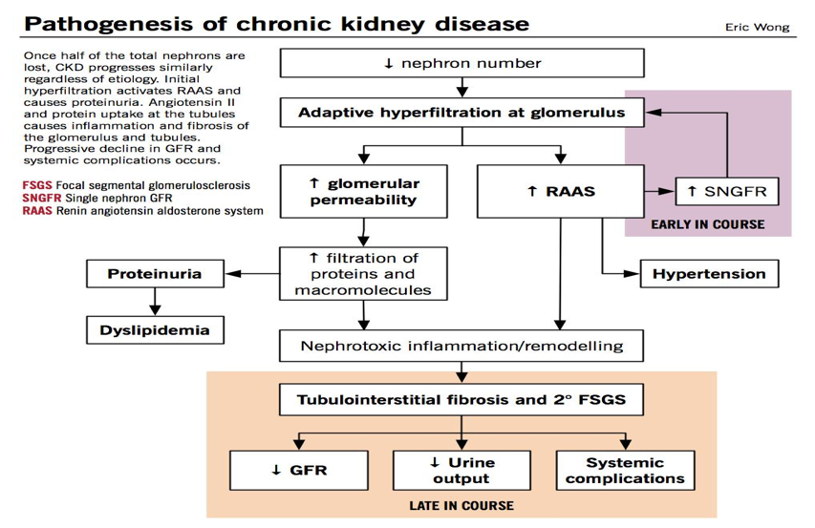
The five stages of kidney disease, or CKD, and the GFR for each stage, is shown below:

Stage 1 with normal or high GFR (GFR > 90 mL/min)
Stage 2 Mild CKD (GFR = 60-89 mL/min)
Stage 3A Moderate CKD (GFR = 45-59 mL/min)
Stage 3B Moderate CKD (GFR = 30-44 mL/min
Stage 4 Severe CKD (GFR = 15-29 mL/min)
Stage 5 End Stage CKD (GFR <15 mL/min)
Chronic kidney disease (CKD) is initially described as diminished renal reserve or renal insufficiency, which may progress to renal failure (end-stage renal disease). Initially, as renal tissue loses function, there are few noticeable abnormalities because the remaining tissue increases its performance (renal functional adaptation).
Decreased renal function interferes with the kidneys’ ability to maintain fluid and electrolyte homeostasis. The ability to concentrate urine declines early and is followed by decreases in ability to excrete excess phosphate, acid, and potassium. When renal failure is advanced (glomerular filtration rate [GFR] ≤ 15 mL/min/1.73 m2), the ability to effectively dilute or concentrate urine is lost; thus, urine osmolality is usually fixed at about 300 to 320 mOsm/kg, close to that of plasma (275 to 295 mOsm/kg), and urinary volume does not respond readily to variations in water intake.

Creatinine and urea
Plasma concentrations of creatinine and urea (which are highly dependent on glomerular filtration) begin a hyperbolic rise as GFR diminishes. These changes are minimal early on. When the GFR falls below 15 mL/min/1.73 m2 (normal > 90 mL/min/1.73 m2), creatinine and urea levels are high and are usually associated with systemic manifestations (uremia). Urea and creatinine are not major contributors to the uremic symptoms; they are markers for many other substances (some not yet well defined) that cause the symptoms.

Sodium and water
Despite a diminishing GFR, sodium and water balance is well maintained by increased fractional excretion of sodium in urine and a normal response to thirst. Thus, the plasma sodium concentration is typically normal, and hypervolemia is infrequent unless dietary intake of sodium or water is very restricted or excessive. Heart failure can occur due to sodium and water overload, particularly in patients with decreased cardiac reserve.

Potassium
For substances whose secretion is controlled mainly through distal nephron secretion (eg, potassium), renal adaptation usually maintains plasma levels at normal until renal failure is advanced or dietary potassium intake is excessive. Potassium-sparing diuretics, angiotensin-converting enzyme inhibitors, beta-blockers, nonsteroidal anti-inflammatory drugs, cyclosporine, tacrolimus, trimethoprim/sulfamethoxazole, pentamidine, or angiotensin II receptor blockers may raise plasma potassium levels in patients with less advanced renal failure.

Calcium and phosphate
Abnormalities of calcium, phosphate, parathyroid hormone (PTH), and vitamin D metabolism can occur, as can renal osteodystrophy. Decreased renal production of calcitriol (1,25(OH)2D, the active vitamin D hormone) contributes to hypocalcemia. Decreased renal excretion of phosphate results in hyperphosphatemia. Secondary hyperparathyroidism is common and can develop in renal failure before abnormalities in calcium or phosphate concentrations occur. For this reason, monitoring PTH in patients with moderate CKD, even before hyperphosphatemia occurs, has been recommended.
Renal osteodystrophy (abnormal bone mineralization resulting from hyperparathyroidism, calcitriol deficiency, elevated serum phosphate, or low or normal serum calcium) usually takes the form of increased bone turnover due to hyperparathyroid bone disease (osteitis fibrosa) but can also involve decreased bone turnover due to adynamic bone disease (with increased parathyroid suppression) or osteomalacia. Calcitriol deficiency may cause osteopenia or osteomalacia.

pH and bicarbonate
Moderate metabolic acidosis (plasma bicarbonate content 15 to 20 mmol/L) is characteristic. Acidosis causes muscle wasting due to protein catabolism, bone loss due to bone buffering of acid, and accelerated progression of kidney disease.

Anemia
Anemia is characteristic of moderate to advanced CKD (≥ stage 3). The anemia of CKD is normochromic-normocytic, with an Hct of 20 to 30% (35 to 40% in patients with polycystic kidney disease). It is usually caused by deficient erythropoietin production due to a reduction of functional renal mass (see Overview of Decreased Erythropoiesis). Other causes include deficiencies of iron, folate, and vitamin B12.

2. With the aid of a suitable diagram discuss the type of dialysis you know. Dialysis is a procedure to remove waste products and excess fluid from the blood when the kidneys stop working normally. There are three different types of dialysis namely ;

1. Hemodialysis
Hemodialysis is the most common type of dialysis. This process uses an artificial kidney (hemodialyzer) to remove waste and extra fluid from the blood. The blood is removed from the body and filtered through the artificial kidney. The filtered blood is then returned to the body with the help of a dialysis machine.
To get the blood to flow to the artificial kidney, your doctor will perform surgery to create an entrance point (vascular access) into your blood vessels. The three types of entrance points are:
* Arteriovenous (AV) fistula. This type connects an artery and a vein. It’s the preferred option.
* AV graft. This type is a looped tube.
* Vascular access catheter. This may be inserted into the large vein in your neck
Both the AV fistula and AV graft are designed for long-term dialysis treatments. People who receive AV fistulas are healed and ready to begin hemodialysis two to three months after their surgery. People who receive AV grafts are ready in two to three weeks. Catheters are designed for short-term or temporary use.
Hemodialysis treatments usually last three to five hours and are performed three times per week. However, hemodialysis treatment can also be completed in shorter, more frequent sessions.
Most hemodialysis treatments are performed at a hospital, doctor’s office, or dialysis center. The length of treatment depends on your body size, the amount of waste in your body, and the current state of your health.
After you’ve been on hemodialysis for an extended period of time, your doctor may feel that you’re ready to give yourself dialysis treatments at home. This option is more common for people who need long-term treatment.
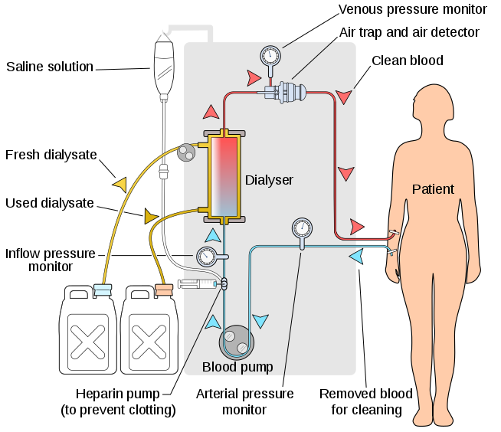
2. Peritoneal dialysis
Peritoneal dialysis involves surgery to implant a peritoneal dialysis (PD) catheter into your abdomen. The catheter helps filter your blood through the peritoneum, a membrane in your abdomen. During treatment, a special fluid called dialysate flows into the peritoneum. The dialysate absorbs waste. Once the dialysate draws waste out of the bloodstream, it’s drained from your abdomen.
This process takes a few hours and needs to be repeated four to six times per day. However, the exchange of fluids can be performed while you’re sleeping or awake.
There are numerous different types of peritoneal dialysis. The main ones are:
* Continuous ambulatory peritoneal dialysis (CAPD). In CAPD, your abdomen is filled and drained multiple times each day. This method doesn’t require a machine and must be performed while awake.
* Continuous cycling peritoneal dialysis (CCPD). CCPD uses a machine to cycle the fluid in and out of your abdomen. It’s usually done at night while you sleep.
* Intermittent peritoneal dialysis (IPD). This treatment is usually performed in the hospital, though it may be performed at home. It uses the same machine as CCPD, but the process takes longer.
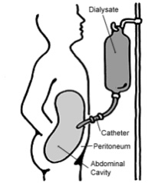

3. Continuous renal replacement therapy (CRRT)
This therapy is used primarily in the intensive care unit for people with acute kidney failure. It’s also known as hemofiltration. A machine passes the blood through tubing. A filter then removes waste products and water. The blood is returned to the body, along with replacement fluid. This procedure is performed 12 to 24 hours a day, generally every day.
