Name: Ekeadah Adaeze c
Matric no: 17/mhs01/107
Dept: MBBS
Level: 300

- DISCUSS THE PATHOPHYSIOLOGICAL PROCESS INVOLED IN RENAL FAILURE?
OUTLINE:
- INTRODUCTION
- Types of renal failure
- Causes
- Phases
- Pathophysiology of renal failure
INTRODUCTION: The urinary system, also known as the renal system, produces stores and eliminates urine, the fluid waste excreted by the kidneys. The kidneys make urine by filtering wastes and extra water from blood. Urine travels from the kidneys through two thin tubes called ureters and fills the bladder. When the bladder is full, a person urinates through the urethra to eliminate the waste, this is also known as a process called micturition in which a voids his/her bladder. NOTE: the renal system includes the kidneys, ureters, bladder and urethra.
The urinary system is susceptible to a variety of infections and other problems, including blockages and injuries. These can be treated by a urologist or another health care professional who specializes in the renal system.
Pathophysiology is basically a disordered physiological processes associated with disease or injury.
TYPES
We have at least 2 major types;
- Acute kidney injury (AKI)
- Chronic Renal Disease (CKD)
Acute Kidney Injury: This is defined as the abrupt clinical and/ or laboratory manifestation of abnormal kidney function within 48 hours of kidney injury.
A reduction in urine output documented as less than 0.5 ml/kg/hour for more than 6 hours.
Absolute increase in serum creatinine of more than or equal to 0.3 mg/di (26.4 umol/L) or a percentage increase in serum creatinine of more than or equal to 50% (1.5 fold from baseline).
The term AKI was introduced by the International Consensus Conference on Acute Dialysis Quality Initiative (ADQI) workgroup [Critical Care 2004] in place of the highly restrictive and commonly used term, acute renal failure (ARF)
CAUSES
Pathophysiology of AKI have 3 possible causes, these causes are;
- Prerenal
- Intrinsic
- postrenal
PHASES
There are also three major phases of AKI these are:
  - Initiation Phase
  - Maintenance Phase
  - Recovery Phase
PRERENAL- Mean arterial blood pressure reduction from changes in cardiac output or systemic vascular resistance, Increase sympathetic neural tone and the release of both renin (leading to the generation of angiotensin II) and ADH.
Arteriolar and venular constriction and stimulation of cardiac function returns the systemic blood pressure and cardiac output toward normal. Although these are appropriate systemic responses, the renal vasoconstriction diminishes renal blood flow and usually the glomerular filtration rate (GFR), which is flow-dependent. If the compensatory responses are incomplete, persistent reductions in cardiac output or arterial pressure can also contribute to the decline in the GFR.
Hypovolemia caused by dehydration, hemorrhage, renal fluid (diuretics) or gastrointestinal losses (vomiting, diarrhea), effective volume depletion also occurs in edematous states. These include heart failure (cardiorenal syndrome type 1) and cirrhosis from splanchnic venous pooling, systemic vasodilatation, and ascites.
In prerenal disease, the kidney is normal and the GFR is diminished because of decreased renal blood flow. Thus, the glomeruli, kidney tubules, and interstitium are intact. To reverse this process, the appropriate treatment is to increase renal perfusion, most commonly with volume repletion.
Intrinsic renal causes of AKI: this can be challenging to evaluate because of the wide variety of injuries that can occur to the kidney. Generally, four structures of the kidney are involved including tubules, glomeruli, the interstitium, and intra-renal blood vessels.
Acute tubular necrosis (ATN) is the term used to designate AKI resulting from damage to the tubules. It is the most common type of intrinsic kidney injury. AKI from glomerular damage occurs in severe cases of acute glomerulonephritis (GN). AKI from vascular damage occurs because injury to intra-renal vessels decreases renal perfusion and diminishes GFR and finally acute interstitial nephritis occurs due to an allergic reaction to a variety medications or an infection.
Post-renal AKI: this occurs after acute obstruction of the urinary flow, which increases intra-tubular pressure and thus decreases GFR. In addition, acute urinary tract obstruction can lead to impaired renal blood flow and inflammatory processes that also contribute to diminished GFR. Post-renal AKI can develop if the obstruction is located at any level within the urinary collection system (from the renal tubule to urethra). In case the obstruction is above the bladder it must involve both kidneys (and one kidney in the case of a patient with a single functioning kidney) to produce significant renal failure. However, a patient with pre-existing renal insufficiency may develop AKI with obstruction of only one kidney. Urinary obstruction may present as anuria or intermittent urine flow (such as polyuria alternating with oliguria) but may also present as nocturia or nonoliguric AKI. Timely reversion of pre-renal or post-renal causes usually results in prompt recovery of function, but late correction can lead to kidney damage. Intra-renal – tubular precipitation of insoluble crystals e.g methotrexate, acyclovir, sulfonamides, indinavir, uric acid, oxalic acid, Hb, myoglobin, paraprotein Rhabdomyolysis-marked exercise, statin, seizures, pressure necrosis, alcohol abuse and limb ischaemia Contrast nephropathy (Scr >2mg/dl)- old age, DM, CCF, volume depletion, high dose or extra-renal Can have complete recovery Post obstructive diuresis and hyperkalaemic Renal Tubular Acidosis.
Causes of acute kidney injury.
Category | Abnormality |  |  |  | Possible causes
Prerenal | Hypovolaemia |  |  |  | Haemorrhage  Volume depletion  Renal fluid loss (over-diuresis)  Third space (burns, peritonitis, muscle trauma)
 | Impaired cardiac function |  |  |  | Congestive heart failure  Acute myocardial infarction  Massive pulmonary embolism
 | Systemic vasodilatation |  |  |  | Anti-hypertensive medications  Gram negative bacteraemia  Cirrhosis  Anaphylaxis
 | Increased vascular resistance |  |  |  | Anaesthesia  Surgery  Hepatorenal syndrome  NSAID medications  Drugs that cause renal vasoconstriction (i.e. cyclosporine)
Instrinsic | Tubular |  |  |  | Renal ischaemia  (shock, complications of surgery, haemorrhage, trauma, bacteraemia, pancreatitis, pregnancy)  Nephrotoxic drugs  (antibiotics, antineoplastic drugs, contrast media, organic solvents, anaesthetic drugs, heavy metals)  Endogenous toxins  (myoglobin, haemoglobin, uric acid)
 | Glomerular |  |  |  | Acute post-infectious glomerulonephritis  Lupus nephritis  IgA glomerulonephritis  Infective endocarditis  Goodpasture syndrome  Wegener disease
 | Interstitium |  |  |  | Infections  (bacterial, viral)  Medications  (antibiotics, diuretics, NSAIDs, and many more drugs)
 | Vascular |  |  |  | Large vessels  (bilateral renal artery stenosis, bilateral renal vein thrombosis)  Small vessels  (vasculitis, malignant hypertension, atherosclerotic or thrombotic emboli, haemolytic uraemic syndrome, thrombotic thrombocytopenic purpura)
Postrenal | Extrarenal obstruction |  |  |  | Prostate hypertrophy  Improperly placed catheter  Bladder, prostate or cervical cancer  Retroperitoneal fibrosis
 | Intrarenal obstruction |  |  |  | Nephrolithiasis  Blood clots  Papillary necrosis

- CHRONIC KIDNEY DISEASE: Defined by the presence of kidney damage and/or level of kidney function—irrespective of the type of kidney disease.
Definition of Chronic Kidney Disease (CKD)
1. |  |  |  | Kidney damage for 3 months , with or without decreased GFR, as manifest by either:
 |  |  |  | - Pathologic abnormalities; or
Markers of kidney damage , including abnormalities in the composition of the blood urine ,or
Abnormalities in imaging test.
2 |  |  | GFR < 60ml/min/1.73m² for 3 months with or without kidney damage.
- Pathophysiology of chronic renal failure: Regardless of the primary cause of nephron loss, some usually survive or are less severely damaged, These nephrons then adapt and enlarge, and clearance per nephron markedly increases. If the initiating process is diffuse, sudden, and severe, such as in some patients with rapidly progressive glomerulonephritis (crescentic glomerulonephritis), acute or subacute renal failure may ensue with the rapid development of ESRD. In most patients, however, disease progression is more gradual and nephron adaptation is possible. Focal glomerulosclerosis develops in these glomeruli, and they eventually become non-functional. At the same time that focal glomerulosclerosis develops, proteinuria markedly increases and systemic hypertension worsens. This process of nephron adaptation has been termed the "final common path." Adapted nephrons enhance the ability of the kidney to postpone uremia, but ultimately the adaptation process leads to the demise of these nephrons. Adapted nephrons have not only an enhanced GFR but also enhanced tubular functions in terms of, for example, potassium and proton secretion.
CLINICAL FEATURES
- Usually asymptomatic in its early stages.
- Symptoms appear in later stages in association with complications.
PANSYSTEMIC

- WITH THE AID OF SUITABLE DIAGRAMS DISCUSS THE TYPES OF DIALYSIS?
There are 3 types of dialysis and these are;
- Hemodialysis
- Peritoneal dialysis
Hemodialysis: This is a treatment to filter wastes and water from your blood, as your kidneys did when they were healthy. Hemodialysis helps control blood pressure and balance important minerals, such as potassium, sodium, and calcium, in your blood.
Hemodialysis can help you feel better and live longer, but it’s not a cure for kidney failure.
During hemodialysis, your blood goes through a filter, called a dialyzer, outside your body. A dialyzer is sometimes called an “artificial kidney.”
At the start of a hemodialysis treatment, a dialysis nurse or technician places two needles into your arm. You may prefer to put in your own needles after you’re trained by your health care team. A numbing cream or spray can be used if placing the needles bothers you. Each needle is attached to a soft tube connected 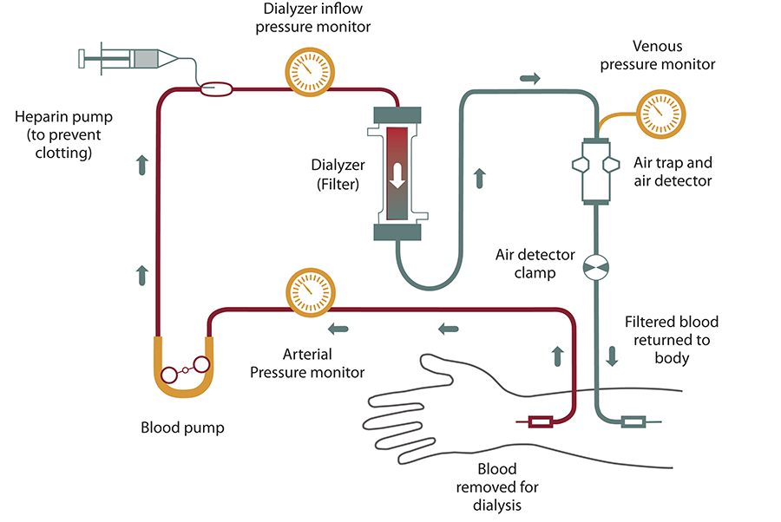to the dialysis machine.
The dialysis machine pumps blood through the filter and returns the blood to your body. During the process, the dialysis machine checks your blood pressure and controls how quickly
- blood flows through the filter
- fluid is removed from your body
Blood enters at one end of the filter and is forced into many, very thin, hollow fibers. As your blood passes through the hollow fibers, dialysis solution passes in the opposite direction on the outside of the fibers. Waste products from your blood move into the dialysis solution. Filtered blood remains in the hollow fibers and returns to your body.
The dialysis solution contains water and chemicals that are added to safely remove wastes, extra salt, and fluid from your blood. Your doctor can adjust the balance of chemicals in the solution if
- Your blood tests show your blood has too much or too little of certain minerals, such as potassium or calcium.
- You have problems such as low blood pressure or muscle cramps during dialysis.

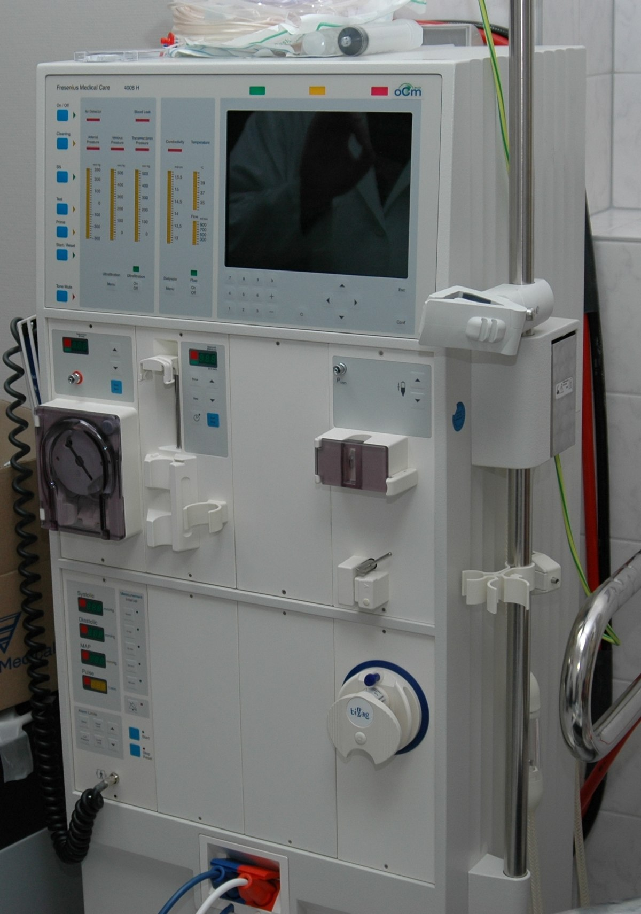
Peritoneal Dialysis: is a way to remove waste products from your blood when your kidneys can't adequately do the job any longer. This procedure filters the blood in a different way than does the more common blood-filtering procedure called hemodialysis. During peritoneal dialysis, a cleansing fluid flows through a tube (catheter) into part of your abdomen. The lining of your abdomen (peritoneum) acts as a filter and removes waste products from your blood. After a set period of time, the fluid with the filtered waste products flows out of your abdomen and is discarded.
These treatments can be done at home, at work or while traveling. But peritoneal dialysis isn't an option for everyone with kidney failure. You need manual dexterity and the ability to care for yourself at home, or you need a reliable caregiver.
When you start treatment, dialysis solution—water with salt and other additives—flows from a bag through the catheter into your belly. When the bag is empty, you disconnect it and place a cap on your catheter so you can move around and do your normal activities. While the dialysis solution is inside your belly, it absorbs wastes and extra fluid from your body. After a few hours, the solution and the wastes are drained out of your belly into the empty bag. You can throw away the used solution in a toilet or tub. Then, you start over with a fresh bag of dialysis solution. When the solution is fresh, it absorbs wastes quickly. As time passes, filtering slows. For this reason, you need to repeat the process of emptying the used solution and refilling your belly with fresh solution four to six times every day. This process is called an exchange.
You can do your exchanges during the day, or at night using a machine that pumps the fluid in and out. For the best results, it is important that you perform all of your exchanges as prescribed. Dialysis can help you feel better and live longer, but it is not a cure for kidney failure.
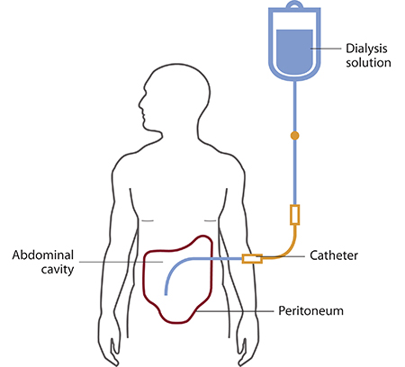

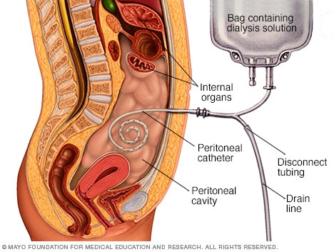
There are different types of peritoneal dialysis that best fits your life:
- continuous ambulatory peritoneal dialysis (CAPD)
- automated peritoneal dialysis
The main differences between the two types of peritoneal dialysis are
- the schedule of exchanges
- one uses a machine and the other is done by hand
If one type of peritoneal dialysis doesn’t suit you, talk with your doctor about trying the other type.

