NAME: AJAYI EMMANUEL OLUWASEGUN
MATRICULATION NUMBER: 17/MHS01/039
DEPARTMENT: MEDICINE AND SURGERY
COURSE CODE: PHS 303

THE PATHOPHYSIOLOGICAL PROCESS INVOLVED IN RENAL FAILURE
Chronic renal failure (CRF) and end-stage renal disease (ESRD) are functional diagnoses characterised by a progressive decrease in glomerular filtration rate (GFR). CRF occurs where GFR has been reduced to 10% of normal function (20 ml/min) and ESRD when GFR falls below 5% (10 ml/min). The main causes of chronic renal failure are:
- Diabetes mellitus (30%)
- Hypertension (24%)
- Glomerulonephritis (17%)
- Polycystic kidney disease (4%)
- Chronic pyelonephritis (5%)
- Unknown (20%)
Patients with ESRD frequently manifest a wide range of pathological organ dysfunction either caused by the primary disease (e.g. diabetes mellitus), intrinsic pathological effects of uraemia or a combination of both. Uraemia refers to the multitude of effects resulting from the inability to excrete products of the metabolism of proteins and amino acids. The multi-organ effects of uraemia are also caused by the impairment of the wide range of metabolic and endocrine functions normally carried out by the kidney.

Fluid and electrolyte derangement
Acidosis
Chronic metabolic acidosis is a common feature of ESRD. The inability to secrete protons and buffers (e.g. phosphate) or to regenerate bicarbonate limits the clearance of hydrogen ions. Furthermore, reduction in glutamine utilisation reduces ammonia prod
uction and secretion into the proximal tubule. Retention of organic anions causes a progressive increase in the anion gap and a further fall in plasma bicarbonate concentration. Although plasma bicarbonate concentrations rarely fall below 12–15 mmol/litre, there is little reserve to counter acute acidosis caused by ketoacidosis or sepsis.
Sodium
In a normal individual, more than 25,000 mmol of sodium ions are filtered daily with < 1% being excreted. CRF can be associated with sodium retention, sodium depletion or normal sodium balance and is influenced by factors such as diuretic use and cardiac function.
However, most patients demonstrate a mild degree of sodium and water retention whist the extracellular fluid volume remains isotonic. Ironically, the patient with CRF also has impaired renal concentrating mechanisms and thus extra renal fluid losses such as vomiting, diarrhoea or pyrexia may rapidly cause hypervolemia.
Potassium and magnesium
Adaptive processes increase potassium secretions in the distal nephron (collecting tubules) and also in the gut. Whilst a wide range of plasma potassium concentrations can be encountered dependent on factors such as diuretic use, it tends to be elevated. Acute changes present the greatest threats to life. A range of drugs may cause hyperkalaemia such as β-blockers, potassium-sparing diuretics (e.g. spironolactone), ACE inhibitors, angiotensin antagonists, NSAIDs and nephrotoxins such as aminoglycosides and cyclosporins. Extracellular acidosis causes an exchange of intracellular potassium for extracellular hydrogen ions in an attempt to maintain electrical neutrality. In acute acidosis, the serum potassium will rise 0.5mmol/litre for each 0.1 unit decrease in pH. For this reason, hypercarbia should be avoided during general anaesthesia.

Haematological abnormalities
A normochromic normocytic anaemia is a common finding in CRF. Decreased renal parenchymal erythropoietin production reduces stem cell transformation into erythrocytes, while uraemic toxins reduce red cell life. Chronic upper GI tract losses and those from dialysis further compound the problem. Dietary deficiency in iron and folate also occurs. A rapid increase in haemoglobin concentration above 10 g/dl often worsens hypertension and may precipitate heart failure.
Coagulopathy
Patients with CRF have a tendency to excessive bleeding in the peri-operative period. Standard tests of coagulation are usually normal (i.e. prothrombin time, activated partial prothromboplastin time, international normalised ratio) and platelet count is within the normal limits. However, platelet activity is deranged with decreased adhesiveness and aggregation, probably caused by inadequate vascular endothelial release of a von Willebrand factor/factor VIII complex which binds to and activates platelets. Increased platelet release of β-thromboglobulin and vascular production of PGI₂ also contribute to the coagulopathy.

Immune function
Sepsis is a leading cause of death in patients with CRF. Inhibition of cell-mediated immunity and humoral defence mechanisms occurs, with little improvement following dialysis. There is an increased production of pro-inflammatory cytokines suggesting that activation of monocytes may play a role in uraemic immune dysfunction. Superficial infections are common in fistula and catheter sites; wound healing is poor.
Gastrointestinal abnormalities
Gastrointestinal abnormalities are frequent with anorexia, nausea and vomiting contributing to malnutrition. Urea is a mucosal irritant and bleeding may occur from any part of the GI tract. Gastric emptying is delayed, residual volume increased and pH lowered. Peptic ulcer disease is common and most patients will receive proton pump inhibitors.

Endocrine disturbances
Changes in parathyroid function and lipid clearance are significant. Glucose tolerance is impaired but there is a reduced requirement for exogenous insulin in diabetic patients, probably related to the reduced metabolism of insulin by the failing kidney. Patients with CRF have abnormalities of temperature regulation with reduced basal metabolic rate and a tendency to hypothermia.

Neurological Abnormalities
Many patients with CRF have abnormalities in central (CNS) and peripheral (PNS) nervous system function. There is a wide spectrum of CNS changes; for example, from mild personality alterations to asterixis (i.e. lapse of posture, usually manifest by bilateral flapping tremor), myoclonus, encephalopathy and convulsions. Peripheral neuropathy is common in advanced stages of the disease. Initially, it presents as a distal ‘glove and stocking’ sensory loss but then progresses to motor changes. Both dialysis and renal transplantation may improve the neuropathy. The presence of a peripheral neuropathy should alert the anaesthetist to the presence of an autonomic neuropathy with delayed gastric emptying, postural hypotension and silent myocardial ischaemia. Two types of neurological disturbances are unique to patients on dialysis. Dialysis dementia with dyspraxia, myoclonus and dementia occurs in patients on dialysis for many years and may be related to aluminium toxicity. The dialysis disequilibrium syndrome is associated with rapid initial reduction in plasma urea concentrations at the start of dialysis.

DIALYSIS
Dialysis is the process of removing excess water, solutes, and toxins from the blood in people whose kidneys can no longer perform these functions naturally. This is referred to as renal replacement therapy.
Dialysis is used in patients with rapidly developing loss of kidney function, called acute kidney injury (previously called acute renal failure), or slowly worsening kidney function, called Stage 5 chronic kidney disease (previously called chronic kidney failure, end-stage renal disease, and end-stage kidney disease).
Dialysis is used as a temporary measure in either acute kidney injury or in those awaiting kidney transplants and as a permanent measure in those for whom a transplant is not indicated or not possible.
TYPES
There are three primary and two secondary types of dialysis:
- Haemodialysis (primary)
- Peritoneal dialysis (primary)
- Hemofiltration (primary)
- Hemodiafiltration (secondary)
- Intestinal dialysis (secondary).

Haemodialysis In haemodialysis, the patient's blood is pumped through the blood compartment of a dialyzer, exposing it to a partially permeable membrane. The dialyzer is composed of thousands of tiny hollow synthetic fibres. The fibre wall acts as the semipermeable membrane. Blood flows through the fibres, dialysis solution flows around the outside of the fibres, and water and wastes move between these two solutions. The cleansed blood is then returned via the circuit back to the body. Ultrafiltration occurs by increasing the hydrostatic pressure across the dialyzer membrane. This usually is done by applying a negative pressure to the dialysate compartment of the dialyzer. This pressure gradient causes water and dissolved solutes to move from blood to dialysate and allows the removal of several litres of excess fluid during a typical 4-hour treatment.
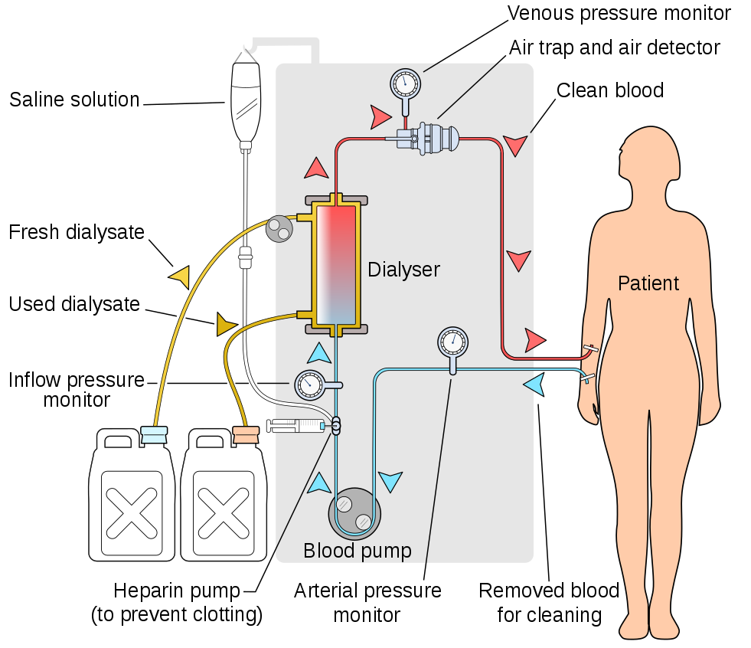

Peritoneal dialysis
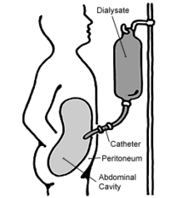
In peritoneal dialysis, a sterile solution containing glucose (called dialysate) is run through a tube into the peritoneal cavity, the abdominal body cavity around the intestine, where the peritoneal membrane acts as a partially permeable membrane.
This exchange is repeated 4–5 times per day; automatic systems can run more frequent exchange cycles overnight. Peritoneal dialysis is less efficient than haemodialysis, but because it is carried out for a longer period of time the net effect in terms of removal of waste products and of salt and water are similar to haemodialysis. Peritoneal dialysis is carried out at home by the patient, often without help. This frees patients from the routine of having to go to a dialysis clinic on a fixed schedule multiple times per week. Peritoneal dialysis can be performed with little to no specialized equipment (other than bags of fresh dialysate).

Hemofiltration
Hemofiltration is a similar treatment to haemodialysis, but it makes use of a different principle. The blood is pumped through a dialyzer or "hemofilter" as in dialysis, but no dialysate is used. A pressure gradient is applied; as a result, water moves across the very permeable membrane rapidly, "dragging" along with it many dissolved substances, including ones with large molecular weights, which are not cleared as well by haemodialysis. Salts and water lost from the blood during this process are replaced with a "substitution fluid" that is infused into the extracorporeal circuit during the treatment.

Hemodiafiltration
Hemodiafiltration is a combination of haemodialysis and hemofiltration, thus used to purify the blood from toxins when the kidney is not working normally and also used to treat acute kidney injury (AKI).

Intestinal Dialysis
In intestinal dialysis, the diet is supplemented with soluble fibres such as acacia fibre, which is digested by bacteria in the colon. This bacterial growth increases the amount of nitrogen that is eliminated in faecal waste. An alternative approach utilizes the ingestion of 1 to 1.5 litres of non-absorbable solutions of polyethylene glycol or mannitol every fourth hour.

