NAME: SUOWARI OYINEBI PASCHELIA
MATRIC NUMBER: 17/MHS01/299
DEPARTMENT: MEDICINE AND SURGERY
RENAL PHYSIOLOGY ASSIGNMENT
1. Discuss the pathophysiological process involves in renal failure?
2. With the aid of suitable diagrams discuss the types of dialysis you know?
ANSWERS
- Pathophysiological process in renal failure.
Renal failure is a condition in which the kidneys lose the ability to remove waste and balance fluids. Renal failure could be chronic or acute but which ever it is, there are underlying pathophysiological processes involved before the kidneys fails. Whatever the underlying etiology is, once the loss of nephrons and reduction of functional renal mass reaches a certain point, the remaining nephrons begin a process of irreversible sclerosis that leads to a progressive decline in the glomerular filtration rate. There are two types of renal failure, these are:
- Acute Renal Failure
Acute kidney failure (AKF), otherwise known as acute kidney injury or acute renal failure, comes on suddenly, typically within a few hours or days. It may occur due to trauma to the kidney or decreased blood flow in the area. It can also occur due to a blockage, such as a kidney stone, or very high blood pressure. The causes of acute renal failure can be divided into three main categories:
- Acute renal failure resulting from decreased blood supply to the kidneys; this condition is often referred to as prerenal acute renal failure to reﬂect the fact that the abnormality occurs in a system before the kidneys. This can be a consequence of heart failure with reduced cardiac output and low blood pressure or conditions associated with diminished blood volume and low blood pressure, such as severe haemorrhage.
- Intrarenal acute renal failure resulting from abnormalities within the kidney itself, including those that affect the blood vessels, glomeruli, or tubules.
- Post renal acute renal failure, resulting from obstruction of the urinary collecting system anywhere from the calyces to the outﬂow from the bladder. The most common causes of obstruction of the urinary tract outside the kidney are kidney stones, caused by precipitation of calcium, urate, or cystine.
There are two types of Acute Renal failure and they are:
- Acute prerenal kidney failure: Insufficient blood flow to the kidneys can cause acute prerenal kidney failure. The kidneys can’t filter toxins from the blood without enough blood flow.
- Acute intrinsic kidney failure: Acute intrinsic kidney failure can result from direct trauma to the kidneys, such as physical impact or an accident. Causes also include toxin overload and ischemia, which is a lack of oxygen to the kidneys.
A major physiologic effect of acute renal failure is retention in the blood and extracellular ﬂuid of water, waste products of metabolism, and electrolytes. This can lead to water and salt overload, which in turn can lead to edema and hypertension. Excessive retention of potassium, however, is often a more serious threat to patients with acute renal failure, because increases in plasma potassium concentration (hyperkalaemia) to more than about 8 mEq/L (only twice normal) can be fatal. Because the kidneys are also unable to excrete sufﬁcient hydrogen ions, patients with acute renal failure develop metabolic acidosis, which in itself can be lethal or can aggravate the hyperkalaemia. In the most severe cases of acute renal failure, complete anuria occurs. The patient will die in 8 to 14 days unless kidney function is restored or unless an artiﬁcial kidney is used to rid the body of the excessive retained water, electrolytes, and waste products of metabolism.
- Chronic Renal Failure
When a condition is chronic, it means that it occurs over a long period of time. Damage to the kidneys occurs gradually and can eventually lead to kidney failure.
Chronic renal failure results from progressive and irreversible loss of large numbers of functioning nephrons. Serious clinical symptoms often do not occur until the number of functional nephrons falls to at least 70 to 75 per cent below normal. In fact, relatively normal blood concentrations of most electrolytes and normal body ﬂuid volumes can still be maintained until the number of functioning nephrons decreases below 20 to 25 per cent of normal. Chronic renal failure, like acute renal failure, can occur because of disorders of the blood vessels, glomeruli, tubules, renal interstitium, and, and lower urinary tract. Despite the wide variety of diseases that can lead to chronic renal failure, the end result is essentially the same—a decrease in the number of functional nephrons
There are three types, namely:
- Chronic prerenal kidney failure: When there isn’t enough blood flowing to the kidneys for an extended period of time, the kidneys begin to shrink and lose the ability to function.
- Chronic intrinsic kidney failure: This happens when there’s long-term damage to the kidneys due to intrinsic kidney disease. Intrinsic kidney disease develops from a direct trauma to the kidneys, such as severe bleeding or a lack of oxygen.
- Chronic post-renal kidney failure: A long-term blockage of the urinary tract prevents urination. This causes pressure and eventual kidney damage.
- Dialysis
Dialysis is a procedure to remove waste products and excess fluid from the blood when the kidneys stop working properly. It often involves diverting blood to a machine to be cleaned. Normally, the kidneys filter the blood, removing harmful waste products and excess fluid and turning these into urine to be passed out of the body. Properly functioning kidneys prevent extra water, waste, and other impurities from accumulating in your body. They also help control blood pressure and regulate the levels of chemical elements in the blood. These elements may include sodium and potassium. Your kidneys even activate a form of vitamin D that improves the absorption of calcium.
A healthy person’s kidneys filter around 120 to 150 quarts of blood each day. If the kidneys are not working correctly, waste builds up in the blood. The cause might be a chronic, or long-term condition, or an acute problem, such as an injury or a short-term illness that affects the kidneys. Eventually, this can lead to coma and death
Dialysis prevents the waste products in the blood from reaching hazardous levels. It can also remove toxins or drugs from the blood in an emergency situation.
There are three types of Dialysis, namely:
- Haemodialysis: This is the most common type of dialysis and the one most people are aware of. A minor surgery is carried out first to create direct access to the bloodstream. This can be done in a few ways:
- Fistula (also known as arteriovenous fistula or A-V fistula): An artery and vein are joined together under the skin in the arm. Most of the time, this is done in the arm you don’t write with. An A-V fistula needs 6 weeks or longer to heal before it can be used for haemodialysis. Then, it can be used for many years.
- Graft (arteriovenous graft or A-V graft): A plastic tube is used to join an artery and vein under the skin. This heals in only 2 weeks, and haemodialysis can start faster. This won’t last as long as a fistula and will likely need to be changed to another graft after a few years.
- Catheter (central venous catheter): This method is an option if haemodialysis is needed very quickly. A flexible tube (catheter) is put into a vein in the neck, below the collarbone, or next to the groin. It’s only meant to be used for a short time.
Blood passes along the tube and into an external machine that filters it, before it's passed back into the arm along another tube. At dialysis centres, this is usually carried out 3 days a week, with each session lasting around 4 hours. It can also be done at home.
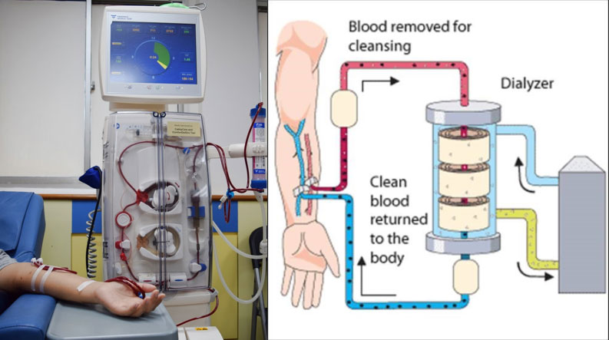
Risks associated with haemodialysis include: low blood pressure,
Anaemia, muscle cramping, difficulty sleeping, itching, high blood potassium levels, pericarditis, sepsis, a bloodstream infection, irregular heartbeat, etc.

- Peritoneal dialysis: Peritoneal dialysis uses the inside lining of your abdomen (the peritoneum) as the filter, rather than a machine, Like the kidneys, the peritoneum contains thousands of tiny blood vessels, making it a useful filtering device. Before treatment starts, a cut (incision) is made near your belly button and a thin tube called a catheter is inserted through the incision and into the space inside your abdomen (the peritoneal cavity). The catheter is used to transfer dialysis solution from a bag into the belly; this is left in place permanently. Fluid is pumped into the peritoneal cavity through the catheter, this special fluid called dialysate flows into the peritoneum. The dialysate absorbs waste. Once the dialysate draws waste out of the bloodstream, it’s drained from your abdomen. Dialysate contains water with salt and other additives. It soaks up waste and extra fluids inside your body. After a few hours, you’ll drain it out into a separate bag. This process is called an “exchange.”
As blood passes through the blood vessels lining the peritoneal cavity, waste products and excess fluid are drawn out of the blood and into the dialysis fluid. The used fluid is drained into a bag a few hours later and replaced with fresh fluid. Changing the fluid usually takes about 30 to 40 minutes and normally needs to be repeated around 4 times a day.
There are numerous different types of peritoneal dialysis. The main ones are:
- Continuous ambulatory peritoneal dialysis (CAPD): In CAPD, the abdomen is filled and drained multiple times each day. This method doesn’t require a machine and must be performed while awake.
- Continuous cycling peritoneal dialysis (CCPD): CCPD uses a machine to cycle the fluid in and out of the abdomen. It’s usually done at night when asleep.
- Intermittent peritoneal dialysis (IPD): This treatment is usually performed in the hospital, though it may be performed at home. It uses the same machine as CCPD, but the process takes longer.
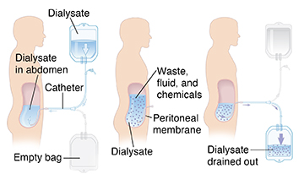
Risks associated with peritoneal dialysis include: Peritonitis (an infection of the membrane lining the abdominal wall), abdominal muscle weakening, high blood sugar due to the dextrose in the dialysate, weight gain, hernia, fever, stomach pain.

- Continuous renal replacement therapy (CRRT): This therapy is used primarily in the intensive care unit for people with acute kidney failure. It’s also known as hemofiltration. A machine passes the blood through tubing. A filter then removes waste products and water. The blood is returned to the body, along with replacement fluid. This procedure is performed 12 to 24 hours a day, generally every day.
Dialysis can be intermittent or continuous; while a session of intermittent dialysis lasts for up to 6 hours, continuous renal replacement therapies (CRRT) are designed for 24-hour use in an intensive care unit (ICU).There are different types of CRRT. It can involve either filtration or diffusion. It is better tolerated than intermittent dialysis, because the solute or fluid removal is slower. This leads to fewer complications, for example, a lower chance of hypotension.

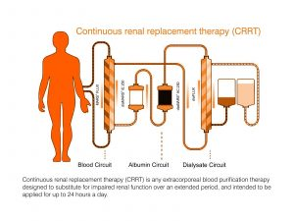

Risks associated with CRRT include: infection, hypothermia, low blood pressure, electrolyte disturbances, bleeding, anaphylaxis, etc.

NOTE: Those who undergo long-term dialysis treatments are also at risk of developing other medical conditions, including amyloidosis (This disease can occur when amyloid proteins produced in bone marrow build up in organs such as the kidneys, liver, and heart) which usually causes joint pain, stiffness, and swelling.
Some people may also develop depression after receiving a diagnosis of long-term kidney failure.

