ADEBAYO ADETUTU MERCY
17/MHS01/012
MEDICINE AND SURGERY
300 LEVEL

- TYPES OF DIALYSIS

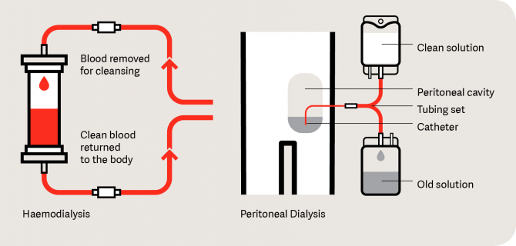

Hemodialysis
Hemodialysis uses an external machine and a special type of filter to remove excess waste products and water from the blood.
During hemodialysis, blood passes from the patient's body to the dialysis machine through sterile tubing and into a filter, called a dialysis membrane. For this procedure, the patient has a specialized vascular tube placed between an artery and a vein in the arm or leg (called a gortex graft). Sometimes, a direct connection is made between an artery and a vein in the arm. This procedure is called a Cimino fistula. Needles are then placed in the graft or fistula, and blood passes to the dialysis machine, through the filter, and back to the patient. If the patient requires dialysis before a graft or a fistula is placed, a large diameter catheter (hemodialysis catheter) is placed directly into a large vein in the neck or leg in order to perform dialysis. In the dialysis machine, a solution on the other side of the filter receives the waste products from the patient.

Peritoneal dialysis
Peritoneal dialysis uses a fluid that is placed into the patient's abdominal cavity through a plastic tube (peritoneal dialysis catheter) to remove excess waste products and fluid from the body.
Peritoneal dialysis uses the patients own body tissues inside of the belly (abdominal cavity) to act as the filter. The abdominal cavity is lined with a special membrane called the peritoneal membrane. A plastic tube called a peritoneal dialysis catheter is placed through the abdominal wall into the abdominal cavity. A special fluid called dialysate is then flushed into the abdominal cavity and washes around the intestines. The peritoneal membrane acts as a filter between this fluid and the blood stream. By using different types of solutions, waste products and excess water can be removed from the body through this process.

Pathophysiology of renal failure

A normal kidney contains approximately 1 million nephrons, each of which contributes to the total glomerular filtration rate (GFR). In the face of renal injury (regardless of the etiology), the kidney has an innate ability to maintain GFR, despite progressive destruction of nephrons, as the remaining healthy nephrons manifest hyperfiltration and compensatory hypertrophy. This nephron adaptability allows for continued normal clearance of plasma solutes. Plasma levels of substances such as urea and creatinine start to show measurable increases only after total GFR has decreased 50%.
The plasma creatinine value will approximately double with a 50% reduction in GFR. For example, a rise in plasma creatinine from a baseline value of 0.6 mg/dL to 1.2 mg/dL in a patient, although still within the adult reference range, actually represents a loss of 50% of functioning nephron mass.
The hyperfiltration and hypertrophy of residual nephrons, although beneficial for the reasons noted, has been hypothesized to represent a major cause of progressive renal dysfunction. The increased glomerular capillary pressure may damage the capillaries, leading initially to secondary focal and segmental glomerulosclerosis (FSGS) and eventually to global glomerulosclerosis.
Factors other than the underlying disease process and glomerular hypertension that may cause progressive renal injury include the following:
- Systemic hypertension
- Nephrotoxins (eg, nonsteroidal anti-inflammatory drugs [NSAIDs], intravenous contrast media)
- Decreased perfusion (eg, from severe dehydration or episodes of shock)
- Proteinuria (in addition to being a marker of CKD)
- Hyperlipidemia
- Hyperphosphatemia with calcium phosphate deposition
- Smoking
- Uncontrolled diabetes

