NAME: NWANDU UCHNNA SANDRA

MAT NO: 18/MHS02/120

URINE FORMATION AND CONCENTRATION

Formation of urine is a process important for the whole organism. Not only acid- base balance is modulated by it, but also blood osmolarity, plasma composition and fluid volume, and thus it influence all cells in the body.

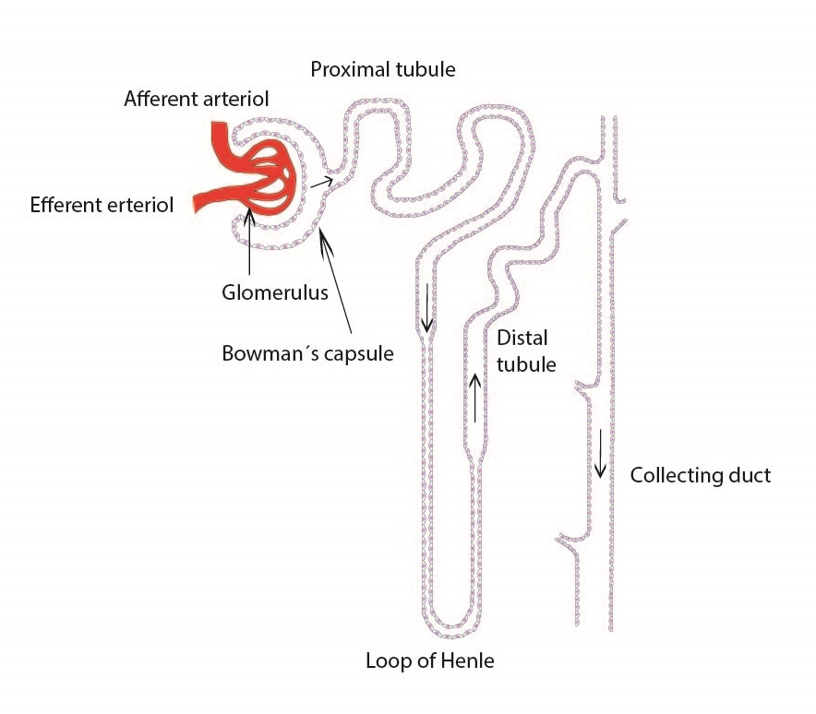

Glomerular Filtration
Glomerular filtration occurs as blood passes into the glomerulus producing a plasma-like filtrate (minus proteins) that gets captured by the Bowman’s (glomerular) capsule and funneled into the renal tubule. This filtrate produced then becomes highly modified along its route through the nephron by the following processes, finally producing urine at the end of the collecting duct. Glomerular Filtration Rate is regulated by mechanisms:
- Autoregulation – the smooth muscle in the afferent arteriole responds to blood pressure changes by constricting and dilating to regulate filtration rate.
- Sympathetic control – causes afferent arterioles to constrict or dilate when activated by a nerve impulse (fight or flight response to keep blood pressure up)
Renin-angiotensin mechanism – triggered by the juxtaglomerular apparatus; when filtration rate decreases, the enzyme renin is released. Renin converts a plasma protein called angiotensinogen into angiotensin I. Angiotensin I is quickly converted into angiotensin II by another enzyme. Angiotensin II causes 3 changes:
(1) Constriction of the arterioles – decreases urine formation and water loss
(2) Stimulates the adrenal cortex to release aldosterone – promotes water reabsorption by causing the absorption of salt
(3) Stimulates the posterior pituitary to release ADH – antidiuretic hormone – promotes water reabsorption
(4) Stimulates the thirst and water intake (hypothalamus says we’re thirsty so we get a drink)

Tubular Reabsorption
As the filtrate travels along the length of the nephron, the cells lining the tubule selectively, and often actively, take substances from the filtrate and move them out of the tubule into the blood. Recall that the glomerulus is simply a filter and anything suspended in the plasma that can fit through the holes in the filtration membrane can end up in the filtrate. This includes very physiologically important molecules such as water, sodium, chloride, and bicarbonate (along with many others) as well as molecules that the digestive system used a lot of energy to absorb, such as glucose and amino acids. These molecules would be lost in the urine if not reclaimed by the tubule cells. These cells are so efficient that they can reclaim all of the glucose and amino acids and up to 99% of the water and important ions lost due to glomerular filtration. The filtrate that is not reasbsorbed becomes urine at the base of the collecting duct.
As these substances are reabsorbed, the blood becomes hypertonic so water easily follows by osmosis
Reabsorption in the distal convoluted tubule is under hormonal control…aldosterone causes more salt to be absorbed, ADH causes more water to be absorbed
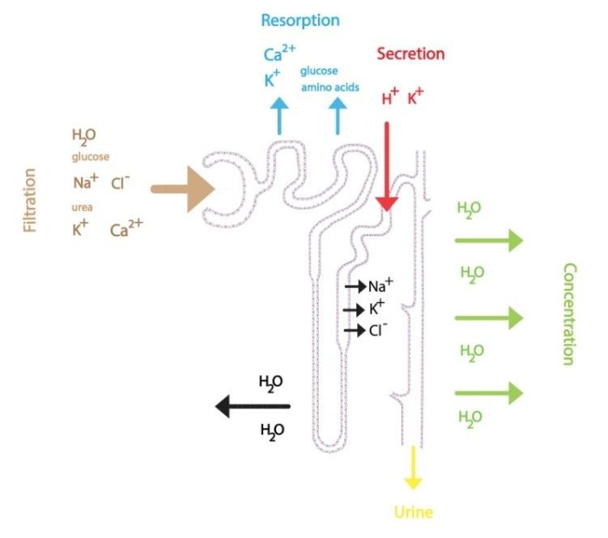
Tubular Secretion
Tubular secretion occurs mostly in the PCT and DCT where unfiltered substances are moved from the peritubular capillary into the lumen of the tubule. Secretion usually removes substances from the blood that are too large to be filtered (ex: antibiotics, toxins) or those that are in excess in the blood (ex: H⁺, K⁺). These substances secreted into the tubule are destined to leave the body as components of urine.eview

URINE CONCENTRATION
The mammalian kidney maintains nearly constant blood plasma osmolality and nearly constant blood plasma sodium concentration by means of mechanisms that independently regulate water and sodium excretion. Because many mammals do not have continuous access to water, the ability to vary water excretion can be essential for survival. Because sodium and its anions are the principal osmotic constituents of blood plasma, and stable electrolyte concentrations are also essential, water excretion must be regulated by mechanisms that decouple it from sodium excretion. The urine concentrating mechanism plays a fundamental role in regulating water and sodium excretion. When water intake is large enough to dilute blood plasma, urine more dilute than blood plasma is produced; when water intake is so small that blood plasma is concentrated, urine more concentrated than blood plasma is produced. In both cases, the total urinary solute excretion rate and the urinary sodium excretion rate are small and normally vary within narrow bounds.
In contrast to solute excretion, urine osmolality varies widely in response to changes in water intake. Following several hours without water intake, such as occurs overnight during sleep, human urine osmolality may rise to ∼1,200 mOsm/kg H₂O, about 4-times plasma osmolality (∼290 mOsm/kg H₂O). Conversely, urine osmolality may decrease rapidly following the ingestion of large quantities of water, such as commonly occurs at breakfast, human (and other mammals) urine osmolality may decrease to ∼50 mOsm/kg H₂O. Most physiologic studies relevant to the urine concentrating mechanism have been conducted in species (rodents, rabbits) that can achieve higher maximum urine osmolalities than humans. For example, rabbits can concentrate to ∼1,400 mOsm/kg H₂O, rats to ∼3,000 mOsm/kg H₂O, mice and hamsters to ∼4,000 mOsm/kg H₂O, and chinchillas to ∼7,600 mOsm/kg H₂O (reviewed in).
All mammalian kidneys maintain an osmotic gradient that increases from the cortico-medullary boundary to the tip of the medulla (papillary tip). This osmotic gradient is sustained even in diuresis, although its magnitude is diminished relative to antidiuresis. NaCl is the major constituent of the osmotic gradient in the outer medulla, while NaCl and urea are the major constituents in the inner medulla . The cortex is nearly isotonic to plasma, while the inner medullary (papillary) tip is hypertonic to plasma, and has osmolality similar to urine during antidiuresis . Sodium and potassium, accompanied by univalent anions, and urea are the major urinary solutes; urea is normally predominant urinary solute during a strong antidiuresis.
The mechanisms for the independent control of water and sodium excretion are mostly contained within the renal medulla. The medullary nephron segments and vasa recta are arranged in complex but specific anatomic relationships, both in terms of three-dimensional configuration and in terms of which segments connect to which segments. The production of concentrated urine involves complex interactions among the medullary nephron segments and vasculature. In outer medulla, the thick ascending limbs of the loops of Henle actively reabsorb NaCl. This serves two vital functions: it dilutes the luminal fluid; and it provides NaCl to increase the osmolality of the medullary interstitium, pars recta, descending limbs, vasculature, and collecting ducts. Both the nephron segments and vessels are arranged in a countercurrent configuration, thereby facilitating the generation of a medullary osmolality gradient along the cortico-medullary axis. In inner medulla, osmolality continues to increase, although the source of the concentrating effect remains controversial. The most widely accepted mechanism remains the passive reabsorption of NaCl, in excess of solute secretion, from the thin ascending limbs of the loops of Henle.
Perfused tubule studies provided the basis for many of the theories of how concentrated urine is produced (reviewed in. The cloning of many of the proteins that mediate urea, sodium, and water transport in nephron segments that are important for urinary concentration and dilution have provided additional insights into the urine concentrating mechanism. In general, the urea, sodium, and water transport proteins are highly specific and appear to eliminate a molecular basis for solvent drag; this specifically suggests that the reflection coefficients should be 1.

