MARTHA MOLKALE GAJERE
17/MHS01/134
MEDICINE AND SURGERY
300 LEVEL
PHYSIOLOGY ASSIGNMENT (RENAL PHYSIOLOGY)

QUESTIONS
1. Discuss the pathophysiological process involved in renal failure
2. With the aid of suitable diagrams, discuss the types of dialysis you know.
ANSWERS
1. Pathophysiological process involved in renal failure.
A normal kidney of responsible for the filtration of blood to remove waste.
Renal failure is also called kidney failure
It can be acute renal failure or chronic kidney disease.
Two thirds of cases are caused by diabetics or high blood pressure.
ACUTE KIDNEY FAILURE
Acute kidney failure occurs when your kidneys suddenly become unable to filter waste products from your blood. When your kidneys lose their filtering ability, dangerous levels of wastes may accumulate, and your blood's chemical makeup may get out of balance
Symptoms include; Decreased urine output, although occasionally urine output remains normal, fluid retention causing swelling in your legs, ankles or feet, shortness of breath, fatigue, confusion, nausea, weakness, irregular heartbeat, chest pain or pressure, seizures or coma.
CHRONIC KIDNEY DISEASE
Chronic kidney disease is a longstanding disease of the kidneys leading to renal failure.
With chronic kidney disease, the kidneys don’t usually fail all at once. Instead, kidney disease often progresses slowly over a period of years. This is good news because if CKD is caught early, medicines and lifestyle changes may help slow its progress and keep you feeling your best for as long as possible.
Glomerular filtration rate (GFR) is the best measure of kidney function. Once the loss of nephrons and reduction of functional renal mass reaches a certain point, the remaining nephrons begin a process of irreversible sclerosis that leads to a progressive decline in GFR. The GFR is the number used to figure out a person’s stage of kidney disease. A math formula using the person’s age, race, gender and their serum creatinine is used to calculate a GFR. A blood test is carried out to measure the serum creatinine level. Creatinine is a waste product that comes from muscle activity. When kidneys are working well they remove creatinine from the blood. As kidney function slows, blood levels of creatinine rise.
Below shows the five stages of CKD and GFR for each stage:
Stage 1 with normal or high GFR (GFR > 90 mL/min)
Stage 2 Mild CKD (GFR = 60-89 mL/min)
Stage 3A Moderate CKD (GFR = 45-59 mL/min)
Stage 3B moderate CKD (GFR = 30-44 mL/min)
Stage 4 Severe CKD (GFR = 15-29 mL/min)
Stage 5 End Stage CKD (GFR <15 mL/min)
Treatment usually consists of measures to help control signs and symptoms, reduce complications, and slow progression of the disease. If your kidneys become severely damaged, dialysis or transplants become necessary.
2. Types of dialysis
There are 3 types
1. Hemodialysis. Hemodialysis is the most common type of dialysis.
During hemodialysis, your blood goes through a filter, called a dialyzer, outside your body. A dialyzer is sometimes called an “artificial kidney.”
At the start of a hemodialysis treatment, a dialysis nurse or technician places two needles into your arm. You may prefer to put in your own needles after you’re trained by your health care team. A numbing cream or spray can be used if placing the needles bothers you. Each needle is attached to a soft tube connected to the dialysis machine.
The dialysis machine pumps blood through the filter and returns the blood to your body. During the process, the dialysis machine checks your blood pressure and controls how quickly blood flows through the filter and how fluid is removed from your body.
Hemodialysis can replace part, but not all, of your kidney function. Dialysis will help improve your energy level, and changes you make to your diet can help you feel better. Limiting how much water and other liquid you drink and take in through foods can help keep too much fluid from building up in your body between treatments.
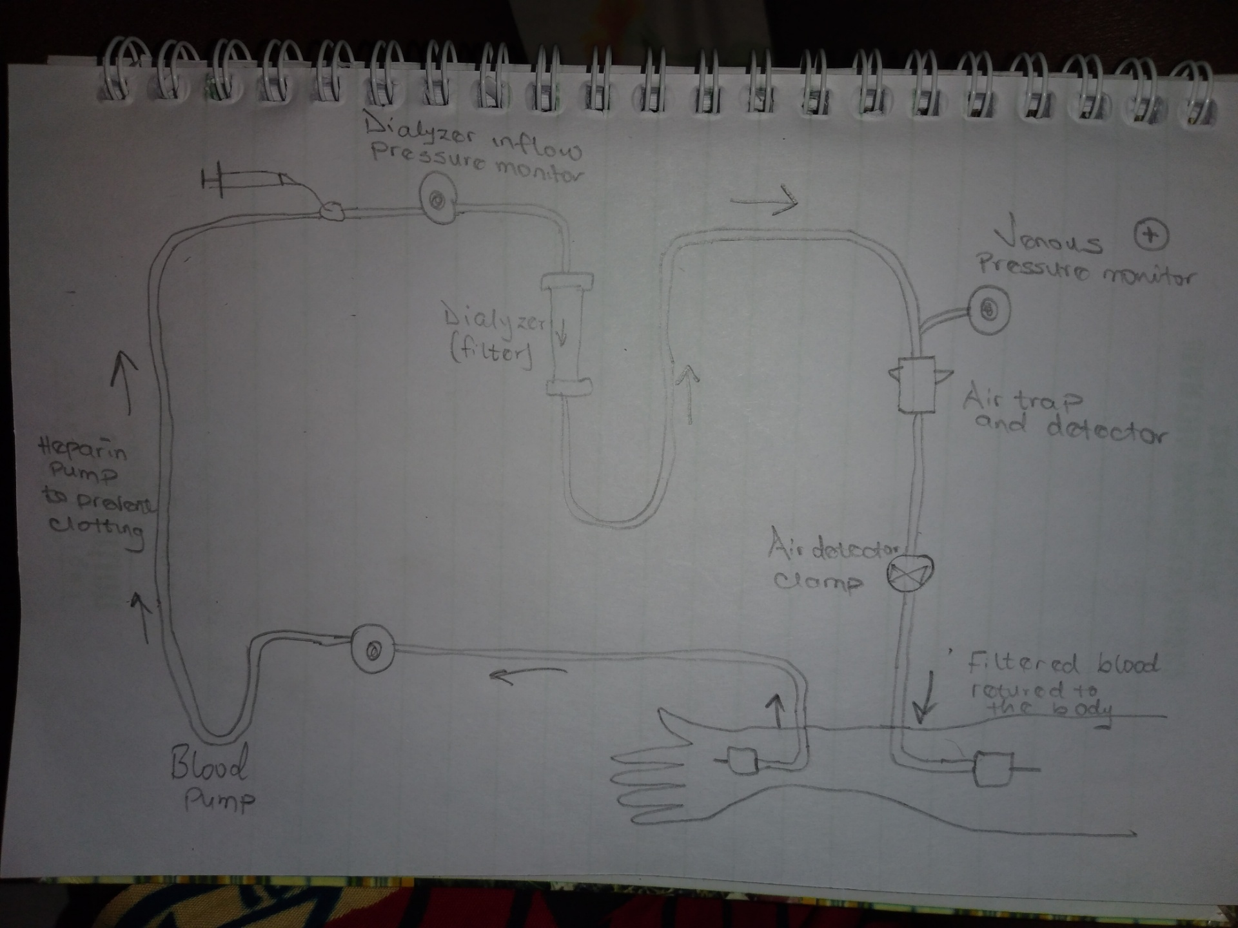

2. Peritoneal dialysis. Peritoneal dialysis involves surgery to implant a peritoneal dialysis (PD) catheter into your abdomen
During peritoneal dialysis, a cleansing fluid flows through a tube (catheter) into part of your abdomen. The lining of your abdomen (peritoneum) acts as a filter and removes waste products from your blood. After a set period of time, the fluid with the filtered waste products flows out of your abdomen and is discarded.
These treatments can be done at home, at work or while traveling. But peritoneal dialysis isn't an option for everyone with kidney failure. You need manual dexterity and the ability to care for yourself at home, or you need a reliable caregiver.
The benefits of peritoneal dialysis compared with hemodialysis include:
Greater lifestyle flexibility and independence. These can be especially important if you work, travel or live far from a hemodialysis centre.
A less restricted diet. Peritoneal dialysis is done more continuously than hemodialysis, resulting in less accumulation of potassium, sodium and fluid. This allows you to have a more flexible diet than you could have on hemodialysis.
Longer lasting residual kidney function. People who use peritoneal dialysis might retain kidney function slightly longer than people who use hemodialysis.
Risks of infections, weight gain, hernia and inadequate dialysis may occur.
3. Continuous renal replacement therapy (CRRT)
Continuous renal replacement therapy (CRRT) is commonly used to provide renal support for critically ill patients with acute kidney injury, particularly patients who are hemodynamically unstable.

