Ibisagba Titilopemi I.

17/MHS01/144

MEDICINE AND SURGERY

300 LEVEL

RENAL PHYSIOLOGY

ASSIGNMENT
1. Discuss the pathophysiological process involves in renal failure?
2. With the aid of suitable diagrams discuss the types of dialysis you know?
ANSWER
1. The Pathophysiological Processes of Renal Failure
Renal failure refers to the failure of excretory functions of the kidney, ending end with terminal kidney damage. It is usually characterized by decrease in glomerular filtration rate (GFR) During this time, there is modulation and adaptation in the still-functional glomeruli, which keeps the kidneys functioning normally for as long as possible. The remaining glomeruli, therefore, experience a rise in pressure through hyperfiltration.
The release of various cytokines and growth factors leads to hypertrophy and hyperplasia. At the same time, the function of the glomeruli suffers due to the excessive demands on them, leading to increased permeability and proteinuria. Increased protein concentrations in the proximal tube system are direct nephrotoxins and can further impair kidney function.
There are four phases of chronic renal failure:
1. Reduction in Excretory Function: Breakdown of excretory function is the consequence of an accumulation of endogenous andextraneous substances. This leads to changes in pharmacokinetics and an increase in the concentration of various medications. Breakdown occurs when the remaining glomeruli are confronted by a surplus of waste products, leading to osmotic diuresis. There is a reduction in the maximal concentrating capacity of the kidney. In order to filter the physiological quantity of dissolved substances, the nephrons produce between 3 and 4 times as much urine during renal failure, resulting in an accumulation of waste substances.
2. Reduction in Incretory Renal Function: Because the kidney plays a part in the regulation of many important hormonal cycles, chronic renal failure also has endocrinal consequences. Through a shortage of erythropoietin, there is a reduction in erythrocyte synthesis, which leads to renal anemia; uremia then leads to a reduction of functional erythrocytes due to hemolysis or hemorrhages.
Vitamin D production is also impaired, and phosphate excretion is reduced. Secondary hyperparathyroidism and the associated renal osteopathy (‘high-turnover’ osteopathy) develop as a result of hyperphosphatemia. Parallel to this, other pathomechanisms lead to a disruption in bone metabolism: osteomalacia occurs due to a disruption of mineralization, and adynamic bone disease occurs due to a reduction in bone cell activity (particularly in dialysis patients).
3. Over-hydration and the Disruption of Electrolyte Balance: As long as the glomeruli can manage to compensate, diuresis and fractional sodium excretion rise. If the glomerular filtration rate noticeably drops, then the ability to compensate is exhausted, leading to increased retention of water and electrolytes.
Hypertension, pulmonary edema, and peripheral edema result from overhydration. Water and salt excretion are thereby inextricably linked. Diuretics can aid in water and salt excretion where critical glomerular damage is present. Early loss of salts as a result of the disturbance in the resorption process can actually be made worse by the use of diuretics.
Thus, as the glomeruli adapt to compensate, the tubular transport mechanisms also adapt in order to prevent hyperkalemia through increased potassium secretion. Hyperkalemia only develops as a result of hyperstimulation of the resorption capacity. As many patients are treated with calcium-sparing diuretics due to previous conditions, it is vital to refer to patient’s medication history and adapt the treatment plan accordingly.
Acidosis also rises alongside hyperkalemia. The kidneys can no longer sufficiently eliminate accumulating protons due to a strongly reduced glomerular filtration rate. This metabolic acidosis leads to increased bone calcium release and strengthening renal osteopathy, an increase in gastrointestinal problems, and the impairment of protein metabolism.
4. Toxic Organ Damage as a Result of Retention of Urinary Excreted Metabolites: Toxic organ damage can be explained under the umbrella term ‘uremic syndrome.’ The rise in urinary excreted metabolites in the blood is called azotemia. These metabolites include urea, creatinine, beta-2 microglobulin, parathyroid hormone, among others. Uremic syndrome (uremia) principally describes a systemic disruption of all organ functions, especially the circulatory system, central nervous system, blood, and membranes.
Clinically, many symptoms of chronic renal failure can be detected via the skin. Patients often have macules (‘café au lait’ spots), are conspicuously pale, and have a gray, dirty-looking complexion. They often complain of pruritus. Internal membranes are also affected, leading to pericarditis, peritonitis, and pleurisy.
Uremia can also lead to hemolysis with anemia. Simultaneously, thrombocyte and leukocyte dysfunctions or deficiencies can arise.
People with chronic renal failure have a generally increased risk of atherosclerosis with an elevated cardiovascular risk. This leads to media calcification caused by calcium phosphate and to intima calcification through inflammatory factors and cholesterol plaques. Hypertension is common, along with edemas and pulmonary congestion.
Impairments of the central nervous system are indicated by a reduction in vigilance, from general drowsiness to uremic coma. Seizures can occur. Uremia also causes polyneuropathy with paresthesia. `

2. Dialysis is a common treatment practice for those who are suffering from kidney function failure. The dialysis process helps in removing the wastes and excessive water content from the blood artificially, with the support of machines, which is otherwise the task of the kidneys.
It is used in patients with rapidly developing loss of kidney function, called acute kidney injury also called acute renal failure, or slowly worsening kidney function, called Stage 5 chronic kidney disease (previously called chronic kidney failure, end-stage renal disease, and end-stage kidney disease).
Dialysis is used as a temporary measure in either acute kidney injury or in those awaiting kidney transplant and as a permanent measure in those for whom a transplant is not indicated or not possible. There are different types of dialysis. All of these types help in purifying the blood in some way or the other. Depending on the method used, the types of dialysis vary. There are three major or primary types of dialysis and two secondary types. They primary types of dialysis are:
Haemodialysis: This is the most common method of dialysis. In this method, the doctor will create a vascular access into the body, surgically. This will allow more blood to flow through the dialyzer and return back to the body after purification. The vascular access is an entrance to the blood vessel. Inside the dialyzer, there are thousands of tiny synthetic fibres that act as semi-permeable membrane. A dialysis solution, also known as dialysate, is used to purify the blood that runs through this membrane of fibres. A negative pressure is used to remove the water from the blood to the dialysate. The usual span for the haemodialysis process is 4 hours. Typically, a person has to undergo three haemodialysis sessions per week. However, depending on the condition, requirement or disease, haemodialysis can be done more frequently and for shorter or longer sessions.
The body size and the amount of waste in the blood determine the frequency of haemodialysis suitable for the patient. Usually the procedure is done at a doctor’s office or at a hospital or at a dialysis centre. Nowadays, with advanced technology, haemodialysis is also being offered at the patient’s home. Those, who are in need for a long-term dialysis, are recommended the at-home haemodialysis treatment.
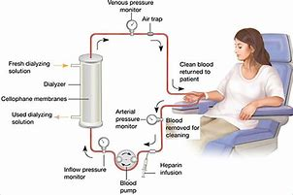
Peritoneal Dialysis: This is a surgical procedure of dialysis. The doctor implants a catheter into the patient’s belly and this comes out from below the belly button. A dialysate fluid is inserted into the abdomen through the catheter. This fluid draws out the waste materials and extra water from the blood, through the small blood vessels in the abdomen. Once the process is done, the waste materials and extra water from the blood along with the dialysate fluid, all get deposited into a bag through the catheter. There are two types of peritoneal dialysis;
(i) Continuous ambulatory peritoneal dialysis (CAPD): It is useful for those, who want to undergo the dialysis treatment while staying mobile or while doing other tasks. It is carried out multiple times a day. This method does not require any machine to carry out the dialysis treatment.
(ii)Continuous cycling peritoneal dialysis (CCPD): It is useful for those, who do not want any interruption throughout the day. It is done at night, while the patient is asleep.
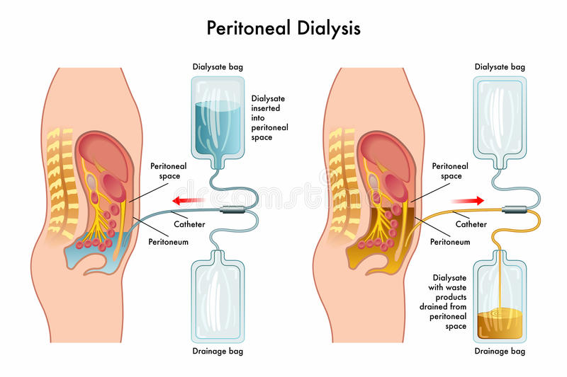

Hemofiltration: Hemofiltration is similar to haemodialysis except for the principle which it follows. In this process, the blood is passed via the dialyzer but the dialysate is not used. The water is passed through permeable membranes rapidly, taking along with it the dissolved substances including large molecular substances which are usually not cleared in hemodialysis. During the treatment process, water and salts that are replaced during this filtration process is infused back in the extracorporeal circuit.
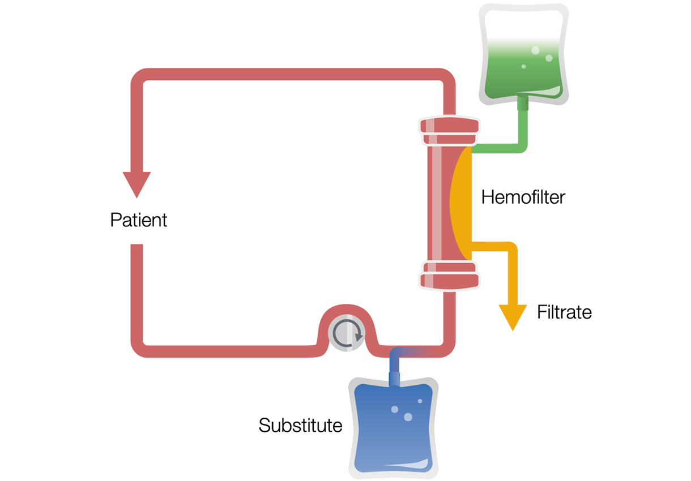

The secondary types of dialysis include:
Hemodiafiltration: This is actually a combination of hemodialysis and hemofiltration, thus used to purify the blood from toxins when the kidney is not working normally and also used to treat acute kidney injury (AKI).
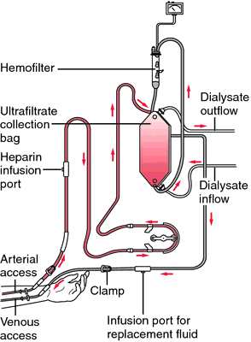
Intestinal Dialysis: In this type of dialysis, the diet is incorporating acacia fibre, a soluble fibre, which is easily digested by the bacteria in the colon. This bacterial growth increases the nitrogen content in the digestive system which is then eliminated from the body through faeces.
An alternative approach utilizes the ingestion of 1 to 1.5 liters of non-absorbable solutions of polyethylene glycol or mannitol every fourth hour.
Advantages of Haemodialysis and Peritoneal Dialysis
- The main advantage of haemodialysis is that it is carried out only 3 times a week. This means
that the patient has 4 dialysis free days in a week.
- With Peritoneal dialysis the main advantage is, it does not require any huge dialysis
machines. Instead, it can be carried out well at home.
- If you are travelling, it is much easier to carry the portable peritoneal dialysis machine, than
the Haemodialysis machine, which is huge.
Disadvantages of Haemodialysis and Peritoneal Dialysis
- Since, haemodialysis is always carried out at a dialysis clinic; when you are travelling, you
need to find a clinic that will help you to do the procedure.
- Patients undergoing haemodialysis treatment have to maintain a very strict diet. Certain
foods must be avoided and there is also a restriction on the fluid intake. Some patients cannot drink more than a cup of fluid a day.
- With peritoneal dialysis, the main disadvantage is that it has to be carried out every day.
- Another upsetting matter with the peritoneal dialysis is that the catheter, almost permanently,
hangs loose from the belly. Though it can be hidden under the clothes, the patient may feel uncomfortable.
- Yet another disadvantage of peritoneal dialysis is that the patient has a tendency of
developing peritonitis infection, along the line of the abdomen where the thin membrane of the catheter touches the abdomen. In such a case, after a few years of peritoneal dialysis, the patient has to switch to haemodialysis to avoid peritonitis. The dialysate fluid that is used for peritoneal dialysis reduces the protein level in the blood, leading to malnutrition and lack of energy. It also results in weight gain as a side effect of the dialysate fluid.
Advantages of Hemofiltration
- Hemodialysis helps in treating heart failure while hemodialysis might worsen the condition
sometimes.
- Hemofiltration can lower the rate of refractory hypertension to 1% and sometimes one might
also be in a position to stop antihypertensive medicines.
- The incidence of hypotension and water and salt retention in patients undergoing
hemofiltration is reduced to 5%.
- Hemofiltration, either continuous or intermittent, is actually an effective treatment of acute
kidney failure.
- In case of hepatic coma, hemofiltration has shown better results as compared to hemodialysis;
however, it is not as effective as blood perfusion or plasma exchange.
Disadvantages of Hemofiltration
- Patient’s mobility is restricted in case of hemofiltration and the procedure requires a constant
patient centred activity which hinders the resting and sleep times.
- The patient has to be on anticoagulant medicines except in cases where a patient has
mechanical valve which regulates the effective running of pump.
- Many a times, fluid balance is open to various potential errors.

