NAME: OBUNADIKE CHINENYE
MATRIC NUMBER: 17/MHS01/225
COURSE TITLE: RENAL PHYSIOLOGY BODY FLUID AND TEMPERATURE REGULATION
COURSE CODE: PHS303

ASSIGNMENT
1. DISCUSS THE PATHOPHYSIOLOGICAL PROCESS INVOLVED IN RENAL FAILURE?
2. WITH THE AID OF SUITABLE DIAGRAM, DISCUSS THE TYPES OF DIALYSIS YOU KNOW.

QUESTION 1
INTRODUCTION
The kidneys are a pair of organs located toward your lower back. One kidney is on each side of the spine. They filter blood and remove toxins from the body. Kidneys send toxins to the bladder, which the body later removes toxins during urination.
Renal failure, also known as end-stage kidney disease, is a medical condition in which the kidneys are functioning at less than 15% of normal. Kidney failure is classified as either acute kidney failure, which develops rapidly and may resolve; and chronic kidney failure, which develops slowly. Symptoms may include leg swelling, feeling tired, vomiting, loss of appetite, and confusion. Complications of acute and chronic failure include uremia, high blood potassium, and volume overload. Complications of chronic failure also include heart disease, high blood pressure, and anemia. Kidney failure occurs when the kidneys lose the ability to sufficiently filter waste from the blood. Usually someone with kidney failure will have a few symptoms of the disease. Sometimes no symptoms are present. Possible symptoms include: a reduced amount of urine swelling of your legs, ankles, and feet from retention of fluids caused by the failure of the kidneys to eliminate water waste unexplained shortness of breath excessive drowsiness or fatigue persistent nausea confusionpain or pressure in your chest seizures, coma.

PATHOPHYSIOLOGICAL PROCESS INVOLVED IN RENAL FAILURE

Chronic kidney disease (CKD) is initially described as diminished renal reserve or renal insufficiency, which may progress to renal failure (end-stage renal disease). Initially, as renal tissue loses function, there are few noticeable abnormalities because the remaining tissue increases its performance (renal functional adaptation).
Decreased renal function interferes with the kidneys’ ability to maintain fluid and electrolyte homeostasis. The ability to concentrate urine declines early and is followed by decreases in ability to excrete excess phosphate, acid, and potassium. When renal failure is advanced (glomerular filtration rate [GFR] ≤ 15 mL/min/1.73 m2), the ability to effectively dilute or concentrate urine is lost; thus, urine osmolality is usually fixed at about 300 to 320 mOsm/kg, close to that of plasma (275 to 295 mOsm/kg), and urinary volume does not respond readily to variations in water intake.

Creatinine and urea
Plasma concentrations of creatinine and urea (which are highly dependent on glomerular filtration) begin a hyperbolic rise as GFR diminishes. These changes are minimal early on. When the GFR falls below 15 mL/min/1.73 m2 (normal > 90 mL/min/1.73 m2), creatinine and urea levels are high and are usually associated with systemic manifestations (uremia). Urea and creatinine are not major contributors to the uremic symptoms; they are markers for many other substances (some not yet well defined) that cause the symptoms.

Sodium and water
Despite a diminishing GFR, sodium and water balance is well maintained by increased fractional excretion of sodium in urine and a normal response to thirst. Thus, the plasma sodium concentration is typically normal, and hypervolemia is infrequent unless dietary intake of sodium or water is very restricted or excessive. Heart failure can occur due to sodium and water overload, particularly in patients with decreased cardiac reserve.

Potassium
For substances whose secretion is controlled mainly through distal nephron secretion (eg, potassium), renal adaptation usually maintains plasma levels at normal until renal failure is advanced or dietary potassium intake is excessive. Potassium-sparing diuretics, angiotensin-converting enzyme inhibitors, beta-blockers, nonsteroidal anti-inflammatory drugs, cyclosporine, tacrolimus, trimethoprim/sulfamethoxazole, pentamidine, or angiotensin II receptor blockers may raise plasma potassium levels in patients with less advanced renal failure.

Calcium and phosphate
Abnormalities of calcium, phosphate, parathyroid hormone (PTH), and vitamin D metabolism can occur, as can renal osteodystrophy. Decreased renal production of calcitriol (1,25(OH)2D, the active vitamin D hormone) contributes to hypocalcemia. Decreased renal excretion of phosphate results in hyperphosphatemia. Secondary hyperparathyroidism is common and can develop in renal failure before abnormalities in calcium or phosphate concentrations occur. For this reason, monitoring PTH in patients with moderate CKD, even before hyperphosphatemia occurs, has been recommended.
Renal osteodystrophy (abnormal bone mineralization resulting from hyperparathyroidism, calcitriol deficiency, elevated serum phosphate, or low or normal serum calcium) usually takes the form of increased bone turnover due to hyperparathyroid bone disease (osteitis fibrosa) but can also involve decreased bone turnover due to adynamic bone disease (with increased parathyroid suppression) or osteomalacia. Calcitriol deficiency may cause osteopenia or osteomalacia.

pH and bicarbonate
Moderate metabolic acidosis (plasma bicarbonate content 15 to 20 mmol/L) is characteristic. Acidosis causes muscle wasting due to protein catabolism, bone loss due to bone buffering of acid, and accelerated progression of kidney disease.

Haematological abnormalities
A normochromic normocytic anaemia is a common finding in CRF. Decreased renal parenchymal erythropoietin production reduces stem cell transformation into erythrocytes, while uraemic toxins reduce red cell life. Chronic upper GI tract losses and those from dialysis further compound the problem. Dietary deficiency in iron and folate also occurs. The introduction in 1989 of synthetic erythropoietin has revolutionised the management of anaemia in these patients but a compensated relative anaemia is still to be expected. A rapid increase in haemoglobin concentration above 10 g dlitre–1 often worsens hypertension and may precipitate heart failure. Compensatory mechanisms increase 2,3-diphosphoglycerate production and move the oxyhaemoglobin dissociation curve to the right.

Endocrine disturbances
Changes in parathyroid function and lipid clearance have been noted above. Glucose tolerance is impaired but there is a reduced requirement for exogenous insulin in diabetic patients, probably related to the reduced metabolism of insulin by the failing kidney. Patients with CRF have abnormalities of temperature regulation with reduced basal metabolic rate and a tendency to hypothermia. This is may by important when assessing fever.

Cardiovascular and pulmonary abnormalities
Cardiovascular abnormalities are common in CRF and are responsible for 48% of deaths in these patients. Systemic hypertension is the most common with an incidence approaching 80%, although it is often not a feature of sodium-wasting nephropathies such as polycystic kidney disease or papillary necrosis. Plasma volume expansion resulting from sodium and water retention is the most frequent cause of hypertension; it may be improved significantly by dialysis. Some patients may require β-blockers, ACE inhibitors, α-antagonists and vasodilators to control their blood pressure adequately. Alteration in the control of renin and angiotensin secretion may also contribute to hypertension in 30% of patients. Ischaemic heart disease (IHD) is a frequent cause of mortality in patients with CRF. The incidence varies with patient subgroup but is present in 85% of diabetics > 45 years of age with CRF. Accelerated atherosclerosis results from a decreased plasma triglyceride clearance, hypertension and fluid overload causing left ventricular hypertrophy and failure. The elevation in plasma triglyceride concentrations is caused by a defect in lipoprotein lipase activity and reduced lipolysis

Gastrointestinal abnormalities
Gastrointestinal abnormalities are frequent with anorexia, nausea and vomiting contributing to malnutrition. Urea is a mucosal irritant and bleeding may occur from any part of the GI tract. Gastric emptying is delayed, residual volume increased and pH lowered. Peptic ulcer disease is common and most patients will receive proton pump inhibitors. The use of a rapid sequence induction technique needs be balanced against the risks of difficult intubation in chronically ill patients with poor dentition. Succinylcholine will increase the plasma potassium concentration by approximately 0.5 mmol litre–1 and is not reliably prevented by precurarisation with a non-depolarising agent. Patients with diabetes mellitus have an increased incidence of difficult intubation and autonomic gastric paresis even in the absence of CRF. In practice, rapid sequence induction is restricted to patients who are inadequately fasted or have symptoms of gastric reflux and a low serum potassium.

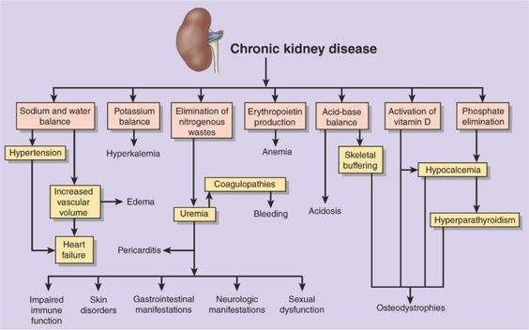

QUESTION 2
INTRODUCTION
The term dialysis in physiological sense refers to the diffusion of solutes from an area of higher concentration to the area of lower concentration through a semipermeable membrane. This principle has been used to dialyse the blood of patients with renal failure especially those developing uraemia.
The kidneys are responsible for filtering waste products from the blood. Dialysis is a procedure that is a substitute for many of the normal functions of the kidneys. The kidneys are two organs located on either side in the back of the abdominal cavity. Dialysis can allow individuals to live productive and useful lives, even though their kidneys no longer work adequately. Statistics from 2015, U.S. Renal Data System Annual Data Report (USRDS), showed approximately 468,000 patients were receiving dialysis in the United States. More than an additional 193,000 patients had a functioning kidney transplant for end stage renal disease. When the kidneys fail to filter the blood effectively, and fluid and waste products build up in the body to a critical level a person may need to start dialysis. The two main causes of kidney failure and need for dialysis treatment are diabetes and high blood pressure.
When a person’s levels of waste products in their body become so high they start to become sick from them, he or she may need dialysis. The level of the waste products usually builds up slowly. Doctors that specialize in diseases and conditions of the kidneys are called nephrologists. To help nephrologists decide when dialysis is necessary for a patient, he she will order tests that measure several blood chemical levels in the patient’s body. The two major blood chemical levels that are measured are the "creatinine level" and the "blood urea nitrogen" (BUN) level. As these two levels rise, they are indicators of the decreasing ability of the kidneys to cleanse the body of waste products.

TYPES OF DIALYSIS
There are two basic types of dialysis. They include;
- Haemodialysis or artificial kidney and
- Peritoneal dialysis.

HAEMODIALYSIS OR ARTIFICIAL KIDNEY
Haemodialysis machine is also called artificial kidney. Haemodialysis is done in a hospitalized patient through intravenous (IV) line for 3–5 h. During haemodialysis, the patient’s radial artery is connected to the haemodialysis machine. Inside the haemodialysis machine, the blood is passed through a long and coiled cellophane tube immersed in a dialysis fluid (Fig. 6.6-4). Heparin is used as an anticoagulant while passing the blood through the machine.
Dialyzing fluid
The composition of a dialyzing fluid is similar to that of the plasma, except it is free of waste products like urea, uric acid, etc. The fluid contains less amount of sodium, potassium and chloride ions than in the uraemic blood. But the quantity of glucose, bicarbonate and calcium ions are more in the dialyzing fluid than in the uraemic blood.
During haemolysis, the semipermeable cellophane membrane permits the free diffusion of the constituents of plasma except proteins. In this way, the dialysis of patient’s blood removes the toxic waste products and restores normal electrolyte concentration in the plasma. The dialysed blood is returned back to the patient’s body through a peripheral vein (Fig. 6.6-4). At a time about 500 mL is passed through the artificial kidney. Haemodialysis is done usually thrice a week in severe uraemia. Haemodialysis can save the life in many types of acute renal failure. The intermittent haemodialysis may prolong the life of many patients with chronic renal failure, which may lead an active life for many useful years. The dialysis can partially replace the excretory function of the kidneys but does not replace endocrine and metabolic functions.

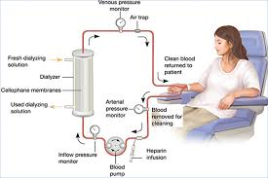

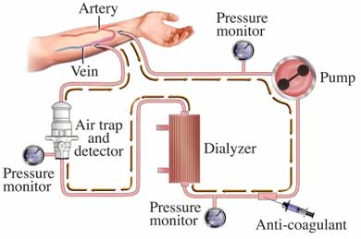
DIAGRAM OF HEMODIALYSIS.

PERITONEAL DIALYSIS
Peritoneal dialysis is a form of long-term dialysis done by the patients at home or at work. In this type of dialysis, the peritoneum acts as a semipermeable membrane. Two litres of dialyzing fluid is introduced through a intraperitoneal catheter. It is then kept in the peritoneal cavity for exchange to take place for a period of 15–20 min called dwell time. Fluid is then drained out and measured. A strict input and output chart is maintained. The whole procedure constitutes one cycle. It is done at 6 h intervals (4 cycles/day), even when the patient is ambulatory or mobile. There is no need for hospitalization. It is useful for young children and old patients with cardiovascular disorders. It prolongs survival in patients with chronic renal failure for many years. Peritoneal dialysis is not very suitable for drug poisoning cases.

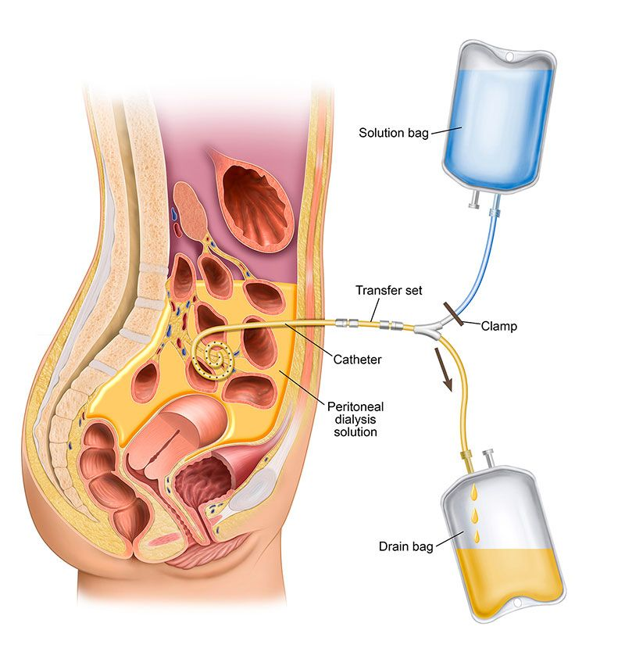
DIAGRAM OF PERITONEAL DIALYSIS.

