NAME: OMOTOSO MOYOSOREOLUWA OMONE
MATRIC NO: 17/MHS01/259
DEPARTMENT: MEDICINE AND SURGERY
ASSIGNMENT
- Discuss the pathophysiological process involved in renal failure
Acute Renal Failure
The causes of acute renal failure can be divided into three main categories:
1. Acute renal failure resulting from decreased blood supply to the kidneys; this condition is often referred to as prerenal acute renal failure to reflect the fact that the abnormality occurs as a result of an abnormality originating outside the kidneys. For example, prerenal acute renal failure can be a consequence of heart failure with reduced cardiac output and low blood pressure or conditions associated with diminished blood volume and low blood pressure, such as severe hemorrhage.
2. Intrarenal acute renal failure resulting from abnormalities within the kidney itself, including those that affect the blood vessels, glomeruli, or tubules.
3. Postrenal acute renal failure, resulting from obstruction of the urinary collecting system anywhere from the calyces to the outflow from the bladder. The most common causes of obstruction of the urinary tract outside the kidney are kidney stones, caused by precipitation of calcium, urate, or cystine.
Prerenal Acute Renal Failure Caused by Decreased Blood Flow to the Kidney
The kidneys normally receive an abundant blood supply of about 1100 ml/min, or about 20 to 25 percent of the cardiac output. The main purpose of this high blood flow to the kidneys is to provide enough plasma for the high rates of glomerular filtration needed for effective regulation of body fluid volumes and solute concentrations. Therefore, decreased renal blood flow is usually accompanied by decreased GFR and decreased urine output of water and solutes. Consequently, conditions that acutely diminish blood flow to the kidneys usually cause oliguria, which refers to diminished urine output below the level of intake of water and solutes. This causes accumulation of water and solutes in the body fluids. If renal blood flow is markedly reduced, total cessation of urine output can occur, a condition referred to as anuria.
Intrarenal Acute Renal Failure Caused by Abnormalities Within the Kidney
Abnormalities that originate within the kidney and that abruptly diminish urine output fall into the general category of intrarenal acute renal failure. This category of acute renal failure can be further divided into (1) conditions that injure the glomerular capillaries or other small renal vessels, (2) conditions that damage the renal tubular epithelium, and (3) conditions that cause damage to the renal interstitium. This type of classification refers to the primary site of injury, but because the renal vasculature and tubular system are functionally interdependent, damage to the renal blood vessels can lead to tubular damage, and primary tubular damage can lead to damage of the renal blood vessels.
Acute Tubular Necrosis Caused by Toxins or Medications
There is a long list of renal poisons and medications that can damage the tubular epithelium and cause acute renal failure. Some of these are carbon tetrachloride, heavy metals (such as mercury and lead), ethylene glycol (which is a major component in antifreeze), various insecticides, some medications (such as tetracyclines) used as antibiotics, and cis-platinum, which is used in treating certain cancers. Each of these substances has a specific toxic action on the renal tubular epithelial cells, causing death of many of them. As a result, the epithelial cells slough away from the basement membrane and plug the tubules. In some instances, the basement membrane also is destroyed. If the basement membrane remains intact, new tubular epithelial cells can grow along the surface of the membrane, so the tubule may repair itself within 10 to 20 days.
Postrenal Acute Renal Failure Caused by Abnormalities of the Lower Urinary Tract
Multiple abnormalities in the lower urinary tract can block or partially block urine flow and therefore lead to acute renal failure even when the kidneys’ blood supply and other functions are initially normal. If the urine output of only one kidney is diminished, no major change in body fluid composition will occur because the contralateral kidney can increase its urine output sufficiently to maintain relatively normal levels of extracellular electrolytes and solutes, as well as normal extracellular fluid volume. With this type of renal failure, normal kidney function can be restored if the basic cause of the problem is corrected within a few hours. But chronic obstruction of the urinary tract, lasting for several days or weeks, can lead to irreversible kidney damage. Some of the causes of postrenal acute failure include (1) bilateral obstruction of the ureters or renal pelvises caused by large stones or blood clots, (2) bladder obstruction, and (3) obstruction of the urethra.
Physiologic Effects of Acute Renal Failure
A major physiologic effect of acute renal failure is retention in the blood and extracellular fluid of water, waste products of metabolism, and electrolytes. This can lead to water and salt overload, which, in turn, can lead to edema and hypertension. Excessive retention of potassium, however, is often a more serious threat to patients with acute renal failure because increases in plasma potassium concentration (hyperkalemia) above 8 mEq/L (only twice normal) can be fatal. Because the kidneys are also unable to excrete sufficient hydrogen ions, patients with acute renal failure develop metabolic acidosis, which in itself can be lethal or can aggravate the hyperkalemia.
In the most severe cases of acute renal failure, complete anuria occurs. The patient will die in 8 to 14 days unless kidney function is restored or unless an artificial kidney is used to rid the body of the excessive retained water, electrolytes, and waste products of metabolism.

2. With the aid of suitable diagrams, discuss the types of dialysis you know
In medicine, dialysis is the process of removing excess water, solutes, and toxins from the blood in people whose kidneys can no longer perform these functions naturally. This is referred to as renal replacement therapy.
Dialysis is used in patients with rapidly developing loss of kidney function, called acute kidney injury (previously called acute renal failure), or slowly worsening kidney function, called Stage 5 chronic kidney disease (previously called chronic kidney failure, end-stage renal disease, and end-stage kidney disease).
Dialysis is used as a temporary measure in either acute kidney injury or in those awaiting kidney transplant and as a permanent measure in those for whom a transplant is not indicated or not possible.

Types
There are two types of dialysis: peritoneal and hemodialysis. There are three primary and two secondary types of dialysis: hemodialysis (primary), peritoneal dialysis (primary), hemofiltration (primary), hemodiafiltration (secondary) and intestinal dialysis (secondary).

Hemodialysis

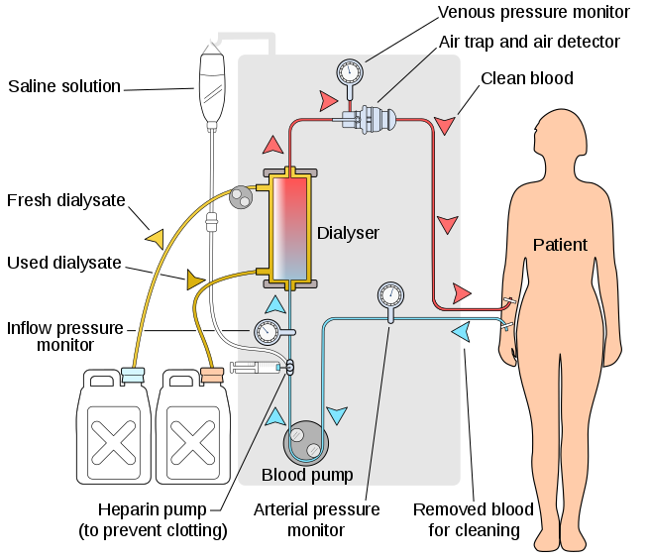
In hemodialysis, the patient's blood is pumped through the blood compartment of a dialyzer, exposing it to a partially permeable membrane. The dialyzer is composed of thousands of tiny hollow synthetic fibers. The fiber wall acts as the semipermeable membrane. Blood flows through the fibers, dialysis solution flows around the outside of the fibers, and water and wastes move between these two solutions. The cleansed blood is then returned via the circuit back to the body. Ultrafiltration occurs by increasing the hydrostatic pressure across the dialyzer membrane This usually is done by applying a negative pressure to the dialysate compartment of the dialyzer. This pressure gradient causes water and dissolved solutes to move from blood to dialysate and allows the removal of several litres of excess fluid during a typical 4-hour treatment.

Hemodiafiltration
Hemodiafiltration is a combination of hemodialysis and hemofiltration, thus used to purify the blood from toxins when the kidney is not working normally and also used to treat acute kidney injury (AKI).

Intestinal dialysis
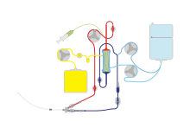
In intestinal dialysis, the diet is supplemented with soluble fibres such as acacia fibre, which is digested by bacteria in the colon. This bacterial growth increases the amount of nitrogen that is eliminated in fecal waste. An alternative approach utilizes the ingestion of 1 to 1.5 liters of non-absorbable solutions of polyethylene glycol or mannitol every fourth hour.

Pediatric dialysis
Over the past 20 years, children have benefited from major improvements in both technology and clinical management of dialysis. Morbidity during dialysis sessions has decreased with seizures being exceptional and hypotensive episodes rare. Pain and discomfort have been reduced with the use of chronic internal jugular venous catheters and anesthetic creams for fistula puncture. Non-invasive technologies to assess patient target dry weight and access flow can significantly reduce patient morbidity and health care costs. Mortality in paediatric and young adult patients on chronic hemodialysis is associated with multifactorial markers of nutrition, inflammation, anaemia and dialysis dose, which highlights the importance of multimodal intervention strategies besides adequate hemodialysis treatment as determined by Kt/V alone.
Biocompatible synthetic membranes, specific small size material dialyzers and new low extra-corporeal volume tubing have been developed for young infants. Arterial and venous tubing length is made of minimum length and diameter, a <80ml to <110ml volume tubing is designed for pediatric patients and a >130 to <224ml tubing are for adult patients, regardless of blood pump segment size, which can be of 6.4mm for normal dialysis or 8.0mm for high flux dialysis in all patients. All dialysis machine manufacturers design their machine to do the pediatric dialysis. In pediatric patients, the pump speed should be kept at low side, according to patient blood output capacity, and the clotting with heparin dose should be carefully monitored. The high flux dialysis (see below) is not recommended for pediatric patients.

