Name: Onyema Gideon T
Mat No: 17/Mhs01/265
Medicine & surgery
Physiology Assignment
1. Discuss the pathophysiological process involved in renal failure
First of all Renal failure is a condition in which the kidneys lose the ability to remove waste and balance fluids. And there are 2 common types
1. Chronic Kidney Disease: Longstanding disease of the kidneys leading to renal failure.
The kidneys filter waste and excess fluid from the blood. As kidneys fail, waste builds up.
2. Acute Kidney Injury or Acute Renal Failure: A condition in which the kidneys suddenly can't filter waste from the blood.
Acute renal failure develops rapidly over a few hours or days. It may be fatal. It's most common in those who are critically ill and already hospitalised.

Pathophysiology
Chronic kidney disease (CKD) is initially described as diminished renal reserve or renal insufficiency, which may progress to renal failure (end-stage renal disease). Initially, as renal tissue loses function, there are few noticeable abnormalities because the remaining tissue increases its performance (renal functional adaptation).

Decreased renal function interferes with the kidneys’ ability to maintain fluid and electrolyte homeostasis. The ability to concentrate urine declines early and is followed by decreases in ability to excrete excess phosphate, acid, and potassium. When renal failure is advanced (glomerular filtration rate [GFR] ≤ 15 mL/min/1.73 m2), the ability to effectively dilute or concentrate urine is lost; thus, urine osmolality is usually fixed at about 300 to 320 mOsm/kg, close to that of plasma (275 to 295 mOsm/kg), and urinary volume does not respond readily to variations in water intake.

Creatinine and urea
Plasma concentrations of creatinine and urea (which are highly dependent on glomerular filtration) begin a hyperbolic rise as GFR diminishes. These changes are minimal early on. When the GFR falls below 15 mL/min/1.73 m2 (normal > 90 mL/min/1.73 m2), creatinine and urea levels are high and are usually associated with systemic manifestations (uremia). Urea and creatinine are not major contributors to the uremic symptoms; they are markers for many other substances (some not yet well defined) that cause the symptoms.

Sodium and water
Despite a diminishing GFR, sodium and water balance is well maintained by increased fractional excretion of sodium in urine and a normal response to thirst. Thus, the plasma sodium concentration is typically normal, and hypervolemia is infrequent unless dietary intake of sodium or water is very restricted or excessive. Heart failure can occur due to sodium and water overload, particularly in patients with decreased cardiac reserve.

Potassium
For substances whose secretion is controlled mainly through distal nephron secretion (eg, potassium), renal adaptation usually maintains plasma levels at normal until renal failure is advanced or dietary potassium intake is excessive. Potassium-sparing diuretics, angiotensin-converting enzyme inhibitors, beta-blockers, nonsteroidal anti-inflammatory drugs, cyclosporine, tacrolimus, trimethoprim/sulfamethoxazole, pentamidine, or angiotensin II receptor blockers may raise plasma potassium levels in patients with less advanced renal failure.

Calcium and phosphate
Abnormalities of calcium, phosphate, parathyroid hormone (PTH), and vitamin D metabolism can occur, as can renal osteodystrophy. Decreased renal production of calcitriol (1,25(OH)2D, the active vitamin D hormone) contributes to hypocalcemia. Decreased renal excretion of phosphate results in hyperphosphatemia. Secondary hyperparathyroidism is common and can develop in renal failure before abnormalities in calcium or phosphate concentrations occur. For this reason, monitoring PTH in patients with moderate CKD, even before hyperphosphatemia occurs, has been recommended.

Renal osteodystrophy (abnormal bone mineralization resulting from hyperparathyroidism, calcitriol deficiency, elevated serum phosphate, or low or normal serum calcium) usually takes the form of increased bone turnover due to hyperparathyroid bone disease (osteitis fibrosa) but can also involve decreased bone turnover due to adynamic bone disease (with increased parathyroid suppression) or osteomalacia. Calcitriol deficiency may cause osteopenia or osteomalacia.

pH and bicarbonate
Moderate metabolic acidosis (plasma bicarbonate content 15 to 20 mmol/L) is characteristic. Acidosis causes muscle wasting due to protein catabolism, bone loss due to bone buffering of acid, and accelerated progression of kidney disease.

Anemia
Anemia is characteristic of moderate to advanced CKD (≥ stage 3). The anemia of CKD is normochromic-normocytic, with an Hct of 20 to 30% (35 to 40% in patients with polycystic kidney disease). It is usually caused by deficient erythropoietin production due to a reduction of functional renal mass (see Overview of Decreased Erythropoiesis). Other causes include deficiencies of iron, folate, and vitamin B12.

Pathophysiology of Acute Kidney Injury

Acute kidney injury (AKI), previously called acute renal failure (ARF) is an abrupt loss of kidney function that develops within 7 days.

Acute kidney injury
Other names
Acute renal failure (ARF)
Its causes are numerous. Generally it occurs because of damage to the kidney tissue caused by decreased kidney blood flow (kidney ischemia) from any cause (e.g., low blood pressure), exposure to substances harmful to the kidney, an inflammatory process in the kidney, or an obstruction of the urinary tract that impedes the flow of urine. AKI is diagnosed on the basis of characteristic laboratory findings, such as elevated blood urea nitrogen and creatinine, or inability of the kidneys to produce sufficient amounts of urine.

AKI may lead to a number of complications, including metabolic acidosis, high potassium levels, uremia, changes in body fluid balance, and effects on other organ systems, including death. People who have experienced AKI may have an increased risk of chronic kidney disease in the future. Management includes treatment of the underlying cause and supportive care, such as renal replacement therapy.

Signs and symptoms
The clinical picture is often dominated by the underlying cause. The various symptoms of acute kidney injury result from the various disturbances of kidney function that are associated with the disease. Accumulation of urea and other nitrogen-containing substances in the bloodstream lead to a number of symptoms, such as fatigue, loss of appetite, headache, nausea and vomiting.Marked increases in the potassium level can lead to abnormal heart rhythms, which can be severe and life-threatening. Fluid balance is frequently affected, though blood pressure can be high, low or normal.

Pain in the flanks may be encountered in some conditions (such as clotting of the kidneys' blood vessels or inflammation of the kidney); this is the result of stretching of the fibrous tissue capsule surrounding the kidney .If the kidney injury is the result of dehydration, there may be thirst as well as evidence of fluid depletion on physical examination. Physical examination may also provide other clues as to the underlying cause of the kidney problem, such as a rash in interstitial nephritis (or vasculitis) and a palpable bladder in obstructive nephropathy.

2. With the aid of suitable diagrams, discuss the types of dialysis you know
There are three primary and two secondary types of dialysis:
1.hemodialysis (primary)
2.peritoneal dialysis (primary)
3.hemofiltration (primary
4.hemodiafiltration (secondary)
5.intestinal dialysis (secondary).

Hemodialysis

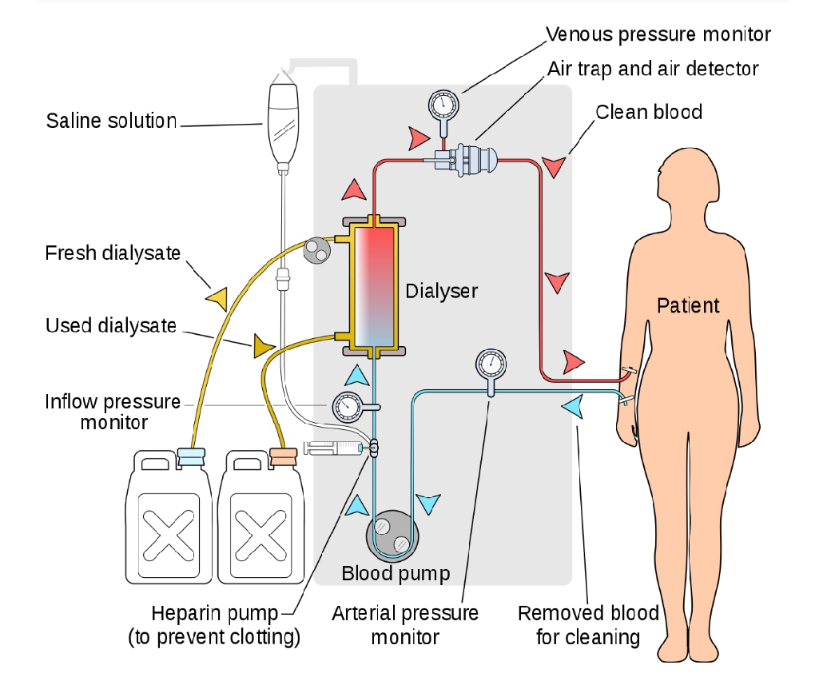
In hemodialysis, the patient's blood is pumped through the blood compartment of a dialyzer, exposing it to a partially permeable membrane. The dialyzer is composed of thousands of tiny hollow synthetic fibers. The fiber wall acts as the semipermeable membrane. Blood flows through the fibers, dialysis solution flows around the outside of the fibers, and water and wastes move between these two solutions.The cleansed blood is then returned via the circuit back to the body. Ultrafiltration occurs by increasing the hydrostatic pressure across the dialyzer membrane This usually is done by applying a negative pressure to the dialysate compartment of the dialyzer. This pressure gradient causes water and dissolved solutes to move from blood to dialysate and allows the removal of several litres of excess fluid during a typical 4-hour treatment. In the United States, hemodialysis treatments are typically given in a dialysis center three times per week (due in the United States to Medicare reimbursement rules); however, as of 2005 over 2,500 people in the United States are dialyzing at home more frequently for various treatment lengths Studies have demonstrated the clinical benefits of dialyzing 5 to 7 times a week, for 6 to 8 hours. This type of hemodialysis is usually called nocturnal daily hemodialysis, which a study has shown it provides a significant improvement in both small and large molecular weight clearance and decreases the need for phosphate bindersThese frequent long treatments are often done at home while sleeping, but home dialysis is a flexible modality and schedules can be changed day to day, week to week. In general, studies show that both increased treatment length and frequency are clinically beneficial

Hemo-dialysis was one of the most common procedures performed in U.S. hospitals in 2011, occurring in 909,000 stays (a rate of 29 stays per 10,000 population)

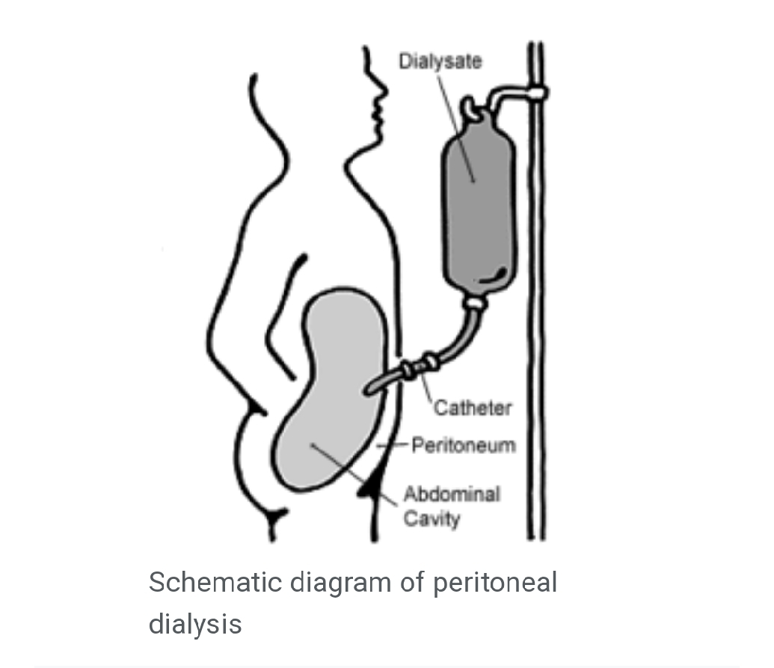
Peritoneal dialysis
In peritoneal dialysis, a sterile solution containing glucose (called dialysate) is run through a tube into the peritoneal cavity, the abdominal body cavity around the intestine, where the peritoneal membrane acts as a partially permeable membrane.

This exchange is repeated 4–5 times per day; automatic systems can run more frequent exchange cycles overnight. Peritoneal dialysis is less efficient than hemodialysis, but because it is carried out for a longer period of time the net effect in terms of removal of waste products and of salt and water are similar to hemodialysis. Peritoneal dialysis is carried out at home by the patient, often without help. This frees patients from the routine of having to go to a dialysis clinic on a fixed schedule multiple times per week. Peritoneal dialysis can be performed with little to no specialized equipment (other than bags of fresh dialysate).

Hemofiltration
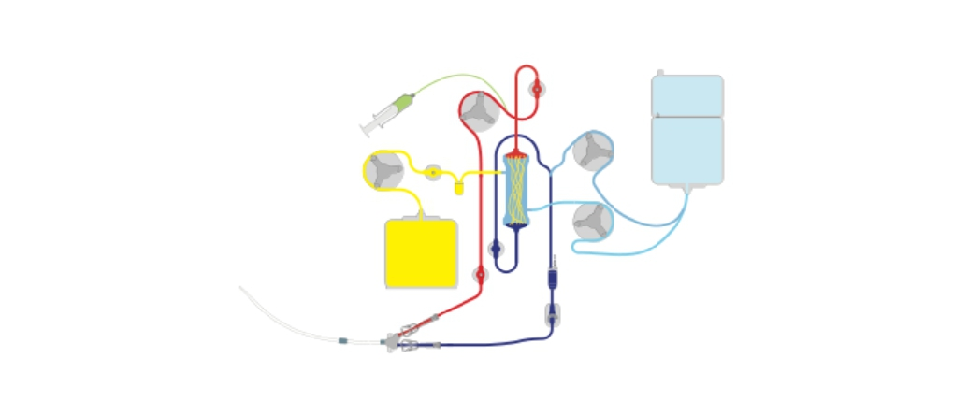
Continuous veno-venous haemofiltration with pre- and post-dilution (CVVH)
Hemofiltration is a similar treatment to hemodialysis, but it makes use of a different principle. The blood is pumped through a dialyzer or "hemofilter" as in dialysis, but no dialysate is used. A pressure gradient is applied; as a result, water moves across the very permeable membrane rapidly, "dragging" along with it many dissolved substances, including ones with large molecular weights, which are not cleared as well by hemodialysis. Salts and water lost from the blood during this process are replaced with a "substitution fluid" that is infused into the extracorporeal circuit during the treatment.

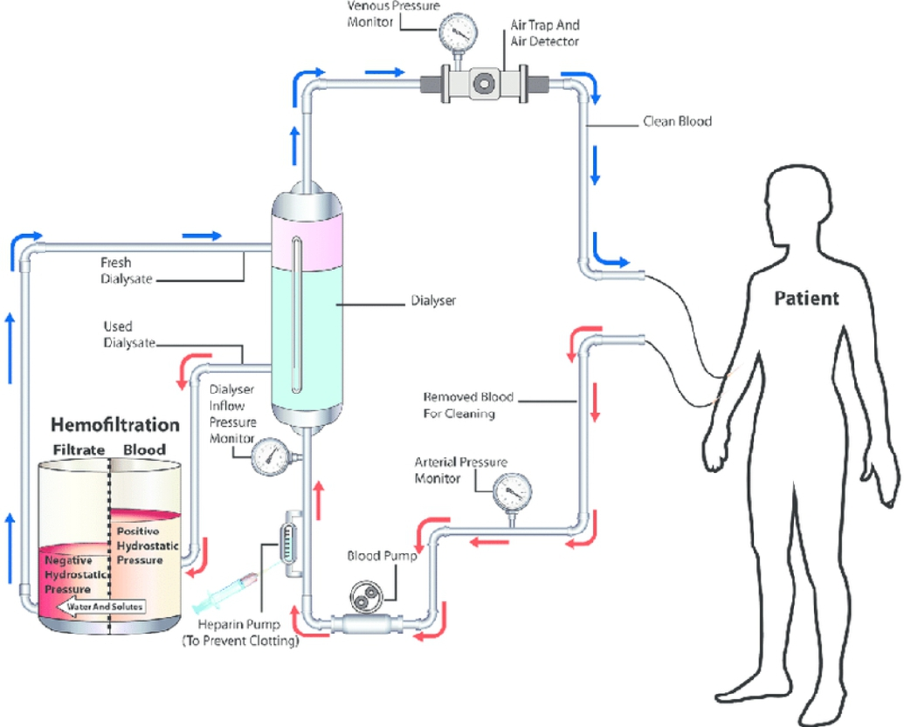
Hemodiafiltration
Hemodiafiltration is a combination of hemodialysis and hemofiltration, thus used to purify the blood from toxins when the kidney is not working normally and also used to treat acute kidney injury (AKI).

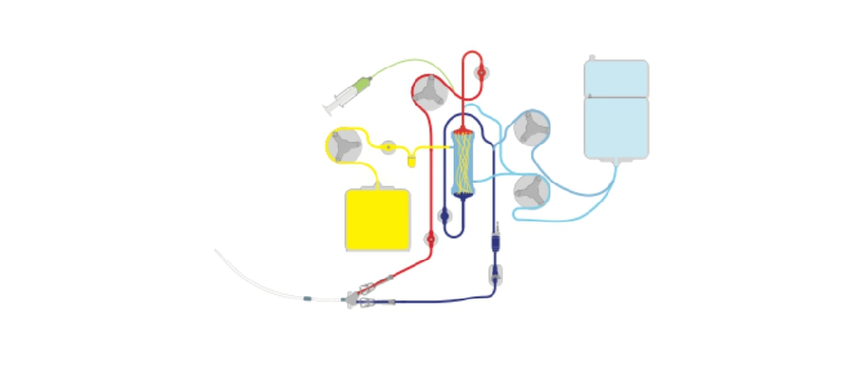
Intestinal dialysis

Continuous veno-venous haemodiafiltration (CVVHDF)
In intestinal dialysis, the diet is supplemented with soluble fibres such as acacia fibre, which is digested by bacteria in the colon. This bacterial growth increases the amount of nitrogen that is eliminated in fecal waste. An alternative approach utilizes the ingestion of 1 to 1.5 liters of non-absorbable solutions of polyethylene glycol or mannitol every fourth hour.

