NAME: ABIWO, ENIAYO AYOWOLE.
DEPARTMENT: MEDICINE AND SURGERY.
MATRIC NO: 17/MHS05/003.
COURSE TITLE: RENAL PHYSIOLOGY, BODY FLUID AND TEMPERATURE REGULATION.
COURSE CODE: PHS 303.
QUESTIONS.
- Discuss the pathophysiological process involved in renal failure.
- With the aid of suitable diagrams, discuss the type of dialysis you know.
ANSWERS.
- PATHOPHYSIOLOGICAL PROCESS INVOLVED IN RENAL FAILURE.
Renal failure refers to failure of excretory functions of kidney. It is usually, characterized by decrease in glomerular filtration rate (GFR). So GFR is considered as the best index of renal failure. However, decrease in GFR is not affected much during the initial stages of renal failure. If 50% of the nephrons are affected, GFR decreases only by 20% to 30%. It is because of the compensatory mechanism by the unaffected nephrons. The renal failure may be either acute or chronic. Regardless of the cause, renal disease usually results in the evolution of major pathological syndromes.
Severe kidney diseases can be divided into two main categories:(1) acute renal failure, in which the kidneys abruptly stop working entirely or almost entirely but may eventually recover nearly normal function, and (2) chronic renal failure, in which there is progressive loss of function of more and more nephrons that gradually decreases overall kidney function. Within these two general categories, there are many speciﬁc kidney diseases that can affect the kidney blood vessels, glomeruli, tubules, renal interstitium, and parts of the urinary tract outside the kidney, including the ureters and bladder.
Acute Renal Failure.
The causes of acute renal failure can be divided into three main categories: 1. Acute renal failure resulting from decreased blood supply to the kidneys; this condition is often referred to as prerenal acute renal failure to reﬂect the fact that the abnormality occurs in a system before the kidneys. This can be a consequence of heart failure with reduced cardiac output and low blood pressure or conditions associated with diminished blood volume and low blood pressure, such as severe hemorrhage.
2. Intrarenal acute renal failure resulting from abnormalities within the kidney itself, including those that affect the blood vessels, glomeruli, or tubules.
3. Post renal acute renal failure, resulting from obstruction of the urinary collecting system anywhere from the calyces to the outﬂow from the bladder. The most common causes of obstruction of the urinary tract outside the kidney are kidney stones, caused by precipitation of calcium, urate, or cysteine.
Chronic renal failure.
This is the progressive, long standing and irreversible impairment of renal functions. When some of the nephrons loose the function, the unaffected nephrons can compensate it. However, when more and more nephrons start losing the function over the months or years, the compensatory mechanism fails and chronic renal failure develops.
CAUSES,
1. Chronic nephritis 2. Polycystic kidney disease 3. Renal calculi (kidney stones) 4. Urethral constriction 5. Hypertension 6. Atherosclerosis 7. Tuberculosis 8. Slow poisoning by drugs or metals.
CLINICAL FEATURES OF RENAL FAILURE.
The clinical manifestations of renal failure are described under two main headings:
- Primary renal manifestations.
- Secondary systemic/extra-renal manifestations.
-`PRIMARY RENAL MANIFESTATIONS: These develop when there is slow and progressive deterioration of renal function. The resulting imbalances cause the following manifestations:
1. Metabolic Acidosis: As a result of renal dysfunction, acid balance is progressively lost. Excess of hydrogen ions occurs, while bicarbonate level declines in the blood, resulting in metabolic acidosis. The clinical symptoms of metabolic acidosis include; compensatory breathing, hyperkalemia and hypercalcemia.
2. Hyperkalemia: A decreased GFR results in excessive accumulation of potassium in the blood since potassium is normally excreted mainly in the urine. The clinical features of hyperkalemia are cardiac arrhythmia, weakness, nausea, intestinal colic, diarrhea, muscular irritability and flaccid paralysis.
3. Sodium and Water imbalance: As GFR declines, sodium and water cannot pass sufficiently into Bowman’s capsule leading to their retention. Release of renin from juxtaglomerular apparatus further aggravates sodium and water retention.
4. Hyperuricemia: Decreased GFR results in excessive accumulation of uric acid in the blood. Uric acid crystals may be deposited in joints and soft tissues resulting in gout.
5. Azotemia: The waste products of protein metabolism fail to be excreted resulting in elevation in the blood levels of urea, creatinine, phenols and guanidine causing biochemically abnormality, azotemia.
- SECONDARY SYSTEMIC/ EXTRA-RENAL MANIFESTATIONS: A number of extra-renal systemic manifestations develop secondarily following fluid-electrolyte and acid-base imbalances. These include the following;
1. Anemia: Decreased production of erythropoietin by diseased kidney results in decline in erythropoiesis and anemia. Besides, gastrointestinal bleeding may further aggravate anemia.
2. Integumentary System: Deposit of urinary pigment such as urochrome in the skin causes sallow-yellow color, The urea content in the sweat as well as in the plasma rises. On evaporation of the perspiration, urea remains on the facial skin as powdery ‘uremic frost’.
3. Cardiovascular System: Fluid retention secondarily causes cardiovascular symptoms such as increased workload on the heart due to hypervolemia and eventually congestive heart failure.
4. Digestive System: Hypervolemia and heart failure cause pulmonary congestion and pulmonary edema due to back pressure. Radiologically, uremic pneumonitis shows characteristic central, butterfly-pattern of edema and congestion in the chest radiograph.
5. Digestive System: Azotemia directly induces mucosal ulcerations in the lining of the stomach and intestines. Subsequent bleeding can aggravate the existing anemia. Gastrointestinal irritation may cause nausea, vomiting and diarrhea.
6. Skeletal System: The skeletal manifestations of renal failure are referred to as renal osteodystrophy.
Two major types of skeletal disorders may occur:
- Osteomalacia: This occurs from deficiency of a form of vitamin D which is normally activated by the kidney. Since vitamin D is essential for absorption of calcium, its deficiency results in inadequate deposits of calcium in bone tissue.
- Osteotitis Fibrosa: This occurs due to elevated levels of parathormone. As the GFR is decreased, increasing levels of phosphates accumulate in the extracellular fluid which, in turn, cause decline in calcium levels.
Decreased calcium level triggers the secretion of parathormone which mobilizes calcium from bone and increases renal tubular reabsorption of calcium thereby conserving it.
- DIALYSIS.
Dialysis is the process of removing excess water, solutes, and toxins from the blood in people whose kidneys can no longer perform these functions naturally. This is referred to as renal replacement therapy. Dialysis is used in patients with rapidly developing loss of kidney function, called acute kidney injury (previously called acute renal failure), or slowly worsening kidney function, called Stage 5 chronic kidney disease (previously called chronic kidney failure, end-stage renal disease, and end-stage kidney disease).
Dialysis is used as a temporary measure in either acute kidney injury or in those awaiting kidney transplant and as a permanent measure in those for whom a transplant is not indicated or not possible.
Dialysis works on the principles of the diffusion of solutes and ultrafiltration of fluid across a semi-permeable membrane. Diffusion is a property of substances in water; substances in water tend to move from an area of high concentration to an area of low concentration. Blood flows by one side of a semi-permeable membrane, and a dialysate, or special dialysis fluid, flows by the opposite side. A semipermeable membrane is a thin layer of material that contains holes of various sizes, or pores. Smaller solutes and fluid pass through the membrane, but the membrane blocks the passage of larger substances (for example, red blood cells and large proteins). This replicates the filtering process that takes place in the kidneys when the blood enters the kidneys and the larger substances are separated from the smaller ones in the glomerulus.
The two main types of dialysis, hemodialysis and peritoneal dialysis, remove wastes and excess water from the blood in different ways. Hemodialysis removes wastes and water by circulating blood outside the body through an external filter, called a dialyzer, that contains a semipermeable membrane. The blood flows in one direction and the dialysate flows in the opposite. The counter-current flow of the blood and dialysate maximizes the concentration gradient of solutes between the blood and dialysate, which helps to remove more urea and creatinine from the blood. The concentrations of solutes normally found in the urine (for example potassium, phosphorus and urea) are undesirably high in the blood, but low or absent in the dialysis solution, and constant replacement of the dialysate ensures that the concentration of undesired solutes is kept low on this side of the membrane. The dialysis solution has levels of minerals like potassium and calcium that are similar to their natural concentration in healthy blood. For another solute, bicarbonate, dialysis solution level is set at a slightly higher level than in normal blood, to encourage diffusion of bicarbonate into the blood, to act as a pH buffer to neutralize the metabolic acidosis that is often present in these patients. The levels of the components of dialysate are typically prescribed by a nephrologist according to the needs of the individual patient.
In peritoneal dialysis, wastes and water are removed from the blood inside the body using the peritoneum as a natural semipermeable membrane. Wastes and excess water move from the blood, across the peritoneal membrane and into a special dialysis solution, called dialysate, in the abdominal cavity.
TYPES OF DIALYSIS.
There are five types of dialysis. They are;
- Hemodialysis
- Peritoneal dialysis.
- Hemofiltration.
- Hemodiafiltration.
- Intestinal dialysis.
- Hemodialysis.
In hemodialysis, the patient's blood is pumped through the blood compartment of a dialyzer, exposing it to a partially permeable membrane. The dialyzer is composed of thousands of tiny hollow synthetic fibers. The fiber wall acts as the semipermeable membrane. Blood flows through the fibers, dialysis solution flows around the outside of the fibers, and water and wastes move between these two solutions.
The cleansed blood is then returned via the circuit back to the body. Ultrafiltration occurs by increasing the hydrostatic pressure across the dialyzer membrane This usually is done by applying a negative pressure to the dialysate compartment of the dialyzer. This pressure gradient causes water and dissolved solutes to move from blood to dialysate and allows the removal of several liters of excess fluid during a typical 4-hour treatment. In the United States, hemodialysis treatments are typically given in a dialysis center three times per week (due in the United States to Medicare reimbursement rules); however, as of 2005 over 2,500 people in the United States are dialyzing at home more frequently for various treatment lengths. Studies have demonstrated the clinical benefits of dialyzing 5 to 7 times a week, for 6 to 8 hours. This type of hemodialysis is usually called nocturnal daily hemodialysis, which a study has shown it provides a significant improvement in both small and large molecular weight clearance and decreases the need for phosphate binders. These frequent long treatments are often done at home while sleeping, but home dialysis is a flexible modality and schedules can be changed day to day, week to week. In general, studies show that both increased treatment length and frequency are clinically beneficial.
DIAGRAM SHOWING THE PROCESS OF HEMODIALYSIS.
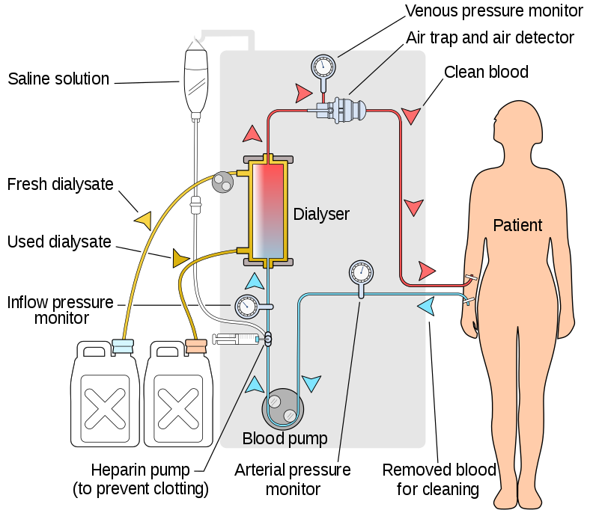
- Peritoneal Dialysis.
In peritoneal dialysis, a sterile solution containing glucose (called dialysate) is run through a tube into the peritoneal cavity, the abdominal body cavity around the intestine, where the peritoneal membrane acts as a partially permeable membrane. This exchange is repeated 4–5 times per day; automatic systems can run more frequent exchange cycles overnight. Peritoneal dialysis is less efficient than hemodialysis, but because it is carried out for a longer period of time the net effect in terms of removal of waste products and of salt and water are similar to hemodialysis. Peritoneal dialysis is carried out at home by the patient, often without help. This frees patients from the routine of having to go to a dialysis clinic on a fixed schedule multiple times per week. Peritoneal dialysis can be performed with little to no specialized equipment (other than bags of fresh dialysate).
DIAGRAM SHOWING THE PROCESS OF PERITONEAL DIALYSIS.
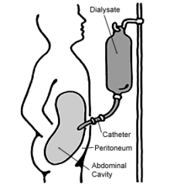
- Hemofiltration.
Hemofiltration is a similar treatment to hemodialysis, but it makes use of a different principle. The blood is pumped through a dialyzer or "hemofilter" as in dialysis, but no dialysate is used. A pressure gradient is applied; as a result, water moves across the very permeable membrane rapidly, "dragging" along with it many dissolved substances, including ones with large molecular weights, which are not cleared as well by hemodialysis. Salts and water lost from the blood during this process are replaced with a "substitution fluid" that is infused into the extracorporeal circuit during the treatment.
DIAGRAM SHOWING THE PROCESS OF HMOFILTRATION.
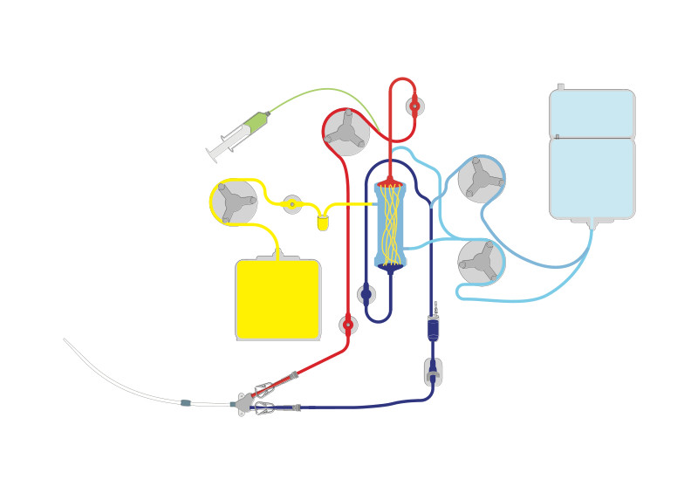
- Hemodiafiltration.
Hemodiafiltration is a combination of hemodialysis and hemofiltration, thus used to purify the blood from toxins when the kidney is not working normally and also used to treat acute kidney injury (AKI).
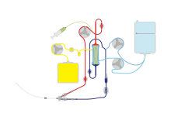
DIAGRAM SHOWING THE PROCESS OF HEMODIAFILTRATION.
- Intestinal Dialysis.
In intestinal dialysis, the diet is supplemented with soluble fibers such as acacia fiber, which is digested by bacteria in the colon. This bacterial growth increases the amount of nitrogen that is eliminated in fecal waste. An alternative approach utilizes the ingestion of 1 to 1.5 liters of non-absorbable solutions of polyethylene glycol or mannitol every fourth hour.

