Name: Oparaocha freda uloma
Matric number: 17/mhs01/268
Department: medicine and surgery
College: MHS
Assignment: PHS303
Date: 19/06/20
QUESTION:
1.Discuss the pathophysiological process involves in renal failure
Answer:
Renal failure pathophysiology can be described by a sequence of events that happen while during acute insult in the setting of acute renal failure and also gradually over a period in cases of chronic kidney diseases.
- Acute renal failure (ARF) - It refers to the sudden decline in glomerular filtration rate over a period of days or weeks associated with a rapid rise in blood urea.
Causes of ARF: There are three main reasons your renal fail all of a sudden:
- Something is stopping blood flow to your renal. It could be because of:
- An infection, Liver failure, Medications (aspirin, ibuprofen, naproxen, or COX-2 inhibitors, like Celebrex), Blood pressure medications, Heart failure, Severe burns or dehydration, Blood or fluid loss
- You have a condition that’s blocking urine from leaving your kidneys. This could mean:
- Bladder, cervical, colon or prostate cancer, Blood clots in your urinary tract, An enlarged prostate, Kidney stones, Nerve damage in your bladder
3. Something has directly damaged your kidneys, like:
•Blood clots, Cholesterol deposits, Medications that can directly damage kidneys, including NSAIDs like ibuprofen and naproxen, chemotherapy, and antibiotics, Glomerulonephritis (inflamed kidney filters; can be caused by an infection, autoimmune disease (like lupus), multiple myeloma, scleroderma, chemotherapy drugs, antibiotics, or other toxins)

Physiological effects of acute renal failure include:
- Retention of salt and water, waste metabolites and electrolytes (rise in creatinine and urea) in blood and extracellular fluid can lead to oedema and hypertension.
- Excessive retention of potassium (hyperkalaemia) is a serious threat to a patient with acute renal failure.
- Kidneys are unable to excrete hydrogen ions resulting in metabolic acidosis and that itself is a fatal condition and also aggravates hyperkalaemia.
- In severe cases of acute renal failure, oliguria or complete anuria occurs and the patient may die unless kidney functions are restored.
Features of ARF:
- Oliguria
- Anuria
- Proteinuria
- Hematuria
- Edema
- Hypertension
- Acidosis
- Coma

- Chronic renal failure (CRF) - It refers to a slow, insidious, irreversible deterioration of renal functions resulting in the development of clinical syndrome of uraemia, manifested by excretory, metabolic, neurological, haematological and endocrinal abnormalities.
Common causes which lead on to slow, progressive nephron loss and ultimately chronic renal failure can be grouped as under:
1. Congenital disorders, e.g. polycystic kidney.
2. Vascular diseases of kidney, renal hypertension. Injury to renal vasculature can lead to renal ischemia. The most common cause of renal vascular injury is atherosclerosis. Atherosclerosis of the larger renal arteries leads to hypertension and involvement of smaller arteries (interlobular arteries and efferent arterioles) results in thickening of vessel walls due to deposits of fibrinoid tissue (nephrosclerosis), eventually leading to constriction (ischemic injury).
3. Glomerular diseases, e.g. proliferative glomerulonephritis and diabetic nephropathy. Chronic glomerulonephritis: injury to glomeruli can be caused by several diseases. In most cases, it begins with accumulation of antigen–antibody complexes in the glomerular membrane and ultimately glomeruli are replaced by fibrous tissue, therefore unable to filter the fluid. Therefore, glomerular capillary filtration coefficient gets markedly reduced.
4. Tubulointerstitial disease, e.g. chronic pyelonephritis and analgesic nephropathy. These diseases are referred to as interstitial nephritis. Injury to renal interstitium can be caused by bacterial infection (called as pyelonephritis) or as a result of vascular, glomerular and tubular damage by poison and toxic drugs.
5. Obstructive renal diseases, e.g. benign enlargement of prostate, renal calculi and ureteral constriction.
Features:
- Uremia
- Acidosis
- Edema
- Blood loss
- Anemia
- hyperparathyroidism

2.With the aid of a suitable diagrams discuss the types of dialysis you know
There are two type of dialysis which are: hemodialysis and peritoneal dialysis
- Hemodialysis:
During hemodialysis, your blood goes through a filter, called a dialyzer, outside your body. A dialyzer is sometimes called an “artificial kidney.”
At the start of a hemodialysis treatment, a dialysis nurse or technician places two needles into your arm. You may prefer to put in your own needles after you’re trained by your health care team. A numbing cream or spray can be used if placing the needles bothers you. Each needle is attached to a soft tube connected to the dialysis machine.
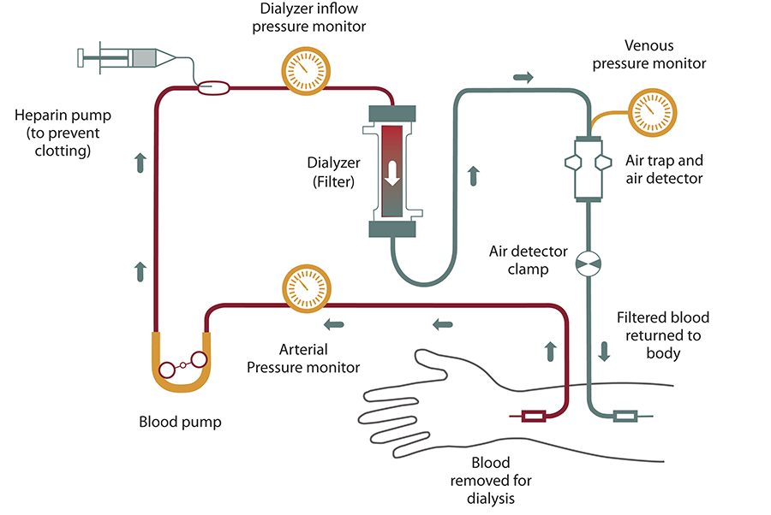
During hemodialysis, your blood is pumped through a filter, called a dialyzer.
The dialysis machine pumps blood through the filter and returns the blood to your body. During the process, the dialysis machine checks your blood pressure and controls how quickly
•blood flows through the filter
•fluid is removed from your body
Blood enters at one end of the filter and is forced into many, very thin, hollow fibers. As your blood passes through the hollow fibers, dialysis solution passes in the opposite direction on the outside of the fibers. Waste products from your blood move into the dialysis solution. Filtered blood remains in the hollow fibers and returns to your body.
A doctor who specializes in renal problems—will prescribe a dialysis solution to meet your needs. The dialysis solution contains water and chemicals that are added to safely remove wastes, extra salt, and fluid from your blood. Your doctor can adjust the balance of chemicals in the solution if
•your blood tests show your blood has too much or too little of certain minerals, such as potassium or calcium
•you have problems such as low blood pressure or muscle cramps during dialysis

- Peritoneal dialysis
Peritoneal Dialysis (PD): Peritoneal dialysis is a home-based treatment that can be done anywhere (at home, work, or when sleeping). It must be done daily. You will need a minor operation to place a catheter in your abdomen (belly). With peritoneal dialysis, the blood is cleaned inside your body, not outside. The lining of your abdomen (the peritoneum) acts as a natural filter. During treatment a cleansing solution, called dialysate, flows into your abdomen (your belly) through a soft tube called a PD catheter. Wastes and extra fluid pass from your blood into the cleansing solution. After several hours, you drain the used solution from your abdomen and refill with fresh cleansing solution to begin the process again. Removing the used solution and adding fresh solutions takes about a half hour and is called an "exchange."

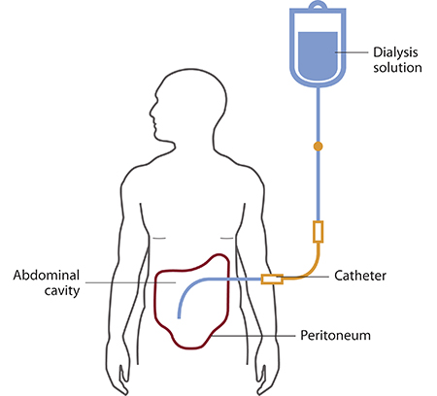
There are numerous different types of peritoneal dialysis. The main ones are:
• Continuous ambulatory peritoneal dialysis (CAPD). In CAPD, your abdomen is filled and drained multiple times each day. This method doesn’t require a machine and must be performed while awake.
• Continuous cycling peritoneal dialysis (CCPD). CCPD uses a machine to cycle the fluid in and out of your abdomen. It’s usually done at night while you sleep.
• Intermittent peritoneal dialysis (IPD). This treatment is usually performed in the hospital, though it may be performed at home. It uses the same machine as CCPD, but the process takes longer.
Risks associated with peritoneal dialysis include: weight gain, hernia, fever, stomach pain, etc.

