BISI-KAZEEM ABISAYO AMEERAH
17/MHS01/085
MBBS
300L
PHYSIOLOGY ASSIGNMENT

- Discuss the pathophysiological process involved in renal failure.
Renal failure refers to failure of excretory functions of kidney. It is usually, characterized by decrease in glomerular filtration rate (GFR). So GFR is considered as the best index of renal failure. However, decrease in GFR is not affected much during the initial stages of renal failure. If 50% of the nephrons are affected, GFR decreases only by 20% to 30%. It is because of the compensatory mechanism by the unaffected nephrons.
The renal failure may be either acute or chronic.
Renal failure is always accompanied by other complications such as:
1. Deficiency of calcitriol (activated vitamin D) resulting in reduction of calcium absorption from intestine and hypocalcemia. Deficiency of calcitriol and hypocalcemia may cause secondary hyperparathyroidism in some patients
2. Deficiency of erythropoietin resulting in anemia
3. Disturbances in acidbase balance.
 ACUTE RENAL FAILURE
Acute renal failure is the abrupt or sudden stoppage of renal functions. It is often reversible within few days to few weeks. Acute renal failure may result in sudden life-threatening reactions in the body with the need for emergency treatment.
 Causes
1. Acute nephritis (inflammation of kidneys), which usually develops by immune reaction
2. Damage of renal tissues by poisons like lead, mercury and carbon tetrachloride
3. Renal ischemia, which develops during circulatory shock
4. Acute tubular necrosis (necrosis of tubular cells in kidney) caused by burns, hemorrhage, snakebite, toxins (like insecticides, heavy metals and carbon tetrachloride) and drugs (like diuretics, aminoglycosides and platinum derivatives)
5. Severe transfusion reactions
6. Sudden fall in blood pressure during hemorrhage, diarrhea, severe burns and cholera
7. Blockage of ureter due to the formation of calculi (renal stone) or tumor.
 Features
1. Oliguria (decreased urinary output)
2. Anuria (cessation of urine formation) in severe cases
3. Proteinuria (appearance of proteins in urine) including albuminuria (excretion of albumin in urine)
4. Hematuria (presence of blood in urine)
5. Edema due to increased volume of extracellular fluid (ECF) caused by retention of sodium and water
6. Hypertension within few days because of increased ECF volume
7. Acidosis due to the retention of metabolic end products
8. Coma due to severe acidosis (if the patient is not treated in time) resulting in death within 10 to 14 days.

 CHRONIC RENAL FAILURE
Chronic renal failure is the progressive, long standing and irreversible impairment of renal functions. When some of the nephrons loose the function, the unaffected nephrons can compensate it. However, when more and more nephrons start losing the function over the months or years, the compensatory mechanism fails and chronic renal failure develops.
 Causes
1. Chronic nephritis
2. Polycystic kidney disease
3. Renal calculi (kidney stones)
4. Urethral constriction
5. Hypertension
6. Atherosclerosis
7. Tuberculosis
8. Slow poisoning by drugs or metals.
 Features
1. Uremia is the condition characterized by excess accumulation of end products of protein metabolism such as urea, nitrogen and creatinine in blood. There is also accumulation of some toxic substances like organic acids and phenols. Uremia occurs because of the failure of kidney to excrete the metabolic end products and toxic substances.
Common features of uremia
i. Anorexia (loss of appetite)
ii. Lethargy
iii. Drowsiness
iv. Nausea and vomiting
v. Pigmentation of skin
vi. Muscular twitching, tetany and convulsion
vii. Confusion and mental deterioration
viii. Coma.
2. Acidosis: Uremia results in acidosis, which leads to coma and death.
3. Edema: Failure of kidney to excrete sodium and electrolytes causes increase in extracellular fluid volume resulting in development of edema.
4. Blood Loss: Gastrointestinal bleeding accompanied by platelet dysfunction leads to heavy loss of blood.
5. Anemia: Since, erythropoietin is not secreted in the kidney during renal failure, the production of RBC decreases resulting in normocytic normochromic anemia.
6. Hyperparathyroidism: Secondary hyperparathyroidism is developed due to the deficiency of calcitriol. It increases the removal of calcium from bones resulting in osteomalacia.

- With the aid of suitable diagrams, discuss the types of dialysis you know.
Dialysis is the procedure to remove waste materials and toxic substances and to restore normal volume and composition of body fluid in severe renal failure. It is also called hemodialysis.
Artificial kidney is the machine that is used to carry out dialysis during renal failure. It is used to treat the patients suffering from acute renal failure and chronic renal failure.

 MECHANISM OF FUNCTION OF ARTIFICIAL KIDNEY
The term dialysis refers to diffusion of solutes from an area of higher concentration to the area of lower concentration, through a semipermeable membrane. This forms the principle of artificial kidney. Patient’s arterial blood is passed continuously through the artificial kidney and then back to the body through the vein. Heparin is used as an anticoagulant while passing the blood through the machine.
Inside the artificial kidney, the blood passes through a dialyzer called hemofilter, which contains minute channels interposed between two cellophane membranes. The cellophane membranes are porous in nature. The outer surface of these membranes is bathed in the dialyzing fluid called dialysate. The used dialysate in the artificial kidney is constantly replaced by fresh dialysate. Urea, creatinine, phosphate and other unwanted substances from the blood pass into the dialysate by concentration gradient. The essential substances required by the body diffuse from dialysate into blood. Almost all the substances, except plasma proteins are exchanged between the blood and dialysate through the cellophane membranes.
In addition to the dialyzer, the dialysis machine has several blood pumps with pressure monitors, which enable easy flow of blood from the patient to the machine and back to the patient. It also has pumps for flow of fresh dialysate and for drainage of used dialysate.
Total amount of blood in the dialysis machine at a time is about 500 mL. The rate of blood flow through the dialysis machine is about 200 to 300 mL/minute. The rate of dialysate flow is about 500 mL/minute.
The frequency and duration of dialysis depends upon the severity of renal dysfunction. Dialysis is done usually thrice a week in severe uremia. Each time, the artificial kidney is used for about 6 hours.
 DIALYSATE
The concentration of various substances in the dialysate is adjusted in accordance with the needs of the patient’s body. The fluid does not contain urea, urate, sulfate, phosphate or creatinine, so that, these substances move from the blood to the dialysate. The fluid has low concentration of sodium, potassium and chloride ions than in the uremic blood. But the concentration of glucose, bicarbonate and calcium ions is more in the dialysate than in the uremic blood.
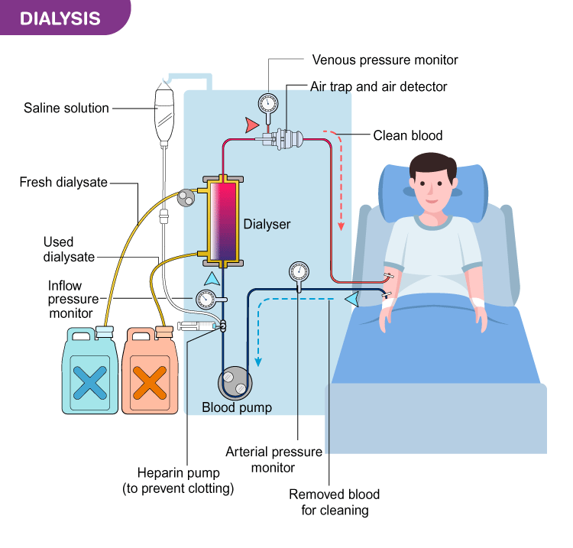
PERITONEAL DIALYSIS
Peritoneal dialysis is the technique in which peritoneal membrane is used as a semipermeable membrane. It is also used to treat the patients suffering from renal failure.
A catheter is inserted into the peritoneal cavity through anterior abdominal wall and sutured. The dialysate is passed through this catheter under gravity. The required electrolytes from dialysate pass through vascular peritoneum into blood vessels of abdominal cavity. Urea, creatinine, phosphate and other unwanted substances diffuse from blood vessels into dialysate. Later, dialysate is drained from peritoneal cavity by gravity. Peritoneal dialysis is a simple, convenient and less expensive technique, compared to hemodialysis.
Patients themselves can change the fluid on an outpatient basis. However, it has few drawbacks. It is less efficient in removing some of the toxic substances and it may lead to complications by infections.
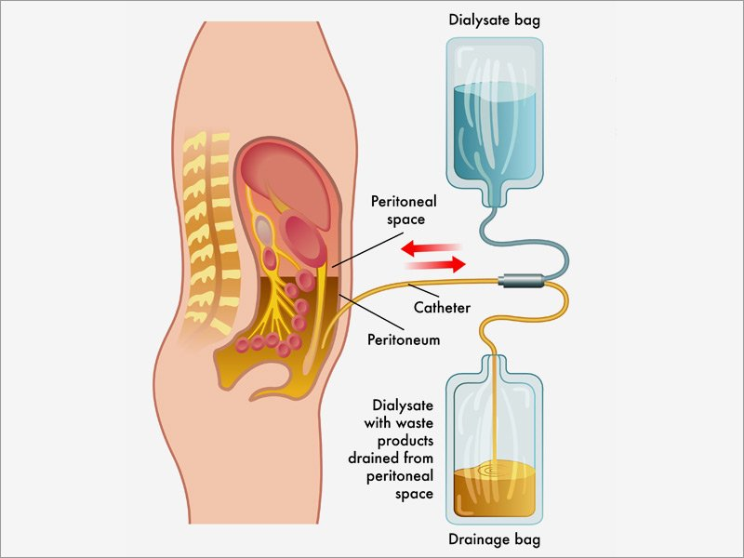

Uremia is the condition characterized by excess accumulation of end products of protein metabolism such as urea, nitrogen and creatinine in blood. There is also accumulation of some toxic substances like organic acids and phenols. Uremia occurs because of the failure of kidney to excrete the metabolic end products and toxic substances
Blood level of urea, nitrogen and creatinine increases during uremia. Toxic substances such as organic acids and phenols also accumulate in blood. Artificial kidney can excrete more than double the amount of urea that could be excreted by both the normal kidneys. About 200 to 250 mL of plasma could be cleared off urea per minute by the artificial kidney. But, the urea clearance by normal kidney is only about 70 mL/minute.
 COMPLICATIONS OF DIALYSIS
Complications of dialysis depend upon the patient’s condition, age, existence of diseases other than renal failure and many other factors.
Common complications of dialysis in individuals having only renal dysfunction are:
1. Sleep disorders
2. Anxiety
3. Depression.

