NAME: AHAMEFULE JONAS IKENNA
MATRIC NO: 17/MHS01/038
LEVEL: 300
MBBS: MEDICINE AND SURGERY

1. DISCUSS THE PATHOPHYSIOLOGICAL PROCESS INVOLVES IN RENAL FAILURE?
PATHOLOGICAL PROCESS INVOLVED IN RENAL FAILURE
Initially, as renal tissue loses function, there are few noticeable abnormalities because the remaining tissue increases its performance (renal functional adaptation).
Decreased renal function interferes with the kidneys’ ability to maintain ﬂuid and electrolyte homeostasis. The ability to concentrate urine declines early and is followed by decreases in ability to excrete excess phosphate, acid, and potassium.
CREATININE AND UREA
Plasma concentrations of creatinine and urea (which are highly dependent on glomerular ﬁltration) begin a hyperbolic rise as GFR diminishes. These changes are minimal early on. When the GFR falls below 15 mL/min/1.73 m2 (normal > 90 mL/min/1.73 m2), creatinine and urea levels are high and are usually associated with systemic manifestations (uremia). Urea and creatinine are not major contributors to the uremic symptoms; they are markers for many other substances (some not yet well deﬁned) that cause the symptoms.
SODIUM AND WATER
Despite a diminishing GFR, sodium and water balance are well maintained by increased fractional excretion of sodium in urine and a normal response to thirst. Thus, the plasma sodium concentration is typically normal, and hypervolemia is infrequent unless dietary intake of sodium or water is very restricted or excessive. Heart failure can occur due to sodium and water overload, particularly in patients with decreased cardiac reserve.
POTASSIUM AND MAGNESIUM
Adaptive processes increase potassium secretion in the distal nephron (collecting tubules) and also in the gut. Whilst a wide range of plasma potassium concentrations can be encountered dependent on factors such as diuretic use, it tends to be elevated. Acute changes present the greatest threats to life. A range of drugs may cause acute hyperkalaemia such as β-blockers, potassium-sparing diuretics, ACE inhibitors, angiotensin antagonists, NSAIDs and nephrotoxins such as aminoglycosides. Extracellular acidosis causes an exchange of intracellular potassium for extracellular hydrogen ions in an attempt to maintain electrical neutrality. In acute acidosis, the serum potassium will rise 0.5 mmollitre–1 for each 0.1 unit decrease in pH. For this reason, hypercarbia should be avoided during general anaesthesia. Magnesium is handled by the kidney much like potassium. Reduced excretion may cause hypermagnesemia, muscle weakness and potentiate non-depolarising muscle relaxants.
CALCIUM AND PHOSPHATE
Abnormalities of calcium, phosphate, parathyroid hormone (PTH), and vitamin D metabolism can occur, as can renal osteodystrophy. Decreased renal production of calcitriol (1,25(OH)2D, the active vitamin D hormone) contributes to hypocalcaemia. Decreased renal excretion of phosphate results in hyperphosphatemia. Secondary hyperparathyroidism is common and can develop in renal failure before abnormalities in calcium or phosphate concentrations occur. For this reason, monitoring PTH in patients with moderate CKD, even before hyperphosphatemia occurs, has been recommended.
PH AND BICARBONATE
Moderate metabolic acidosis (plasma bicarbonate content 15 to 20 mmol/L) is characteristic. Acidosis causes muscle wasting due to protein catabolism, bone loss due to bone buﬀering of acid, and accelerated progression of kidney disease.
ANEMIA
Anemia is characteristic of moderate to advanced CKD (≥ stage 3). The anemia of chronic renal disease is normochromic-normocytic, with an Hct of 20 to 30% (35 to 40% in patients with polycystic kidney disease). It is usually caused by deﬁcient erythropoietin production due to a reduction of functional renal mass.
IMMUNE FUNCTION
Sepsis is a leading cause of death in patients with renal failure. Inhibition of cell-mediated immunity and humoral defence mechanisms occurs, with little improvement following dialysis. There is an increased production of pro-inflammatory cytokines suggesting that activation of monocytes may play a role in uraemic immune dysfunction.
GASTROINTESTINAL ABNORMALITIES
Gastrointestinal abnormalities are frequent with anorexia, nausea and vomiting contributing to malnutrition. Urea is a mucosal irritant and bleeding may occur from any part of the GI tract. Gastric emptying is delayed, residual volume increased and pH lowered. Peptic ulcer disease is common and most patients will receive proton pump inhibitors.
NEUROLOGICAL ABNORMALITIES
Many patients with chronic renal failure have abnormalities in central (CNS) and peripheral nervous system function. There is a wide spectrum of CNS changes. for example, from mild personality alterations to asterixis (i.e. lapse of posture, usually manifest by bilateral flapping tremor), myoclonus, encephalopathy and convulsions. Peripheral neuropathy is common in advanced stages of the disease.
CARDIOVASCULAR AND PULMONARY ABNORMALITIES
Cardiovascular abnormalities are common in CRF and are responsible for 48% of deaths in these patients. Systemic hypertension is the most common with an incidence approaching 80%, although it is often not a feature of sodium-wasting nephropathies such as polycystic kidney disease or papillary necrosis. Plasma volume expansion resulting from sodium and water retention is the most frequent cause of hypertension; it may be improved significantly by dialysis.
2. WITH THE AID OF SUITABLE DIAGRAMS DISCUSS THE TYPES OF DIALYSIS YOU KNOW?
TYPES OF DIALYSIS
Dialysis is the process of removing excess water, solutes, and toxins from the blood in people whose kidneys can no longer perform these functions naturally. Dialysis is used in patients with rapidly developing loss of kidney function, called acute kidney injury, or slowly worsening kidney function, called stage 5 chronic kidney disease. Types of dialysis are:
Hemodialysis

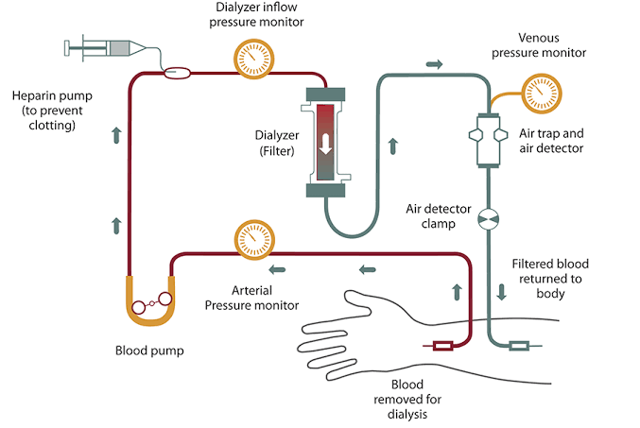
In hemodialysis, the patient's blood is pumped through the blood compartment of a dialyzer, exposing it to a partially permeable membrane. The dialyzer is composed of thousands of tiny hollow synthetic fibers. The fiber wall acts as the semipermeable membrane. Blood flows through the fibers, dialysis solution flows around the outside of the fibers, and water and wastes move between these two solutions. The cleansed blood is then returned via the circuit back to the body. Ultrafiltration occurs by increasing the hydrostatic pressure across the dialyzer membrane. This usually is done by applying a negative pressure to the dialysate compartment of the dialyzer. This pressure gradient causes water and dissolved solutes to move from blood to dialysate and allows the removal of several litres of excess fluid during a typical 4-hour treatment.
DISADVANTAGES
Restricts independence, as people undergoing this procedure cannot travel around because of supplies' availability.
Requires more supplies such as high-water quality and electricity.
Requires reliable technology like dialysis machines.
The procedure is complicated and requires that care givers have more knowledge.
PERITONEAL DIALYSIS
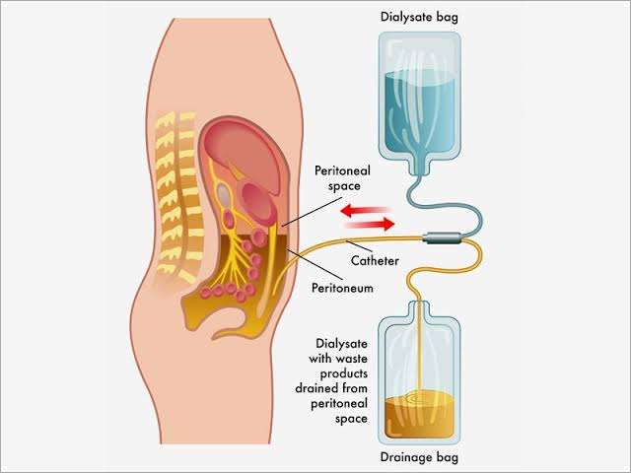
In peritoneal dialysis, a sterile solution containing glucose (called dialysate) is run through a tube into the peritoneal cavity, the abdominal body cavity around the intestine, where the peritoneal membrane acts as a partially permeable membrane.
This exchange is repeated 4–5 times per day; automatic systems can run more frequent exchange cycles overnight. Peritoneal dialysis is less efficient than hemodialysis, but because it is carried out for a longer period of time the net effect in terms of removal of waste products and of salt and water are similar to hemodialysis. Peritoneal dialysis is carried out at home by the patient, often without help. This frees patients from the routine of having to go to a dialysis clinic on a fixed schedule multiple times per week. Peritoneal dialysis can be performed with little to no specialized equipment (other than bags of fresh dialysate).
Complications may include infections within the abdomen, hernias, high blood sugar, bleeding in the abdomen, and blockage of the catheter. Use is not possible in those with significant prior abdominal surgery or inflammatory bowel disease. It requires some degree of technical skill to be done properly.

