Okoye Nwabufo Chukwuekezie
17/MHS01/249
Medicine and Surgery
PHS 303: Renal Physiology Body Fluid and Temperature Regulation
Assignment

Question 1
Discuss the pathophysiological process involves in renal failure?
Renal failure, also known as end-stage kidney disease, is a medical condition in which the kidneys are functioning at less than 15% of normal. Renal failure is classified as either acute kidney failure, which develops rapidly and may resolve; and chronic kidney failure, which develops slowly.
Acute renal failure(ARF) refers to the sudden decline in glomerular filtration rate over a period of days or weeks associated with a rapid rise in blood urea. According to Kidney Disease Improving Global Outcomes (KDIGO), ARF is defined by one of the following 3 criteria:
- Increase in creatinine serum level of more than 0.3 mg/dl (within 48 hours).
- Increase in creatinine serum level by more than 50% (within the prior 7 days).
- Decrease in urine volume (oliguria) to less than 0.5 ml/kg body weight/hour for 6 hours.
Common causes of acute renal failure (ARF) can be grouped as:
- Prerenal causes: include Reduced blood supply to the kidneys. Normally, kidneys receive about 20–25% of the cardiac output (1100 ml/min). Decreased renal blood flow is usually accompanied by decreased glomerular filtration rate and reduced urinary output. When blood flow is reduced below the basal requirements (i.e. 20–25% less than normal renal blood flow), renal ischemia occurs causing damage to renal cells, particularly tubular epithelial cells. The common causes of reduced blood flow to kidney are severe haemorrhage, shock, severe burns, hypovolaemia, septicaemia, cardiac failure and so on.
- Intrarenal causes: include acute glomerulonephritis and acute tubular necrosis
  - Acute glomerulonephritis is usually caused by an abnormal immune reaction, which causes damage to the glomeruli. In 95% of cases of glomerulonephritis, streptococcal infection involving other parts of body (tonsillitis or skin infection). The antibodies develop against the streptococcal antigen (within few weeks), react and form insoluble antigen–antibody complexes, which get deposited in the glomeruli and evoke an inflammatory reaction. The glomeruli get blocked and those which are not blocked, their permeability increases and allow leak of proteins and red cells from the glomerular capillaries into the glomerular filtrate. In severe cases, there is renal shutdown and this results in acute renal failure.
  - Acute tubular necrosis means destruction of tubular epithelial cells. Tubular necrosis occurs due to diminution of oxygen and nutrition to epithelial cells. Toxins, poisons and certain drugs also damage the tubular epithelium resulting in acute renal failure due to toxins or ischaemia.
- Obstructive causes: include urinary tract obstruction at any site. Postrenal or obstructive renal failure occurs due to abnormalities of lower urinary tract which partially or completely blocks urinary flow (though renal blood flow is normal). If the urine output of only one kidney is blocked, no major changes occur in body fluids composition because the contralateral kidney undergoes compensation. The causes of postrenal acute renal failure include:
  - Bilateral obstruction of ureters, or of renal pelvis, by large stones or blood clots
  - Bladder or urethral obstruction
The clinical manifestation of ARF is very diverse and largely depends on a persistent underlying disease. The clinical course of the disease can be divided into three stages:
- Initiating stage: Before ARF manifests, it is mostly asymptomatic. Possible symptoms of an underlying disease predominate.
- Oliguric stage: The preeminent symptom of ARF is oliguria or anuria. It leads to a corporeal hyperhydration with a number of complications, including hypertension, pulmonary edema, pleural effusion, left ventricular heart failure, ascites, cerebral edema, and more. A consequence of urinary retention may be hyperkalemia with acidosis. However, as noted above, there are many normuric or polyuric stages.
- Diuretic or polyuric stage: Usually, the glomeruli recover faster than the tubular system, which means that during recovery, reabsorption may remain disturbed while the filtration capacity of the kidney begins to function again.
Depending on what is causing the ARF, side pain, fever, fatigue, and symptoms relating to complications may also be present.
Complications are due to ARF could cause many organ systems to be affected:
- The lungs can be affected by hyperhydration, including edema and effusion. Acute respiratory distress syndrome may occur.
- Heart failure may develop due to hypertension or hyperhydration, or arrhythmias may develop due to imbalanced electrolyte concentrations.
- If heart failure occurs, there is a risk of congestion in the venous circuit causing gastritis, ulcerations, or gastrointestinal bleeding. The stress-associated release of hormones can increase the likelihood of gastrointestinal bleeding.
- Seizures may occur due to a cerebral edema or electrolyte imbalance. In addition, vigilance can be impaired.
Treatment of Acute Renal Failure include:
- Substitution of Fluids and Electrolytes for Acute Renal Insult of Prerenal Genesis: In prerenal ARF, kidney function can only recover when the underlying pathophysiological mechanism has been eliminated. Nephrotoxic substances should be avoided, and fluid and electrolyte balances must be thoroughly controlled and treated. The reason for the hypoperfusion must be uncovered and then treated. The administration of fluids and electrolytes is a prudent option. Loop diuretics can also be helpful in maintaining diuresis. while this medication measurably increases diuresis, it does not increase glomerular filtration or have any impact on the recovery of kidney function. Patients with sepsis or with severe heart failure often require treatment in the intensive care unit.
- Immunosuppressive Therapy and Revascularization for Acute Renal Failure of Intrinsic Genesis: In intrinsic AFI, it is important to first treat the underlying disease. Immunosuppressive treatment is advisable for glomerulonephritis, and revascularization for ischemia. For raising diuresis, loop diuretics can be administered; however, the use of diuretics is controversial and therefore not generally recommended. The only absolute indication for the administration of diuretics is hyperhydration.
- Treatment of Acute Renal Insult of Postrenal Genesis: In cases of postrenal ARF, it is imperative to remove the urinary obstruction. If this is not immediately possible, the surgical insertion of an artificial excretory opening (percutaneous nephrostomy) is indicated.
- Extracorporeal Treatment of Acute Renal Failure: Extracorporeal treatment with hemodialysis or hemofiltration for electrolyte imbalances, water overloads, or acid-base imbalances can also be attempted. This type of renal replacement therapy should be considered only as a temporary measure and limited accordingly. If kidney function cannot be restored sufficiently, permanent dialysis may become necessary. This type of renal replacement therapy should be considered only as a temporary measure which must be limited accordingly. If the kidney function cannot be restored sufficiently, permanent dialysis might become necessary.
Chronic renal failure(CRF) refers to a slow, insidious, irreversible deterioration of renal functions resulting in the development of clinical syndrome of uraemia, manifested by excretory, metabolic, neurological, haematological and endocrinal abnormalities. Chronic renal failure, like acute renal failure, also occurs in a wide variety of diseases, but the end result is reduction of functional nephrons and deterioration of the kidney function to the point, where the patient must be placed on dialysis treatment or transplanted with a functional kidney for survival. This condition is referred as end-stage renal disease (ESRD). The exact mechanism of this stage is not well understood, but a slowly progressing vicious cycle due to renal adaptive changes may be responsible.
Common causes which lead on to slow, progressive nephron loss and ultimately chronic renal failure can be grouped as under:
- Congenital disorders, e.g. polycystic kidney.
- Vascular diseases of kidney, renal hypertension. Injury to renal vasculature can lead to renal ischemia. The most common cause of renal vascular injury is atherosclerosis. Atherosclerosis of the larger renal arteries leads to hypertension and involvement of smaller arteries (interlobular arteries and efferent arterioles) results in thickening of vessel walls due to deposits of fibrinoid tissue (nephrosclerosis), eventually leading to constriction (ischemic injury).
- Glomerular diseases, e.g. proliferative glomerulonephritis and diabetic nephropathy. Chronic glomerulonephritis: injury to glomeruli can be caused by several diseases. In most cases, it begins with accumulation of antigen–antibody complexes in the glomerular membrane and ultimately glomeruli are replaced by fibrous tissue, therefore unable to filter the fluid. Therefore, glomerular capillary filtration coefficient gets markedly reduced.
- Tubulointerstitial disease, e.g. chronic pyelonephritis and analgesic nephropathy. These diseases are referred to as interstitial nephritis. Injury to renal interstitium can be caused by bacterial infection (called as pyelonephritis) or as a result of vascular, glomerular and tubular damage by poison and toxic drugs.
- Obstructive renal diseases, e.g. benign enlargement of prostate, renal calculi and ureteral constriction.
Chronic renal failure often begins with generalized symptoms such as tiredness, loss of appetite, and headaches. Further early indicators are polyuria, newly emerging or worsening hypertension, or peripheral edemas. Depending on the etiology, there can also be flank pain or fever.
As the disease progresses, increased tiredness, paleness, headaches, visual disturbances, and a severe loss of renal capacity become noticeable. Uremic gastroenteropathy leads to a loss of appetite and nausea. Pruritus occurs and muscle fibrillations become apparent.
In the final stages, renal failure leads to oliguria or anuria, dyspnea, vomiting, uremic encephalopathy with a severe reduction in vigilance, and increased susceptibility to bleeding.
TREATMENT
- Loop diuretics are recommended for more advanced renal failure. If over time, the diuretic effect begins to weaken, diuretic resistance may be present; this can be overcome by sequential nephron blockade in which loop diuretics are combined with thiazide. The resultant loss of electrolytes must be closely monitored and replaced, however.
- Symptoms of hyperkalemia should be monitored. A low-potassium diet is recommended and potassium-sparing diuretics should not be prescribed. If renal acidosis occurs, serum bicarbonate values of < 22 mmol/L can be counterbalanced by the administration of bicarbonate.
- Adequate regulation of blood pressure can often be achieved by undertaking combined antihypertensive therapy, during which angiotensin-converting-enzyme inhibitors or angiotensin receptor blockers should be avoided due to their nephroprotective properties.
- As renal failure is accompanied by a change in pharmacokinetics, appropriate medication adjustments must be made in order to avoid intoxication.
- Renal anemia can be improved with synthetic erythropoietin. Depending on the blood parameters, iron supplements can also be necessary, particularly if dialysis is underway and blood loss is occurring, as this is often accompanied by iron deficiency.
- If it is not possible to stop or slow the progress of renal failure via conservative therapies, then renal replacement therapy is essential. There is a range of different extra or intracorporeal dialysis treatments available.
- The treatment of choice for terminal renal failure is kidney transplant. Kidney transplant is far preferable to long-term dialysis, despite the operative procedure and immunosuppressive therapy necessary.

Question 2
With the aid of suitable diagrams discuss the types of dialysis you know?
Dialysis is a minimally invasive blood purifying treatment (removing excess water, solutes, and toxins) given when kidney function is not optimum. This is referred to as renal replacement therapy.
There are three major or primary types of dialysis and two secondary types. They primary types of dialysis are:
HAEMODIALYSIS
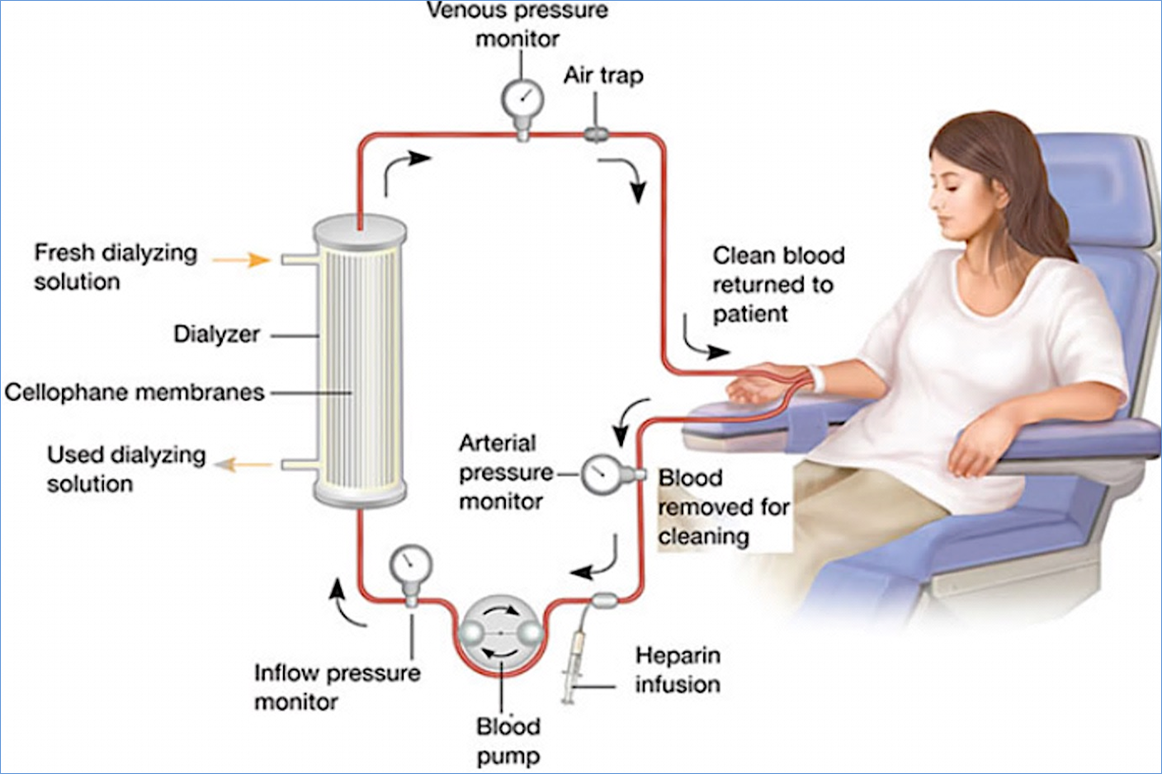
The most common method of dialysis is the Haemodialysis. In this method, the doctor will create a vascular access into the body, surgically. This will allow more blood to flow through the dialyzer and return back to the body after purification. The vascular access is an entrance to the blood vessels. The three types of entrance points are:
- Arteriovenous (AV) fistula: This type connects an artery and a vein. It’s the preferred option.
- AV graft: This type is a looped tube.
- Vascular access catheter: This may be inserted into the large vein in your neck.
Inside the dialyzer, there are thousands of tiny synthetic fibres that act as semi-permeable membrane. A dialysis solution, also known as dialysate, is used to purify the blood that runs through this membrane of fibres. A negative pressure is used to remove the water from the blood to the dialysate. The usual span for the haemodialysis process is 4 hours. Typically, a person has to undergo three haemodialysis sessions per week. However, depending on the condition, requirement or disease, haemodialysis can be done more frequently and for shorter or longer sessions.
The body size and the amount of waste in the blood determine the frequency of haemodialysis suitable for the patient. Usually the procedure is done at a doctor’s office or at a hospital or at a dialysis centre. Nowadays, with advanced technology, haemodialysis is also being offered at the patient’s home. Those, who are in need for a long-term dialysis, are recommended the at-home haemodialysis treatment.

PERITONEAL DIALYSIS
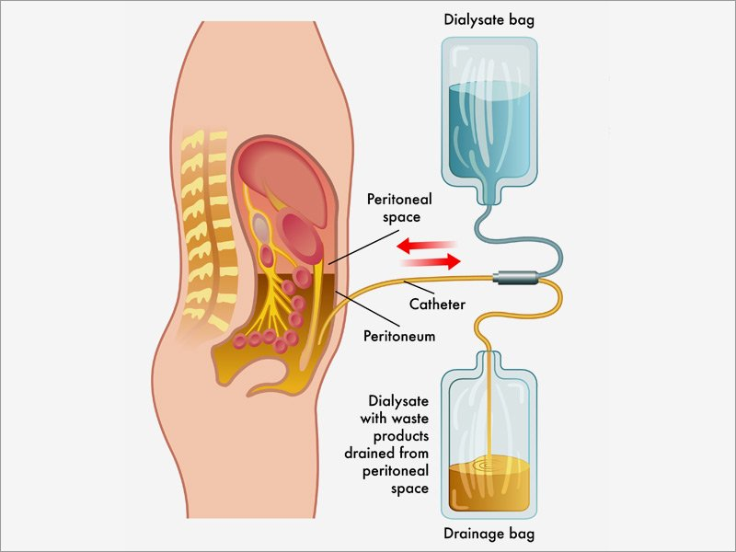
This is a surgical procedure of dialysis. The doctor implants a catheter into the patient’s belly and this comes out from below the navel. A dialysate fluid is inserted into the abdomen through the catheter. This fluid draws out the waste materials and extra water from the blood, through the small blood vessels in the abdomen. Once the process is done, the waste materials and extra water from the blood along with the dialysate fluid, all get deposited into a bag through the catheter and the bag is discarded. Here it must be mentioned that there are two types of peritoneal dialysis
- Continuous ambulatory peritoneal dialysis (CAPD)
- Continuous cycling peritoneal dialysis (CCPD)
CAPD is useful for those, who want to undergo the dialysis treatment while staying mobile or while doing other tasks. It is carried out multiple times a day. This method does not require any machine to carry out the dialysis treatment. CCPD is useful for those, who do not want any interruption throughout the day. It is done at night, while the patient is asleep.

HEMOFILTRATION
Hemofiltration is similar to haemodialysis except for the principle which it follows. In this process, the blood is passed via the dialyzer but the dialysate is not used. The water is passed through permeable membranes rapidly, taking along with it the dissolved substances including large molecular substances which are usually not cleared in hemodialysis. During the treatment process, water and salts that are replaced during this filtration process is infused back in the extracorporeal circuit.
The secondary types of dialysis include:
- Haemodiafiltration: This is actually a combination of hemodialysis and hemofiltration.
- Intestinal Dialysis: In this type of dialysis, the diet is incorporating acacia fibre, a soluble fibre, which is easily digested by the bacteria in the colon. This bacterial growth increases the nitrogen content in the digestive system which is then eliminated from the body through feaces.
Advantages of Haemodialysis and Peritoneal Dialysis
- The main advantage of haemodialysis is that it is carried out only 3 times a week. This means that the patient has 4 dialysis free days in a week.
- With Peritoneal dialysis the main advantage is, it does not require any huge dialysis machines. Instead, it can be carried out well at home.
- If you are travelling, it is much easier to carry the portable peritoneal dialysis machine, than the Haemodialysis machine, which is huge.
Disadvantages of Haemodialysis and Peritoneal Dialysis
- Since, haemodialysis is always carried out at a dialysis clinic; so when you are travelling, you need to find a clinic that will help you to do the procedure.
- Patients undergoing haemodialysis treatment have to maintain a very strict diet. Certain foods must be avoided and there is also a restriction on the fluid intake. Some patients cannot drink more than a cup of fluid a day.
- If you have arteriovenous fistulas or grafts, hemodialysis may fail if narrowings, called stenoses, develop in your blood vessels. Those narrowing cause poor flow, which affects the ability to efficiently dialyze the blood. The narrowings may cause additional symptoms, such as swelling of the head and arms. Without treatment, poor flow can result in clot formation, which prevents the ability to dialyze. It can even lead to permanent fistula or graft failure.
- With peritoneal dialysis, the main disadvantage is that it has to be carried out every day.
- Another upsetting matter with the peritoneal dialysis is that the catheter, almost permanently, hangs loose from the belly. Though it can be hidden under the clothes, the patient may feel uncomfortable.
- The patient has a tendency of developing peritonitis infection, along the line of the abdomen where the thin membrane of the catheter touches the abdomen. In such a case, after a few years of peritoneal dialysis, the patient has to switch to haemodialysis to avoid peritonitis. The dialysate fluid that is used for peritoneal dialysis reduces the protein level in the blood, leading to malnutrition and lack of energy. It also results in weight gain as a side effect of the dialysate fluid.

Advantages of Hemofiltration
- Hemodialysis helps in treating heart failure while hemodialysis might worsen the condition sometimes.
- Hemofiltration can lower the rate of refractory hypertension to 1% and sometimes one might also be in a position to stop antihypertensive medicines.
- The incidence of hypotension and water and salt retention in patients undergoing hemofiltration is reduced to 5%.
- Hemofiltration, either continuous or intermittent, is actually an effective treatment of acute kidney failure.
- In case of hepatic coma, hemofiltration has shown better results as compared to hemodialysis; however, it is not as effective as blood perfusion or plasma exchange.
Disadvantages of Hemofiltration
- Patient’s mobility is restricted in case of hemofiltration and the procedure requires a constant patient centred activity which hinders the resting and sleep times.
- The patient has to be on anticoagulant medicines except in cases where a patient has mechanical valve which regulates the effective running of pump.
- Many a times, fluid balance is open to various potential errors.
Dialyzable substances (substances removable with dialysis) have these properties:
- Low molecular mass
- High water solubility
- Low protein binding capacity
- Prolonged elimination (long half-life)
- Small volume of distribution
Substances include: Ethylene glycol, Procainamide, Methanol, Isopropyl alcohol, Bromide, Sotalol, Chloral hydrate, Ethanol and Acetone

