MATRIC NO: 17/MHS01/275
NAME: Osubor Stephanie Ifeomachukwu
COURSE: PHY 303
QUESTION 1
- Pathophysiological Processes involved in Renal Failure
Chronic kidney disease (CKD) is long-standing, progressive deterioration of renal function. Symptoms develop slowly and in advanced stages include anorexia, nausea, vomiting, stomatitis, dysgeusia, nocturia, lassitude, fatigue, pruritus, decreased mental acuity, muscle twitches and cramps, water retention, undernutrition, peripheral neuropathies, and seizures. Diagnosis is based on laboratory testing of renal function, sometimes followed by renal biopsy. Treatment is primarily directed at the underlying condition but includes fluid and electrolyte management, blood pressure control, treatment of anemia, various types of dialysis, and kidney transplantation.
Chronic kidney disease (CKD) is initially described as diminished renal reserve or renal insufficiency, which may progress to renal failure (end-stage renal disease). Initially, as renal tissue loses function, there are few noticeable abnormalities because the remaining tissue increases its performance (renal functional adaptation).
Decreased renal function interferes with the kidneys’ ability to maintain fluid and electrolyte homeostasis. The ability to concentrate urine declines early and is followed by decreases in ability to excrete excess phosphate, acid, and potassium. When renal failure is advanced (glomerular filtration rate [GFR] ≤ 15 mL/min/1.73 m2), the ability to effectively dilute or concentrate urine is lost; thus, urine osmolality is usually fixed at about 300 to 320 mOsm/kg, close to that of plasma (275 to 295 mOsm/kg), and urinary volume does not respond readily to variations in water intake.
Creatinine and urea
Plasma concentrations of creatinine and urea (which are highly dependent on glomerular filtration) begin a hyperbolic rise as GFR diminishes. These changes are minimal early on. When the GFR falls below 15 mL/min/1.73 m2 (normal > 90 mL/min/1.73 m2), creatinine and urea levels are high and are usually associated with systemic manifestations (uremia). Urea and creatinine are not major contributors to the uremic symptoms; they are markers for many other substances (some not yet well defined) that cause the symptoms.
Sodium and water
Despite a diminishing GFR, sodium and water balance is well maintained by increased fractional excretion of sodium in urine and a normal response to thirst. Thus, the plasma sodium concentration is typically normal, and hypervolemia is infrequent unless dietary intake of sodium or water is very restricted or excessive. Heart failure can occur due to sodium and water overload, particularly in patients with decreased cardiac reserve.

Potassium
For substances whose secretion is controlled mainly through distal nephron secretion (eg, potassium), renal adaptation usually maintains plasma levels at normal until renal failure is advanced or dietary potassium intake is excessive. Potassium-sparing diuretics, angiotensin-converting enzyme inhibitors, beta-blockers, nonsteroidal anti-inflammatory drugs, cyclosporine, tacrolimus, trimethoprim/sulfamethoxazole, pentamidine, or angiotensin II receptor blockers may raise plasma potassium levels in patients with less advanced renal failure.
Calcium and phosphate
Abnormalities of calcium, phosphate, parathyroid hormone (PTH), and vitamin D metabolism can occur, as can renal osteodystrophy. Decreased renal production of calcitriol (1,25(OH)2D, the active vitamin D hormone) contributes to hypocalcemia. Decreased renal excretion of phosphate results in hyperphosphatemia. Secondary hyperparathyroidism is common and can develop in renal failure before abnormalities in calcium or phosphate concentrations occur. For this reason, monitoring PTH in patients with moderate CKD, even before hyperphosphatemia occurs, has been recommended.
Renal osteodystrophy (abnormal bone mineralization resulting from hyperparathyroidism, calcitriol deficiency, elevated serum phosphate, or low or normal serum calcium) usually takes the form of increased bone turnover due to hyperparathyroid bone disease (osteitis fibrosa) but can also involve decreased bone turnover due to adynamic bone disease (with increased parathyroid suppression) or osteomalacia. Calcitriol deficiency may cause osteopenia or osteomalacia.
pH and bicarbonate
Moderate metabolic acidosis (plasma bicarbonate content 15 to 20 mmol/L) is characteristic. Acidosis causes muscle wasting due to protein catabolism, bone loss due to bone buffering of acid, and accelerated progression of kidney disease.
Anemia
Anemia is characteristic of moderate to advanced CKD (≥ stage 3). The anemia of CKD is normochromic-normocytic, with an Hct of 20 to 30% (35 to 40% in patients with polycystic kidney disease). It is usually caused by deficient erythropoietin production due to a reduction of functional renal mass (see Overview of Decreased Erythropoiesis). Other causes include deficiencies of iron, folate, and vitamin B12.
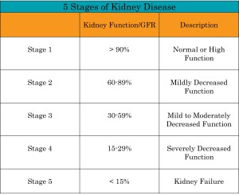
The five stages of kidney disease, or CKD,
and the GFR for each stage, is shown below:
•Stage 1 with normal or high GFR (GFR > 90 mL/min)
•Stage 2 Mild CKD (GFR = 60-89 mL/min)
•Stage 3A Moderate CKD (GFR = 45-59 mL/min)
•Stage 3B Moderate CKD (GFR = 30-44 mL/min
•Stage 4 Severe CKD (GFR = 15-29 mL/min)
•Stage 5 End Stage CKD (GFR <15 mL/min)
QUESTION 2
- Dialysis
The kidneys filter your blood by removing waste and excess fluid from your body. This waste is sent to the bladder to be eliminated when you urinate. Dialysis performs the function of the kidneys if they’ve failed. Dialysis is a treatment that filters and purifies the blood using a machine. This helps keep fluids and electrolytes in balance when the kidneys can’t do their job.
Types of Dialysis
There are three primary and two secondary types of dialysis:
Primary: hemodialysis, peritoneal dialysis and hemofiltration.
Secondary: hemodiafiltration and intestinal dialysis.

- Hemodialysis
Hemodialysis is the most common type of dialysis. This process uses an artificial kidney (hemodialyzer) to remove waste and extra fluid from the blood. The blood is removed from the body and filtered through the artificial kidney. The filtered blood is then returned to the body with the help of a dialysis machine. In hemodialysis, the patient's blood is pumped through the blood compartment of a dialyzer, exposing it to a partially permeable membrane. The dialyzer is composed of thousands of tiny hollow synthetic fibers. The fiber wall acts as the semipermeable membrane. Blood flows through the fibers, dialysis solution flows around the outside of the fibers, and water and wastes move between these two solutions. The cleansed blood is then returned via the circuit back to the body. Ultrafiltration occurs by increasing the hydrostatic pressure across the dialyzer membrane This usually is done by applying a negative pressure to the dialysate compartment of the dialyzer. This pressure gradient causes water and dissolved solutes to move from blood to dialysate and allows the removal of several litres of excess fluid during a typical 4-hour treatment.
To get the blood to flow to the artificial kidney, a surgery is performed to create an entrance point (vascular access) into your blood vessels. The three types of entrance points are:
- Arteriovenous (AV) fistula. This type connects an artery and a vein. It’s the preferred option.
- AV graft. This type is a looped tube.
- Vascular access catheter. This may be inserted into the large vein in your neck.
Both the AV fistula and AV graft are designed for long-term dialysis treatments. People who receive AV fistulas are healed and ready to begin hemodialysis two to three months after their surgery. People who receive AV grafts are ready in two to three weeks. Catheters are designed for short-term or temporary use.
Hemodialysis treatments usually last three to five hours and are performed three times per week. However, hemodialysis treatment can also be completed in shorter, more frequent sessions. Most hemodialysis treatments are performed at a hospital, doctor’s office, or dialysis center. The length of treatment depends on your body size, the amount of waste in your body, and the current state of your health.
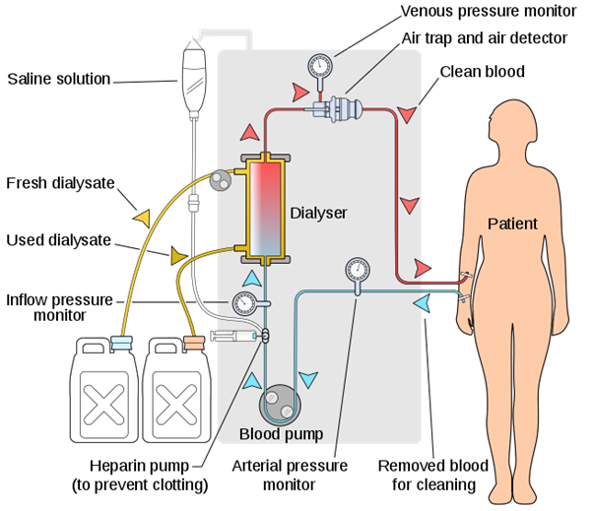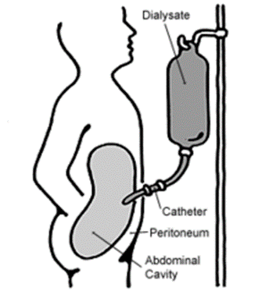
Diagram 1: Hemodialysis Diagram 2: Peritoneal Dialysis

- Peritoneal dialysis
It involves, a sterile solution containing glucose (called dialysate) is run through a tube into the peritoneal cavity, the abdominal body cavity around the intestine, where the peritoneal membrane acts as a partially permeable membrane. A surgery is performed to implant a peritoneal dialysis (PD) catheter into your abdomen. The catheter helps filter your blood through the peritoneum, a membrane in your abdomen. During treatment, a special fluid called dialysate flows into the peritoneum. The dialysate absorbs waste. Once the dialysate draws waste out of the bloodstream, it’s drained from your abdomen.
This process takes a few hours and needs to be repeated four to six times per day. However, the exchange of fluids can be performed while you’re sleeping or awake.
There are numerous different types of peritoneal dialysis. The main ones are:
Continuous ambulatory peritoneal dialysis (CAPD). In CAPD, your abdomen is filled and drained multiple times each day. This method doesn’t require a machine and must be performed while awake.
Continuous cycling peritoneal dialysis (CCPD). CCPD uses a machine to cycle the fluid in and out of your abdomen. It’s usually done at night while you sleep.
Intermittent peritoneal dialysis (IPD). This treatment is usually performed in the hospital, though it may be performed at home. It uses the same machine as CCPD, but the process takes longer.
- Hemofiltration
Hemofiltration is a similar treatment to hemodialysis, but it makes use of a different principle. The blood is pumped through a dialyzer or "hemofilter" as in dialysis, but no dialysate is used. A pressure gradient is applied; as a result, water moves across the very permeable membrane rapidly, "dragging" along with it many dissolved substances, including ones with large molecular weights, which are not cleared as well by hemodialysis. Salts and water lost from the blood during this process are replaced with a "substitution fluid" that is infused into the extracorporeal circuit during the treatment.
This therapy is used primarily in the intensive care unit for people with acute kidney failure. It’s also known as Continuous renal replacement therapy (CRRT). A machine passes the blood through tubing. A filter then removes waste products and water. The blood is returned to the body, along with replacement fluid. This procedure is performed 12 to 24 hours a day, generally every day.
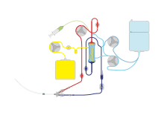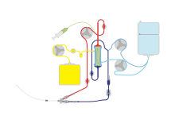
Diagram 1: Continuous veno-venous Diagram 2: Continuous veno-venous
hemofiltration with pre- and post-dilution hemodiafilteration

- Hemodiafiltration
Hemodiafiltration is a combination of hemodialysis and hemofiltration, thus used to purify the blood from toxins when the kidney is not working normally and also used to treat acute kidney injury (AKI).
- Intestinal dialysis
In intestinal dialysis, the diet is supplemented with soluble fibres such as acacia fibre, which is digested by bacteria in the colon. This bacterial growth increases the amount of nitrogen that is eliminated in fecal waste. An alternative approach utilizes the ingestion of 1 to 1.5 liters of non-absorbable solutions of polyethylene glycol or mannitol every fourth hour.

