NAME: Afuwape Zainab Omobolanle
MATRIC NO: 17/MHS01/030
DEPT: MBBS
COURSE: Renal Physiology
ASSIGNMENT: 1. Discuss the pathophysiological process involved in renal failure.
2. With the aid of suitable diagrams discuss the types of dialysis you know.

- Pathophysiological Process Involved in Renal Failure.
Renal failure refers to failure of excretory functions of the kidney. It is usually characterized by decrease in glomerular filtration rate (GFR). So, GFR is considered as the best index of renal failure. However, decrease in GFR is not affected much during the initial stages of renal failure. If 50% of the nephrons are affected, GFR decreases only by 20 to 30%, this is because of the compensatory mechanism by the unaffected nephrons. Renal failure may either be chronic or acute.
Acute Renal Failure
It is the abrupt or sudden stoppage of renal functions. It is often reversible within few days to few weeks. The causes of acute renal failure can be divided into three main categories:
Prerenal Acute Renal Failure Caused by Decreased Blood Flow to the Kidney.
The kidneys normally receive an abundant blood supply of about 1100 ml/min, or about 20 to 25 percent of the cardiac output. The main purpose of this high blood flow to the kidneys is to provide enough plasma for the high rates of glomerular filtration needed for effective regulation of body fluid volumes and solute concentrations. Therefore, decreased renal blood flow is usually accompanied by decreased GFR and decreased urine output of water and solutes. Consequently, conditions that acutely diminish blood flow to the kidneys usually cause oligouria. This causes accumulation of water and solutes in the body fluids. If renal blood flow is markedly reduced, total cessation of urine output can occur.
As long as renal blood flow does not fall below about 20 to 25% of normal, acute renal failure can usually be reversed if the cause of the ischemia is corrected before damage to the renal cells has occurred. When blood flow is reduced below 20 to 25% of the normal renal blood flow, the renal cells start to become hypoxic, and further decreases in renal blood flow, if prolonged, will cause damage or even death of the renal cells, especially the tubular epithelial cells. If the cause of prerenal acute renal failure is not corrected and ischemia of the kidney persists longer than a few hours, this type of renal failure can evolve into intrarenal acute renal failure.
Intrarenal Acute Renal Failure Caused by Abnormalities within the Kidney: including those that affect the blood vessels, glomeruli, or tubules.
Acute Renal Failure Caused by Glomerulonephritis
This is a type of intrarenal acute renal failure usually caused by an abnormal immune reaction that damages the glomeruli. In about 95% of the patients with this disease, damage to the glomeruli occurs 1 to 3 weeks after an infection elsewhere in the body, usually caused by certain types of group A beta streptococci. It is not the infection itself that damages the kidney, instead, over a few weeks, as antibodies develop against the streptococcal antigen; the antibodies and antigen react with each other to form an insoluble complex that becomes entrapped in the gromeruli.
Once the immune complex has deposited in the glomeruli, many of the cells of the glomeruli begin to proliferate, but mainly the mesangial cells that lie between the endothelium and the epithelium. In addition, large numbers of white blood cells become entrapped in the glomeruli. Many of the glomeruli become blocked by this inflammatory reaction, and those that are not blocked usually become excessively permeable, allowing both protein and red blood cells to leak from the blood of the glomerular capillaries into the glomerular filtrate. In severe cases, either total or almost complete renal shutdown occurs.
The acute inflammation of the glomerui usually subsides in about 2 weeks and, in most patients, the kidneys return to almost normal function within the next few weeks to few months. Sometimes however, many of the glomeruli are destroyed beyond repair and in a small percentage of patients, progressive renal deterioration continues indefinitely, leading to chronic renal failure.

Postrenal Acute Renal Failure Caused by Abnormalities of the Lower Urinary Tract.
Multiple abnormalities in the lower urinary tract can block urine flow and therefore lead to acute renal failure even when the kidneys blood supply and other functions are initially normal. If the urine output of only one kidney is diminished, no major change in body fluid composition will occur because the contralateral kidney can increase its urine output sufficiently to maintain relatively normal levels of extracellular electrolytes and solutes, as well as normal extracellular fluid volume. with this type of renal failure, normal kidney function can be restored if the basic cause of the problem is corrected within a few hours. But chronic obstruction of the urinary tract, lasting for several days to weeks, can lead to irreversible kidney damage.
Physiologic Effects of Acute Renal Failure.
A major physiological effect of acute renal failure is retention in the blood and extracellular fluid of water, waste products of metabolism and electrolytes. This can lead to water and salt overload, which in turn, can lead to edema and hypertention. Excessive retention of potassium, however, is often a more serious threat to patients with acute renal failure increases in plasma potassium concentration above 8mEq/L can be fatal. Because the kidneys are also unable to excrete sufficient hydrogen ions, patients with acute renal failure develop metabolic acidosis, which in itself can be lethal or can aggravate the hyperkalemia.

- Types of Dialysis
Kidneys filter your blood by removing waste and excess fluid from your body. This waste is sent to the bladder to be eliminated when you urinate.
Dialysis performs the function of the kidneys if they’ve failed. Dialysis is a treatment that filters and purifies the blood using a machine. This helps keep your fluids and electrolytes in balance when the kidneys can’t do their job.
There are three different types of dialysis.

Hemodialysis
Hemodialysis is the most common type of dialysis. This process uses an artificial kidney (hemodialyzer) to remove waste and extra fluid from the blood. The blood is removed from the body and filtered through the artificial kidney. The filtered blood is then returned to the body with the help of a dialysis machine.
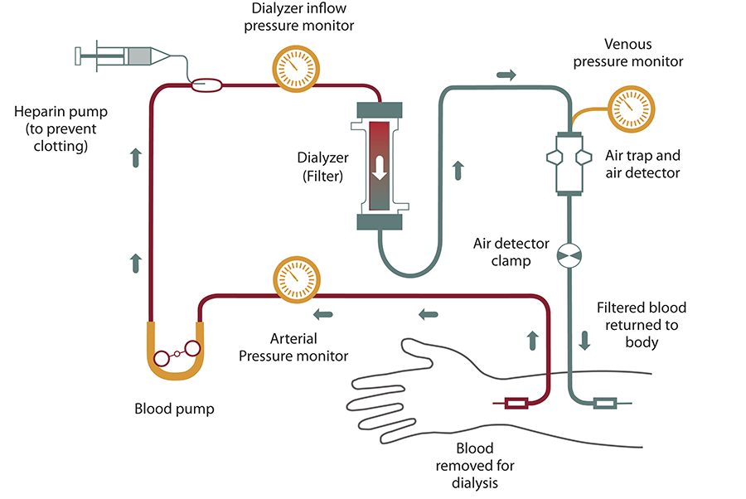
To get the blood to flow to the artificial kidney, your doctor will perform surgery to create an entrance point (vascular access) into your blood vessels. The three types of entrance points are:
- Arteriovenous (AV) fistula. This type connects an artery and a vein. It’s the preferred option.
- AV graft. This type is a looped tube.
- Vascular access catheter. This may be inserted into the large vein in your neck.
Both the AV fistula and AV graft are designed for long-term dialysis treatments. People who receive AV fistulas are healed and ready to begin hemodialysis two to three months after their surgery. People who receive AV grafts are ready in two to three weeks. Catheters are designed for short-term or temporary use.
Hemodialysis treatments usually last three to five hours and are performed three times per week. However, hemodialysis treatment can also be completed in shorter, more frequent sessions.

Peritoneal dialysis
Peritoneal dialysis involves surgery to implant a peritoneal dialysis (PD) catheter into your abdomen. The catheter helps filter your blood through the peritoneum, a membrane in your abdomen. During treatment, a special fluid called dialysate flows into the peritoneum. The dialysate absorbs waste. Once the dialysate draws waste out of the bloodstream, it’s drained from your abdomen.
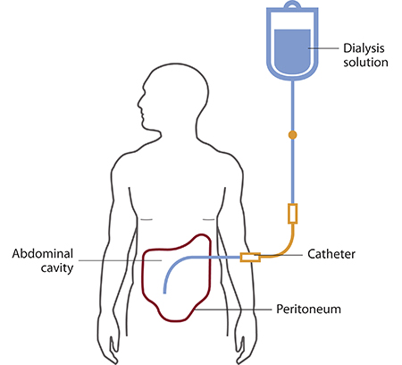
This process takes a few hours and needs to be repeated four to six times per day. However, the exchange of fluids can be performed while you’re sleeping or awake.
There are numerous different types of peritoneal dialysis. The main ones are:
- Continuous ambulatory peritoneal dialysis (CAPD). In CAPD, your abdomen is filled and drained multiple times each day. This method doesn’t require a machine and must be performed while awake.
- Continuous cycling peritoneal dialysis (CCPD). CCPD uses a machine to cycle the fluid in and out of your abdomen. It’s usually done at night while you sleep.
- Intermittent peritoneal dialysis (IPD). This treatment is usually performed in the hospital, though it may be performed at home. It uses the same machine as CCPD, but the process takes longer.

Continuous renal replacement therapy (CRRT)
This therapy is used primarily in the intensive care unit for people with acute kidney failure. It’s also known as hemofiltration. A machine passes the blood through tubing. A filter then removes waste products and water. The blood is returned to the body, along with replacement fluid. This procedure is performed 12 to 24 hours a day, generally every day.
Risks associated with hemodialysis
- Low blood pressure
- Anemia, or not having enough red blood cell
- Muscle cramping
- difficulty sleeping
- itching
- high blood potassium levels
- pericarditis, an inflammation of the membrane around the heart
- sepsis
- bacteremia, or a bloodstream infection
- irregular heartbeat
- sudden cardiac death, the leading cause of death in people undergoing dialysis

Risks associated with peritoneal dialysis
Peritoneal dialysis is associated with an increased risk for infections in or around the catheter site in the abdominal cavity. For example, after catheter implantation, a person can experience peritonitis. Peritonitis is an infection of the membrane lining the abdominal wall.
Other risks include:
- abdominal muscle weakening
- high blood sugar due to the dextrose in the dialysate
- weight gain
- hernia
- fever
- stomach pain

Risks associated with CRRT
The risks associated with CRRT include:
- infection
- hypothermia
- low blood pressure
- electrolyte disturbances
- bleeding
- delayed renal recovery
- weakening of bones

