NAME: BABALOLA AANUOLUWPO OLOLADE
MATRIC NO: 17/MHS01 /077
COURSE TITLE: RENAL PHYSIOLOGY
COURSE CODE: PHY 303
DATE: 24th June, 2020.
ASSIGNMENT TITLE: RENAL PHYSIOLOGY BODY FLUID AND TEMPERATURE REGULATION
QUESTION: 1. Discuss the pathophysiological process involved in renal failure
2.With the aid of suitable diagrams, discuss the types of dialysis you know.

- When discussing the pathophysiology of CKD, renal structural and physiological characteristics, as well as the principles of renal tissue injury and repair should be taken into consideration.

- Firstly, the rate of renal blood flow of approximately 400 ml/100g of tissue per minute is much greater than that observed in other well perfused vascular beds such as heart, liver and brain. As a consequence, renal tissue might be exposed to a significant quantity of any potentially harmful circulating agents or substances.
- Secondly, glomerular filtration is dependent on rather high intra- and transglomerular pressure (even under physiologic conditions), rendering the glomerular capillaries vulnerable to hemodynamic injury, in contrast to other capillary beds. In line with this, Brenner and coworkers identified glomerular hypertension and hyper filtration as major contributors to the progression of chronic renal disease.
- Thirdly, glomerular filtration membrane has negatively charged molecules which serve as a barrier retarding anionic macromolecules. With disruption in this electrostatic barrier, as is the case in many forms of glomerular injury, plasma protein gains access to the glomerular filtrate.
- Fourthly, the sequential organization of nephron’s microvasculature (glomerular convolute and the peritubular capillary network) and the downstream position of the tubuli with respect to glomeruli, not only maintains the glomerulo-tubular balance but also facilitates the spreading of glomerular injury to tubulointerstitial compartment in disease, exposing tubular epithelial cells to abnormal ultra filtrate. As peritubular vasculature underlies glomerular circulation, some mediators of glomerular inflammatory reaction may overflow into the peritubular circulation contributing to the interstitial inflammatory reaction frequently recorded in glomerular disease. Moreover, any decrease in preglomerular or glomerular perfusion leads to decrease in peritubular blood flow, which, depending on the degree of hypoxia, entails tubulointerstitial injury and tissue remodeling. Thus, the concept of the nephron as a functional unit applies not only to renal physiology, but also to the pathophysiology of renal diseases.
- In the fifth place, the glomerulus itself should also be regarded as a functional unit with each of its individual constituents, i.e. endothothelial, mesangial, visceral and parietal epithelial cells - podocytes, and their extracellular matrix representing an integral part of the normal function. Damage to one will in part affect the other through different mechanisms, direct cell-cell connections (e.g., gap junctions), soluble mediators such as chemokines, cytokines, growth factors, and changes in matrix and basement membrane composition.

The main causes of renal injury are based on immunologic reactions (initiated by immune complexes or immune cells), tissue hypoxia and ischaemia, exogenic agents like drugs, endogenous substances like glucose or paraproteins and others, and genetic defects. Irrespective of the underlying cause glomerulosclerosis and tubulointerstitial fibrosis are common to CKD.
An overview of the pathophysiology of CKD should give special consideration to mechanisms of glomerular, tubular and vascular injury.

2. In medicine, dialysis (from Greek διάλυσις, Dialysis, "dissolution"; from διά, dia, "through", and λύσις, lysis, "loosening or splitting") is the process of removing excess water, solutes, and toxins from the blood in people whose kidneys can no longer perform these functions naturally. The kidneys filter your blood by removing waste and excess fluid from your body. This waste is sent to the bladder to be eliminated when you urinate.
Dialysis performs the function of the kidneys if they’ve failed. This is referred to as renal replacement therapy. Dialysis is a treatment that filters and purifies the blood using a machine. This helps keep your fluids and electrolytes in balance when the kidneys can’t do their job.
Dialysis has been used since the 1940s to treat people with kidney problems.

There are three primary and two secondary types of dialysis:
- Hemodialysis (primary),
- Peritoneal dialysis (primary),
- Hemofiltration (primary),
- Hemodiafiltration (secondary) and
- Intestinal dialysis (secondary).

1.Hemodialysis:
In hemodialysis, the patient's blood is pumped through the blood compartment of a dialyzer, exposing it to a partially permeable membrane. The dialyzer is composed of thousands of tiny hollow synthetic fibers. The fiber wall acts as the semipermeable membrane. Blood flows through the fibers, dialysis solution flows around the outside of the fibers, and water and wastes move between these two solutions. The cleansed blood is then returned via the circuit back to the body. Ultrafiltration occurs by increasing the hydrostatic pressure across the dialyzer membrane This usually is done by applying a negative pressure to the dialysate compartment of the dialyzer. This pressure gradient causes water and dissolved solutes to move from blood to dialysate and allows the removal of several litres of excess fluid during a typical 4-hour treatment.
Hemodialysis is the most common type of dialysis. This process uses an artificial kidney (hemodialyzer) to remove waste and extra fluid from the blood.
To get the blood to flow to the artificial kidney, your doctor will perform surgery to create an entrance point (vascular access) into your blood vessels.
The three types of entrance points are:
* Arteriovenous (AV) fistula. This type connects an artery and a vein. It’s the preferred option.
* AV graft. This type is a looped tube.
* Vascular access catheter. This may be inserted into the large vein in your neck
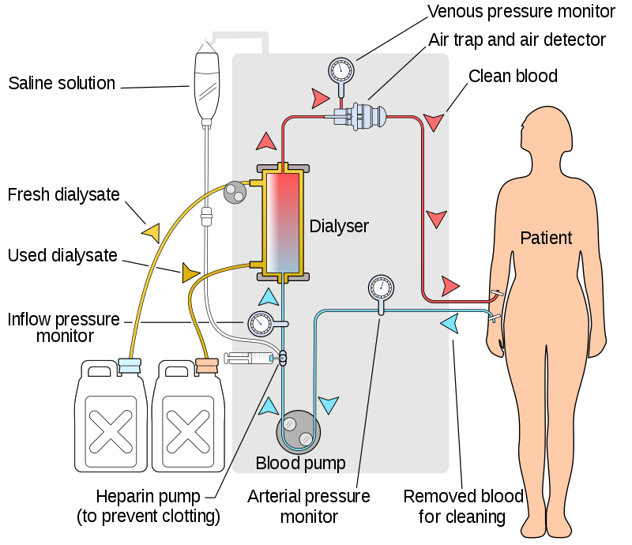

2.Peritoneal dialysis:
In peritoneal dialysis, a sterile solution containing glucose (called dialysate) is run through a tube into the peritoneal cavity, the abdominal body cavity around the intestine, where the peritoneal membrane acts as a partially permeable membrane. Peritoneal dialysis involves surgery to implant a peritoneal dialysis (PD) catheter into your abdomen.
This exchange is repeated 4–5 times per day; automatic systems can run more frequent exchange cycles overnight. Peritoneal dialysis is less efficient than hemodialysis, but because it is carried out for a longer period of time the net effect in terms of removal of waste products and of salt and water are similar to hemodialysis. Peritoneal dialysis is carried out at home by the patient, often without help. This frees patients from the routine of having to go to a dialysis clinic on a fixed schedule multiple times per week. Peritoneal dialysis can be performed with little to no specialized equipment (other than bags of fresh dialysate).
here are numerous different types of peritoneal dialysis. The main ones are:
* Continuous ambulatory peritoneal dialysis (CAPD). In CAPD, your abdomen is filled and drained multiple times each day. This method doesn’t require a machine and must be performed while awake.
* Continuous cycling peritoneal dialysis (CCPD). CCPD uses a machine to cycle the fluid in and out of your abdomen. It’s usually done at night while you sleep.
* Intermittent peritoneal dialysis (IPD). This treatment is usually performed in the hospital, though it may be performed at home. It uses the same machine as CCPD, but the process takes longer.
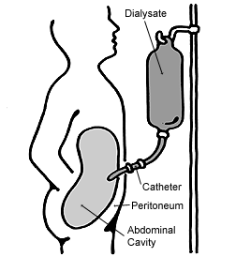

3.Hemofiltration:
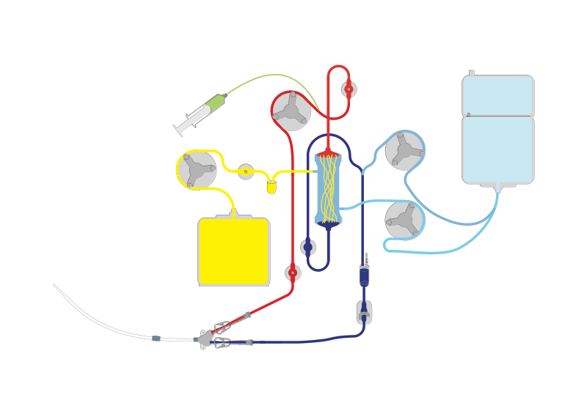
Hemofiltration is a similar treatment to hemodialysis, but it makes use of a different principle. The blood is pumped through a dialyzer or "hemofilter" as in dialysis, but no dialysate is used. A pressure gradient is applied; as a result, water moves across the very permeable membrane rapidly, "dragging" along with it many dissolved substances, including ones with large molecular weights, which are not cleared as well by hemodialysis. Salts and water lost from the blood during this process are replaced with a "substitution fluid" that is infused into the extracorporeal circuit during the treatment.
Continuous veno-venous haemofiltration with pre- and post-dilution (CVVH)

4.Hemodiafiltration:
Hemodiafiltration is a combination of hemodialysis and hemofiltration, thus used to purify the blood from toxins when the kidney is not working normally and also used to treat acute kidney injury (AKI).

5.Intestinal dialysis:
In intestinal dialysis, the diet is supplemented with soluble fibres such as acacia fibre, which is digested by bacteria in the colon. This bacterial growth increases the amount of nitrogen that is eliminated in fecal waste. An alternative approach utilizes the ingestion of 1 to 1.5 liters of non-absorbable solutions of polyethylene glycol or mannitol every fourth hour.
