Name: Nwapa Benedict Nzeregwu
Matric Number: 17/MHS01/333
Course Title: Renal Physiology Body Fluid and Temperature Regulation
Course Code: PHS 303
Department: Medicine and Surgery

Question
- Discuss the pathophysiological process involves in renal failure?
- With the aid of suitable diagrams discuss the types of dialysis you know?
Answers
- RENAL FAILURE
Renal failure refers to the deterioration of renal functions resulting in a decline in the glomerular filtration rate (GFR) and rise in urea and non-nitrogenous substances in the blood.
It is of two types:
- Acute renal failure and
- Chronic renal failure.
Acute renal failure
Acute renal failure refers to a sudden decline in GFR over a period of days or weeks associated with the rapid rise in blood urea.
Chronic renal failure
Chronic renal failure refers to a slow, insidious, irreversible deterioration of renal functions resulting in the development of clinical syndrome of uraemia, manifested by excretory, metabolic, neurological, haematological and endocrinal abnormalities.
NEPHROTIC SYNDROME
Nephrotic syndrome refers to a massive proteinuria (more than 3.5 g/day), mainly albuminuria and its associated consequences which include:
- Hypoalbuminaemia,
- Oedema,
- Hyperlipidaemia,
- Lipiduria and
- Hypercoagulability.
Pathophysiology. A wide variety of disease processes including immunological disorders, toxic injuries, metabolic abnormalities, biochemical defects and vascular disorders involving glomeruli contribute to the development of nephrotic syndrome.
- DIURETICS
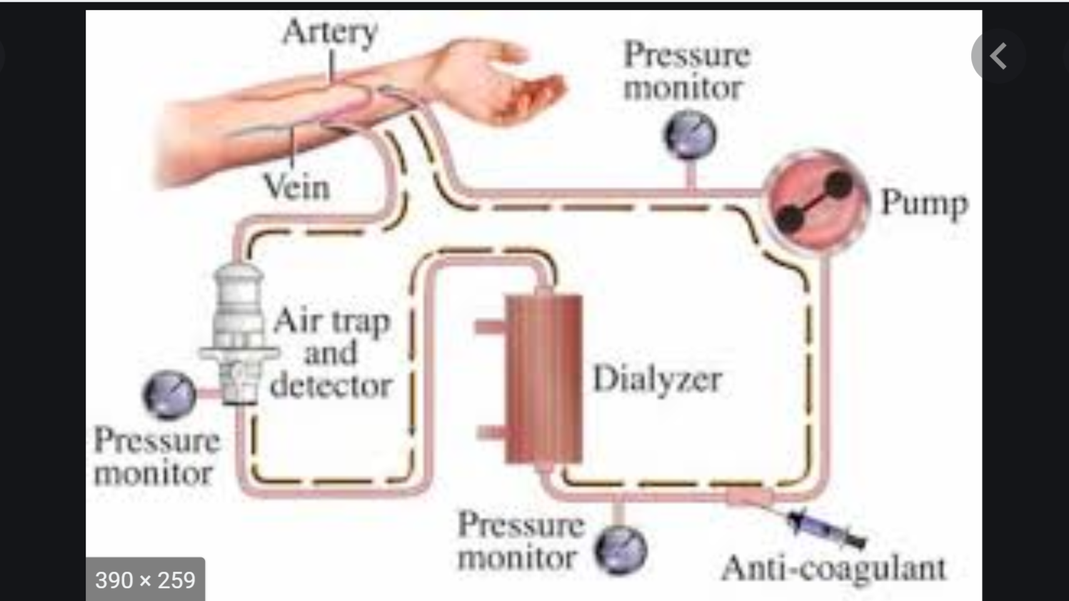
The diuretics are the drugs which primarily cause a net loss of Na+ (natriuresis) associated with water loss (secondary to natriuresis) and thus increase the rate of urine flow.
Classification
Depending upon their efficacy, the diuretic drugs can be classified as:
1. High-efficacy diuretics (inhibitors of Na+–K+–2Cl− transport), also called loop diuretics, e.g. Furosemide.

