Name: Adeyemo Sinmiloluwa Crystal
Matric no: 17/MHS01/025
Department: Medicine and surgery
Course: PHS 303
Question 1: Pathophysiological process involved in renal failure
Kidney failure, also called end-stage renal disease (ESRD), is the last and most severe stage of chronic kidney disease. When your kidneys fail, it means they have stopped working well enough for you to survive without dialysis or a kidney transplant.
Causes of kidney failure
In most cases, kidney failure is caused by other health problems that have done permanent damage (harm) to your kidneys little by little, over time.
Diabetes is the most common cause of ESRD. High blood pressure is the second most common cause of ESRD. Other problems that can cause kidney failure include:
- Autoimmune diseases, such as lupus and IgA nephropathy
- Genetic diseases (diseases you are born with), such as polycystic kidney disease
- Nephrotic syndrome
- Urinary tract problems
- Sometimes the kidneys can stop working very suddenly (within two days). This type of kidney failure is called acute kidney injury or acute renal failure.
Common causes of acute renal failure include:
- Heart attack
- Illegal drug use and drug abuse
- Not enough blood flowing to the kidneys
- Urinary tract problems
This type of kidney failure is not always permanent. Your kidneys may go back to normal or almost normal with treatment and if you do not have other serious health problems.
Estimated glomerular filtration rate is the best test to measure your level of kidney function and determine your stage of kidney disease. Your doctor can calculate it from the results of your blood creatinine test, your age, body size and gender. Your GFR tells your doctor your stage of kidney disease and helps the doctor plan your treatment. If your GFR number is low, your kidneys are not working as well as they should. The earlier kidney disease is detected, the better the chance of slowing or stopping its progression.

Five Stages of Kidney Disease
The National Kidney Foundation (NKF) created a guideline to help doctors identify each level of kidney disease. The NKF divided kidney disease (CKD) into five stages. Identifying the stage of kidney disease a person is in helps health care practitioners provide the best care, since each stage requires different treatment.
To understand each stage, we must first understand how kidney function is measured. The universally accepted measure of kidney function is the Glomerular Filtration Rate (GFR). Kidney function is measured by how effectively your kidneys clean your blood. The main way of estimating GFR is a blood test to determine the level of Creatinine in the blood, or serum creatinine. As kidney function declines, the levels of creatinine increase.
An equation is used to determine GFR. In addition to serum creatinine, factors such as age, race, and gender are included in the equation. Additional factors that may be included are weight, blood urea nitrogen (BUN), and serum albumin.
The five stages of kidney disease, or CKD, and the GFR for each stage, is shown below:
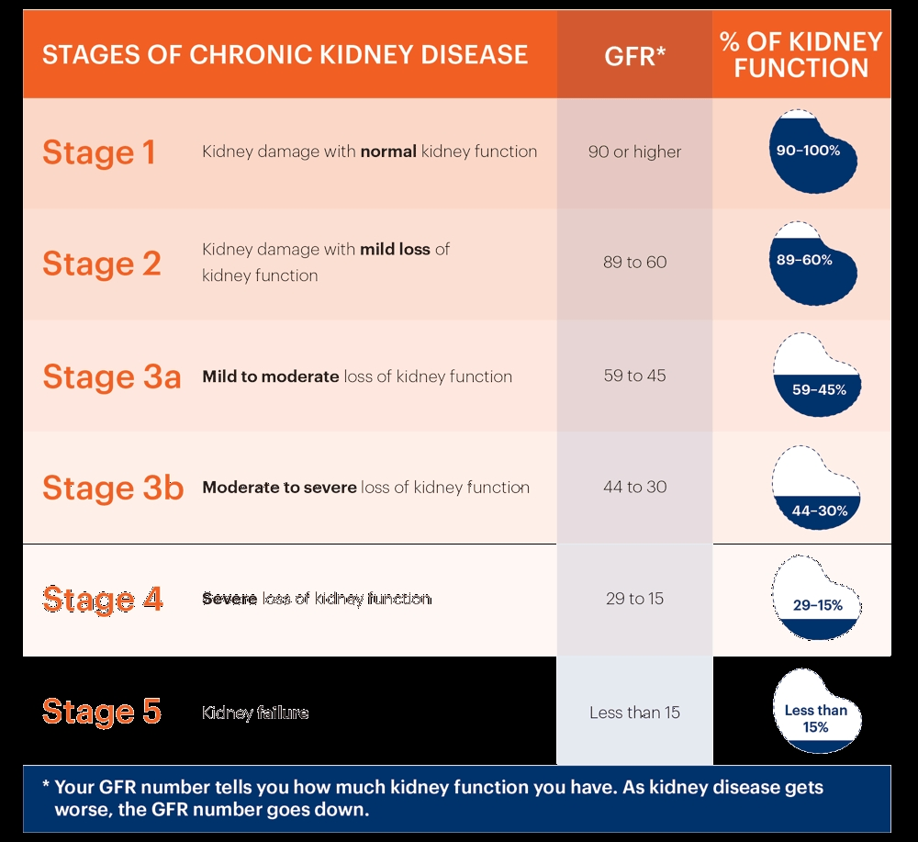

- Stage 1 with normal or high GFR (GFR > 90 mL/min)
- Stage 2 Mild CKD (GFR = 60-89 mL/min)
- Stage 3A Moderate CKD (GFR = 45-59 mL/min)
- Stage 3B Moderate CKD (GFR = 30-44 mL/min
- Stage 4 Severe CKD (GFR = 15-29 mL/min)
- Stage 5 End Stage CKD (GFR <15 mL/min)

Stage 1 Chronic kidney Disease: eGFR 90 or Greater
Stage 1 CKD means you have mild kidney damage and an eGFR of 90 or greater. Most of the time, an eGFR of 90 or greater means your kidneys are healthy and working well, but you have other signs of kidney damage. Signs of kidney damage could be protein in your urine (pee) or physical damage to your kidneys.
Stage 2 CKD: eGFR Between 60 and 89
Stage 2 CKD means you have mild kidney damage and an eGFR between 60 and 89. Most of the time, an eGFR between 60 and 89 means your kidneys are healthy and working well. But if you have Stage 2 kidney disease, this means you have other signs of kidney damage even though your eGFR is normal. Signs of kidney damage could be protein in your urine (pee) or physical damage to your kidneys.
Stage 3 CKD means you have an eGFR between 30 and 59. An eGFR between 30 and 59 means that there is some damage to your kidneys and they are not working as well as they should. Stage 3 is separated into two stages:
Stage 3a means you have an eGFR between 45 and 59
Stage 3b means you have an eGFR between 30 and 44
Many people with Stage 3 kidney disease do not have any symptoms. But if there are symptoms, there may be:
- Swelling in your hands and feet
- Back pain
- Urinating (peeing) more or less than normal
- At this stage, you are also more likely to have health complications as waste builds up in your body and your kidneys are not working well, such as:
- High blood pressure
- Anaemia (a low number of red blood cells)
- Bone disease
Stage 4 CKD: eGFR Between 15 and 29
Stage 4 CKD means you have an eGFR between 15 and 29. An eGFR between 15 and 30 means your kidneys are moderately or severely damaged and are not working as they should. Stage 4 kidney disease should be taken very seriously – it is the last stage before kidney failure. At Stage 4 kidney disease, many people have symptoms such as:
- Swelling in your hands and feet
- Back pain
- Urinating (peeing) more or less than normal
At Stage 4 kidney disease, this is the time to start talking with your nephrologist about how to prepare for kidney failure. Once your kidneys have failed, you will need to start dialysis or have a kidney transplant to live.
Stage 5 CKD: eGFR Less than 15
Stage 5 CKD means you have an eGFR less than 15.An eGFR less than 15 means the kidneys are getting very close to failure or have completely failed. If your kidneys fail, waste builds up in your blood, which makes you very sick. Some of the symptoms of kidney failure are:
- Itching
- Muscle cramps
- Feeling sick and throwing up
- Not feeling hungry
- Swelling in your hands and feet
- Back pain
- Urinating (peeing) more or less than normal
- Trouble breathing
- Trouble sleeping
Chronic renal disease (CRD) is defined as a glomerular filtration rate (GFR) of <60 (mL × min–1 per 1.73 m2 body surface area) for at least three months, whatever the cause and regardless of the presence of kidney damage (1). Patients in whom signs of damage are found on diagnostic imaging or renal biopsy and those with albuminuria also have nephropathy, even if their GFR is >60. Patients without signs of kidney damage whose GFR is >60 are highly unlikely to be nephropathic (2). CRD is classified into five stages according to the GFR .
Estimated glomerular filtration rate is the best test to measure your level of kidney function and determine your stage of kidney disease. Your doctor can calculate it from the results of your blood creatinine test, your age, body size and gender. Your GFR tells your doctor your stage of kidney disease and helps the doctor plan your treatment. If your GFR number is low, your kidneys are not working as well as they should. The earlier kidney disease is detected, the better the chance of slowing or stopping its progression.
Chronic renal failure can be detected early by direct measurement of the GFR with the aid of an exogenous filtration marker. Such techniques are costly and time-consuming and are therefore indicated only for patients at special risk. Chronic renal disease can also be diagnosed early with the aid of the endogenous filtration markers creatinine and cystatin C, which serve as indicators of a low GFR. The serum levels of these two substances are not taken as measures of GFR in themselves, but are rather entered into predictive equations for the estimation of GFR. Cystatin C-based equations seem to be more sensitive indicators of low GFR than creatinine-based equations.

Measuring GFR by means of endogenous filtration markers (eGFR)
Internal markers of filtration such as creatinine and cystatin C are endogenous substances that are almost completely filtered out by the glomeruli. Increasing serum levels of these parameters indicate decreasing GFR. It is recommended that whenever creatinine is determined the eGFR should be calculated and reported along with the serum value. Equations frequently used to ascertain eGFR based upon creatinine and cystatin C are presented in.
Serum creatinine
Determination of creatinine in serum is the method most frequently used to evaluate renal function. Creatinine derives from the muscular metabolism of creatine and phosphocreatine. As such, the synthesis of creatinine at a daily rate of approximately 20 mg/kg body weight reflects muscle mass and varies little from day to day.
Creatinine synthesis is age-dependent. As measured by urinary excretion, it decreases with increasing age, falling from a mean 23.8 mg/kg body weight in men aged 20 to 29 years to 9.8 mg/kg body weight in men aged 90 to 99 years. The essential reason is reduction in muscle mass.

When renal function is normal, creatinine is filtered out by the glomeruli and 15% of it is secreted by the tubuli. There is a reciprocal non-linear relationship between GFR and serum creatinine, such that a decrease in GFR to around 40 often does not lead to an increase to above the upper limit of normal. If no previously obtained values are available, a concentration within the normal range cannot be interpreted as potentially showing a decrease in GFR. In acute renal failure serum creatinine rises within 2 days as a direct result of retention within the body. In Chronic renal disease the increase in serum is only 30% to 50% of what would be expected from the prevailing GFR. The reason for this is that, depending on the extent of GFR reduction, 16% to 66% of creatinine is eliminated extraglomularly. Tubular secretion and intestinal elimination reach their maximum when GFR falls to =15. Extrarenal patient-related factors that influence creatinine synthesis and thus the concentration in serum include sex, age, ethnicity, muscle mass, chronic illness, and the consumption of cooked meat. Medications such as cimetidine and trimethoprim inhibit creatinine secretion and increase the serum concentration without affecting GFR.
Serum cystatin C
Cystatin C is a plasma protein with a molecular weight of 13.4 kDa and belongs to the cysteine protease inhibitors. It is synthesized at a constant rate by all nucleated cells, excreted into plasma, filtered by the glomeruli, and reabsorbed and metabolized by the proximal tubule cells. In the age group from 1 to 50 years, the serum concentration is independent of muscle mass, sex, and age.
These properties show that cystatin C is a good marker for assessment of renal function. Comparably with serum creatinine, there is an inverse, non-linear relationship between GFR and serum cystatin C. In comparison with serum creatinine, the proportional increase of cystatin C is higher when GFR falls to a level between 70 and 40 . Cystatin C rises age-dependently from the age of 50 years and correlates with the decrease in GFR.

Question 2: types of dialysis with diagrams
Dialysis
The kidneys filter your blood by removing waste and excess fluid from your body. This waste is sent to the bladder to be eliminated when you urinate.
Dialysis performs the function of the kidneys if they’ve failed. According to the National Kidney Foundation, end-stage kidney failure occurs when the kidneys are performing at only 10 to 15 percent of their normal function.
Dialysis is a treatment that filters and purifies the blood using a machine. This helps keep your fluids and electrolytes in balance when the kidneys can’t do their job.
Function of dialysis
Properly functioning kidneys prevent extra water, waste, and other impurities from accumulating in your body. They also help control blood pressure and regulate the levels of chemical elements in the blood. These elements may include sodium and potassium. Your kidneys even activate a form of vitamin D that improves the absorption of calcium.
When your kidneys can’t perform these functions due to disease or injury, dialysis can help keep the body running as normally as possible. Without dialysis, salts and other waste products will accumulate in the blood, poison the body, and damage other organs.
However, dialysis isn’t a cure for kidney disease or other problems affecting the kidneys. Different treatments may be needed to address those concerns.
Types of dialysis
There are three different types of dialysis.
- Hemodialysis
- Peritoneal dialysis
- Continuous renal replacement therapy

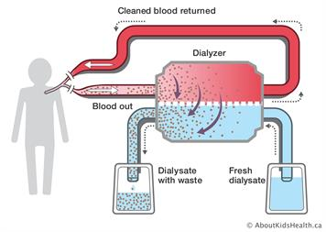
Hemodialysis
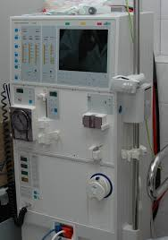
Diagram showing dialysis machine
Hemodialysis is the most common type of dialysis. This process uses an artificial kidney (hemodialysis) to remove waste and extra fluid from the blood. The blood is removed from the body and filtered through the artificial kidney. The filtered blood is then returned to the body with the help of a dialysis machine. To get the blood to flow to the artificial kidney, your doctor will perform surgery to create an entrance point (vascular access) into your blood vessels. The three types of entrance points are:
- Arteriovenous (AV) fistula. This type connects an artery and a vein. It’s the preferred option.
- AV graft. This type is a looped tube.
- Vascular access catheter. This may be inserted into the large vein in your neck.
Both the AV fistula and AV graft are designed for long-term dialysis treatments. People who receive AV fistulas are healed and ready to begin hemodialysis two to three months after their surgery. People who receive AV grafts are ready in two to three weeks. Catheters are designed for short-term or temporary use.
Hemodialysis treatments usually last three to five hours and are performed three times per week. However, hemodialysis treatment can also be completed in shorter, more frequent sessions.
Most hemodialysis treatments are performed at a hospital, doctor’s office, or dialysis centre. The length of treatment depends on your body size, the amount of waste in your body, and the current state of your health.
Peritoneal dialysis
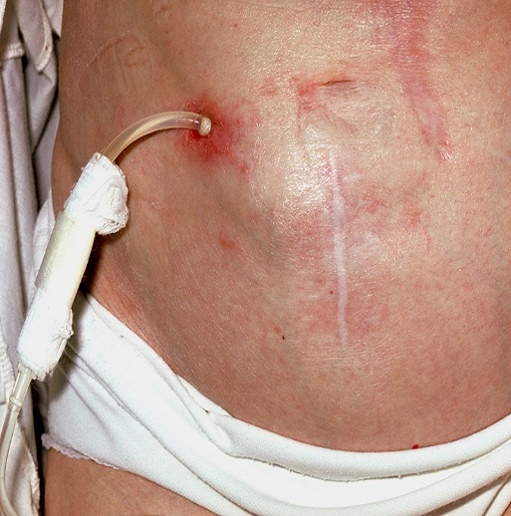
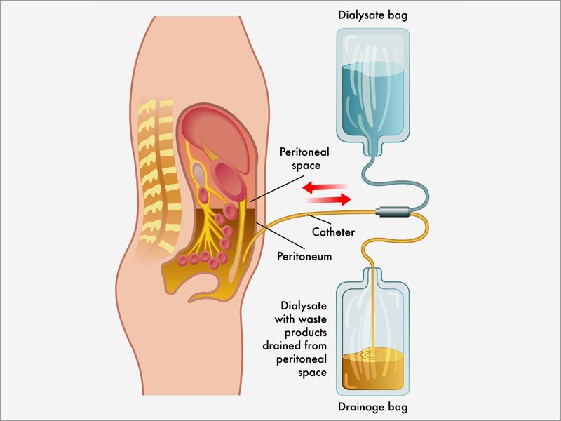

Peritoneal dialysis involves surgery to implant a peritoneal dialysis (PD) catheter into your abdomen. The catheter helps filter your blood through the peritoneum, a membrane in your abdomen. During treatment, a special fluid called dialysate flows into the peritoneum. The dialysate absorbs waste. Once the dialysate draws waste out of the bloodstream, it’s drained from your abdomen.
This process takes a few hours and needs to be repeated four to six times per day. However, the exchange of fluids can be performed while you’re sleeping or awake. There are numerous different types of peritoneal dialysis. The main ones are:
Continuous ambulatory peritoneal dialysis (CAPD). In CAPD, your abdomen is filled and drained multiple times each day. This method doesn’t require a machine and must be performed while awake.
Continuous cycling peritoneal dialysis (CCPD). CCPD uses a machine to cycle the fluid in and out of your abdomen. It’s usually done at night while you sleep.
Intermittent peritoneal dialysis (IPD). This treatment is usually performed in the hospital, though it may be performed at home. It uses the same machine as CCPD, but the process takes longer.

Continuous renal replacement therapy (CRRT)
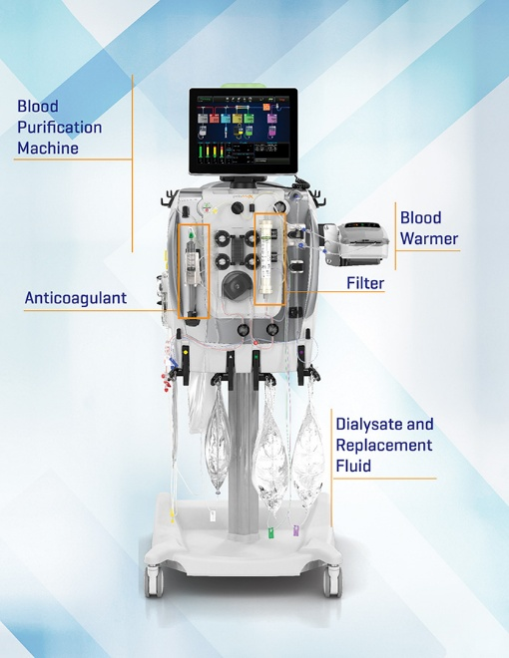
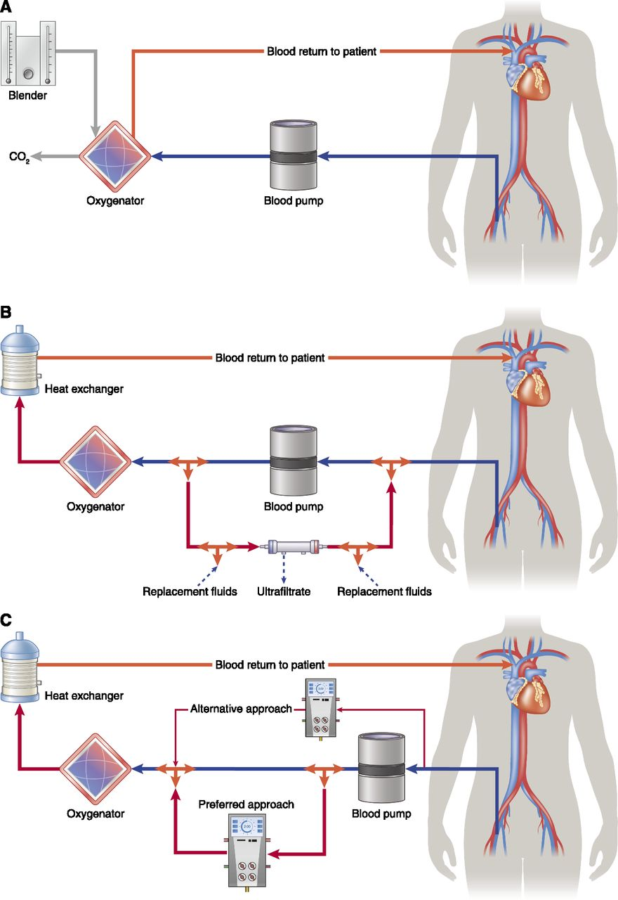

This therapy is used primarily in the intensive care unit for people with acute kidney failure. It’s also known as hemofiltration. A machine passes the blood through tubing. A filter then removes waste products and water. The blood is returned to the body, along with replacement fluid. This procedure is performed 12 to 24 hours a day, generally every day.

