OKE SUCCESS OLUWASEYI
17/MHS01/243
MEDICINE AND SURGERY
QUESTION 1: Discuss the pathophysiological process involved in renal failure.
ANSWER: Renal failure or Kidney failure can be defined as a significant loss of renal function in one or both kidneys to the point where it results to an inability to excrete metabolic waste products and water, and it contributes to disturbances of all body system. Renal failure may occur as an acute and rapidly progressing process or may present as a chronic form on which there is a progressive loss of renal function over a number of years.
Acute renal failure has an abrupt onset and is potentially reversible. Chronic failure progresses slowly over at least three months and can lead permanent renal failure.
In renal failure there is either GLOMERULAR or TABULAR dysfunction e,g
- Glomerulonephritis primary cause of Glomerular dysfunction.
- Aminoglycoside nephrotoxicity is mainly in Tubular.
GLOMERULAR DYSFUNCTION: As the main function of glomeruli is filtration, glomerular dysfunction leads to fall in GFR which retention of those substances usually cleared by filtration, including water.
TUBULAR DYSFUNCTION: As the main function of tubule is reabsorption, tubular failure results in the voiding of large volumes of dilute urine (polyuria) of low specific gravity, along with electrolytes and nutrients.

ACUTE RENAL FAILURE
Acute renal failure occurs when the kidneys suddenly become unable to filter waste products from the blood. When the kidneys lose their filtering ability, dangerous levels of wastes may accumulate, and the blood’s chemical makeup may get out of balance. Acute renal failure may be pre-renal, intra-renal or post-renal in nature. Acute renal failure is often reversible so long as permanent injury to the kidney has not occurred.
MANIFESTATIONS- Oligouria(reduced urine output), Possible edema and fluid retention, Elevated blood urea nitrogen levels (BUN) and serum creatinine, alterations in serum electrolytes.
CAUSES- Myocardial infarction, rhabdomyolysis, decreased blood flow, obstruction, hemolytic uremic syndrome, Glomerulonephritis.
Acute renal failure classifiedas pre-renal failure, intra-renal failure and post-renal failure
PRE-RENAL FAILURE: It results from impaired or reduced blood flow to the kidney. Possible causes include; shock, hypertension, anaphylaxis, ischemic formation. When there is a decrease in circulating blood volume, autoregulatory mechanisms increase Angiotensin II, aldosterone, norepinephrine and Anti-diuretic hormone as an attempt to preserve blood flow to essential organs. If the causes are not corrected, the decreased perfusion persist, the kidney lose their ability to compensate and damage to kidney parenchyma occurs (intrarenal damage).
INTRA-RENAL FAILURE: Results from acute damage to renal structures. Direct damage to the kidney tissues from prolonged ischemia, nephrotoxins, hemoglobin released from hemolyzed RBCs, or myoglobin released from necrotic muscle cells, acute glomerulonephritis, pyelonephritis, may also result from Acute Tubular Necrosis (ATN)-which is the most common cause, exposure to toxins, solvents, drugs and heavy metals.
POST-RENAL FAILURE: Results from conditions block of urine outflow. Post renal causes of Acute Kidney Injury (AKI) involve mechanical obstruction in the outflow of urine. Urine refluxes into the renal pelvis leads to hydronephrosis, increase in hydrostatic pressure and tubular blockage. Possible causes include obstruction of urine outflow by calculi, tumors, prostatic hypertrophy.
SYMPTOMS OF ACUTE RENAL FAILURE
- Decreased kidney function (electrolyte imbalance)
- Obstruction in the urinary tract
- Blood in urine
- Reduced urine output
- Dehydration
- Detectable abnormal mass
- Pale skin
- Poor appetite

DIAGNOSIS
- Routine laboratory test (creatinine and blood urea nitrogen)
- Ultrasound of the kidney helps to determine whether the kidney problem is acute or chronic.
- Kidney biopsy
- Computed tomography scan

TREATMENT
- Prevention of acute renal failure through support of blood pressure and blood volume
- Correction of fluid and electrolyte imbalances
- Dialysis, which may be employed while the kidneys are in recovery phase
- Low protein, high carbohydrate diet to minimize the formation of nitrogenous wastes

CHRONIC RENAL FAILURE
Chronic renal failure is the end result of progressive kidney damage and loss of function. Chronic renal failure is often classified into four progressive stages based on the loss of GFR. They include:
Diminished Renal Reserve- Glomerular Filtration Rate decreased to 35 to 50% of normal
Renal insufficiency- Glomerular Filtration Rate decreased to 20 to 35% of normal
Renal failure- Glomerular Filtration Rate reduced to less than 20% of normal
End-Stage Renal Disease- Glomerular Filtration Rate is less than 5% of normal.

CAUSES OF CHRONIC RENAL FAILURE
- Chronic glomerulonephritis
- Chronic infections
- Renal obstruction (prolonged)
- Exposure to toxic chemicals, toxins or drugs (aminoglycoside antibiotics and nephrotoxicity)
- Diabetes
- Hypertension
- Nephrosclerosis (atherosclerosis of the renal artery)
- Diabetic nephropathy
- Alport syndrome (inherited disorder causes deafness, progressive kidney damage and eye defects)
- Polycystic kidney disease
- Interstitial nephritis or pyelonephritis

SYMPTOMS OF CHRONIC RENAL FAILURE
- Anemia, increased levels of phosphates (in blood) are complications of kidney failure
- Malaise
- Dry skin
- Poor appetite
- Vomiting
- Bone pain
- Metallic taste in mouth
- Detectable abdominal mass

TREATMENT OF CHRONIC RENAL FAILURE
- Careful management of fluids and electrolytes
- Prudent use of diuretics
- Careful dietary management; restriction of dietary protein intake
- Recombinant erythropoietin to treat anemia
- Renal dialysis
- Renal transplantation

QUESTION 2: With the aid of suitable diagrams discuss the types of dialysis you know.
ANSWER: There are two main types of dialysis and one other type:

HEMODIALYSIS
Hemodialysis is the most common type of dialysis. This process uses an artificial kidney (hemodialyzer) to remove waste and extra fluid from the blood. The blood is removed from the body and filtered thrugh the artificial kidney. The filtered blood is then returned to the body with the help of a dialysis machine.
To get the blood to flow to the artificial kidney, the doctor will perform surgery to create an entrance point (vascular access) into your blood vessels. The three types of entrance points are:
- ARTERIOVENOUS (AV): This type connects an artery and a vein. It is the preferred option.
- AV GRAFT: This type is a looped tube.
- VASCULAR ACCESS CATHETER: This may be inserted into the large vein in the neck.
Both AV fistula and AV graft are designed for long-term dialysis treatments. People who receive AV fistulas are healed and ready to begin hemodialysis two to three months after their surgery. People who receive AV grafts are ready in two to three weeks. Catheters are designed for short-term or temporary use. Hemodialysis treatments usually last three to five hours and are performed three times per week. However, hemodialysis treatment can also be completed in shorter, more frequent sessions.
Most hemodialysis treatments are performed at a hospital, doctor’s office, or dialysis center. The length of treatment depends on individual body size, the amount of waste in your body, and current state of one’s health. The doctor may feel a patient is ready for home dialysis treatment if he/she has been on hemodialysis for an extended period of time. This option is more common for people who need long-term treatment.

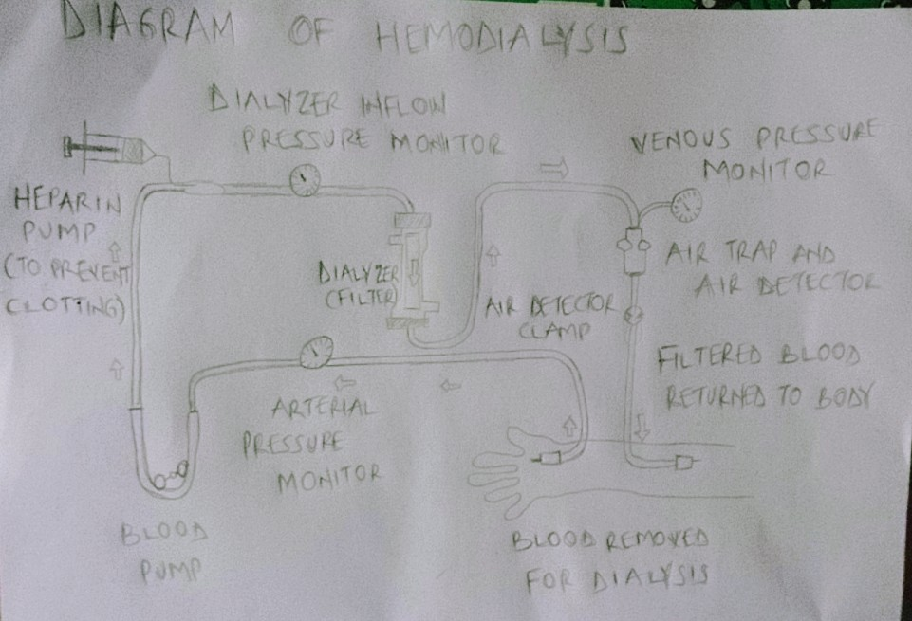

PERITONEAL DIALYSIS
Peritoneal dialysis involves surgery to implant a peritoneal dialysis (PD) catheter into the abdomen. The catheter helps filter the blood through the peritoneum, a membrane in the abdomen. During treatment, a special fluid called dialysate (Dialysis solution) flows into the peritoneum. The dialysate absorbs waste. Once the dialysate draws waste out of the bloodstream, it’s drained from the abdomen. This process takes a few hours and needs to be repeated four to six times per day. However, the exchange of fluids can be performed while the patient is sleeping or awake. There are numerous different types of peritoneal dialysis. The main ones:
- CONTINUOUS AMBULATORY PERITONEAL DIALYSIS (CAPD): In CAPD, the abdomen is filled and drained multiple times each day. This method does not require a machine and must be performed while awake.
- CONTINUOUS CYCLING PERITONEAL DIALYSIS (CCPD): CCPD uses a machine to cycle the fluid in and out of the abdomen. It’s usually done at night when the individual is asleep.
- INTERMITTENT PERITONEAL DIALYSIS (IPD): this treatment is usually performed in the hospital, though it may be performed at home. It uses the same machine as CCPD, but the process takes longer.
Peritoneal dialysis is associated with an increased risk for infections in or around the abdominal cavity. E.g, after catheter implantation, a person can experience Peritonitis.
Peritonitis is an infection of the membrane lining the abdominal wall.

The last type of dialysis which is not often mentioned is
CONTINUOUS RENAL REPLACEMENT THERAPY (CRRT): This therapy is used primarily in the intensive care unit for people with acute kidney failure. It is also known as hemofiltration. A machine passes the blood through tubing. A filter then removes waste products and water. The blood is returned to the body, along with replacement fluid. The blood is returned to the body, along with replacement fluid. This procedure is performed 12 to 24 hours a day, generally every day.

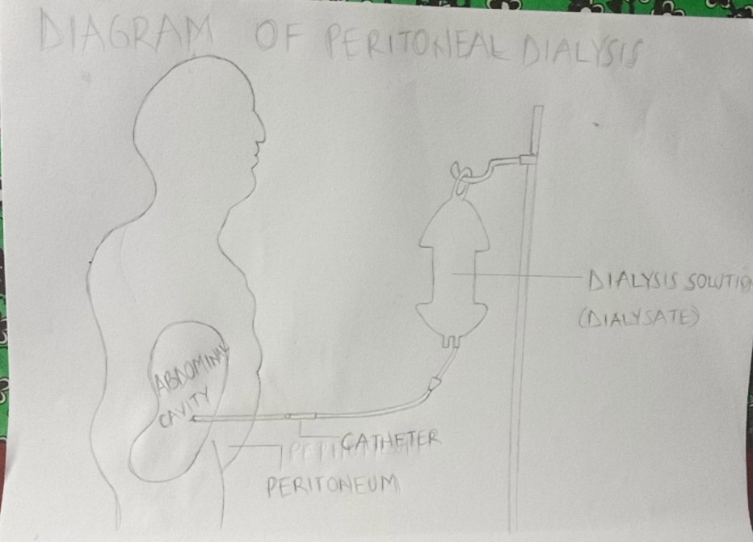S

