NAME: ADEBARA FAITH INUMIDUN
MATRIC NO.: 17/SCI05/001
COLLEGE: MEDICAL AND HEALTH SCIENCES
DEPARTMENT: MEDICINE AND SURGERY
LEVEL: 300

ASSIGNMENT
Course title: renal physiology body fluid and temperature regulation
Course code: PHS 303
Question assignment
- Discuss the pathophysiological process involved in renal failure
- With the aid of suitable diagrams discuss the types of dialysis you know

QUESTION ONE
Discuss the pathophysiological process involved in renal failure

PATHOPHYSIOLOGICAL PROCESS INVOLVED IN RENAL FAILURE
Pathophysiology is the physiological processes associated with disease or injury
Renal failure refers to failure of excretory functions of kidney. It is a medical condition in which the kidneys are functioning at less than 15% of normal. It is usually, characterized by decrease in glomerular filtration rate (GFR). So GFR is considered as the best index of renal failure. However, decrease in GFR is not affected much during the initial stages of renal failure. If 50% of the nephrons are affected, GFR decreases only by 20% to 30%. It is because of the compensatory mechanism by the unaffected nephrons.
The renal failure may be either acute or chronic. Acute renal failure develops rapidly and may resolve while chronic kidney failure develops slowly. Diseases of the kidneys are among the most important causes of death and disability in many countries throughout the world. For example, in 2009, more than 26 million adults in the United States were estimated to have chronic kidney disease, and many more millions of people have acute renal failure or less severe forms of kidney dysfunction.
Symptoms of renal failure may include leg swelling, feeling tired, vomiting, loss of appetite, and confusion.

- ACUTE RENAL FAILURE (ARF)
Acute renal failure(ARF) now known as acute kidney injury (AKI), is the abrupt or sudden stoppage of renal functions. It is a rapidly progressive loss of renal function. It usually occurs when the blood supply to the kidneys is suddenly interrupted or when the kidneys become overloaded with toxins.
ARF is generally characterized by oliguria(decreased urine production, quantified as less than 400 mL per day in adults, less than 0.5 mL/kg/h in children or less than 1 mL/kg/h in infants) and fluid and electrolyte imbalance.
ARF is often reversible within few days to few weeks. It may result in sudden life-threatening reactions in the body with the need for emergency treatment
DIAGNOSIS OF ACUTE FAILURE
In acute renal failure,
- The glomerular filtration rate is reduced,
- There is sudden retention of endogenous and exogenous metabolites (urea, potassium, creatinine, phosphate, administered drugs),
- The urine volume is usually very low.
CAUSES OF ACUTE RENAL FAILURE
The causes of acute renal failure can be divided into three main categories:
- Prerenal acute renal failure
- Intrarenal or intrinsic acute renal failure
- Postrenal acute renal failure
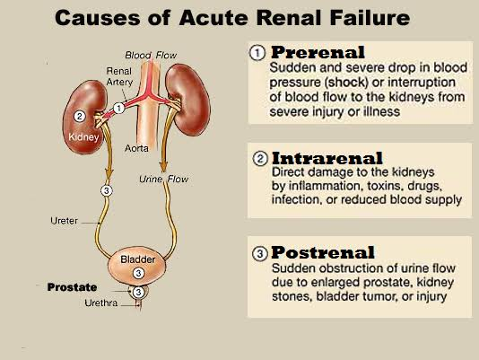
- PRERENAL ACUTE RENAL FAILURE
It is a type of acute renal failure resulting from decreased blood supply to the kidneys; this condition is often referred to as prerenal acute renal failure to reflect the fact that the abnormality occurs as a result of an abnormality originating outside the kidneys. For example, prerenal acute renal failure can be a consequence of heart failure with reduced cardiac output and low blood pressure or conditions associated with diminished blood volume and low blood pressure, such as severe hemorrhage.
Causes of prerenal acute renal failure
Acute reduction of renal blood flow is a common cause of acute renal failure in hospitalized patients, especially those who have suffered severe injuries. Causes of reduced renal blood flow and consequently, prerenal acute renal failure includes the following:
- Intravascular Volume Depletion Hemorrhage (trauma, surgery, postpartum, gastrointestinal)
- Diarrhea or vomiting
- Burns
- Dehydration
- Cardiac Failure
- Cardiogenic shock
- Myocardial infarction
- Valvular damage
- Tumor
- Peripheral Vasodilation and Resultant Hypotension
- Anaphylactic shock
- Anesthesia
- Sepsis, severe infections
- Primary renal hemodynamic abnormalities
- Renal artery stenosis, embolism, or thrombosis of renal artery or vein
- Eclampsia
- Malignant hypertension
- Complications from surgeries in which the kidneys are deprived of normal blood flow for extended periods of time e.g. in Heart-bypass surgery.
- Vasculitis

PATHOPHYSIOLOGY OF PRERENAL ACUTE RENAL FAILURE
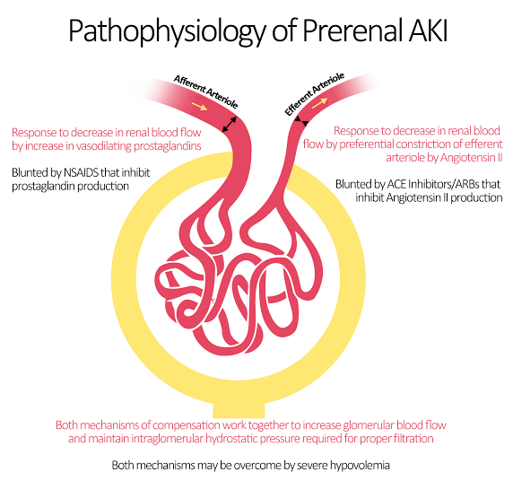
The kidneys normally receive an abundant blood supply of about 1100 ml/min, or about 20 to 25 percent of the cardiac output. The main purpose of this high blood flow to the kidneys is to provide enough plasma for the high rates of glomerular filtration needed for effective regulation of body fluid volumes and solute concentrations. Therefore, decreased renal blood flow is usually accompanied by decreased glomerular filtration rate (GFR) and decreased urine output of water and solutes. Consequently, conditions that acutely diminish blood flow to the kidneys usually cause oliguria, which refers to diminished urine output below the level of intake of water and solutes. This causes accumulation of water and solutes in the body fluids.
If renal blood flow is markedly reduced, total cessation of urine output can occur, a condition referred to as anuria, and also result in azotemia (the accumulation in the blood of nitrogen-bearing waste products (such as urea) that are usually excreted in the urine).
As long as renal blood flow does not fall below about 20 to 25 percent of normal, acute renal failure can usually be reversed if the cause of the ischemia is corrected before damage to the renal cells has occurred. Unlike some tissues, the kidney can endure a relatively large reduction in blood flow before actual damage to the renal cells occurs. The reason for this is that as renal blood flow is reduced, the glomerular filtration rate (GFR) and the amount of sodium chloride filtered by the glomeruli (as well as the filtration rate of water and other electrolytes) are reduced. This decreases the amount of sodium chloride that must be reabsorbed by the tubules, which use most of the energy and oxygen consumed by the normal kidney. Therefore, as renal blood flow and GFR fall, the requirement for renal oxygen consumption is also reduced. As the GFR approaches zero, oxygen consumption of the kidney approaches the rate that is required to keep the renal tubular cells alive even when they are not reabsorbing sodium.
When blood flow is reduced below this basal requirement, which is usually less than 20 to 25 percent of the normal renal blood flow, the renal cells start to become hypoxic, and further decreases in renal blood flow, if prolonged, will cause damage or even death of the renal cells, especially the tubular epithelial cells.
If the cause of prerenal acute renal failure is not corrected and ischemia of the kidney persists longer than a few hours, this type of renal failure can evolve into intrarenal acute renal failure.
Hence the major features of prerenal acute failure include:
- Decreased GFR
- Accumulation of water and tubular reabsorption of water and sodium
- Edema due to increased volume of extracellular field caused by retention of sodium and water
- Accumulation of solutes in the body fluids e.g. azotemia
- Oliguria (decreased urinary output below the level of intake of water and solutes)
- Anuria (cessation of urine formation) in severe cases
- Electrolyte imbalance
- Metabolic acidosis due to the retention of metabolic end products
- Hypoxia
- Damage or death of the renal cells, if prolonged

- INTRARENAL OR INTRINSIC ACUTE RENAL FAILURE
It is the type of acute renal failure, resulting from abnormalities within the kidney itself, including those that affect the blood vessels, glomeruli, or tubules.
Abnormalities that originate within the kidney and that abruptly diminish urine output fall into the general category of intrarenal acute renal failure.
This category of acute renal failure can be further divided into
- Conditions that injure the glomerular capillaries or other small renal vessels,
- Conditions that damage the renal tubular epithelium, and
- Conditions that cause damage to the renal interstitium.
This type of classification refers to the primary site of injury, but because the renal vasculature and tubular system are functionally interdependent, damage to the renal blood vessels can lead to tubular damage, and primary tubular damage can lead to damage of the renal blood vessels.
Causes of intrarenal acute renal failure
Some Causes of Intrarenal Acute Renal Failure include:
- Small Vessel and/or Glomerular Injury
- Vasculitis (polyarteritis nodosa)
- Cholesterol emboli
- Malignant hypertension
- Acute glomerulonephritis
- Tubular Epithelial Injury (Tubular Necrosis)
- Acute tubular necrosis due to severe ischemia
- Acute tubular necrosis due to toxins (heavy metals, ethylene glycol, insecticides, poison mushrooms, carbon tetrachloride)
- Renal Interstitial Injury
- Acute pyelonephritis (an ascending urinary tract infection of the renal pelvis)
- Acute allergic interstitial nephritis
- Others
- Poorly treated prerenal failure
- Obstetric complications
- Myopathy
- Transfusion reaction
- Sickle cell disease
- Systemic lupus erythematosus (a systemic autoimmune disease where the immune system attacks the body’s cells and tissues and causes inflammation and tissue damage).

PATHOPHYSIOLOGY OF INTRARENAL ACUTE RENAL FAILURE
- Acute Renal Failure Caused by Glomerulonephritis
Acute glomerulonephritis is a type of intrarenal acute renal failure usually caused by an abnormal immune reaction that damages the glomeruli. In about 95 percent of the patients with this disease, damage to the glomeruli occurs 1 to 3 weeks after an infection elsewhere in the body, usually caused by certain types of group A beta streptococci. The infection may have been a streptococcal sore throat, streptococcal tonsillitis, or even streptococcal infection of the skin. It is not the infection itself that damages the kidneys. Instead, over a few weeks, as antibodies develop against the streptococcal antigen, the antibodies and antigen react with each other to form an insoluble immune complex that becomes entrapped in the glomeruli, especially in the basement membrane portion of the glomeruli.
Once the immune complex has deposited in the glomeruli, many of the cells of the glomeruli begin to proliferate, but mainly the mesangial cells that lie between the endothelium and the epithelium. In addition, large numbers of white blood cells become entrapped in the glomeruli. Many of the glomeruli become blocked by this inflammatory reaction, and those that are not blocked usually become excessively permeable, allowing both protein and red blood cells to leak from the blood of the glomerular capillaries into the glomerular filtrate. In severe cases, either total or almost complete renal shutdown occurs.
The acute inflammation of the glomeruli usually subsides in about 2 weeks and, in most patients, the kidneys return to almost normal function within the next few weeks to few months. Sometimes, however, many of the glomeruli are destroyed beyond repair, and in a small percentage of patients, progressive renal deterioration continues indefinitely, leading to chronic renal failure.
- Tubular Necrosis as a Cause of Acute Renal Failure
Another cause of intrarenal acute renal failure is tubular necrosis, which means destruction of epithelial cells in the tubules.
Some common causes of tubular necrosis are:
- severe ischemia and inadequate supply of oxygen and nutrients to the tubular epithelial cells and
- poisons, toxins, or medications that destroy the tubular epithelial cells.

- Acute Tubular Necrosis Caused by Severe Renal Ischemia
Severe ischemia of the kidney can result from circulatory shock or any other disturbance that severely impairs the blood supply to the kidney. If the ischemia is severe enough to seriously impair the delivery of nutrients and oxygen to the renal tubular epithelial cells, and if the insult is prolonged, damage or eventual destruction of the epithelial cells can occur. When this happens, tubular cells "slough off" and plug many of the nephrons, so that there is no urine output from the blocked nephrons; the affected nephrons often fail to excrete urine even when renal blood flow is restored to normal, as long as the tubules remain plugged.
The most common causes of ischemic damage to the tubular epithelium are the prerenal causes of acute renal failure associated with circulatory shock.
- Acute Tubular Necrosis Caused by Toxins or Medications
Examples of renal poisons and medications that can damage the tubular epithelium and cause acute renal failure are carbon tetrachloride, heavy metals (such as mercury and lead), ethylene glycol (which is a major component in antifreeze), various insecticides, some medications (such as tetracyclines) used as antibiotics, and cis-platinum, which is used in treating certain cancers.
Each of these substances has a specific toxic action on the renal tubular epithelial cells, causing death of many of them. As a result, the epithelial cells slough away from the basement membrane and plug the tubules. In some instances, the basement membrane also is destroyed. If the basement membrane remains intact, new tubular epithelial cells can grow along the surface of the membrane, so the tubule may repair itself within 10 to 20 days.
Hence the major features of intrarenal acute failure include:
- Renal damage (intrinsic parenchymal injury). Damage or eventual destruction of the epithelial cells can occur.
- Anuria. When destruction of epithelial cells occurs, tubular cells "slough off" and plug many of the nephrons, so that there is no urine output from the blocked nephrons; the affected nephrons often fail to excrete urine even when renal blood flow is restored to normal, as long as the tubules remain plugged.
- Excess nitrogen in the blood (intrinsic renal azotemia)
- Proteinuria (appearance of proteins in urine) including albuminuria (excretion of albumin in urine). Protein leaks from the blood of the glomerular capillaries into the glomerular filtrate
- Hematuria (presence of blood in urine). Red blood cells leak from the blood of the glomerular capillaries into the glomerular filtrate. Unblocked glomeruli usually become excessively permeable, allowing both protein and red blood cells to leak from the blood of the glomerular capillaries into the glomerular filtrate.
- Hypotension

- POSTRENAL ACUTE RENAL FAILURE
Postrenal acute renal failure results from obstruction of the urinary collecting system anywhere from the calyces to the outflow from the bladder

Causes of postrenal acute failure
- Bilateral obstruction of the ureters or renal pelvises caused by large stones or blood clots (as a result of precipitation of calcium, urate, or cystine)
- Bladder obstruction caused by anticholinergic drugs, autonomic nerve dysfunction, infection, tumors
- Ureteral obstruction caused by blood clots, calculi, edema or inflammation, necrotic renal papillae, retroperitoneal fibrosis or hemorrhage, surgery, tumor or uric acid crystals
- Obstruction of the urethra caused by prostatic hyperplasia, tumor or strictures

PATHOPHYSIOLOGY OF POSTRENAL ACUTE RENAL FAILURE
Postrenal acute renal failure can block or partially block urine flow and therefore lead to acute renal failure even when the kidneys' blood supply and other functions are initially normal.
If the urine output of only one kidney is diminished, no major change in body fluid composition will occur because the contralateral kidney can increase its urine output sufficiently to maintain relatively normal levels of extracellular electrolytes and solutes, as well as normal extracellular fluid volume.
With this type of renal failure, normal kidney function can be restored if the basic cause of the problem is corrected within a few hours. But chronic obstruction of the urinary tract, lasting for several days or weeks, can lead to irreversible kidney damage.

Summary on the Physiologic Effects of Acute Renal Failure
A major physiologic effect of acute renal failure is retention in the blood and extracellular fluid of water, waste products of metabolism, and electrolytes. This can lead to water and salt overload, which, in turn, can lead to edema and hypertension.
Excessive retention of potassium, however, is often a more serious threat to patients with acute renal failure because increases in plasma potassium concentration (hyperkalemia) above 8 mEq/L (only twice normal) can be fatal. Because the kidneys are also unable to excrete sufficient hydrogen ions, patients with acute renal failure develop metabolic acidosis, which in itself can be lethal or can aggravate the hyperkalemia.
In the most severe cases of acute renal failure, complete anuria occurs. The patient will die in 8 to 14 days unless kidney function is restored or unless an artificial kidney is used to rid the body of the excessive retained water, electrolytes, and waste products of metabolism. Other effects of diminished urine output, as well as treatment with an artificial kidney, are discussed in the next section in relation to chronic renal failure.

TREATMENT OF ACUTE RENAL FAILURE
The treatment of acute renal failure depends on the underlying cause
As long as renal blood flow does not fall below about 20 to 25 percent of normal, acute renal failure can usually be reversed if the cause of the ischemia is corrected before damage to the renal cells has occurred. Unlike some tissues, the kidney can endure a relatively large reduction in blood flow before actual damage to the renal cells occurs.
Unlike chronic kidney disease, however, the kidneys can often recover from acute kidney injury, allowing the person with acute renal failure to resume a normal life.
People suffering from acute kidney injury require supportive treatment until their kidneys recover function, and they often remain at increased risk of developing future kidney failure.
Some adopted treatment for acute renal failure includes:
- Correction of the basic or underlying cause of the problem
- High-calorie diet that’s low in protein, sodium, and potassium to meet metabolic needs
- Intravenous therapy to maintain and correct fluid and electrolyte balance
- Fluid restriction to minimize edema
- Diuretic therapy to treat oliguric phase
- Sodium polystyrene sulfonate by mouth or enema to reverse hyperkalemia with mild hyperkalemic symptoms (malaise, loss of appetite, muscle weakness)
- Hypertonic glucose, insulin, and sodium bicarbonate intravenously-for more severe hyperkalemic symptoms (numbness and tingling and electrocardiogram (ECG) changes
- Minimizing exposure to nephrotoxins, etc.

- CHRONIC RENAL FAILURE(CRF)
Chronic renal failure, now called chronic kidney disease, is the progressive, long standing and irreversible impairment or loss of renal functions over time; based on a gradual decline in the GFR and creatinine clearance. It results from progressive and irreversible loss of large numbers of functioning nephrons over time.
Serious clinical symptoms often do not occur until the number of functional nephrons falls to at least 70 to 75 percent below normal. In fact, relatively normal blood concentrations of most electrolytes and normal body fluid volumes can still be maintained until the number of functioning nephrons decreases below 20 to 25 percent of normal. This is because when some of the nephrons lose their function, the unaffected nephrons can compensate it. However, when more and more nephrons start losing the function over the months or years, the compensatory mechanism fails and chronic renal failure develops.
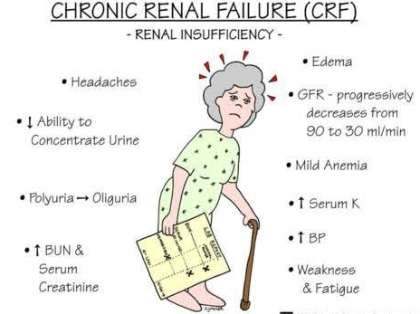
DIAGNOSIS OF CHRONIC RENAL FAILURE
The diagnosis of CKD requires the following:
- Decline of kidney function for 3 months or more, and
- Evidence of kidney damage (e.g. albuminuria or abnormal biopsy) or
GFR <60 mL/min/1.73 m²

CAUSES OF CHRONIC RENAL FAILURE
In general, chronic renal failure, like acute renal failure, can occur because of disorders of the blood vessels, glomeruli, tubules, renal interstitium, and lower urinary tract. Despite the wide variety of diseases that can lead to chronic renal failure, the end result is essentially the same-a decrease in the number of functional nephrons
Some of the most important causes of chronic renal failure include:
- Metabolic Disorders
- Diabetes mellitus
- Obesity
- Amyloidosis (any of a group of disorders in which the fibrous protein amyloid is deposited in an organ of the body)
- Hypertension
- Renal Vascular Disorders
- Atherosclerosis
- Fibromuscular hyperplasia of one or more of the large arteries
- Nephrosclerosis-hypertension
- Immunologic Disorders
- Glomerulonephritis
- Polyarteritis nodosa
- Lupus erythematosus
- Infections
- Pyelonephritis
- Tuberculosis
- Primary Tubular Disorders
- Nephrotoxins (analgesics, heavy metals)
- Urinary Tract Obstruction
- Renal calculi (kidney stones)
- Hypertrophy of prostate
- Urethral constriction
- Congenital Disorders
- Polycystic disease
- Congenital absence of kidney tissue (renal hypoplasia)

Vicious Cycle of Chronic Renal Failure Leading to End-Stage Renal Disease
In many cases, an initial insult to the kidney leads to progressive deterioration of kidney function and further loss of nephrons to the point where the person must be placed on dialysis treatment or transplanted with a functional kidney to survive. This condition is referred to as end-stage renal disease (ESRD).
Each patient is classified into one of the following 5 stages of CRF because management and prognosis varies according to the progression of damage.
- Stage 1: Kidney damage with normal or increased GFR (>90 mL/min/1.73 m²)
- Stage 2: Mild reduction in GFR (60-89 mL/min/1.73 m²)
- Stage 3: Moderate reduction in GFR (30-59 mL/min/1.73 m²)
- Stage 4: Severe reduction in GFR (15-29 mL/min/1.73 m²)
- Stage 5: Kidney failure (GFR <15 mL/min/1.73 m² or dialysis)

Studies in laboratory animals have shown that surgical removal of large portions of the kidney initially causes adaptive changes in the remaining nephrons that lead to increased blood flow, increased GFR, and increased urine output in the surviving nephrons. The exact mechanisms responsible for these changes are not well understood but involve hypertrophy (growth of the various structures of the surviving nephrons), as well as functional changes that decrease vascular resistance and tubular reabsorption in the surviving nephrons. These adaptive changes permit a person to excrete normal amounts of water and solutes even when kidney mass is reduced to 20 to 25 percent of normal. Over a period of several years, however, these renal adaptive changes may lead to further injury of the remaining nephrons, particularly to the glomeruli of these nephrons.
The cause of this additional injury is not known, but some investigators believe that it may be related in part to increased pressure or stretch of the remaining glomeruli, which occurs as a result of functional vasodilation or increased blood pressure; the chronic increase in pressure and stretch of the small arterioles and glomeruli are believed to cause injury and sclerosis of these vessels (replacement of normal tissue with connective tissue).
These sclerotic lesions can eventually obliterate the glomerulus, leading to further reduction in kidney function, further adaptive changes in the remaining nephrons, and a slowly progressing vicious cycle that eventually terminates in ESRD.
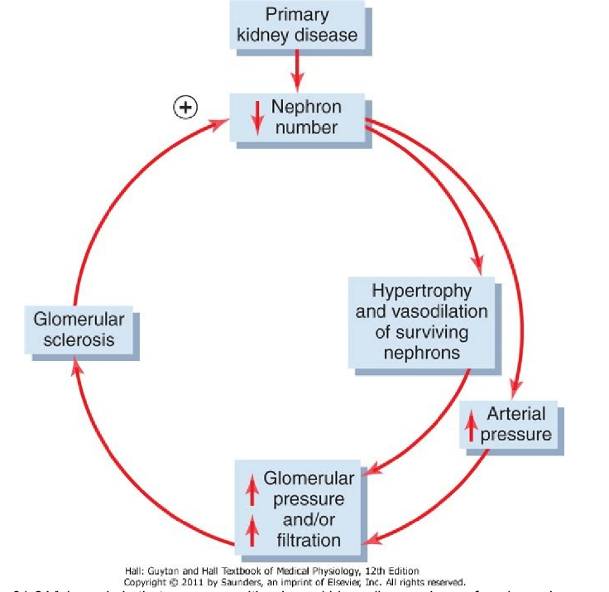
The only proven method of slowing down this progressive loss of kidney function is to lower arterial pressure and glomerular hydrostatic pressure, especially by using drugs such as angiotensin-converting enzyme inhibitors or angiotensin II receptor antagonists.
MOST COMMON CAUSES OF END-STAGE RENAL DISEASE (ESRD
Causes | Percentage of total ESRD patients
Diabetes mellitus | 30-45
Hypertension | 24-27
Glomerulonephritis | 8-17
Polycystic kidney disease | 2-4
Other/unknown | 18-20

In the early 1980s, glomerulonephritis in all its various forms was believed to be the most common initiating cause of ESRD. In recent years, diabetes mellitus and hypertension have become recognized as the leading causes of ESRD, together accounting for more than 70 percent of all chronic renal failure.
Excessive weight gain (obesity) appears to be the most important risk factor for the two main causes of ESRD-diabetes and hypertension; Type II diabetes, which is closely linked to obesity, accounts for more than 90 percent of all diabetes mellitus. Excess weight gain is also a major cause of essential hypertension, accounting for as much as 65 to 75 percent of the risk for developing hypertension in adults. In addition to causing renal injury through diabetes and hypertension, obesity may have additive or synergistic effects to worsen renal function in patients with preexisting kidney disease.

PATHOPHYSIOLOGY OF CHRONIC RENAL FAILURE
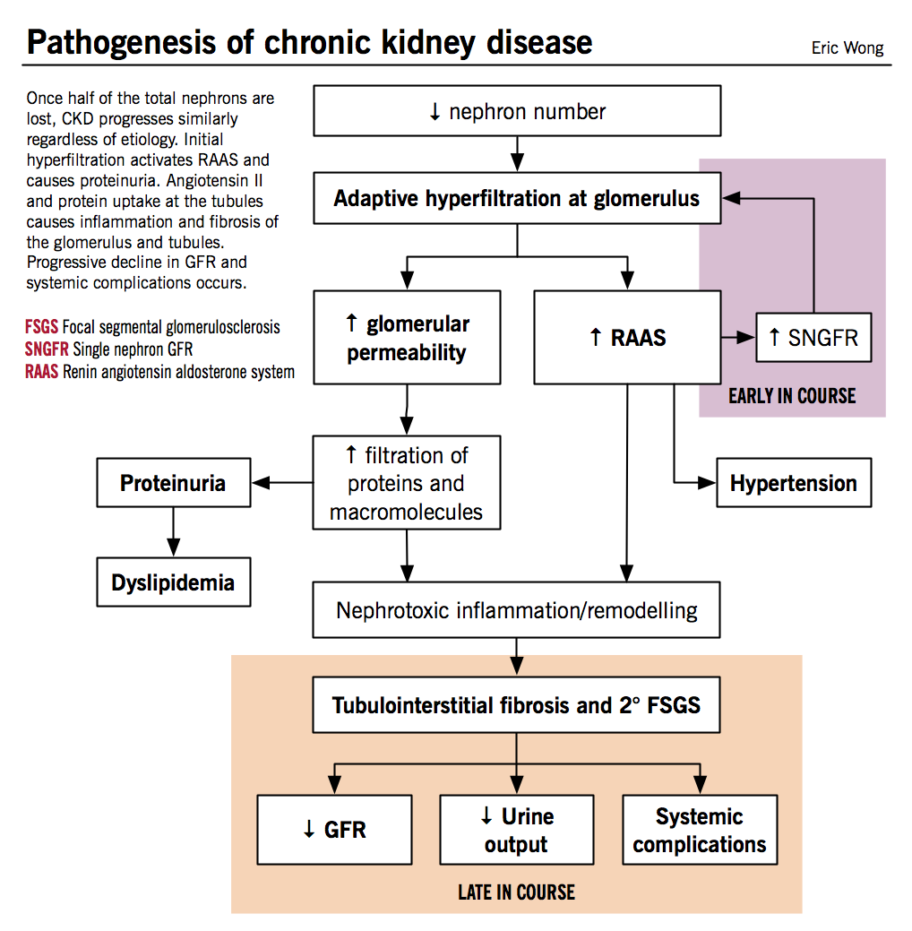
- Loss of Functional Nephrons Requires the Surviving Nephrons to Excrete More Water and Solutes
Decreasing the number of functional nephrons, which reduces the GFR, should also cause as one would expect major decreases in renal excretion of water and solutes. Yet, patients who have lost up to 75 to 80 percent of their nephrons are able to excrete normal amounts of water and electrolytes without serious accumulation of any of these in the body fluids. Further reduction in the number of nephrons, however, leads to electrolyte and fluid retention, and death usually ensues when the number of nephrons falls below 5 to 10 percent of normal.
- For waste products of metabolism such as urea, creatinine
In contrast to the electrolytes, many of the waste products of metabolism, such as urea and creatinine, accumulate almost in proportion to the number of nephrons that have been destroyed. The reason for this is that substances such as creatinine and urea depend largely on glomerular filtration for their excretion, and they are not reabsorbed as avidly as the electrolytes. Creatinine, for example, is not reabsorbed at all, and the excretion rate is approximately equal to the rate at which it is filtered.
Creatinine filtration rate = GFR * plasma creatinine concentration
= Creatinine excretion rate
Therefore, if GFR decreases, the creatinine excretion rate also transiently decreases, causing accumulation of creatinine in the body fluids and raising plasma concentration until the excretion rate of creatinine returns to normal-the same rate at which creatinine is produced in the body. Thus, under steady-state conditions the creatinine excretion rate equals the rate of creatinine production, despite reductions in GFR; however, this normal rate of creatinine excretion occurs at the expense of elevated plasma creatinine concentration.

- For phosphate, urate, and hydrogen ions
Some solutes, such as phosphate, urate, and hydrogen ions, are often maintained near the normal range until GFR falls below 20 to 30 percent of normal. Thereafter, the plasma concentrations of these substances rise, but not in proportion to the fall in GFR.
Maintenance of relatively constant plasma concentrations of these solutes as GFR declines is accomplished by excreting progressively larger fractions of the amounts of these solutes that are filtered at the glomerular capillaries; this occurs by decreasing the rate of tubular reabsorption or, in some instances, by increasing tubular secretion rates.
- For sodium and chloride ions
In a normal individual, more than 25,000 mmol of sodium ions are filtered daily with < 1% being excreted. In the case of sodium and chloride ions for chronic renal failure patients, their plasma concentrations are maintained virtually constant even with severe decreases in GFR. This is accomplished by greatly decreasing tubular reabsorption of these electrolytes. For example, with a 75 percent loss of functional nephrons, each surviving nephron must excrete four times as much sodium and four times as much volume as under normal conditions (as shown in the table below). Part of this adaptation occurs because of increased blood flow and increased GFR in each of the surviving nephrons, owing to hypertrophy of the blood vessels and glomeruli, as well as functional changes that cause the blood vessels to dilate. Even with large decreases in the total GFR, normal rates of renal excretion can still be maintained by decreasing the rate at which the tubules reabsorb water and solutes.
 | Normal | 75% loss of nephrons
Number of nephrons | 2,000,000 | 500,000
Total GFR (ml/min) | 125 | 40
Single nephron GFR (ml/min) | 62.5 | 80
Volume excreted for all nephrons (ml/min) | 1.5 | 1.5
Volume excreted per nephron (ml/min) | 0.75 | 3.0

- For potassium and magnesium
Adaptive processes increase potassium secretion in the distal nephron (collecting tubules) and also in the gut

- Isosthenuria-Inability of the Kidney to Concentrate or Dilute the Urine
One important effect of the rapid rate of tubular flow that occurs in the remaining nephrons of diseased kidneys is that the renal tubules lose their ability to fully concentrate or dilute the urine. In renal disease, the urine becomes less concentrated and urine volume is often increased, producing the symptoms of polyuria and nocturia (waking up at night to void). The ability to form a dilute urine is often retained, but in advanced renal disease, the osmolality of the urine becomes fixed at about that of plasma, indicating that the diluting and concentrating functions of the kidney have both been lost.
- The concentrating ability of the kidney is impaired mainly because (a) the rapid flow of tubular fluid through the collecting ducts prevents adequate water reabsorption, and (b) the rapid flow through both the loop of Henle and the collecting ducts prevents the countercurrent mechanism from operating effectively to concentrate the medullary interstitial fluid solutes.
Therefore, as progressively more nephrons are destroyed, the maximum concentrating ability of the kidney declines and urine osmolarity and specific gravity (a measure of the total solute concentration) approach the osmolarity and specific gravity of the glomerular filtrate, as shown in the diagram below.
- The diluting mechanism in the kidney is also impaired when the number of functioning nephrons decreases because the rapid flushing of fluid through the loops of Henle and the high load of solutes such as urea cause a relatively high solute concentration in the tubular fluid of this part of the nephron. As a consequence, the diluting capacity of the kidney is impaired and the minimal urine osmolality and specific gravity approach those of the glomerular filtrate.
Because the concentrating mechanism becomes impaired to a greater extent than does the diluting mechanism in chronic renal failure, an important clinical test of renal function is to determine how well the kidneys can concentrate urine when a person's water intake is restricted for 12 or more hours.

- Uremia
The effect of renal failure on the body fluids depends on
- water and food intake
- the degree of impairment of renal function.
Assuming that a person with complete renal failure continues to ingest the same amounts of water and food, the concentrations of different substances in the extracellular fluid are approximately those shown in diagram below
Important effects include
- generalized edema resulting from water and salt retention;
- acidosis resulting from failure of the kidneys to rid the body of normal acidic products;
- high concentration of the nonprotein nitrogen-especially urea, creatinine, and uric acid-resulting from failure of the body to excrete the metabolic end products of proteins;
- high concentrations of other substances excreted by the kidney, including phenols, sulfates, phosphates, potassium, and guanidine bases.
This total condition is called uremia because of the high concentration of urea in the body fluids. Uremia is the condition characterized by excess accumulation of end products of protein metabolism such as urea, nitrogen and creatinine in blood. There is also accumulation of some toxic substances like organic acids and phenols.
Uremia occurs because of the failure of kidney to excrete the metabolic end products and toxic substances.
The blood urea nitrogen (BUN) and creatinine levels are high, and the blood levels of these substances are used as an index of the severity of the uremia. It probably is not the accumulation of urea and creatinine per se but rather the accumulation of other toxic substances—possibly organic acids or phenols—that produces the symptoms of uremia
Common features of uremia
The symptoms of uremia include
- lethargy
- anorexia (loss of appetite)
- nausea and vomiting
- mental deterioration and confusion
- drowsiness
- muscle twitching, tetany and convulsions
- coma.
The toxic substances that cause the symptoms of uremia can be removed by dialyzing the blood of uremic patients against a bath of suitable composition in an artificial kidney (hemodialysis). Patients can be kept alive and in reasonable health for many months on dialysis, even when they are completely anuric or have had both kidneys removed. However, the treatment of choice today is certainly transplantation of a kidney from a suitable donor.

- Acidosis in Renal Failure
Acidosis is common in chronic renal disease because of failure to excrete the acid products of digestion and metabolism
In a normal individual, the body normally produces about 50 to 80 millimoles more metabolic acid than metabolic alkali every day. Therefore, when the kidneys fail to function, acid accumulates in the body fluids. The buffers of the body fluids normally can buffer 500 to 1000 millimoles of acid without lethal increases in extracellular fluid H+ concentration, and the phosphate compounds in the bones can buffer an additional few thousand millimoles of H+. However, when this buffering power is used up, the blood pH falls drastically and the patient will become comatose and die if the pH falls below about 6.8.
In the rare syndrome of renal tubular acidosis, there is specific impairment of the ability to make the urine acidic, and other renal functions are usually normal. However, in most cases of chronic renal disease the urine is maximally acidified, and acidosis develops because the total amount of H+ that can be secreted is reduced because of impaired renal tubular production of NH4+.

- Water Retention and Development of Edema in Renal Failure
Failure of kidney to excrete sodium and electrolytes causes increase in extracellular fluid volume resulting in development of edema.
If water intake is restricted immediately after acute renal failure begins, the total body fluid content may become only slightly increased. If fluid intake is not limited and the patient drinks in response to the normal thirst mechanisms, the body fluids begin to increase immediately and rapidly.
With chronic partial kidney failure, accumulation of fluid may not be severe, as long as salt and fluid intake are not excessive, until kidney function falls to 25 percent of normal or lower. The reason for this is that the surviving nephrons excrete larger amounts of salt and water. Even the small fluid retention that does occur, along with increased secretion of renin and angiotensin II that usually occurs in ischemic kidney disease, often causes severe hypertension in chronic renal failure. Almost all patients with kidney function so reduced as to require dialysis to preserve life develop hypertension.
In many of these patients, severe reduction of salt intake or removal of extracellular fluid by dialysis can control the hypertension.
The remaining patients continue to have hypertension even after excess sodium has been removed by dialysis. In this group, removal of the ischemic kidneys usually corrects the hypertension (as long as fluid retention is prevented by dialysis) because it removes the source of excessive renin secretion and subsequent increased angiotensin II formation.

- Anemia in Chronic Renal Failure Caused by Decreased Erythropoietin Secretion.
Patients with severe chronic renal failure almost always develop anemia. The most important cause of this is decreased renal secretion of erythropoietin, which stimulates the bone marrow to produce red blood cells. If the kidneys are seriously damaged, they are unable to form adequate quantities of erythropoietin, which leads to diminished red blood cell production and consequent anemia. The availability since 1989 of recombinant erythropoietin, however, has provided a means of treating anemia in patients with chronic renal failure.

- Osteomalacia and secondary hyperparathyroidism in Chronic Renal Failure
Osteomalacia is a condition in which the bones are partially absorbed and, therefore, become greatly weakened.
- An important cause of this condition is due to the following: Vitamin D must be converted by a two-stage process, first in the liver and then in the kidneys, into 1,25-dihydroxycholecalciferol before it is able to promote calcium absorption from the intestine.
Therefore, serious damage to the kidney greatly reduces the blood concentration of active vitamin D, which in turn decreases intestinal absorption of calcium and the availability of calcium to the bones.
- Another important cause of demineralization of the skeleton in chronic renal failure is the rise in serum phosphate concentration that occurs as a result of decreased GFR.
This rise in serum phosphate increases binding of phosphate with calcium in the plasma, thus decreasing the plasma serum ionized calcium concentration, which, in turn, stimulates parathyroid hormone secretion. This secondary hyperparathyroidism then stimulates the release of calcium from bones, causing further demineralization of the bones. Secondary hyperparathyroidism can also develop due to the deficiency of calcitriol (1,25­dihydroxy-cholecalciferol).

- Hypertension
Hypertension can exacerbate injury to the glomeruli and blood vessels of the kidneys and is a major cause of end-stage renal disease. Abnormalities of kidney function can also cause hypertension. Thus, the relation between hypertension and kidney disease can, in some instances, propagate a vicious cycle: primary kidney damage leads to increased blood pressure, which causes further damage to the kidneys, further increases in blood pressure, and so forth, until end-stage renal disease develops.
Not all types of kidney disease cause hypertension because damage to certain portions of the kidney causes uremia without hypertension. Nevertheless, some types of renal damage are particularly prone to cause hypertension. A classification of kidney disease relative to hypertensive or non-hypertensive effects is the following.

Renal Lesions That Reduce the Ability of the Kidneys to Excrete Sodium and Water Promote Hypertension
Renal lesions that decrease the ability of the kidneys to excrete sodium and water almost invariably cause hypertension. Therefore, lesions that either decrease GFR or increase tubular reabsorption usually lead to hypertension of varying degrees.
Some specific types of renal abnormalities that can cause hypertension are as follows:
- Increased renal vascular resistance, which reduces renal blood flow and GFR. An example is hypertension caused by renal artery stenosis.
- Decreased glomerular capillary filtration coefficient, which reduces GFR. An example of this is chronic glomerulonephritis, which causes inflammation and thickening of the glomerular capillary membranes, thereby reducing the glomerular capillary filtration coefficient.
- Excessive tubular sodium reabsorption. An example is hypertension caused by excessive aldosterone secretion, which increases sodium reabsorption mainly in the cortical collecting tubules.

- Once hypertension has developed, renal excretion of sodium and water returns to normal because the high arterial pressure causes pressure natriuresis and pressure diuresis, so intake and output of sodium and water become balanced once again. Even when there are large increases in renal vascular resistance or decreases in the glomerular capillary coefficient, the GFR may still return to nearly normal levels after the arterial blood pressure rises.
- Likewise, when tubular reabsorption is increased, as occurs with excessive aldosterone secretion, the urinary excretion rate is initially reduced but then returns to normal as arterial pressure rises.
Thus, after hypertension develops, there may be no obvious sign of impaired excretion of sodium and water other than the hypertension. Normal excretion of sodium and water at an elevated arterial pressure means that pressure natriuresis and pressure diuresis have been reset to a higher arterial pressure.
Hypertension Caused by Patchy Renal Damage and Increased Renal Secretion of Renin
- If one part of the kidney is ischemic and the remainder is not ischemic, such as occurs when one renal artery is severely constricted, the ischemic renal tissue secretes large quantities of renin. This secretion leads to increased formation of angiotensin II, which can cause hypertension.
The most likely sequence of events in causing this hypertension is
- the ischemic kidney tissue itself excretes less than normal amounts of water and salt;
- the renin secreted by the ischemic kidney, as well as the subsequent increased angiotensin II formation, affects the nonischemic kidney tissue, causing it also to retain salt and water; and
- excess salt and water cause hypertension in the usual manner.

- A similar type of hypertension can result when patchy areas of one or both kidneys become ischemic as a result of arteriosclerosis or vascular injury in specific portions of the kidneys. When this occurs, the ischemic nephrons excrete less salt and water but secrete greater amounts of renin, which causes increased angiotensin II formation. The high levels of angiotensin II then cause the surrounding otherwise normal nephrons to retain sodium and water. As a result, hypertension develops, which restores the overall excretion of sodium and water by the kidney, so balance between intake and output of salt and water is maintained, but at the expense of high blood pressure.

Kidney Diseases That Cause Loss of Entire Nephrons Lead to Renal Failure but May Not Cause Hypertension
Loss of large numbers of whole nephrons, such as occurs with the loss of one kidney and part of another kidney, almost always leads to renal failure if the amount of kidney tissue lost is great enough.
- If the remaining nephrons are normal and the salt intake is not excessive, this condition might not cause clinically significant hypertension because even a slight rise in blood pressure will raise the GFR and decrease tubular sodium reabsorption sufficiently to promote enough water and salt excretion in the urine, even with the few nephrons that remain intact.
- However, a patient with this type of abnormality may become severely hypertensive if additional stresses are imposed, such as eating a large amount of salt. In this case, the kidneys simply cannot clear adequate quantities of salt at a normal blood pressure with the small number of functioning nephrons that remain. Increased blood pressure restores excretion of salt and water to match intake of salt and water under steady-state conditions.
Effective treatment of hypertension requires that the kidneys' capability to excrete salt and water is increased, either by increasing GFR or by decreasing tubular reabsorption, so that balance between intake and renal excretion of salt and water excretion can be maintained at lower blood pressures. This can be achieved by drugs that block the effects of nervous and hormonal signals that cause the kidneys to retain salt and water (e.g., with β-adrenergic blockers, angiotensin receptor antagonists, or angiotensin-converting enzyme inhibitors) or with diuretic drugs that directly inhibit renal tubular reabsorption of salt and water.

TREATMENT OF CHRONIC KIDNEY FAILURE
The treatment of chronic kidney failure may include
- Renal replacement therapy:
hemodialysis, peritoneal dialysis, or kidney transplant

- Diet:
In non-diabetics and people with type 1 diabetes, a low protein diet is found to have a preventive effect on progression of chronic kidney disease. However, this effect does not apply to people with type 2 diabetes.
A whole food, plant-based diet may help some people with kidney disease. A high protein diet from either animal or plant sources appears to have negative effects on kidney function at least in the short term.

- Slowing progression:
People who received earlier referrals to a nephrology specialist, meaning a longer time before they had to start dialysis, had a shorter initial hospitalization and reduced risk of death after the start of dialysis.
Other methods of reducing disease progression include minimizing exposure to nephrotoxins such as NSAIDs and intravenous contrast. These agents can potentially induce an acute kidney injury (AKI) on the underlying kidney disease and therefore exacerbate the baseline CKD.

- Tight blood pressure control:
Angiotensin-converting enzyme inhibitors (ACEI) and angiotensin II receptor blockers (ARBs) block the effects of angiotensin II on
- sodium and fluid retention,
- vasoconstriction,
- stimulating ADH release,
- stimulating aldosterone release, and
- inducing a sympathetic response.

- Angiotensin-converting inhibitors (ACEI) and angiotensin II receptor blockers (ARBs) also slow down progression of proteinuria in patients with diabetic chronic renal failure.

QUESTION TWO
With the aid of suitable diagrams discuss the types of dialysis you know

DIALYSIS
Severe loss of kidney function, either acutely or chronically, is a threat to life and requires removal of toxic waste products and restoration of body fluid volume and composition toward normal. This can be accomplished by kidney transplantation or by dialysis with an artificial kidney. More than 500,000 patients in the United States are currently receiving some form of end stage renal disease (ESRD) therapy.
Definition
In medicine, dialysis (from Greek διάλυσις, Dialysis, "dissolution"; from διά, dia, "through", and λύσις, lysis, "loosening or splitting") is the process of removing excess water, solutes, waste materials and toxins from the blood in people whose kidneys can no longer perform these functions naturally and to restore normal volume and composition of body fluid in severe renal failure.
The term dialysis refers to diffusion of solutes from an area of higher concentration to the area of lower concentration, through a semipermeable membrane. This forms the principle of artificial kidney
More than 350,000 people in the United States with irreversible renal failure or total kidney removal are being maintained chronically by dialysis with artificial kidneys. Dialysis is also used in certain types of acute renal failure to tide the patient over until the kidneys resume their function, in those awaiting kidney transplant and as a permanent measure in those for whom a transplant is not indicated or not possible. If the loss of kidney function is irreversible, it is necessary to perform dialysis chronically to maintain life.
Artificial kidney is the machine that is used to carry out dialysis during renal failure
The kidneys have an important role in maintaining health. When the person is healthy, the kidneys maintain the body's internal equilibrium of water and minerals (sodium, potassium, chloride, calcium, phosphorus, magnesium, sulphate). The acidic metabolism end-products that the body cannot get rid of via respiration are also excreted through the kidneys. The kidneys also function as a part of the endocrine system, producing renin, calcitriol and erythropoietin. Because dialysis cannot maintain completely normal body fluid composition and cannot replace all the multiple functions performed by the kidneys, the health of patients maintained on artificial kidneys usually remains significantly impaired.

TYPES OF DIALYSIS
There are 3 primary and 2 secondary types of dialysis:
Primary
- Hemodialysis
- Peritoneal dialysis
- hemofiltration
Secondary
- hemodiafiltration
- intestinal dialysis

- HEMODIALYSIS
Hemodialysis is a treatment used to filter wastes and water from your blood, as your kidneys did when they were healthy. It helps to control blood pressure and balance important minerals, such as potassium, sodium and calcium, in the blood.
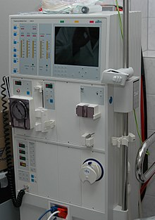A HEMODIALYSIS MACHINE

In hemodialysis, Patient’s arterial blood is passed continuously or intermittently through the artificial kidney and then back to the body through the vein. Heparin is used as an anticoagulant while passing the blood through the machine.
Inside the artificial kidney, the blood passes through a dialyzer called hemofilter. The dialyzer is an external filter that contains minute channels interposed between two cellophane membranes. The cellophane membranes are porous in nature. The outer surface of these membranes is bathed in the dialyzing fluid called dialysate. The used dialysate in the artificial kidney is constantly replaced by fresh dialysate.
The concentration of various substances in the dialysate is adjusted in accordance with the needs of the patient’s body. The fluid does not contain urea, urate, sulfate, phosphate or creatinine, so that, these substances move from the blood to the dialysate. The fluid has low concentration of sodium, potassium and chloride ions than in the uremic blood. But the concentration of glucose, bicarbonate and calcium ions is more in the dialysate than in the uremic blood.
Constant replacement of the dialysate ensures that the concentration of undesired solutes is kept low on this side of the membrane.
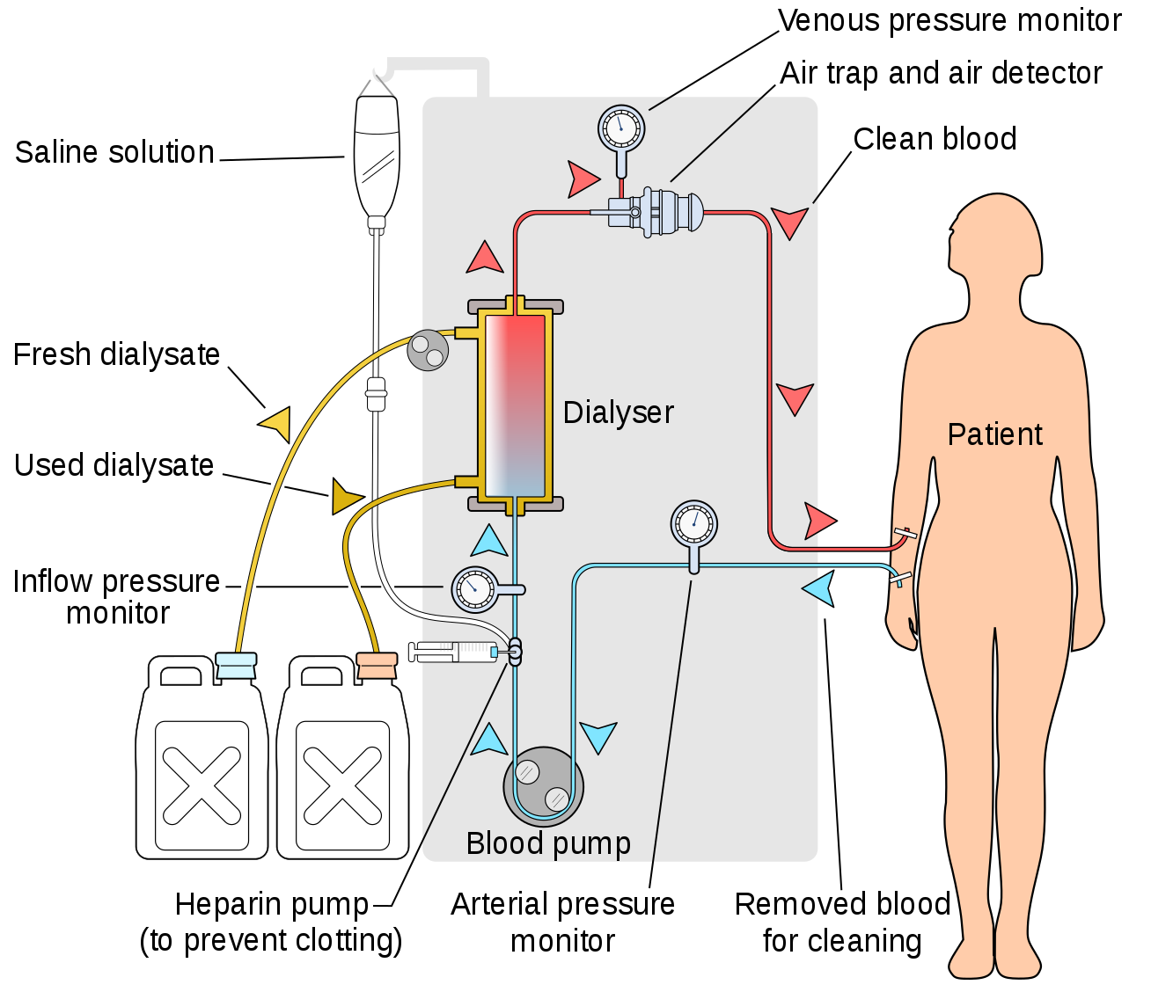
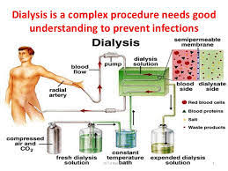
The blood flows in one direction and the dialysate flows in the opposite. The counter-current flow of the blood and dialysate maximizes the concentration gradient of solutes between the blood and dialysate, which helps to remove more urea and creatinine form the blood.
Blood flows through the dialyzer, dialysis solution flows around the outside of the fibers, and water and wastes move between these two solutions. The cleansed blood is then returned via the circuit back to the body.
Ultrafiltration occurs by increasing the hydrostatic pressure across the dialyzer membrane This usually is done by applying a negative pressure to the dialysate compartment of the dialyzer. This pressure gradient causes water, urea, creatinine, phosphate and other unwanted substances from the blood pass into the dialysate and allows the removal of several liters of excess fluid during a typical 4-hour treatment.
The essential substances required by the body diffuse from dialysate into blood. For example, dialysis solution level of bicarbonate is set at a slightly higher level than in normal blood, to encourage diffusion of bicarbonate into the blood, to act as a pH buffer to neutralize the metabolic acidosis that is often present in these patients.
Almost all the substances, except plasma proteins are exchanged between the blood and dialysate through the cellophane membranes.
In addition to the dialyzer, the dialysis machine has several blood pumps with pressure monitors, which enable easy flow of blood from the patient to the machine and back to the patient. It also has pumps for flow of fresh dialysate and for drainage of used dialysate. Total amount of blood in the dialysis machine at a time is about 500 mL. The rate of blood flow through the dialysis machine is about 200 to 300 mL/minute. The rate of dialysate flow is about 500 mL/minute.
FREQUENCY AND DURATION OF DIALYSIS
The frequency and duration of dialysis depends upon the severity of renal dysfunction. Dialysis is done usually thrice a week in severe uremia. Each time, the artificial kidney is used for about 6 hours.

- PERITONEAL DIALYSIS
Peritoneal dialysis is the technique in which peritoneal membrane is used as a semipermeable membrane. It is also used to treat the patients suffering from renal failure. A catheter is inserted into the peritoneal cavity through anterior abdominal wall and sutured. The dialysate is passed through this catheter under gravity.
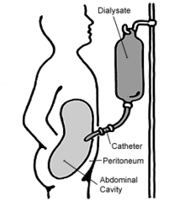
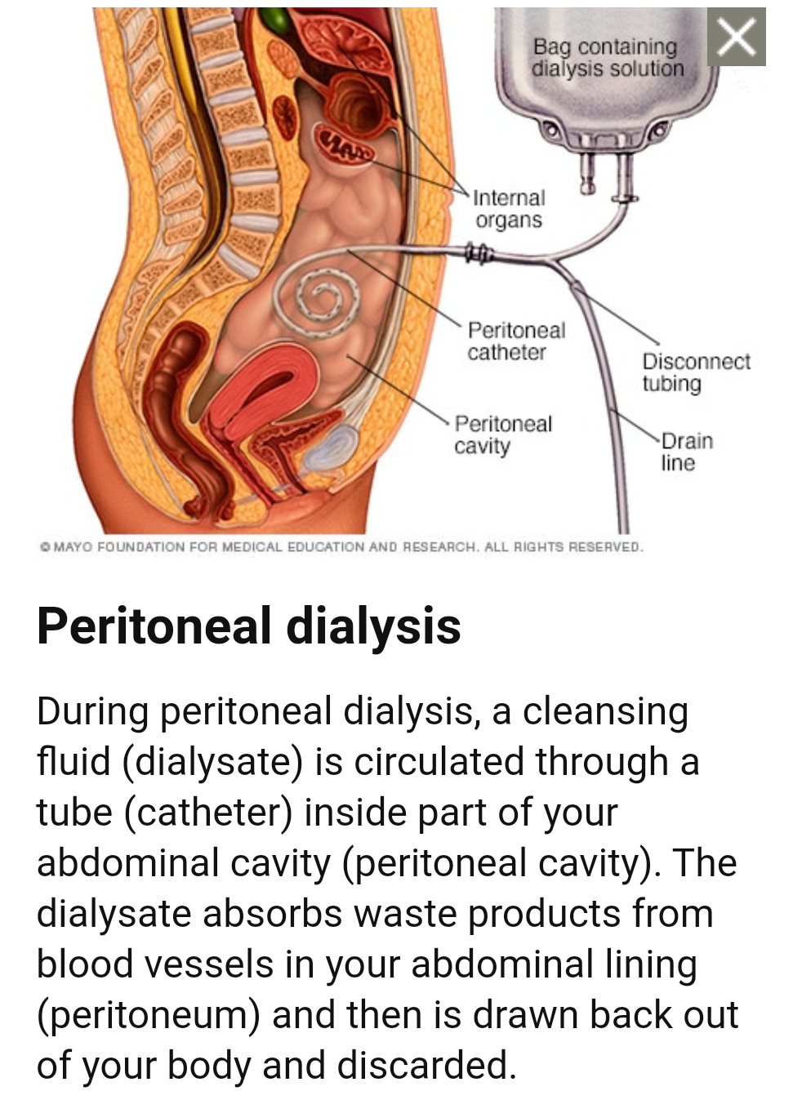

The required electrolytes from dialysate pass through vascular peritoneum into blood vessels of abdominal cavity. Urea, creatinine, phosphate and other unwanted substances diffuse from blood vessels into dialysate. Later, dialysate is drained from peritoneal cavity by gravity.
This exchange is repeated 4–5 times per day; automatic systems can run more frequent exchange cycles overnight.
Peritoneal dialysis is a simple, convenient and less expensive technique, compared to hemodialysis. Peritoneal dialysis can be carried out at home by the patient, often without help, after being trained on how to use it. This frees patients from the routine of having to go to a dialysis clinic on a fixed schedule multiple times per week. Peritoneal dialysis can be performed with little to no specialized equipment (other than bags of fresh dialysate).
However, it has few drawbacks.
It is less efficient than hemodialysis in removing some of the toxic substances and it may lead to complications by infections. But because it is carried out for a longer period of time the net effect in terms of removal of waste products and of salt and water are similar to hemodialysis.
Also, there are some people for whom peritoneal dialysis may not be appropriate. The abdomen or belly of some people, particularly those who are morbidly obese or those with multiple prior abdominal surgeries, may make peritoneal dialysis treatments difficult or impossible.

- HEMOFILTRATION
Hemofiltration is a similar treatment to hemodialysis, but it makes use of a different principle. The blood is pumped through a dialyzer or "hemofilter" as in dialysis, but no dialysate is used. A pressure gradient is applied; as a result, water moves across the very permeable membrane rapidly, "dragging" along with it many dissolved substances, including ones with large molecular weights, which are not cleared as well by hemodialysis. Salts and water lost from the blood during this process are replaced with a "substitution fluid" that is infused into the extracorporeal circuit during the treatment.
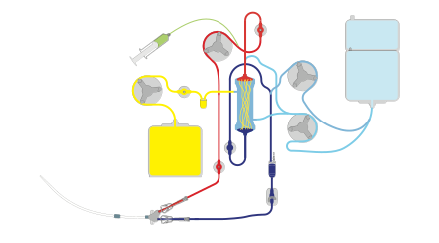

- HEMODIAFILTRATION
Hemodiafiltration is a combination of hemodialysis and hemofiltration, thus used to purify the blood from toxins when the kidney is not working normally and also used to treat acute kidney injury (AKI).

- INTESTINAL DIALYSIS
Intestinal dialysis has been described as the transfer of toxic substances from the blood system of the intestines to the decaying waste matter passing through the intestines and out of the body. This process is assisted by the presence of microorganisms and soluble fiber, in the gut.
In intestinal dialysis, the transfer of waste toxic products, in particular nitrogen compounds, may be assisted by adding to the diet soluble fibers such as acacia fiber, which is digested by bacteria in the colon. This bacterial growth increases the amount of nitrogen that is eliminated in fecal waste.
In the body, equilibrium of uremic toxins normally exists between the blood and the intestinal lumen. In the normal patient, some nitrogenous wastes build up in the blood and start to diffuse into the intestinal fluid by natural physiological process. Microbes target and metabolize the wastes for nutrients and growth and begin to multiply, which consumes some of the nitrogen products and the equilibrium is disturbed, which allows more toxins to diffuse into the bowel and are metabolized by the microbes and then pass out of the body.
An alternative approach utilizes the ingestion of 1 to 1.5 liters of non-absorbable solutions of polyethylene glycol or mannitol every fourth hour.

NOTES
- Successful transplantation of a single donor kidney to a patient with ESRD can restore kidney function to a level that is sufficient to maintain essentially normal homeostasis of body fluids and electrolytes. Patients who receive kidney transplants typically live longer and have fewer health problems than those who are maintained on dialysis.
- Dialysis machines should be disinfected according to the manufacturer’s recommendations, usually daily.
- Every nephrologist should “know their machine” in order to safely troubleshoot problems

CLINICAL PHYSIOLOGY
- Dialysis machine proportioning problems can result in severe serum electrolyte abnormalities. Some of these emergencies include:
- High or low serum sodium, potassium, calcium or magnesium
- High or low plasma osmolarity due to hyper- or hypo-osmolar dialysate
- Clinical emergencies can occur if significant levels of contaminants are in the dialysate. These include:
- Copper or cupraphane may be released from heating element or dialyzer and can cause severe hemolysis
- Chloramines and nitrates can cause severe hemolysis
- Fluoride can cause severe pruritis, nausea, and ventricular tachycardia or fatal ventricular fibrillation
- Aluminum can cause bone disease, anemia, and fatal progressive neurologic deterioration commonly known as dialysis encephalopathy syndrome
- Lead, copper, zinc, and aluminum can leach from metal pipes and cause anemia

- Power Failure
In the event of loss of power, the system is no longer safe for dialysis patients. Blood should be returned manually to patients and patients taken off the machine if power is not restored in 15–30 minutes

