Salihu Umar Gonto
17/MHS01/135
MBBS 300L
RENAL PHYSIOLOGY ASSIGNMENT
Discuss the pathophysiological process involves in renal failure?
Kidney failure, also called renal failure; is the partial or complete loss of kidney function. Chronic kidney disease includes subtle decreases in kidney function that develop over a minimum of 3 months. While acute kidney injury is the decrease in function that happens in less than 3 months (when the onset is sudden or chronic) . Chronic kidney failure results when there is an irreversible loss of the nephrons which can result in a toxic state such as uremia.
There are many causes of renal failure some include:
- Hypertension
- Diabetes
- Acute kidney injury (acute renal failure)
- Diseases of the liver
- Obstruction of the urinary tract
- Blockage of renal arteries
- Destruction of the tubules in the kidney by drugs or organic solvents such as carbon tetrachloride, acetone, and ethylene glycol
- Exposure to compounds of metal such as mercury, lead, and uranium
- Physical injuries. Etc.
Some symptoms of renal failure include:
- Itching
- Muscle cramps
- Nausea and vomiting
- Not feeling hungry
- Swelling in your feet and ankles
- Too much urine (pee) or not enough urine
- Trouble catching your breath
- Trouble sleeping

Hypertension and how it leads to renal failure
In hypertension, the walls of the arteries that supply the kidney start to thicken in order to withstand the pressure. This leads to a narrow lumen which means less blood and oxygen is supplied to the kidneys, which then leads to ischemic injury to the nephron’s glomerulus. Immune cells such as macrophages and foam cells enter the damaged glomerulus and start secreting growth factors like transforming growth factor beta-1. These growth factors cause the mesangial cells to revert back to their more immature stem cell stage known as mesangioblasts which secrete extracellular matrix. Excessive extracellular matrix leads to glomerular sclerosis which diminishes the nephron’s ability to filter the blood and over time this leads to chronic kidney disease (renal failure).
Hypertension leads to the narrowing of the blood vessels which leads to low glomerular filtration rate. The juxtaglomerular cells sense this and secrete renin which leads to the activation of the renin angiotensin aldosterone system (RAAS). The RAAS leads to increase in heart rate and further hypertension. Renal failure occurs as the cycle continues.
Diabetes and how it leads to renal failure
The four main changes seen in diabetes are:
- Mesangial expansion and proliferation
- Podocytopathy
- Glomerular basement membrane thickening
- Sclerosis
In diabetes, excess glucose in the blood starts sticking to proteins, a process called (non- enzymatic glycation). This particular glycation affects the efferent arteriole and causes it to become stiff and narrow (a process called hyaline arteriosclerosis). This makes it difficult for blood to leave the glomerulus and results in an increased pressure within the glomerulu which results in hyperfiltration. Hyperfiltration leads to glomerula sclerosis and over time leads to renal failure.
Acute renal failure
Acute kidney failure unlike chronic kidney failure is reversible. There are many causes of acute renal failure itself. They can be categorized as: pre-renal causes, intra-renal causes and post renal causes.
Pre-renal causes:
- Renal artery stenosis
- Heart failure
- Hemorrhage
Intra-renal failure:
- Glomerulonephritis
- Tubular necrosis
- Interstitial nephritis
Post-renal causes:
- Benign prostatic hyperplasia
- Renal stones
- Tumors
Pre-renal causes and post-renal causes often lead to intra-renal causes which will all lead to acute kidney failure.
Clinical manifestations of renal kidney failure
Sodium and water balance: A decrease in GFR leads to an increase sodium and water retention. This leads to high BP and edema.
Potassium balance: A decrease in GFR results in an increase in potassium retention which causes hyperkalemia. Hyperkalemia can lead to muscle weakness, ECG changes and causes fibrillation.
Metabolic acidosis: diminished capacity to excrete hydrogen which leads to acidosis.
Mineral and osteodystrophy: kidneys lack the ability to produce calcitriol due to loss of nephrons. Lack of calcitrio leads to lack of calcium reabsorption in the kidneys and GIT which results in hypocalcemia. Hypocalcemia and lack of calcitriol leads to secondary hyperparathyroidism. This leads to osteodystrophy.
Kidney failure also results in uremia (condition of having high levels of urea in the blood).
With the aid of suitable diagrams discuss the types of dialysis you know?
The kidneys filter your blood by removing waste and excess fluid from your body. This waste is sent to the bladder to be eliminated when you urinate.
Dialysis performs the function of the kidneys if they fail. Dialysis is a treatment that filters and purifies the blood using a machine. This helps keep your fluids and electrolytes in balance when the kidneys can’t do their job.
There are three different types of dialysis.

Hemodialysis

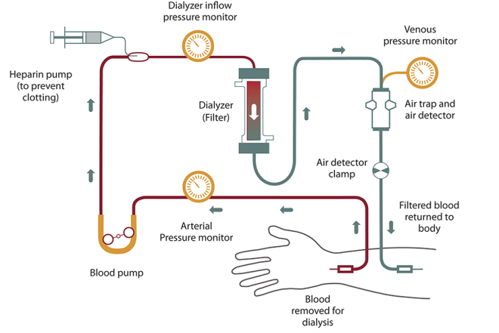
Hemodialysis is the most common type of dialysis. This process uses an artificial kidney (hemodialyzer) to remove waste and extra fluid from the blood. The blood is removed from the body and filtered through the artificial kidney. The filtered blood is then returned to the body with the help of a dialysis machine.
To get the blood to flow to the artificial kidney, your doctor will perform surgery to create an entrance point (vascular access) into your blood vessels. The three types of entrance points are:
- Arteriovenous (AV) fistula. This type connects an artery and a vein. It’s the preferred option.
- AV graft. This type is a looped tube.
- Vascular access catheter. This may be inserted into the large vein in your neck.
Both the AV fistula and AV graft are designed for long-term dialysis treatments. People who receive AV fistulas are healed and ready to begin hemodialysis two to three months after their surgery. People who receive AV grafts are ready in two to three weeks. Catheters are designed for short-term or temporary use.
Hemodialysis treatments usually last three to five hours and are performed three times per week. However, hemodialysis treatment can also be completed in shorter, more frequent sessions.
Most hemodialysis treatments are performed at a hospital, doctor’s office, or dialysis center. The length of treatment depends on your body size, the amount of waste in your body, and the current state of your health.
After you’ve been on hemodialysis for an extended period of time, your doctor may feel that you’re ready to give yourself dialysis treatments at home. This option is more common for people who need long-term treatment.

Peritoneal dialysis

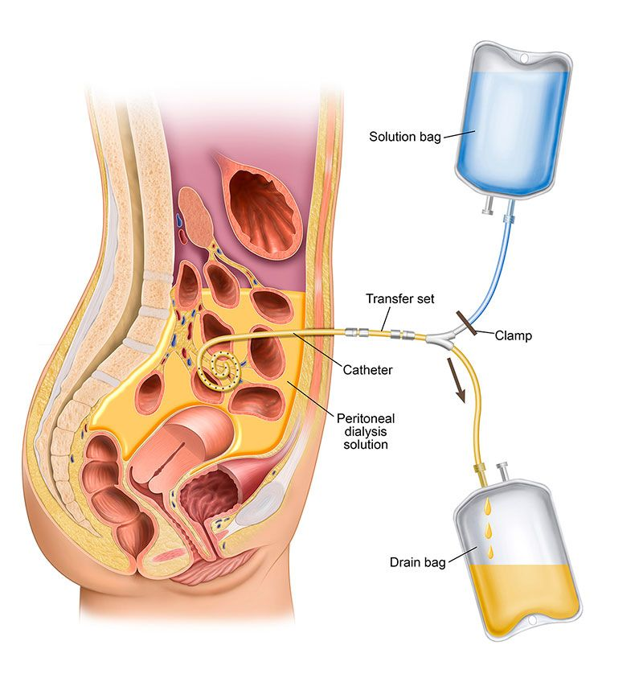
Peritoneal dialysis involves surgery to implant a peritoneal dialysis (PD) catheter into your abdomen. The catheter helps filter your blood through the peritoneum, a membrane in your abdomen. During treatment, a special fluid called dialysate flows into the peritoneum. The dialysate absorbs waste. Once the dialysate draws waste out of the bloodstream, it’s drained from your abdomen.
This process takes a few hours and needs to be repeated four to six times per day. However, the exchange of fluids can be performed while you’re sleeping or awake.
There are numerous different types of peritoneal dialysis. The main ones are:
- Continuous ambulatory peritoneal dialysis (CAPD). In CAPD, your abdomen is filled and drained multiple times each day. This method doesn’t require a machine and must be performed while awake.
- Continuous cycling peritoneal dialysis (CCPD). CCPD uses a machine to cycle the fluid in and out of your abdomen. It’s usually done at night while you sleep.
- Intermittent peritoneal dialysis (IPD). This treatment is usually performed in the hospital, though it may be performed at home. It uses the same machine as CCPD, but the process takes longer.

Continuous renal replacement therapy (CRRT)

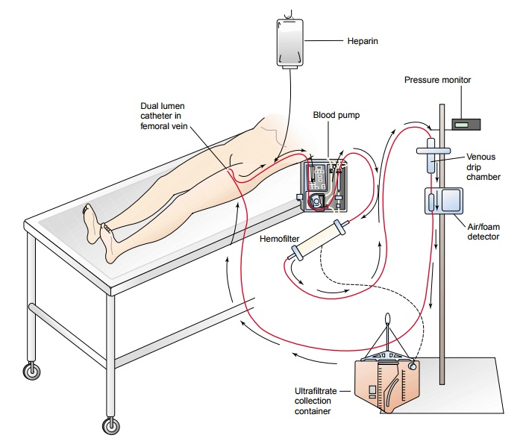
This therapy is used primarily in the intensive care unit for people with acute kidney failure. It’s also known as hemofiltration. A machine passes the blood through tubing. A filter then removes waste products and water. The blood is returned to the body, along with replacement fluid. This procedure is performed 12 to 24 hours a day, generally every day.

