NAME: EKUAYOVWE FAVOUR OGHENEVWAIRE
MATRIC NUMBER: 18/MHS02/070
DEPARTMENT: NURSING
ASSIGNMENT
WRITE A SHORT NOTE ON MICTURITION
ANSWER
Micturition or urination is the process of expelling urine from the bladder. This act is also known as voiding of the bladder. The excretory system in humans includes a pair of kidneys, two ureters, a urinary bladder and a urethra. The kidneys filter the urine and it is transported to the urinary bladder via the ureters where it is stored till its expulsion. The process of micturition is regulated by the nervous system and the muscles of the bladder and urethra. The urinary bladder can store around 350-400ml of urine before it expels it out.

Stages of Micturition
The urinary bladder has two distinct stages or phases:
- Resting or filling stage
- Voiding stage

Resting or Filling Stage
It is in this phase of the bladder that the urine is transported from the kidneys via the ureters into the bladder. The ureters are thin muscular tubes that arise from each of the kidneys and extend downwards where they enter the bladder obliquely.
The oblique placement of the ureters in the bladder wall serves a very important function. The opening of the ureter into the urinary bladder is not guarded by any sphincter or muscle. Therefore, this oblique nature of opening prevents the urine from re-entering the ureters. At the same time, the main muscle of the urinary bladder, the detrusor muscle, is relaxing allowing the bladder to distend and accommodate more urine.

Voiding Stage
During this stage, both the urinary bladder and the urethra come into play together. The detrusor muscle of the urinary bladder which was relaxing so far starts to contract once the bladder’s storage capacity is reached.
The urethra is controlled by two sets of muscles: The internal and external urethral sphincters. The internal sphincter is a smooth muscle whereas the external one is skeletal. Both these sphincters are in a contracted state during the filling stage.

Physiology of Micturition
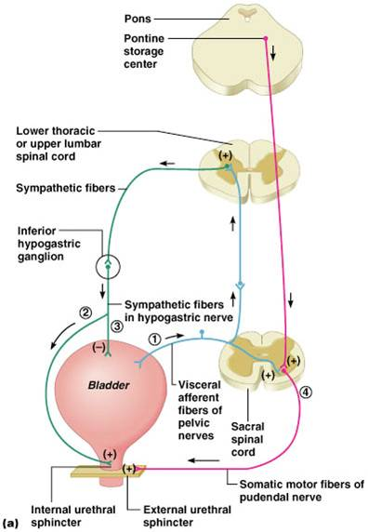
The process of micturition is governed by both the nervous and muscular systems. Within the nervous system, the process is governed by the autonomous nervous system and the somatic system. Once the urinary bladder reaches its maximum capacity, the stretch receptors in the walls of the bladder send an impulse via the pelvic nerve to the brain via the spinal cord. The micturition reflex is ultimately generated from the level of the spinal cord after it receives reflexes from the pontine region in the brain. Once the bladder and the urethra receive the signals to empty the bladder, the two sphincters relax and the detrusor muscle causes the contractions of the bladder. Along with these muscles, the muscles of the abdomen also play a role by putting pressure on the bladder wall. This leads to complete emptying of the bladder. The ureters enter the urinary bladder obliquely. This oblique nature of the ureters prevents the urine from passing back into the ureter from the bladder. The contraction of the ureter, in this case, functions as a sphincter in the absence of one.

