NAME: EKUAYOVWE FAVOUR OGHENEVWAIRE
MATRIC NUMBER: 18/MHS02/070
DEPARTMENT: NURSING
ASSIGNMENT
EXPLAIN THE URINE FORMATION AND CONCENTRATION
ANSWER
Urine Formation – by filtering the blood the nephrons perform the following functions;
(1) Regulate concentration of solutes in blood plasma; this also regulates pH
(2) Regulate water concentrations; this helps regulate blood pressure
(3) Removes metabolic wastes and excess substances
- Urine Formation:
- Glomerular Filtration – water and solutes are forced through the capillary walls of the glomerulus into the Bowman’s capsule (glomerular capsule)
- Filtrate – the fluid that is filtered out into bowman’s capsule
Glomerular Filtration Rate is regulated by mechanisms:
- Auto regulation – the smooth muscle in the afferent arteriole responds to blood pressure changes by constricting and dilating to regulate filtration rate.
- Sympathetic control – causes afferent arterioles to constrict or dilate when activated by a nerve impulse (fight or flight response to keep blood pressure up)
Renin-angiotensin mechanism – triggered by the juxtaglomerular apparatus; when filtration rate decreases, the enzyme renin is released. Renin converts a plasma protein called angiotensinogen into angiotensin I. Angiotensin I is quickly converted into angiotensin II by another enzyme. Angiotensin II causes 3 changes:
(1) Constriction of the arterioles – decreases urine formation and water loss
(2) Stimulates the adrenal cortex to release aldosterone – promotes water reabsorption by causing the absorption of salt
(3) Stimulates the posterior pituitary to release ADH – antidiuretic hormone – promotes water reabsorption
(4) Stimulates the thirst and water intake (hypothalamus says we’re thirsty so we get a drink)

Tubular Reabsorption – occurs both passive and actively; glucose, amino acids, and other needed ions (Na, K, Cl, Ca, and HCO3) are transported out of the filtrate into the peritubular capillaries (they are reabsorbed back into the blood); about 65% of the filtrate is reabsorbed in the proximal convoluted tubule.
- As these substances are reabsorbed, the blood becomes hypertonic so water easily follows by osmosis
- Reabsorption in the distal convoluted tubule is under hormonal control…aldosterone causes more salt to be absorbed, ADH causes more water to be absorbed
Secretion – waste products such as urea and uric acid, drugs and hydrogen and bicarbonate ions are move out of the peritubular capillaries into the filtrate; this removes unwanted wastes and helps regulate pH
- Urine – filtrate after it has passed through the nephron and undergone filtration, reabsorption, and secretion. The urine passes into the collecting duct, which joins with the minor calyx, major calyx, and eventually the renal pelvis. The renal pelvis joins with the ureter.
- Color – yellow color is due to urochrome – a pigment produced from the breakdown of bile pigments in the intestine
  - Deep yellow to orange – more concentrated, less water
  - Light yellow to clear – less concentrated, more water
Glomerular Filtration Rate (GFR): The volume of filtrate formed by both kidneys per minute is termed the glomerular filtration rate (GFR). The heart pumps about 5 L blood per min under resting conditions. Approximately 20 percent or one liter enters the kidneys to be filtered. On average, this liter results in the production of about 125 mL/min filtrate produced in men (range of 90 to 140 mL/min) and 105 mL/min filtrate produced in women (range of 80 to 125 mL/min). This amount equates to a volume of about 180 L/day in men and 150 L/day in women. Ninety-nine percent of this filtrate is returned to the circulation by reabsorption so that only about 1–2 liters of urine are produced per day.
Table 2. Calculating Urine Formation per Day
 | Flow per minute (mL) | Calculation
Renal blood flow | 1050 | Cardiac output is about 5000 mL/minute, of which 21 percent flows through the kidney.  5000*0.21 = 1050 mL blood/min
Renal plasma flow | 578 | Renal plasma flow equals the blood flow per minute times the hematocrit. If a person has a hematocrit of 45, then the renal plasma flow is 55 percent.  1050*0.55 = 578 mL plasma/min
Glomerular filtration rate | 110 | The GFR is the amount of plasma entering Bowman’s capsule per minute. It is the renal plasma flow times the fraction that enters the renal capsule (19 percent).  578*0.19 = 110 mL filtrate/min
Urine | 1296 ml/day | The filtrate not recovered by the kidney is the urine that will be eliminated. It is the GFR times the fraction of the filtrate that is not reabsorbed (0.8 percent).  110*.08 = 0.9 mL urine /min  Multiply urine/min times 60 minutes times 24 hours to get daily urine production.  0.9*60*24 = 1296 mL/day urine

GFR is influenced by the hydrostatic pressure and colloid osmotic pressure on either side of the capillary membrane of the glomerulus. Recall that filtration occurs as pressure forces fluid and solutes through a semi permeable barrier with the solute movement constrained by particle size. Hydrostatic pressure is the pressure produced by a fluid against a surface. If you have a fluid on both sides of a barrier, both fluids exert a pressure in opposing directions. Net fluid movement will be in the direction of the lower pressure. Osmosis is the movement of solvent (water) across a membrane that is impermeable to a solute in the solution. This creates a pressure, osmotic pressure, which will exist until the solute concentration is the same on both sides of a semi permeable membrane. As long as the concentration differs, water will move. Glomerular filtration occurs when glomerular hydrostatic pressure exceeds the luminal hydrostatic pressure of Bowman’s capsule. There is also an opposing force, the osmotic pressure, which is typically higher in the glomerular capillary.

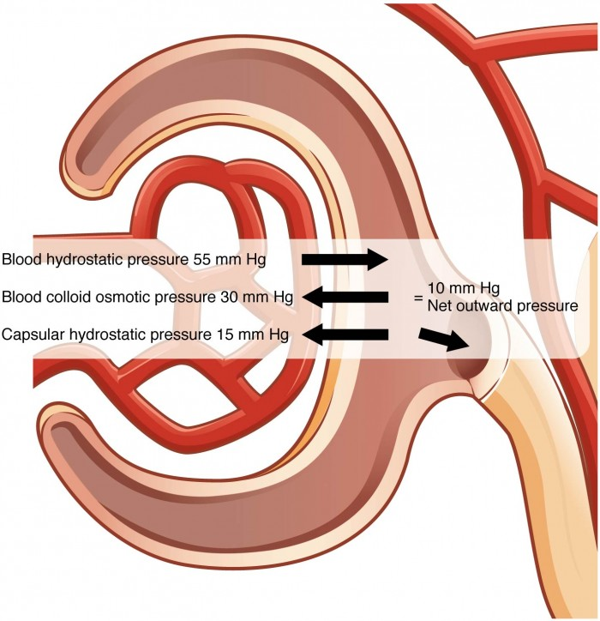 The NFP is the sum of osmotic and hydrostatic pressures.

The sum of all of the influences, both osmotic and hydrostatic, results in a net filtration pressure (NFP) of about 10 mm Hg.

A proper concentration of solutes in the blood is important in maintaining osmotic pressure both in the glomerulus and systemically. There are disorders in which too much protein passes through the filtration slits into the kidney filtrate. This excess protein in the filtrate leads to a deficiency of circulating plasma proteins. In turn, the presence of protein in the urine increases its osmolarity; this holds more water in the filtrate and results in an increase in urine volume. Because there is less circulating protein, principally albumin, the osmotic pressure of the blood falls. Less osmotic pressure pulling water into the capillaries tips the balance towards hydrostatic pressure, which tends to push it out of the capillaries. The net effect is that water is lost from the circulation to interstitial tissues and cells. This “plumps up” the tissues and cells, a condition termed systemic edema.

Net Filtration Pressure (NFP)

NFP determines filtration rates through the kidney. It is determined as follows:

NFP = Glomerular blood hydrostatic pressure (GBHP) – [capsular hydrostatic pressure (CHP) + blood colloid osmotic pressure (BCOP)] = 10 mm Hg

That is:

NFP = GBHP – [CHP + BCOP] = 10 mm Hg

Or:

NFP = 55 – [15 + 30] = 10 mm Hg

