NAME: ATTAH JOY ELEOJO
MATRIC: 18/MHS02/048
DEPT: 200L NURSING
COURSE: PHS 212

URINE FORMATION AD CONCENTRATION
Urine is the liquid waste product of the human body. It contains urea, uric acid, salts, water and other waste products that are the result of various metabolic processes occurring in the body. It is formed in the primary excretory organs– the kidneys. The structural and functional unit of the kidneys is called the nephrons. Millions of nephrons are involved in the process of urine formation.

The formation process occurs in 3 steps or phases:

Glomerular Filtration
Tubular Reabsorption
Tubular Secretion
Anatomy of the Nephron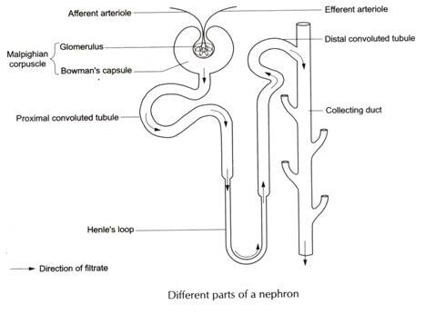

The anatomy of the nephron is important to understand the urine formation process. Each nephron is made up of two parts:

Renal Corpuscle
Renal Tubule
The renal corpuscle is divided into the glomerular capillaries or glomerulus and the Bowman’s capsule. It is in the renal corpuscle that the blood is filtered at high pressure. The arteriole that brings blood into the glomerulus is called the afferent arteriole whereas the artery that takes blood away from the glomerulus is known as the efferent arteriole.

Between these arterioles forms, a network of capillaries called the glomerular capillaries of the glomerulus. The Bowman’s capsule is a cup-shaped structure in which this glomerulus is located. The glomerulus along with the Bowman’s capsule achieve the filtration of blood to form urine. The renal tubule consists of :

The proximal convoluted Tubule(PCT)
The U-shaped Loop Of Henle
The Distal Convoluted Tubule(DCT)
Once the blood is filtered in the renal corpuscle, the resultant fluid is called the glomerular filtrate. This glomerular filtrate now passes into the PCT. In the PCT, substances like NaCl, K+, water, glucose, and bicarbonate are reabsorbed into the filtrate whereas urea, creatinine, uric acid are added to the filtrate.

From the PCT, the filtrate enters the U-shaped Loop of Henle where reabsorption and secretion of water and various metabolites occurs. The filtrate then passes into the DCT. From the DCT, the filtrate passes into the collecting tubules, into the renal pelvis and the ureters as urine to be stored int he urinary bladder.

Process of Urine Formation
Urine Formation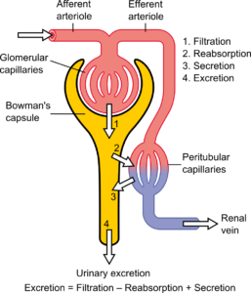

Glomerular Filtration
This process occurs in the glomerular capillaries. The process of filtration leads to the formation of an ultrafiltrate. The blood gushes into these capillaries with high pressure and gets filtered across the thin capillary walls. Everything except the blood cells and proteins are pushed into the capsular space of the Bowman’s capsule to form the ultrafiltrate. The glomerular filtration rate (GFR) is 125ml/min or 180 Litres/day.

Tubular Reabsorption
During glomerular filtration, all substances except blood cells and proteins are pushed through the capillaries at high pressure. At the level of the Proximal Convoluted Tubule(PCT), some of the substances from the filtrate are reabsorbed. These include sodium chloride, potassium, glucose, amino acids, bicarbonate, and 75% of water.

Absorption of some substances is passive, some substances are actively transported while others are co-transported. The absorption depends upon the permeability of different parts of the nephron. The distal convoluted tubule shows selective absorption. The substances and water which is reabsorbed are taken up by the peritubular capillaries to be returned to the blood.

Tubular Secretion
The peritubular capillaries that help in transporting the reabsorbed substances into the bloodstream, also help in actively secreting substances like H+ ions, K+ ions. Whenever excess K+ is secreted into the filtrate, Na+ ions are actively reabsorbed to maintain the Na-K balance. Some drugs are not filtered in the glomerulus and so are actively secreted into the filtrate during the tubular secretion phase.

Composition of Urine
Physical characteristics: Urine is the waste product that is eliminated by the kidneys. Urine contains waste products like urea, salts, excess ions, water, and metabolized products of drugs.

Urine is often light or pale yellow in colour and fresh urine has a slight ammoniacal smell. It is often clear in turbidity with a pH of around 4-8. These characteristics vary depending upon the nature of the disease in the body. Often a urine sample analysis helps to detect diseases like diabetes, kidney failures etc.

Chemical composition: Chemically, urine is composed mainly of urea, sodium chloride, potassium ions, creatinine, ammonia products, and some amount of protein, and other metabolites. Certain abnormalities in the urine composition occur in the following:

Hematuria- When blood is found in the urine, the condition is called as hematuria. This indicates some pathology either injury or infection-related.
Pyuria- This condition is characterized by the presence of pus cells in the urine. This indicates the presence of infection somewhere in the body.
Glycosuria- This is a condition characterized by the presence of glucose in the urine. This is indicative of diabetes that is most likely uncontrolled.
Proteinuria- This is a condition where protein molecules are found in the urine. This indicates some defect in the kidney’s filtration process.

