Name: James Vivian chidera
Matric number: 18/mhs02/096
Course code: PHS212
Department: Nursing science
Write a short note on micturition
Micturition
Micturition or urination is the process of expelling urine from the bladder. This act is also known as voiding of the bladder. The excretory system in humans includes a pair of kidneys, two ureters, a urinary bladder and a urethra. The kidneys filter the urine and it is transported to the urinary bladder via the ureters where it is stored till its expulsion. The process of micturition is regulated by the nervous system and the muscles of the bladder and urethra. The urinary bladder can store around 350-400ml of urine before it expels it out.
Micturition (urination) is the process of urine excretion from the urinary bladder. Most of the time, the bladder (detrusor muscle) is used to store urine. As it fills, the rugae distend and a constant pressure in the bladder (intra-vesicular pressure) is maintained. This is known as the stress-relaxation phenomenon. The ability to voluntarily control micturition develops from 2 years as the CNS develops.
Stages of Micturition
The urinary bladder has two distinct stages or phases:

Resting or filling stage
Voiding stage
Resting or Filling Stage
It is in this phase of the bladder that the urine is transported from the kidneys via the ureters into the bladder. The ureters are thin muscular tubes that arise from each of the kidneys and extend downwards where they enter the bladder obliquely.

The oblique placement of the ureters in the bladder wall serves a very important function. The opening of the ureter into the urinary bladder is not guarded by any sphincter or muscle. Therefore, this oblique nature of opening prevents the urine from re-entering the ureters. At the same time, the main muscle of the urinary bladder, the detrusor muscle, is relaxing allowing the bladder to distend and accommodate more urine.

Voiding Stage
During this stage, both the urinary bladder and the urethra come into play together. The detrusor muscle of the urinary bladder which was relaxing so far starts to contract once the bladder’s storage capacity is reached.

The urethra is controlled by two sets of muscles: The internal and external urethral sphincters. The internal sphincter is a smooth muscle whereas the external one is skeletal. Both these sphincters are in a contracted state during the filling stage.

Physiology of micturition.

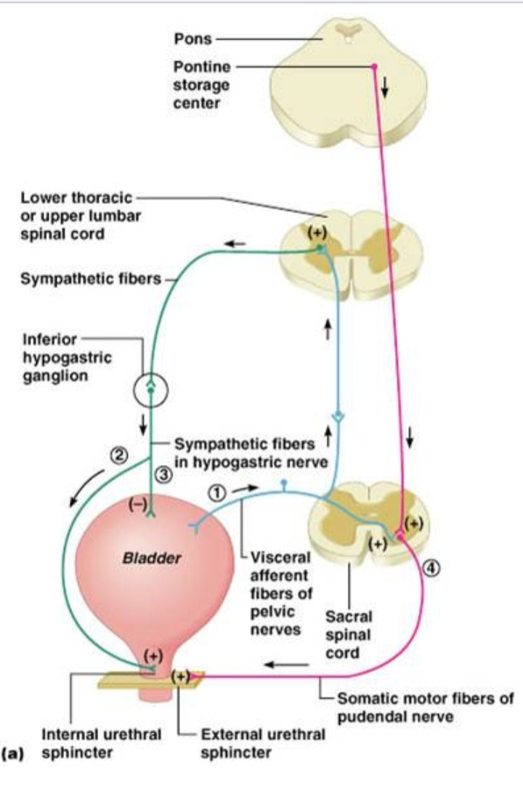

We depend on micturition (urination) to eliminate organic waste products, which are produced as a result of cell metabolism in the body. The urinary system also regulates the concentrations of sodium, potassium, chloride and other ions in the blood as well as helping to maintain normal blood pH, blood pressure and blood volume.

Micturition
Micturition is also known as the voiding phase of bladder control and it is typically a short-lasting event. Urinary flow rate in a full bladder is:

20-25ml/s in men
25-30ml/s in women
Whilst the capacity of the bladder varies from roughly 300-550ml, afferent nerves in the bladder wall signal the need to void the bladder at around 400ml of filling.

Regulation of Micturition
Passing of urine is under parasympathetic control. Bladder afferents signals ascend through the spinal cord and then project to the pontine micturition centre and cerebrum. Upon the voluntary decision to urinate, neurones of the pontine micturition centre fire to excite the sacral preganglionic neurones.

There is subsequent parasympathetic stimulation to the Pelvic Nerve (S2-4) causing a release of ACh, which works on M3 muscarinic ACh receptors on the detrusor muscle, causing it to contract and increase intra-vesicular pressure. The pontine micturition centre also inhibits Onuf’s nucleus, with a resultant reduction in sympathetic stimulation to the internal urethral sphincter causing relaxation.

Finally, a conscious reduction in voluntary contraction of the external urethral sphincter from the cerebral cortex allows for distention of the urethra and the passing of urine. In the female, urination is assisted by gravity, while in the male, bulbospongiosus contractions and squeezing along the length of the penis helps to expel all of the urine
The storage phase of micturition.
Micturition has two discrete phases: the storage/continence phase, when urine is stored in the bladder; and the voiding phase, where urine is released through the urethra. These phases require coordinated contraction/relaxation of the bladder and urethral sphincters, which are all under control of the sympathetic, parasympathetic and somatic nervous systems.
The storage phase of micturition is controlled at the highest level by continence centres of the brain. These in turn control the continence centres of the spinal cord. Storage of urine requires relaxation of the detrusor muscle of the bladder, and simultaneous contraction of both the internal (IUS) and external (EUS) urethral sphincters.

The bladder and IUS are primarily under the control of the sympathetic nervous system. The EUS is under the control of the somatic nervous system.

The neural control of micturition

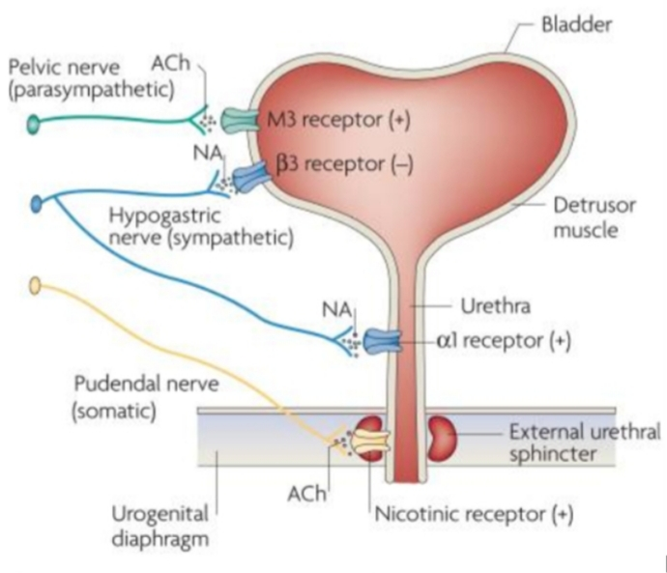

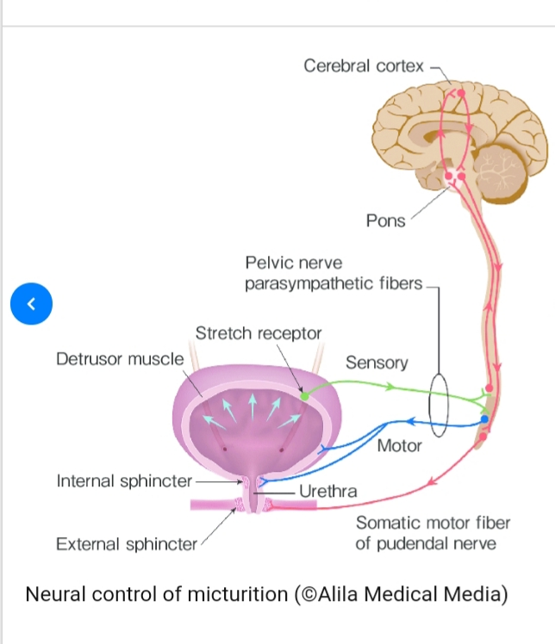

Disorders Of Micturition

Disorders of micturition can arise from a disturbance of bladder function or from abnormalities affecting bladder outflow. Although there are distinct clinical syndromes, many people with incontinence have mixed incontinence; for example, both stress and urge incontinence (see below). Management of disorders of micturition should also consider possible contributory factors, such as diuretics, α1-adrenoceptor antagonists used for treatment of hypertension, and stool impaction, which inhibits sacral parasympathetic neurotransmission.

Overactive bladder syndrome
Detrusor instability produces uncontrolled bladder contractions during normal filling. Symptoms from this include urinary urgency, nocturia and frequency (overactive bladder syndrome), often accompanied by urge incontinence (a sudden compelling desire to urinate). Most cases in women are idiopathic but probably have a neurogenic component, while in men bladder outflow obstruction is the commonest cause. Upper motor neuron lesions, such as those produced by stroke, spinal cord injuries or multiple sclerosis, can also produce an overactive bladder. First-line approaches to management include reduction in excessive fluid intake, weight loss, smoking cessation and behavioural training that includes pelvic floor muscle rehabilitation and suppression of urge.

Drugs For Treatment Of Overactive Bladder Syndrome

Increased understanding of the neural pathways involved in initiating micturition is opening up new avenues for drug therapy to augment the relatively ineffective treatments currently available. Those used at present to treat overactive bladder act at peripheral muscarinic receptors to decrease bladder activity.

Muscarinic receptor antagonists

Examples

darifenacin, fesoterodine, oxybutynin, solifenacin, tolterodine, trospium

These drugs act with various degrees of selectivity at muscarinic receptor subtypes. Antimuscarinic unwanted effects (Ch. 4) are most troublesome with oxybutynin, particularly central nervous system (CNS) effects such as sedation, insomnia, confusion and cognitive problems (from M1 receptor blockade) and dry mouth (from M3 receptor blockade in salivary glands). The need for continued use of these drugs should be reviewed after 6 months.
The urinary bladder is a smooth muscle organ, most of which is the detrusor muscle, that relaxes to allow bladder filling up to 500–600 mL. A smaller muscle, the trigone, is found between the ureteric orifices and bladder neck. Internal and external distal sphincter mechanisms are normally constricted to prevent bladder emptying and maintain continence (Fig. 15.1). Coordination of bladder filling, continence and bladder emptying are brought about by the frontal lobe of the cortex and the pontine micturition centre. Conscious sensations of bladder fullness are processed by the cerebral cortex, which then sends signals to the micturition centre. Oxybutynin is a selective antagonist of M1 and M3 receptors and has additional weak muscle relaxant properties through calcium channel blocking actions and local anaesthetic activity. Oxybutynin is rapidly absorbed from the gut and metabolised in the liver to an active metabolite. Modified-release and transdermal formulations are available because oxybutynin has a short half-life (1–3 h) and use of standard formulations can result in large fluctuations in plasma drug concentrations and increase the severity of unwanted effects.
Tolterodine, fesoterodine and trospium are non-selective muscarinic receptor antagonists with no additional properties and less lipophilicity than oxybutynin. They cross the blood–brain barrier less readily and have fewer cognitive unwanted effects. Both tolterodine and trospium have short half-lives. Tolterodine is better tolerated in a modified-release formulation.
Darifenacin and solifenacin are more selective antagonists of M3 receptors and may have fewer CNS actions.
Beta3-adrenoceptor agonist

Example: Mirabegron: Stimulation of β3-adrenoceptors in the bladder trigone flattens and lengthens the bladder base, which facilitates urine storage. Mirabegron reduces symptoms of urinary frequency and urgency with similar efficacy when compared to the muscarinic receptor antagonists. The main adverse effects are an increase in blood pressure and heart rate. It may be an option for those who fail to respond to muscarinic receptor antagonists, or who cannot tolerate them.

Other drugs

Topical vaginal oestrogen-replacement therapy (Ch. 45) reverses atrophic changes in the lower genital tract in postmenopausal women and may be helpful for overactive bladder syndrome.
Desmopressin, a synthetic antidiuretic hormone (ADH) analogue (Ch. 43), is sometimes helpful to reduce nocturia in unstable bladder syndrome. It is taken orally; the nasal spray is no longer licensed for this indication because of the risk of water intoxication in children.

Hypotonic bladder

Hypotonic bladder is often a result of lower motor neuron lesions, or can arise from bladder distension following chronic urinary retention. Drugs with antimuscarinic properties (such as tricyclic antidepressants; Ch.22) and the specific antimuscarinic drugs above can make the symptoms worse. Hypotonic bladder leads to incomplete bladder emptying, with urinary retention and overflow incontinence. Treatment depends on the cause.

Chronic urinary retention is often caused by bladder outlet obstruction. If renal function is impaired, it should be managed by bladder catheterisation and correction of the underlying cause.
Neurogenic problems are sometimes treated with anticholinesterases (such as distigmine) which may increase the force of detrusor contraction (Ch. 4), although they are probably ineffective. Cholinergic drugs should not be used in the presence of urinary outflow obstruction.
Urethral sphincter incompetence
Urethral sphincter incompetence produces stress incontinence in women (urine leakage with effort, exertion, sneezing or coughing) or sphincter weakness incontinence in men. The most common cause in women is loss of collagenous support in the pelvic floor or perineum; it also arises from trauma to the membranous urethra (sphincter mechanism), such as may occur
from pelvic trauma or following prostatectomy in males. Drugs such as α1-adrenoceptor antagonists (see below) can make the symptoms worse. Pelvic floor muscle training may be helpful, while minimal access surgical sling procedures or colposuspension to provide urethral support are among the surgical options. Drug therapy is limited, and only recommended if surgical treatment is not suitable.
Duloxetine is a serotonin and noradrenaline reuptake inhibitor (SNRI; see Ch. 22). It is believed to augment sympathetic activity, which relaxes the detrusor, and to enhance external urethral sphincter activity by increasing efferent impulses in the motor neurons of the pudendal nerve when the bladder is placed under stress. It reduces the frequency of incontinence episodes significantly in about half of those treated.
Benign prostatic hypertrophy
Benign prostatic hypertrophy (BPH) produces symptoms in more than 25% of men above the age of 60 years, and up to 70% of men over the age of 70 years. The spectrum of symptoms is often called prostatism (Box 15.1). Left untreated, spontaneous improvement occurs or symptoms remain stable in up to half of all those with prostatism. Acute urinary retention occurs at a rate of 1–2% per year. Scoring systems can reliably quantify the extent to which symptoms affect the quality of life and therefore as a guide to treatment.

