Name: James Vivian chidera
Matric number: 18/mhs02/096
Course code: PHS212
Department: Nursing science
1. Write a short note on urinalysis
A urinalysis is a test of urine. A urinalysis is used to detect and manage a wide range of disorders, such as urinary tract infections, kidney disease and diabetes. A urinalysis involves checking the appearance, concentration and content of urine.

A urinalysis is a simple test that looks at a small sample of your urine. It can help find problems that need treatment, including infections or kidney problems. It can also help find serious diseases in the early stages, like kidney disease, diabetes, or liver disease. A urinalysis is also called a “urine test.”
A urine test can include three parts:

Visual exam. The urine will be looked at for color and clearness. Blood may make urine look red or the color of tea or cola. An infection may make urine look cloudy. Foamy urine can be a sign of kidney problems.

Microscopic exam. A small amount of urine will be looked at under a microscope to check for things that do not belong in normal urine that cannot be seen with the naked eye, including red blood cells, white blood cells (or pus cells), bacteria (germs), or crystals (which are formed from chemicals in the urine and may eventually get bigger and become kidney stones).

Dipstick test. A dipstick is a thin, plastic stick with strips of chemicals on it. It is dipped into the urine. The strips change color if a substance is present at a level that is above normal. . Some of the things a dipstick examination can check for include:

  - Acidity (pH) is a measure of the amount of acid in the urine. A pH that is above normal may be a sign of kidney stones, urinary infections, kidney problems, or other disorders.
  - Protein is an important building block in the body. Everyone has protein in their blood. But it should only be in your blood, not your urine. Your kidneys play a role in this process. Healthy kidneys remove waste products and extra water from your blood, but leave behind the things your body needs, like protein. When kidneys are injured, protein leaks into your urine. Having protein in your urine suggests that your kidney's filtering units are damaged by kidney disease.
  - Glucose (sugar) is usually a sign of diabetes.
  - White blood cells (pus cells) are signs of infection.
  - Bilirubin is a waste product from the breakdown of old red blood cells. It is normally removed from the blood by the liver. Its presence in the urine may be a sign of liver disease.
  - Blood can It can be a sign of an infection, a kidney problem, certain medicines, or even heavy exercise. Finding blood in the urine requires further testing. It does not mean you have a serious medical problem.
A urinalysis can help to detect many diseases before you feel symptoms. Finding and treating a problem early can help keep serious diseases from getting worse.
How a sample is collected for testing:
One to two ounces of urine is collected in a clean container. A sufficient sample is required for accurate results.
Urine for a urinalysis can be collected at any time. In some cases, a first morning sample may be requested because it is more concentrated and more likely to detect abnormalities.
Sometimes, you may be asked to collect a "clean-catch" urine sample. For this, it is important to clean the genital area before collecting the urine. Bacteria and cells from the surrounding skin can contaminate the sample and interfere with the interpretation of test results. With women, menstrual blood and vaginal secretions can also be a source of contamination. Women should spread the labia of the vagina and clean from front to back; men should wipe the tip of the penis. Start to urinate, let some urine fall into the toilet, then collect one to two ounces of urine in the container provided, then void the rest into the toilet.
A urine sample will only be useful for a urinalysis if taken to the healthcare provider's office or laboratory for processing within a short period of time. If it will be longer than an hour between collection and transport time, then the urine should be refrigerated or a preservative may be added.

A urinalysis is comprised of several chemical, microscopic and visual examinations used to detect cells, cell fragments and substances such as crystals or casts in the urine associated with the various conditions listed above. It can detect abnormalities that might require follow-up investigation and additional testing. Often, substances such as protein or glucose will begin to appear in the urine before people are aware that they may have a problem.
In people diagnosed with diseases or conditions, such as kidney disease or diabetes, the urinalysis may be used in conjunction with other tests, such as urine albumin, to follow treatment.
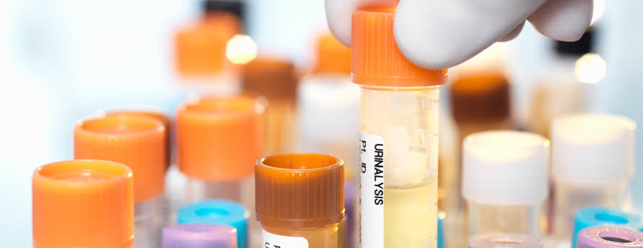

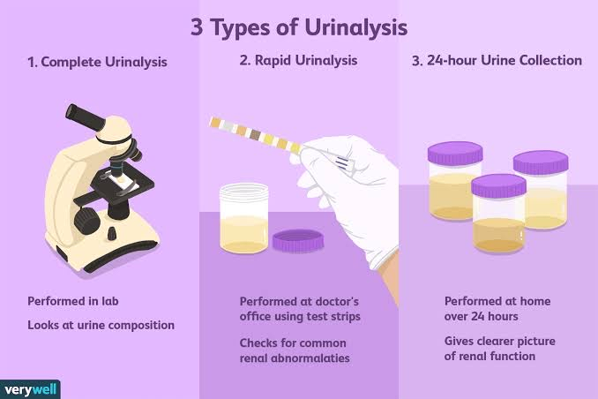
Urine may be tested to determine whether an individual has engaged in recreational drug use. In this case, the urinalysis would be designed to detect whatever marker indicates drug use.
Various colors of urine includes:
- Yellow: Distinctly yellow urine may indicate excessive riboflavin (vitamin B₂) intake.
- Yellow-amber: Normal.
- Yellow-cloudy: excessive crystals (crystalluria) and/or excessive pus (pyuria).
- Orange: Insufficient fluid intake for conditions; intake of orange substances; intake of phenazopyridine for urinary symptoms.
- Red: Leakage of red blood cells or of hemoglobin from such cells; hemolysis; intake of red substances.
- Dark:
  - Reddish-orange: Intake of certain medications or other substances.
  - Rusty-yellow to reddish-brown: Intake of certain medications or other substances.
  - Dark brown: Intake of certain medications or other substances; damaged muscle (myoglobinuria due to rhabdomyolysis) from extreme exercise or other widespread damage, possibly medication related; altered blood; bilirubinuria; intake of phenolic substances; inadequate porphyrin metabolism; melanin from melanocytic tumors; presence of an abnormal form of hemoglobin, methemoglobin.
  - Brownish-black to black: Intake of substances or medications; altered blood; a problem with homogentisic acid metabolism (alkaptonuria), which can also cause dark whites of the eyes and dark-colored internal organs and tissues (ochronosis); Lysol (a product that contains phenols) poisoning; melanin from melanocytic tumors). Paraphenylenediamine is a highly toxic ingredient of hair dye formulations that can cause acute kidney injury and result in black urine.
  - Purple due to Purple urine bag syndrome.
- Magenta to purple-red: Presence of phenolphthalein, a stimulant laxativepreviously found in Ex-Lax.
- Green, or dark with a greenish hue: Jaundice(bilirubinuria); problem with bile metabolism. Recent surgery requiring high doses of propofol infusion. The use of a medication (Uribel) that is similar to phenazopyridine for the relief of urinary symptoms.
- Other colors: Various substances ingested in food or drink, particularly up to 48 hours prior to the presence of colored urine.
Importance of urinalysis
Elimination of the worn-out products of tissue change and the unappropriated parts of the food takes place from the body in the expired air, skin, feces and urine. The oxidized carbon of the tissues by the lungs and cutaneous surface, the insoluble débris of the food excreted by the intestines, while the urine contains essentially the nitrogenous and other soluble products.
The urine containing the watery constituents of the blood, with some dissolved salts, is one of the most important excretions from the body, and with our present knowledge of urinalysis much can be learned by its examination. The changes which this secretion undergoes in health and disease have been studied since the earliest history of medicine. Hippocrates taught the effects of food and drink upon this excretion, its variation in color, odor and transparency, attributing their changes to disease of the urinary organs. Galen simply added to this knowledge

