NAME: AKINBODE OLAJUMOKE ADESOLA
DEPARTMENT: NURSING SCIENCE
MATRIC NUMBER: 18/SCI05/002
COURSE: PHYSIOLOGY
COURSE CODE: PHS 212

Filtration, Reabsorption, Secretion: The Three Steps of Urine Formation
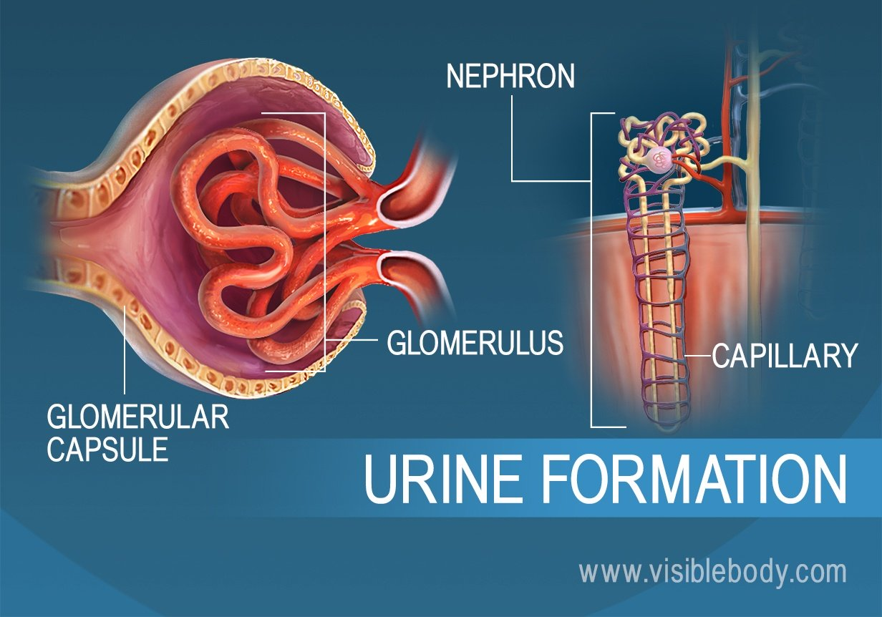
The kidneys filter unwanted substances from the blood and produce urine to excrete them. There are three main steps of urine formation: glomerular filtration, reabsorption, and secretion. These processes ensure that only waste and excess water are removed from the body.

1. The Glomerulus Filters Water and Other from the Bloodstream
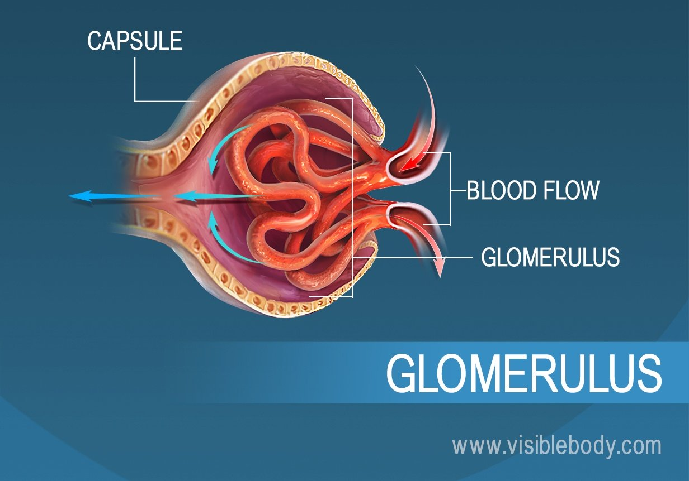
Each kidney contains over 1 million tiny structures called nephrons. Each nephron has a glomerulus, the site of blood filtration. The glomerulus is a network of capillaries surrounded by a cuplike structure, the glomerular capsule (or Bowman’s capsule). As blood flows through the glomerulus, blood pressure pushes water and solutes from the capillaries into the capsule through a filtration membrane. This glomerular filtration begins the urine formation process.

2. The Filtration Membrane Keeps Blood Cells and Large Proteins in the Bloodstream
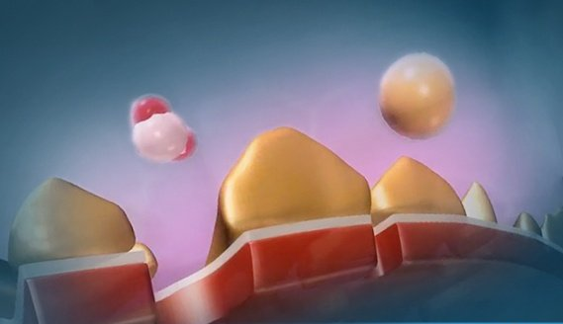
Inside the glomerulus, blood pressure pushes fluid from capillaries into the glomerular capsule through a specialized layer of cells. This layer, the filtration membrane, allows water and small solutes to pass but blocks blood cells and large proteins. Those components remain in the bloodstream. The filtrate (the fluid that has passed through the membrane) flows from the glomerular capsule further into the nephron.
3. Reabsorption Moves Nutrients and Water Back into the Bloodstream
The glomerulus filters water and small solutes out of the bloodstream. The resulting filtrate contains waste, but also other substances the body needs: essential ions, glucose, amino acids, and smaller proteins. When the filtrate exits the glomerulus, it flows into a duct in the nephron called the renal tubule. As it moves, the needed substances and some water are reabsorbed through the tube wall into adjacent capillaries. This reabsorption of vital nutrients from the filtrate is the second step in urine creation.
4. Waste Ions and Hydrogen Ions Secreted from the Blood Complete the Formation of Urine
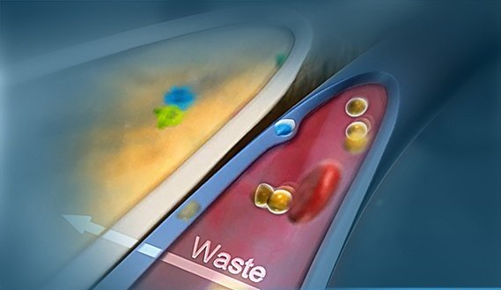
The filtrate absorbed in the glomerulus flows through the renal tubule, where nutrients and water are reabsorbed into capillaries. At the same time, waste ions and hydrogen ions pass from the capillaries into the renal tubule. This process is called secretion. The secreted ions combine with the remaining filtrate and become urine. The urine flows out of the nephron tubule into a collecting duct. It passes out of the kidney through the renal pelvis, into the ureter, and down to the bladder.
5. Urine Is 95% Water
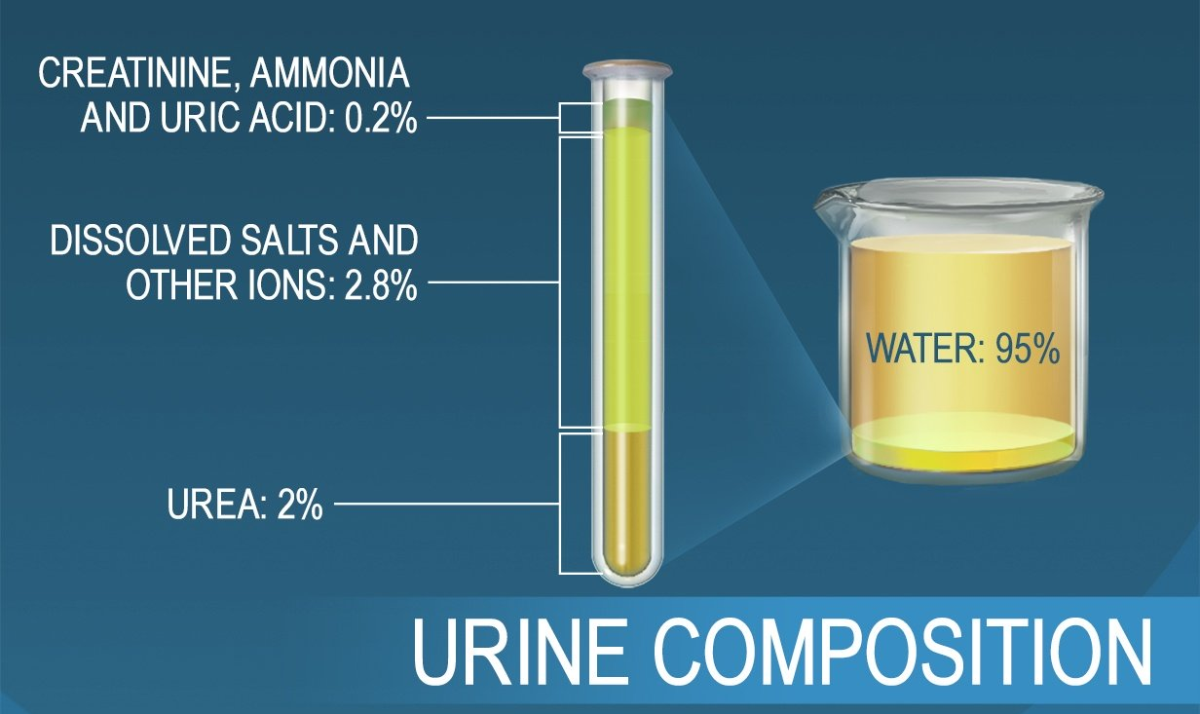
The nephrons of the kidneys process blood and create urine through a process of filtration, reabsorption, and secretion. Urine is about 95% water and 5% waste products. Nitrogenous wastes excreted in urine include urea, creatinine, ammonia, and uric acid. Ions such as sodium, potassium, hydrogen, and calcium are also excreted.

Urine Concentration
What Is a Urine Concentration Test?
A urine concentration test determines how well your kidneys are functioning. The test may be used to test your kidneys’ response to:
- too much fluid intake (water loading)
- too little fluid intake (dehydration)
- a hormone that should concentrate your urine, antidiuretic hormone (ADH)
You may take the test several times under different circumstances. The test itself is painless and all you have to do is provide a clean-catch urine sample.
What is the Purpose of a Urine Concentration Test?
Your doctor may recommend urine concentration testing if you are urinating too much or too little. The test can help identify specific types of problems with your kidneys.
The main reason this test is ordered is to see if you are suffering from central diabetes insipidus — a disease that causes excessive urination. This form of diabetes can occur when a head injury affects how your brain releases antidiuretic hormone (ADH). ADH normally increases the amount of water the kidneys retain. In central diabetes insipidus, your brain does not release enough ADH.
A urine concentration test can also be used to evaluate:
- dehydration
- kidney failure
- heart failure
- other hormone problems
- complications of a urinary tract infection

