Name: Iroegbu Ugochi Miriam
Matric. number: 17/mhs01/164
Department: Medicine and Surgery
Course: Physiology
- Discuss the pathophysiological process involved in renal failure
In view of the different clinical presentations, ARF in the NS is not a single, uniform pathophysiological entity. Factors that can be singled out to contribute to the decrease in glomerular filtration rate (GFR) are a low renal perfusion pressure, a decreased filtration coefficient, high intratubular pressure, ATN, interstitial nephritis and interstitial oedema. In the case of overt hypotension, a pre‐renal cause can be suspected. This is encountered particularly in children with persistent proteinuria that is so severe that blood volume cannot be maintained, such as in congenital NS. In children with relapsing minimal lesion NS, hypovolemic ARF may be encountered early during a relapse. The acute start of heavy proteinuria probably causes a disequilibrium between plasma and interstitial albumin concentrations. However, when plasma protein drops, proteinuria diminishes, and is often insufficient to remain a threat for hypovolemia as in congenital NS. We have tried to amend this in children presenting with early relapse of minimal lesion NS. Half of them had ‘hypovolemic symptoms’. Compared with non‐symptomatic children, they had stimulated neurohumoral factors and strong tubular sodium reabsorption, and a suppressed urinary dilution capacity, compatible with the presence of a pre‐renal factor. However, even in these children renal plasma flow was high, and the decreased GFR thus reflected a decreased filtration fraction.In adults, proteinuria is generally not marked enough to endanger the circulation . Relapses of minimal lesion NS develop more slowly, but may occasionally be acute, as occurs in children. It cannot be excluded, however, that adults with established NS are more liable to develop ARF if they suffer from some other complications such as septicaemia or blood loss. Indeed, blood volume that is normal while recumbent may drop below normal when standing. On the other hand, mobilization of excess tissue fluid in hypoproteinemic conditions is highly efficient. Excess fluid can mostly be removed without inducing hypotension or renal failure. However, complete removal of excess fluid may create an unsteady condition were changes in blood volume cannot be compensated.Approximately 30% of children and adults with idiopatic NS have a significant decrease in GFR. This is due to an intrinsic filtration impairment, since filtration fraction is low. Conceivably, ARF may reflect worsening of this intrinsic problem. However, glomerular changes, i.e. obliteration of epithelial slit pores as visible with electron microscopy, are not correlated with the reduction in GFR in humans. Filtration can also be impaired by a high intratubular pressure caused by protein casts but this possibility has received little attention. The following case history illustrates the possible importance of this factor.

- With the aid of a suitable diagrams discuss the types of dialysis you know?

Hemodialysis
Hemodialysis is the most common type of dialysis. This process uses an artificial kidney (hemodialyzer) to remove waste and extra fluid from the blood. The blood is removed from the body and filtered through the artificial kidney. The filtered blood is then returned to the body with the help of a dialysis machine.To get the blood to flow to the artificial kidney, your doctor will perform surgery to create an entrance point (vascular access) into your blood vessels. The three types of entrance points are:
- Arteriovenous (AV) fistula. This type connects an artery and a vein. It’s the preferred option.
- AV graft. This type is a looped tube.
- Vascular access catheter. This may be inserted into the large vein in your neck.
Both the AV fistula and AV graft are designed for long-term dialysis treatments. People who receive AV fistulas are healed and ready to begin hemodialysis two to three months after their surgery. People who receive AV grafts are ready in two to three weeks. Catheters are designed for short-term or temporary use.Hemodialysis treatments usually last three to five hours and are performed three times per week. However, hemodialysis treatment can also be completed in shorter, more frequent sessions.Most hemodialysis treatments are performed at a hospital, doctor’s office, or dialysis center. The length of treatment depends on your body size, the amount of waste in your body, and the current state of your health.After you’ve been on hemodialysis for an extended period of time, your doctor may feel that you’re ready to give yourself dialysis treatments at home. This option is more common for people who need long-term treatment.
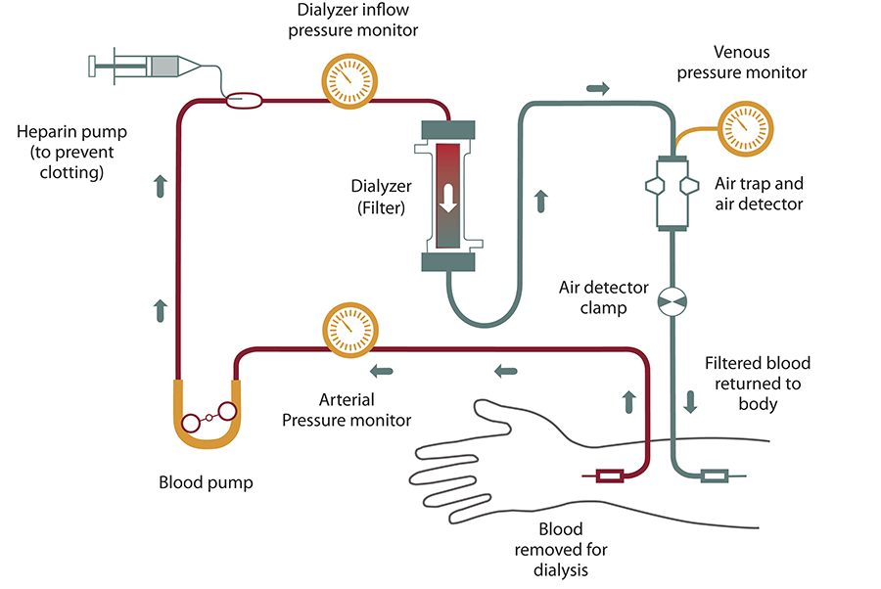

Peritoneal dialysis
Peritoneal dialysis involves surgery to implant a peritoneal dialysis (PD) catheter into your abdomen. The catheter helps filter your blood through the peritoneum, a membrane in your abdomen. During treatment, a special fluid called dialysate flows into the peritoneum. The dialysate absorbs waste. Once the dialysate draws waste out of the bloodstream, it’s drained from your abdomen.This process takes a few hours and needs to be repeated four to six times per day. However, the exchange of fluids can be performed while you’re sleeping or awake.
There are numerous different types of peritoneal dialysis. The main ones are:
- Continuous ambulatory peritoneal dialysis (CAPD). In CAPD, your abdomen is filled and drained multiple times each day. This method doesn’t require a machine and must be performed while awake.
- Continuous cycling peritoneal dialysis (CCPD). CCPD uses a machine to cycle the fluid in and out of your abdomen. It’s usually done at night while you sleep.
- Intermittent peritoneal dialysis (IPD). This treatment is usually performed in the hospital, though it may be performed at home. It uses the same machine as CCPD, but the process takes longer.
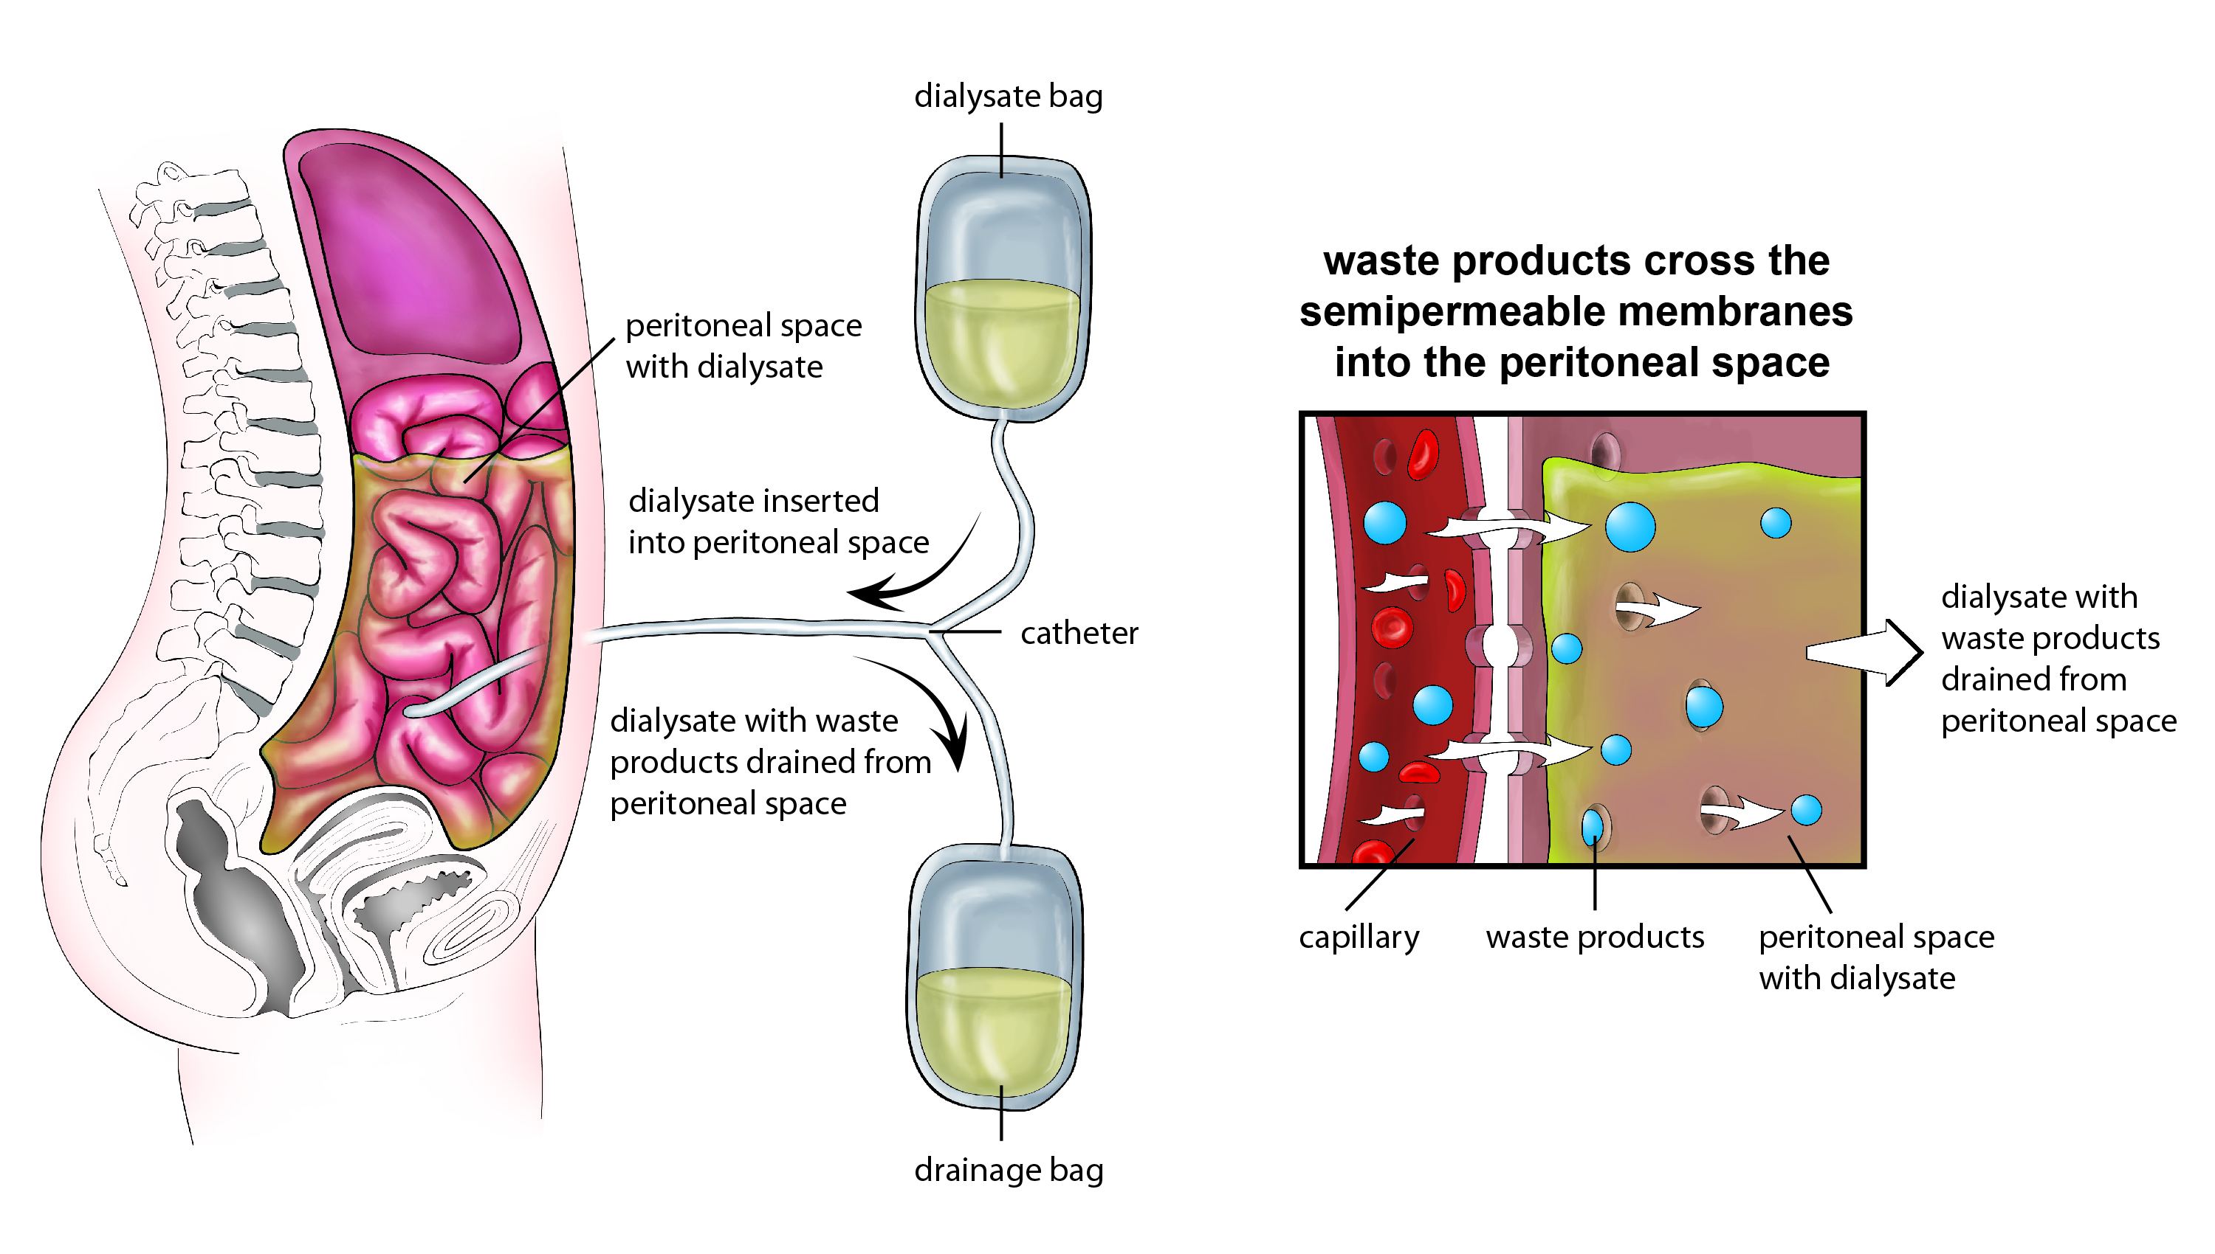

Continuous renal replacement therapy (CRRT)
This therapy is used primarily in the intensive care unit for people with acute kidney failure. It’s also known as hemofiltration. A machine passes the blood through tubing. A filter then removes waste products and water. The blood is returned to the body, along with replacement fluid. This procedure is performed 12 to 24 hours a day, generally every day.
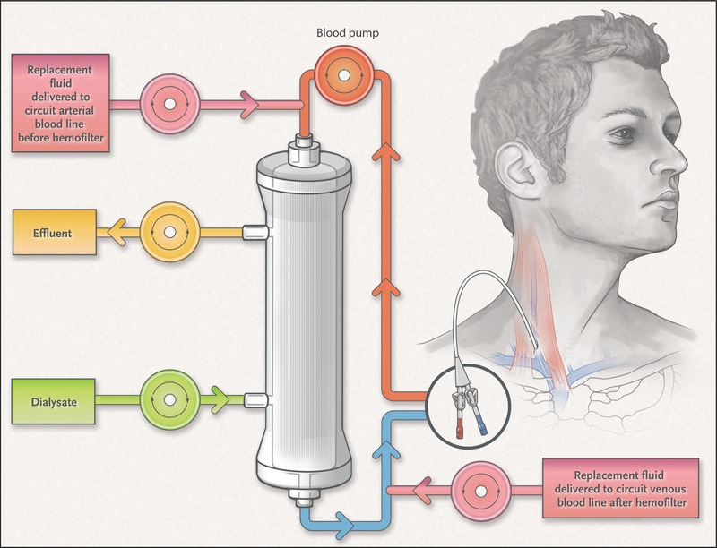

There are risk associated to this dialysis
While all three forms of dialysis can save your life, they also carry certain risks.

Risks associated with hemodialysis
Hemodialysis risks include:
- low blood pressure
- anemia, or not having enough red blood cells
- muscle cramping
- difficulty sleeping
- itching
- high blood potassium levels
- pericarditis, an inflammation of the membrane around the heart
- sepsis
- bacteremia, or a bloodstream infection
- irregular heartbeat
- sudden cardiac death, the leading cause of death in people undergoing dialysis

Risks associated with peritoneal dialysis
Peritoneal dialysis is associated with an increased risk for infections in or around the catheter site in the abdominal cavity. For example, after catheter implantation, a person can experience peritonitis. Peritonitis is an infection of the membrane lining the abdominal wall.
Other risks include:
- abdominal muscle weakening
- high blood sugar due to the dextrose in the dialysate
- weight gain
- hernia
- fever
- stomach pain

Risks associated with CRRT
The risks associated with CRRT include:
- infection
- hypothermia
- low blood pressure
- electrolyte disturbances
- bleeding
- delayed renal recovery
- weakening of bones
- anaphylaxis
If you continue to have these symptoms while on dialysis, tell the healthcare provider performing the treatment.
Those who undergo long-term dialysis treatments are also at risk of developing other medical conditions, including amyloidosis. This disease can occur when amyloid proteins produced in bone marrow build up in organs such as the kidneys, liver, and heart. This usually causes joint pain, stiffness, and swelling.
Some people may also develop depression after receiving a diagnosis of long-term kidney failure. If you’re having thoughts associated with depression, such as thoughts of harming yourself or committing suicide, call 911 or your local emergency services. The National Alliance on Mental Illness can also provide you with resources if you’re dealing with depression and a chronic condition.

