NAME: OYELADE ESTHER KOREDE
MATRIC-NUMBER: 18/MHS02/172
DEPARTMENT: NURSING
COURSE CODE: PHY 212
Explain urine formation and concentration

Urine Formation
Urine Formation – by filtering the blood the nephrons perform the following functions
(1) regulate concentration of solutes in blood plasma; this also regulates pH
(2) regulate water concentrations; this helps regulate blood pressure
(3) removes metabolic wastes and excess substances

- Urine Formation:
- Glomerular Filtration – water and solutes are forced through the capillary walls of the glomerulus into the Bowman’s capsule (glomerular capsule)
- Filtrate – the fluid that is filtered out into bowman’s capsule
Glomerular Filtration Rate is regulated by mechanisms:
- Autoregulation – the smooth muscle in the afferent arteriole responds to blood pressure changes by constricting and dilating to regulate filtration rate.
- Sympathetic control – causes afferent arterioles to constrict or dilate when activated by a nerve impulse (fight or flight response to keep blood pressure up)
Renin-angiotensin mechanism – triggered by the juxtaglomerular apparatus; when filtration rate decreases, the enzyme renin is released. Renin converts a plasma protein called angiotensinogen into angiotensin I. Angiotensin I is quickly converted into angiotensin II by another enzyme. Angiotensin II causes 3 changes:
- (1) Constriction of the arterioles – decreases urine formation and water loss
- (2) Stimulates the adrenal cortex to release aldosterone – promotes water reabsorption by causing the absorption of salt
- (3) Stimulates the posterior pituitary to release ADH – antidiuretic hormone – promotes water reabsorption
- (4) Stimulates the thirst and water intake (hypothalamus says we’re thirsty so we get a drink)

Tubular Reabsorption – occurs both passive and actively; glucose, amino acids, and other needed ions (Na, K, Cl, Ca, HCO3) are transported out of the filtrate into the peritubular capillaries (they are reabsorbed back into the blood); about 65% of the filtrate is reabsorbed in the proximal convoluted tubule.
- As these substances are reabsorbed, the blood becomes hypertonic so water easily follows by osmosis
- Reabsorption in the distal convoluted tubule is under hormonal control…aldosterone causes more salt to be absorbed, ADH causes more water to be absorbed

Secretion – waste products such as urea and uric acid, drugs and hydrogen and bicarbonate ions are move out of the peritubular capillaries into the filtrate; this removes unwanted wastes and helps regulate pH

- Urine – filtrate after it has passed through the nephron and undergone filtration, reabsorption, and secretion. The urine passes into the collecting duct, which joins with the minor calyx, major calyx, and eventually the renal pelvis. The renal pelvis joins with the ureter.

- Color – yellow color is due to urochrome – a pigment produced from the breakdown of bile pigments in the intestine
  - Deep yellow to orange – more concentrated, less water
  - Light yellow to clear – less concentrated, more water

Glomerular Filtration Rate (GFR)
The volume of filtrate formed by both kidneys per minute is termed the glomerular filtration rate (GFR). The heart pumps about 5 L blood per min under resting conditions. Approximately 20 percent or one liter enters the kidneys to be filtered. On average, this liter results in the production of about 125 mL/min filtrate produced in men (range of 90 to 140 mL/min) and 105 mL/min filtrate produced in women (range of 80 to 125 mL/min). This amount equates to a volume of about 180 L/day in men and 150 L/day in women. Ninety-nine percent of this filtrate is returned to the circulation by reabsorption so that only about 1–2 liters of urine are produced per day.
Table 2. Calculating Urine Formation per Day
 | Flow per minute (mL) | Calculation
Renal blood flow | 1050 | Cardiac output is about 5000 mL/minute, of which 21 percent flows through the kidney.  5000*0.21 = 1050 mL blood/min
Renal plasma flow | 578 | Renal plasma flow equals the blood flow per minute times the hematocrit. If a person has a hematocrit of 45, then the renal plasma flow is 55 percent.  1050*0.55 = 578 mL plasma/min
Glomerular filtration rate | 110 | The GFR is the amount of plasma entering Bowman’s capsule per minute. It is the renal plasma flow times the fraction that enters the renal capsule (19 percent).  578*0.19 = 110 mL filtrate/min
Urine | 1296 ml/day | The filtrate not recovered by the kidney is the urine that will be eliminated. It is the GFR times the fraction of the filtrate that is not reabsorbed (0.8 percent).  110*.08 = 0.9 mL urine /min  Multiply urine/min times 60 minutes times 24 hours to get daily urine production.  0.9*60*24 = 1296 mL/day urine
GFR is influenced by the hydrostatic pressure and colloid osmotic pressure on either side of the capillary membrane of the glomerulus. Recall that filtration occurs as pressure forces fluid and solutes through a semipermeable barrier with the solute movement constrained by particle size. Hydrostatic pressure is the pressure produced by a fluid against a surface. If you have a fluid on both sides of a barrier, both fluids exert a pressure in opposing directions. Net fluid movement will be in the direction of the lower pressure. Osmosis is the movement of solvent (water) across a membrane that is impermeable to a solute in the solution. This creates a pressure, osmotic pressure, which will exist until the solute concentration is the same on both sides of a semipermeable membrane. As long as the concentration differs, water will move. Glomerular filtration occurs when glomerular hydrostatic pressure exceeds the luminal hydrostatic pressure of Bowman’s capsule. There is also an opposing force, the osmotic pressure, which is typically higher in the glomerular capillary.
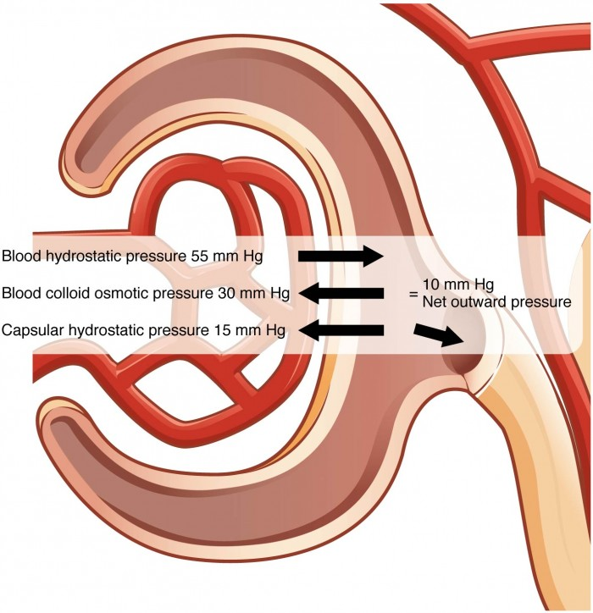
Figure 1. The NFP is the sum of osmotic and hydrostatic pressures.
To understand why this is so, look more closely at the microenvironment on either side of the filtration membrane. You will find osmotic pressure exerted by the solutes inside the lumen of the capillary as well as inside of Bowman’s capsule. Since the filtration membrane limits the size of particles crossing the membrane, the osmotic pressure inside the glomerular capillary is higher than the osmotic pressure in Bowman’s capsule. Recall that cells and the medium-to-large proteins cannot pass between the podocyte processes or through the fenestrations of the capillary endothelial cells. This means that red and white blood cells, platelets, albumins, and other proteins too large to pass through the filter remain in the capillary, creating an average colloid osmotic pressure of 30 mm Hg within the capillary. The absence of proteins in Bowman’s space (the lumen within Bowman’s capsule) results in an osmotic pressure near zero. Thus, the only pressure moving fluid across the capillary wall into the lumen of Bowman’s space is hydrostatic pressure. Hydrostatic (fluid) pressure is sufficient to push water through the membrane despite the osmotic pressure working against it. The sum of all of the influences, both osmotic and hydrostatic, results in a net filtration pressure (NFP) of about 10 mm Hg.
A proper concentration of solutes in the blood is important in maintaining osmotic pressure both in the glomerulus and systemically. There are disorders in which too much protein passes through the filtration slits into the kidney filtrate. This excess protein in the filtrate leads to a deficiency of circulating plasma proteins. In turn, the presence of protein in the urine increases its osmolarity; this holds more water in the filtrate and results in an increase in urine volume. Because there is less circulating protein, principally albumin, the osmotic pressure of the blood falls. Less osmotic pressure pulling water into the capillaries tips the balance towards hydrostatic pressure, which tends to push it out of the capillaries. The net effect is that water is lost from the circulation to interstitial tissues and cells. This “plumps up” the tissues and cells, a condition termed systemic edema.

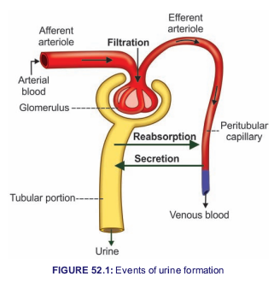

Urine concentration
When the water content in body decreases, kidney retains water and excretes concentrated urine. Formation of concentrated urine is not as simple as that of dilute urine.
It involves two processes:
1. Development and maintenance of medullary gradient by countercurrent system
2. Secretion of ADH.
MEDULLARY GRADIENT
MEDULLARY HYPEROSMOLARITY
Cortical interstitial fluid is isotonic to plasma with the osmolarity of 300 mOsm/L. Osmolarity of medullary interstitial fluid near the cortex is also 300 mOsm/L. However, while proceeding from outer part towards the inner part of medulla, the osmolarity increases gradually and reaches the maximum at the inner most part of medulla near renal sinus. Here, the interstitial fluid is hypertonic with osmolarity of 1,200 mOsm/L (figure 53.1).This type of gradual increase in the osmolarity of the medullary interstitial fluid is called the medullary gradient. It plays an important role in the concentration of urine.
DEVELOPMENT AND MAINTENANCE OF MEDULLARY GRADIENT
Kidney has some unique mechanism called countercurrent mechanism, which is responsible for the develop ­ment and maintenance of medullary gradient and hyperosmolarity of interstitial fluid in the inner medulla.
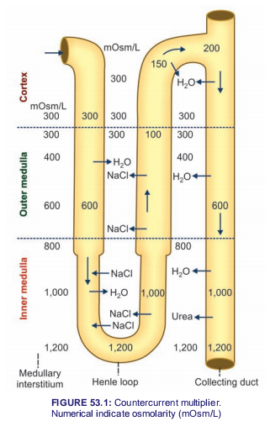
COUNTERCURRENT MECHANISM
COUNTERCURRENT FLOW
A countercurrent system is a system of ‘U’­shaped tubules (tubes) in which, the flow of fluid is in opposite direction in two limbs of the ‘U’­shaped tubules.
Divisions of Countercurrent System
Countercurrent system has two divisions:
1. Countercurrent multiplier formed by loop of Henle
2. Countercurrent exchanger formed by vasa recta.

COUNTERCURRENT MULTIPLIE
Loop of Henle
Loop of Henle functions as countercurrent multiplier. It is responsible for development of hyperosmolarity of medullary interstitial fluid and medullary gradient. Role of Loop of Henle in Development of Medullary Gradient Loop of Henle of juxtamedullary nephrons plays a major role as countercurrent multiplier because loop of these nephrons is long and extends upto the deeper parts of medulla. Main reason for the hyperosmolarity of medullary interstitial fluid is the active reabsorption of sodium chloride and other solutes from ascending limb of Henle loop into the medullary interstitium. These solutes accumulate in the medullary interstitium and increase the osmolarity. Now, due to the concentration gradient, the sodium and chlorine ions diffuse from medullary interstitium into the descending limb of Henle loop and reach the ascending limb again via hairpin bend. Thus, the sodium and chlorine ions are repeatedly recirculated between the descending limb and ascending limb of Henle loop through medullary interstitial fluid leaving a small portion to be excreted in the urine.Apart from this there is regular addition of more and more new sodium and chlorine ions into descending limb by constant filtration. Thus, the reabsorption of sodium chloride from ascending limb and addition ofnew sodium chlorine ions into the filtrate increase or multiply the osmolarity of medullary interstitial fluid and medullary gradient. Hence, it is called countercurrent multiplier. Other Factors Responsible for Hyperosmolarity of Medullary Interstitial Fluid In addition to countercurrent multiplier action provided by the loop of Henle, two more factors are involved in hyperosmolarity of medullary interstitial fluid.
- Reabsorption of sodium from collecting duct
Reabsorption of sodium from medullary part of collecting duct into the medullary interstitium, adds to the osmolarity of inner medulla.
ii. Recirculation of urea
Fifty percent of urea filtered in glomeruli is reabsorbed in proximal convoluted tubule. Almost an equal amount of urea is secreted in the loop of Henle. So the fluid in distal convoluted tubule has as much urea as amount filtered. Collecting duct is impermeable to urea. However, due to the water reabsorption from distal convoluted tubule and collecting duct in the presence of ADH, urea concentration increases in collecting duct. Now due to concentration gradient, urea diffuses from inner medullary part of collecting duct into medullary interstitium. Due to continuous diffusion, the concentration of urea increases in the inner medulla resulting in hyperosmolarity of interstitium in inner medulla. Again, by concentration gradient, urea enters the ascending limb. From here, it passes through distal convoluted tubule and reaches the collecting duct. Urea enters the medullary interstitium from collecting duct. By this way urea recirculates repeatedly and helps to maintain the hyperosmolarity of inner medullary interstitium. Only a small amount of urea is excreted in urine. Urea recirculation accounts for 50% of hyperosmolarity in inner medulla. Diffusion of urea from collecting duct into medullary interstitium is carried out by urea transporters, UT­A1 and UT­A3, which are activated by ADH.
COUNTERCURRENT EXCHANGER
Vasa Recta
Vasa recta functions as countercurrent exchanger. It is responsible for the maintenance of medullary gradient, which is developed by countercurrent multiplier
Role of Vasa Recta in the Maintenance of Medullary Gradient Vasa recta acts like countercurrent exchanger because of its position. It is also ‘U’­shaped tubule with a descending limb, hairpin bend and an ascending limb. Vasa recta runs parallel to loop of Henle. Its descending limb runs along the ascending limb of Henle loop and its ascending limb runs along with descending limb of Henle loop. The sodium chloride reabsorbed from ascending limb of Henle loop enters the medullary interstitium. From here it enters the descending limb of vasa recta. Simultaneously water diffuses from descending limb of vasa recta into medullary interstitium.
The blood flows very slowly through vasa recta. So, a large quantity of sodium chloride accumulates in descending limb of vasa recta and flows slowly towards ascending limb. By the time the blood reaches the ascending limb of vasa recta, the concentration of sodium chloride increases very much. This causes diffusion of sodium chloride into the medullary interstitium. Simultaneously, water from medullary interstitium enters the ascending limb of vasa recta. And the cycle is repeated.
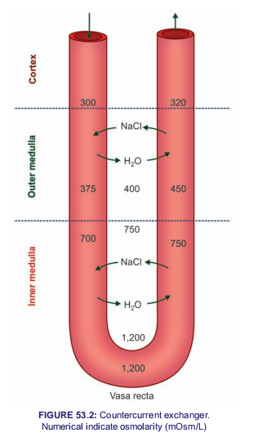
If the vasa recta would be a straight vessel without hairpin arrangement, blood would leave the kidney quickly at renal papillary level. In that case, the blood would remove all the sodium chloride from medullary interstitium and thereby the hyperosmolarity will be decreased. However, this does not happen, since the vasa recta has a hairpin bend. Therefore, when blood passes through the ascending limb of vasa recta, sodium chloride diffuses out of blood and enters the interstitial fluid of medulla and, water diffuses into the blood. Thus, vasa recta retains sodium chloride in the medullary interstitium and removes water from it. So, the hyperosmolarity of medullary interstitium is maintained. The blood passing through the ascending limb of vasa recta may carry very little amount of sodium chloride from the medulla. Recycling of urea also occurs through vasa recta. From medullary interstitium, along with sodium chloride, urea also enters the descending limb of vasa recta. When blood passes through ascending limb of vasa recta, urea diffuses back into the medullary interstitium along with sodium chloride. Thus, sodium chloride and urea are exchanged for water between the ascending and descending limbs of vasa recta, hence this system is called countercurrent exchanger.
ROLE OF ADH
Final concentration of urine is achieved by the action of ADH. Normally, the distal convoluted tubule and collecting duct are not permeable to water. But the presence of ADH makes them permeable, resulting in water reabsorption. Water reabsorption induced by ADH is called facultative reabsorption of water A large quantity of water is removed from the fluid while passing through distal convoluted tubule and collecting duct. So, the urine becomes hypertonic with an osmolarity of 1,200 mOsm/L (Fig. 53.3).
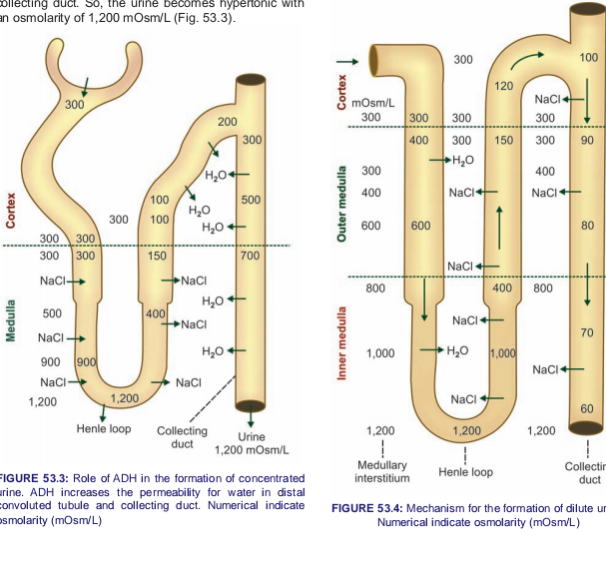

SUMMARY OF URINE CONCENTRATION
When the glomerular filtrate passes through renal tubule, its osmolarity is altered in different segments as described below (Fig. 53.4).

REFERENCE
Physiology of Urine Formation. Retrieved from, https://courses.lumenlearning.com/nemcc-ap/chapter/physiology-of-urine-formation/
K Sembulingam phD and Prema Sembulingam phD (sixth edition: 2012). Jaypee brothers medical publisher (P) ltd. ISBN 978-93-5025-936-8

