NAME: ERUVWETOPHURE JEMILAND
MAT NO: 17/MHS01/121
LEVEL: 300L
COURSE TITLE: RENAL PHYSIOLOGY
QUESTION 1 (PATHOPHYSIOLOGICAL PROCESS IN RENAL FAILURE)
Chronic kidney disease (CKD) occurs when kidneys are no longer able to clean toxins and waste product from the blood and perform their functions to full capacity. This can happen all of a sudden or over time. Chronic kidney disease (CKD) has five distinct stages.
The stages of kidney disease are based on the estimated Glomerular Filtration Rate (eGFR) number. The eGFR is a number based on one’s blood test for creatinine, a waste product in the blood.
- Stage 1 CKD: eGFR 90 mL/min or Greater
- Stage 2 CKD: eGFR Between 60 and 89 (mL/min)
- Stage 3 CKD: eGFR Between 30 and 59 (mL/min)
- Stage 4 CKD: eGFR Between 15 and 29 (mL/min)
- Stage 5 CKD: eGFR Less than 15 mL/min

STAGE 1 CHRONIC KIDNEY DISEASE (CKD)
Stage 1 CKD means you have mild kidney damage and an eGFR of 90 or greater.

Most of the time, an eGFR of 90 or greater means your kidneys are healthy and working well, but you have other signs of kidney damage. Signs of kidney damage could be protein in your urine (pee) or physical damage to your kidneys. Here are some ways to help slow down the damage to your kidneys in Stage 1 kidney disease:
- Control your blood sugar if you have diabetes
- Control your blood pressure
- Eat a healthy diet
- Do not smoke or use tobacco
- Be active 30 minutes a day, 5 days a week
- Stay at a healthy weight
- Ask your doctor if there are medicines you can take to help protect your kidneys
- Make an appointment to see a nephrologist (kidney doctor) even if you already have a general doctor

STAGE 2 CHRONIC KIDNEY DISEASES (CKD)
Stage 2 CKD means you have mild kidney damage and an eGFR between 60 and 89.
Most of the time, an eGFR between 60 and 89 means your kidneys are healthy and working well. But if you have Stage 2 kidney disease, this means you have other signs of kidney damage even though your eGFR is normal. Signs of kidney damage could be protein in your urine (pee) or physical damage to your kidneys. Here are some ways to help slow down the damage to your kidneys in Stage 2 kidney disease:

- Control your blood sugar if you have diabetes
- Control your blood pressure
- Eat a healthy diet
- Do not smoke or use tobacco
- Be active 30 minutes a day, 5 days a week
- Stay at a healthy weight
- Ask your doctor if there are medicines to protect your kidneys
- Make an appointment to see a nephrologist (kidney doctor) even if you already have a general doctor

STAGE 3 CHRONIC KIDNEY DISEASES
Stage 3 CKD means you have an eGFR between 30 and 59.
An eGFR between 30 and 59 means that there is some damage to your kidneys and they are not working as well as they should.
Stage 3 is separated into two stages:
Stage 3a means you have an eGFR between 45 and 59
Stage 3b means you have an eGFR between 30 and 44
Many people with Stage 3 kidney disease do not have any symptoms. But if there are symptoms, there may be:
- Swelling in your hands and feet
- Back pain
- Urinating (peeing) more or less than normal
At this stage, you are also more likely to have health complications as waste builds up in your body and your kidneys are not working well, such as:
- High blood pressure
- Anemia (a low number of red blood cells)
- Bone disease

STAGE 4 CHRONIC KIDNEY DISEASES
Stage 4 CKD means you have an eGFR between 15 and 29.
An eGFR between 15 and 30 means your kidneys are moderately or severely damaged and are not working as they should. Stage 4 kidney disease should be taken very seriously – it is the last stage before kidney failure.
At Stage 4 kidney disease, many people have symptoms such as:
- Swelling in your hands and feet
- Back pain
- Urinating (peeing) more or less than normal
At Stage 4, you will likely also have health complications as waste builds up in your body and your kidneys are not working well, such as:
- High blood pressure
- Anemia (a low number of red blood cells)
- Bone disease
At Stage 4 kidney disease, this is the time to start talking with your nephrologist about how to prepare for kidney failure. Once your kidneys have failed, you will need to start dialysis or have a kidney transplant to live.

STAGE 5 CHRONIC KIDNEY DISEASES
Stage 5 CKD means you have an eGFR less than 15.
An eGFR less than 15 means the kidneys are getting very close to failure or have completely failed. If your kidneys fail, waste builds up in your blood, which makes you very sick.

Some of the symptoms of kidney failure are:

Itching
Muscle cramps
Feeling sick and throwing up
Not feeling hungry
Swelling in your hands and feet
Back pain
Urinating (peeing) more or less than normal
Trouble breathing
Trouble sleeping
Once your kidneys have failed, you will need to start dialysis or have a kidney transplant to live.

QUESTION 2 (TYPES OF DIALYSIS)

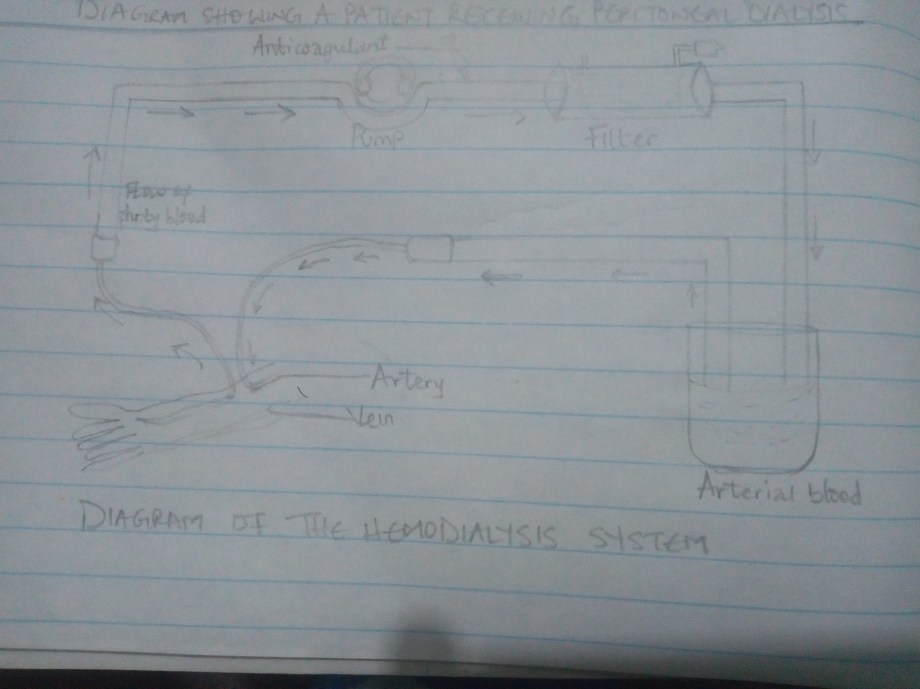

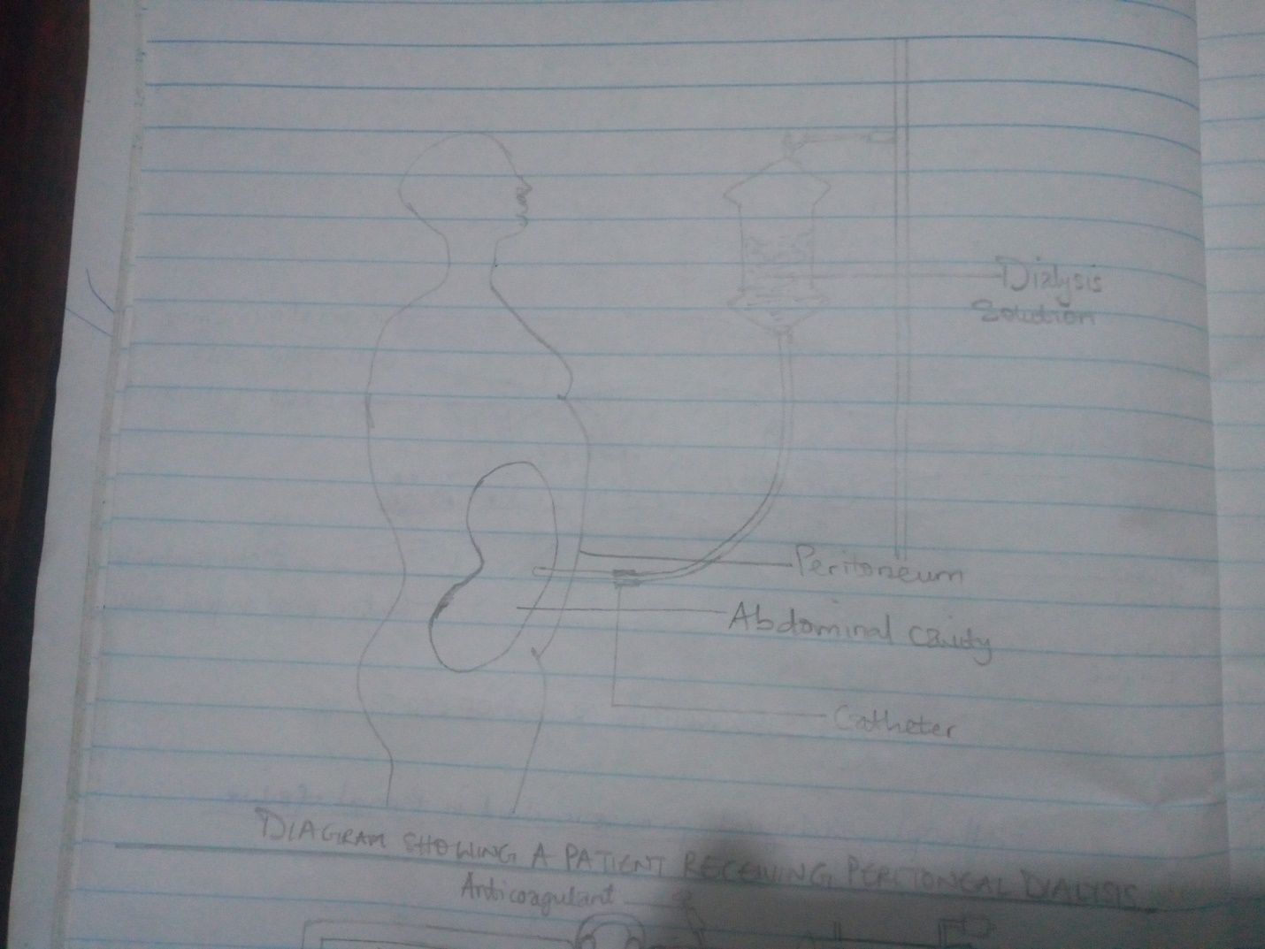

There are three different types of dialysis, they include;
- Hemodialysis
- Peritoneal dialysis
- Continuous renal replacement therapy

HEMODIALYSIS
Hemodialysis is the most common type of dialysis. This process uses an artificial kidney (hemodialyzer) to remove waste and extra fluid from the blood. The blood is removed from the body and filtered through the artificial kidney. The filtered blood is then returned to the body with the help of a dialysis machine.
In order to get blood to flow to the kidney during hemodialysis, a surgery is performed to create an entrance point (vascular access) into your blood vessels. The three types of entrance points are;
- Arteriovenous (AV) fistula. This type connects an artery and a vein. It’s the preferred option.
- AV graft. This type is a looped tube.
- Vascular access catheter. This may be inserted into the large vein in the neck; jugular vein.
Hemodialysis treatments usually last three to five hours and are performed three times per week. However, hemodialysis treatment can also be completed in shorter, more frequent sessions.
The length of treatment depends on your body size, the amount of waste in your body, and the current state of your health.
Risks associated with hemodialysis include;
- low blood pressure
- anemia
- muscle cramping
- difficulty sleeping
- itching
- high blood potassium levels
- pericarditis, an inflammation of the membrane around the heart
- sepsis
- bacteremia, or a bloodstream infection
- irregular heartbeat
- sudden cardiac death, the leading cause of death in people undergoing dialysis

PERITONEAL DIALYSIS
Peritoneal dialysis involves surgery to implant a peritoneal dialysis (PD) catheter into the abdomen of the patient. The catheter helps filter your blood through the peritoneum, a membrane in the abdomen. During treatment, a special fluid called dialysate flows into the peritoneum. The dialysate absorbs waste. Once the dialysate draws waste out of the bloodstream, it’s drained from your abdomen.
This process takes a few hours and needs to be repeated four to six times per day. However, the exchange of fluids can be performed while you’re sleeping or awake.
There are numerous different types of peritoneal dialysis. The main ones are:
- Continuous ambulatory peritoneal dialysis (CAPD). In CAPD, your abdomen is filled and drained multiple times each day. This method doesn’t require a machine and must be performed while awake.
- Continuous cycling peritoneal dialysis (CCPD). CCPD uses a machine to cycle the fluid in and out of your abdomen. It’s usually done at night while you sleep.
- Intermittent peritoneal dialysis (IPD). This treatment is usually performed in the hospital, though it may be performed at home. It uses the same machine as CCPD, but the process takes longer.

Risks associated with peritoneal dialysis include;
- An increased risk for infections in or around the catheter site in the abdominal cavity, e.g. Peritonitis
- abdominal muscle weakening
- high blood sugar due to the dextrose in the dialysate
- weight gain
- hernia
- fever
- stomach pain

CONTINUOUS RENAL REPLACEMENT THERAPY (CRRT)
This therapy is used primarily in the intensive care unit for people with acute kidney failure. It’s also known as hemofiltration. A machine passes the blood through tubing. A filter then removes waste products and water. The blood is returned to the body, along with replacement fluid. This procedure is performed 12 to 24 hours a day, generally every day. The machine used here is similar to that of hemodialysis machine.
Risks associated with CRRT include;
- infection
- hypothermia
- low blood pressure
- electrolyte disturbances
- bleeding
- delayed renal recovery
- weakening of bones
- anaphylaxis

