NAME; BELEMA SUCCESS
MATRIC NO; 18/MHS02/054
ASSIGNMENT: RENAL PHYSIOLOGY
QUESTION: EXPLAIN URINE FORMATION AND CONCENTRATION
Urine – filtrate after it has passed through the nephron and undergone filtration, reabsorption, and secretion. The urine passes into the collecting duct, which joins with the minor calyx, major calyx, and eventually the renal pelvis. The renal pelvis joins with the ureter.
Urine formation is a blood cleansing function. Normally, about 1,300 mL of blood (26% of cardiac output) enters the kidneys. Kidneys excrete the unwanted substances along with water from the blood as urine. Normal urinary output is 1 L/day to 1.5 L/day.
Processes of Urine Formation: When blood passes through glomerular capillaries, the plasma is filtered into the Bowman capsule. This process is called glomerular filtration. Filtrate from Bowman capsule passes through the tubular portion of the nephron. While passing through the tubule, the filtrate undergoes various changes both in quality and in quantity. Many wanted substances like glucose, amino acids, water and electrolytes are reabsorbed from the tubules. This process is called tubular reabsorption. And, some unwanted substances are secreted into the tubule from peritubular blood vessels. This process is called tubular secretion or excretion. Thus, the urine formation includes three processes:
Glomerular filtration
B. Tubular reabsorption
C. Tubular secretion.
Among these three processes filtration is the function of the glomerulus. Reabsorption and secretion are the functions of tubular portion of the nephron.
- Glomerular filtration is the process by which the blood is filtered while passing through the glomerular capillaries by filtration membrane. It is the first process of urine formation. The structure of filtration membrane is well suited for filtration.
- Tubular reabsorption is the process by which water and other substances are transported from renal tubules back to the blood. When the glomerular filtrate flows through the tubular portion of nephron, both quantitative and qualitative changes occur. Large quantity of water (more than 99%), electrolytes and other substances are reabsorbed by the tubular epithelial cells. The reabsorbed substances move into the interstitial fluid of renal medulla. And, from here, the substances move into the blood in peritubular capillaries. Since the substances are taken back into the blood from the glomerular filtrate, the entire process is called tubular reabsorption.
- Tubular secretion is the process by which the substances are transported from blood into renal tubules. It is also called tubular excretion. In addition to reabsorption from renal tubules, some substances are also secreted into the lumen from the peritubular capillaries through the tubular epithelial cells. With all these changes, the filtrate becomes urine.

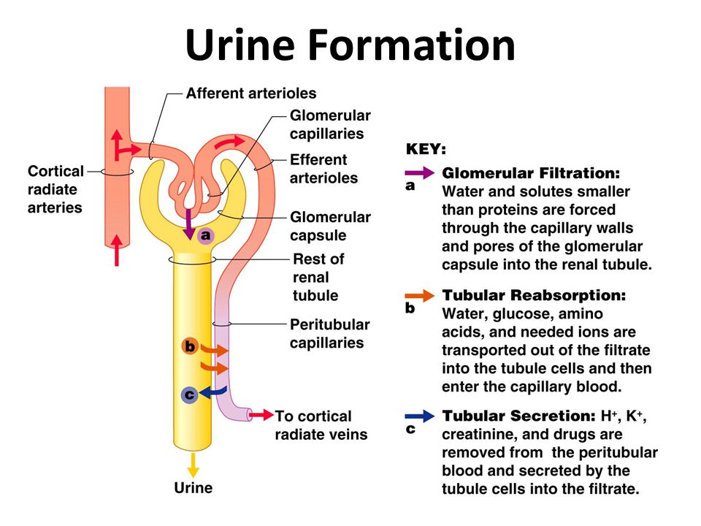

CONCENTRATION OF URINE
As already indicated, the loop of Henle is critical to the ability of the kidney to concentrate urine. The high concentration of salt in the medullary fluid is believed to be achieved in the loop by a process known as countercurrent exchange multiplication. The principle of this process is analogous to the physical principle applied in the conduction of hot exhaust gases past cold incoming gas so as to warm it and conserve heat. That exchange is a passive one, but in the kidney the countercurrent multiplier system uses energy to “pump” sodium and chloride out of the ascending limb of the loop into the medullary fluid. From there it enters (by diffusion) the filtrate (isotonic with plasma) that is entering the descending limb from the proximal tubule, thus raising its concentration a little above that of plasma. As this luminal fluid in turn reaches the ascending limb, and subsequently the distal tubule, it in turn provides more sodium to be pumped out into the surrounding fluid or blood, if necessary, and transported (by diffusion) back into the descending limb; this concentrating process continues until the osmotic pressure of the fluid is sufficient to balance the resorptive power of the collecting ducts in the medulla, through which all of the final urine must pass. This resorptive capacity in the ducts is regulated by antidiuretic hormone (ADH), which is secreted by the hypothalamus and stored in the posterior pituitary gland at the base of the brain. In the presence of ADH, the medullary collecting ducts become freely permeable to solute and water. As a consequence, the fluid entering the ducts (en route to the renal pelvis and subsequent elimination) acquires the concentration of the interstitial fluid of the medulla; i.e., the urine becomes concentrated. On the other hand, in the absence of ADH, the collecting ducts are impermeable to solute and water, and, thus, the fluid in the lumen, from which some solute has been removed, remains less concentrated than plasma; i.e., the urine is dilute.

