NAME: OTENE VICTOR.A.
MATRIC NO: 17/SCI01/072

31)
Finite automata is an abstract computing device. It is a mathematical model of a system with
Discrete (inputs, outputs, states and set of transitions) from state to state that occurs on input
Symbols from alphabet ∑
It can be represented in 3 forms; -Graphical (Transition Diagrams of transition table)
-Tabula (Transition table)
-Mathematical (Transition function of mapping function)
32 – 34)
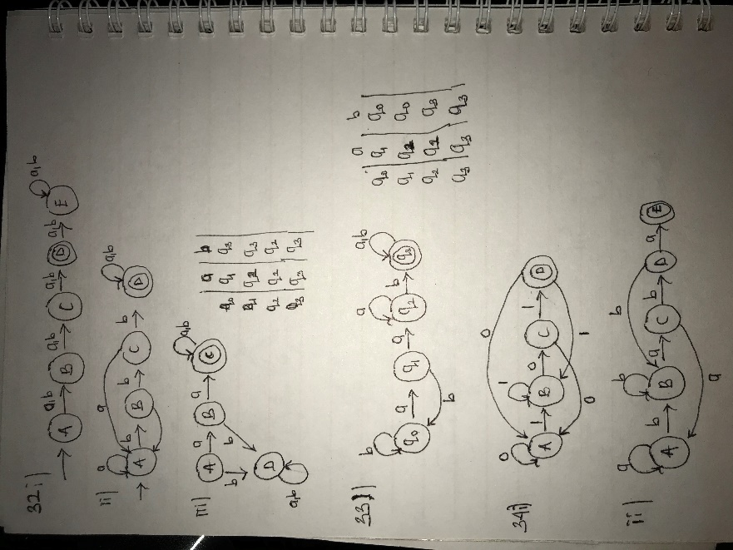

35 – 38)
