NAME: OTENE VICTOR.A.
MATRIC NO: 17/SCI01/072
1)
Complexity
complexity is concerned with the resources required to compute the things that are computable generally, Complexity is about how efficiently can it be computed.
As the amount of resources required to run an algorithm generally varies with the size of the input, the complexity is typically expressed as a function n → f(n), where n is the size of the input and f(n) is either the worst-case complexity
Computability
Put succinctly, computability theory is concerned with what can be computed versus what cannot, Computability is about what can be computed.
2)
Complexity
In general, complexity theory provides new viewpoints on various phenomena that were considered also by past thinkers. Examples include the aforementioned concepts of proofs and representation as well as concepts like randomness, knowledge, interaction, secrecy and learning
Computability
for a simpler example, the set of prime numbers is certainly a decidable set. That is, there are quite mechanical procedures, which are taught in the schools, for deciding whether or not any given integer is a prime number. (For a very large number, the procedure taught in the schools might take a long time.) If we want, we can write a computer program to execute the procedure.
3)
A set
Well, simply put, it's a collection it is just things grouped together with a certain property in common. For example, the set given by the rule “prime numbers less than 10” can also be given by {2, 3, 5, 7}.
Power set
In set theory, the power set (or powerset) of a Set A is defined as the set of all subsets of the Set A including the Set itself and the null or empty set. It is denoted by P(A). Basically, this set is the combination of all subsets including null set, of a given set.
Let us say Set A = { a, b, c }
Number of elements: 3
Therefore, the subsets of the set are:
{ } which is the null or the empty set
{ a }
{ b }
{ c }
{ a, b }
{ b, c }
{ c, d }
{ a, b, c }
The power set P(A) = { { } , { a }, { b }, { c }, { a, b }, { b, c }, { c, d }, { a, b, c } }
Now, the Power Set should have 2³ = 8 elements.

Member of a set
The set membership symbol ∈ is used to say that an object is a member of a set. It has a partner symbol ∈/ which is used to say an object is not in a set.
For example, if AA is the set {♢,♡,♣,♠}{♢,♡,♣,♠}, then ♡∈A♡∈A but △∉A△∉A (where the symbol ∉∉ means “not an element of”).

Subset
For two sets S and T we say that S is a subset of T if each element of S is also an element of T . In formal notation S ⊆ T if for all x ∈ S we have x ∈ T .
If A = {a, b, c} then A has eight different subsets: ∅ {a} {b} {c} {a, b} {a, c} {b, c} {a, b, c} Notice that A ⊆ A and in fact each set is a subset of itself. The empty set ∅ is a subset of every set.

Proper subset
A proper subset of a set A is a subset of A that is not equal to A. In other words, if B is a proper subset of A, then all elements of B are in A but A contains at least one element that is not in B. For example, if A={1,3,5} then B={1,5} is a proper subset of A.

Infinite set
If a set is not finite, it is called an infinite set because the number of elements in that set is not countable and also we cannot represent it in Roster form. Thus, infinite sets are also known as uncountable sets.
Examples
- A set of all whole numbers.W= {0, 1, 2, 3, 4,…}
- A set of all points on a line.

Finite sets
These are the sets having a finite/countable number of members. Finite sets are also known as countable sets as they can be counted. The process will run out of elements to list if the elements of this set have a finite number of members.
Examples of finite sets:
P={ 0, 3, 6, 9, …, 99}
Q={ a : a is an integer, 1<a<10}
A set of all English Alphabets (because it is countable)

Unordered pair
In mathematics, an unordered pair or pair set is a set of the form {a, b}, i.e. a set having two elements a and b with no particular relation between them
For example
Call this object ⟨2, 3⟩, which specifies that 2 is the first component and 3 is the second component. We also make the requirement that ⟨2, 3⟩≠⟨3, 2⟩.
Ordered pair
In contrast, an ordered pair (a, b) has a as its first element and b as its second element.
for example, 2, 32, 3, which can also be thought of as an unordered pair, in that 2, 3=3, 22, 3=3, 2

Union of a set
The union of two sets S and T is the collection of all objects that are in either set. It is written S ∪ T . Using curly brace notion
Example
Suppose S = {1, 2, 3}, T = {1, 3, 5}, and U = {2, 3, 4, 5}. Then: S ∪ T = {1, 2, 3, 5}, S ∪ U = {1, 2, 3, 4, 5}, and T ∪ U = {1, 2, 3, 4, 5}

Intersection of set
The intersection of two sets S and T is the collection of all objects that are in both sets. It is written S ∩ T . Using curly brace notation
Suppose S = {1, 2, 3, 5}, T = {1, 3, 4, 5}, and U = {2, 3, 4, 5}. Then:
S ∩ T = {1, 3, 5}, S ∩ U = {2, 3, 5}, and T ∩ U = {3, 4, 5}

Complement of a set
The compliment of a set S is the collection of objects in the universal set that are not in S. The compliment is written S c . In curly brace notation
Example
Let the universal set be {1, 2, 3, 4, 5}, then the compliment of S = {1, 2, 3} is S c = {4, 5} while the compliment of T = {1, 3, 5} is T c = {2, 4}.

Difference of a set
The difference of two sets S and T is the collection of objects in S that are not in T . The difference is written S − T . In curly brace notation
Example: Let A = {a, b, c, d} and B = {b, d, e}. Then A – B = {a, c} and B – A = {e}

Symmetric difference of a set
the symmetric difference, also known as the disjunctive union, of two sets is the set of elements which are in either of the sets and not in their intersection. The symmetric difference of the sets A and B is commonly denoted by
For example, the symmetric difference of the sets {1,2,3} and {3,4} is {1,2,4}.

4)
B∩C
{Ø}
A∩D
{2,3,5,6,9}
A∩C
{3,5,9}
A∪B
{0,2,3,4,5,6,7,8,9,10,11,12,13,14,15,16,17,18,19,20}
B∪D
{0,1,2,3,4,5,6,7,8,9,10,11,12,13,14,15,16,17,18,19,20}
C∪D
{1,2,3,4,5,6,7,8,9,11,13,15,17….}
B^c
{0,2,4, 8,....,20}
D^c
{2,4,6,8}
C^c
{Ø}
A-B
{3,5,9}
D-C
{2,4,6,8}
C-D
{1,3,5,...}
. A⊕C
A-C = {2,6}
C-A = {1,7,11…}
Therefore {1,2,6,7,11…}

B⊕C
B-C = {0,2,4, 8,....,20}
C-B = {1,3,5,...}
Therefore {1,2,3,4,5,6,7…..}

C⊕D
C-D = {7,11,13,15,17…}
D-C = {2,4,6,8}
Therefore {2,4,6,8,11,13,15,17….}

D⊕B
D-B = {1,3,5,9}
B-D = {10,12,14….20}
Therefore {1,3,5,9,10,12,14….20}

5)
Alphabet
an alphabet is a finite set of symbols. For example {0, 1} is an alphabet with two symbols, {a, b} is another alphabet with two symbols and English alphabet is also an alphabet
Word
A word over an alphabet can be any finite sequence (i.e., string) of letters. The set of all words over an alphabet Σ is usually denoted by Σ*
Length of a word
The length of a word is the number of letters it is composed of.
Substring
a substring is a contiguous sequence of characters within a string. For instance, "the best of" is a substring of "It was the best of times"
Initial segment
This is the first letter of a substring
Concatenation of strings
In formal language theory and computer programming, string concatenation is the operation of joining character strings end-to-end. For example, the concatenation of "snow" and "ball" is "snowball"
Language
In the lectures, the language of set theory is defined to be a language of first-order. predicate calculus with equality, with a single binary predicate symbol G.
6)
i) 13
ii) anocnoitetac
iii) UV = catetionconaconcatenation
iv) E⁰ = {E}
E¹ = {c, a, o, n, t, a, i, o, n, e}
E² = {ca, ac co, nt, ta, at, ti, io, on, ne}
E³ = {cac, aco, con, ont, nta, tat, ati, tio, ion, one}
E⁴ = {caco, acon, cont, onta, ntat, tati, ati, tion, ione}
E⁵ = {cacon, acont, conta, ontat, ntati, tatio, ation, tione}
E⁶ = {cacont, aconta, contat, ontati, ntatio, tation, atione}
E⁷ = {caconta, acontat, contati, ontatio, ntation, tatione}
E⁸ = {cacontat, acontati, contatio, ontation, ntatione}
E⁹ = {cacontati, acontatio, contation, ontatione}
E¹⁰ = {cacontatio, acontation, contatione}
E¹¹ = {cacontation,acontatione}
E¹² = {cacontatione}
M = {c, a, o, n, t, a, i, o, n, e , ca, ac, co, nt, ta, at, ti, io, on, ne, cac, aco, con, ont, nta, tat, ati, tio, ion, one, caco, acon, cont, onta, ntat, tati, ati, tion, ione, cacon, acont, conta, ontat, ntati, tatio, ation, tione, cacont, aconta, contat, ontati, ntatio, tation, atione, caconta, acontat, contati, ontatio, ntation, tatione, cacontat, acontati, contatio, ontation, ntatione, cacontati, acontatio, contation, ontatione, cacontatio, acontation, contatione, cacontation,acontatione, cacontatione}

7) E⁰ = {E}
E¹ = {a, b, c, r}
E² = {ab, br ac, ca, ba, ra}
E³ = {abr, bra, rac, aca, cab, aba}
E⁴ = {abra, brac, raca, acab, caba}
E⁵ = {abrac, braca, racab, acaba}
E⁶ = {abraca, bracaba, racaba}
E⁷ = {abracab, bracaba}
E⁸ = {abracaba}
U = {E, a, b, c, r, ab, br ac, ca, ba, ra, abr, bra, rac, aca, cab, aba, abra, brac, raca, acab, caba, abrac, braca, racab, acaba, abraca, bracaba, racaba, abracab, bracaba, abracaba}
ii) a
8)
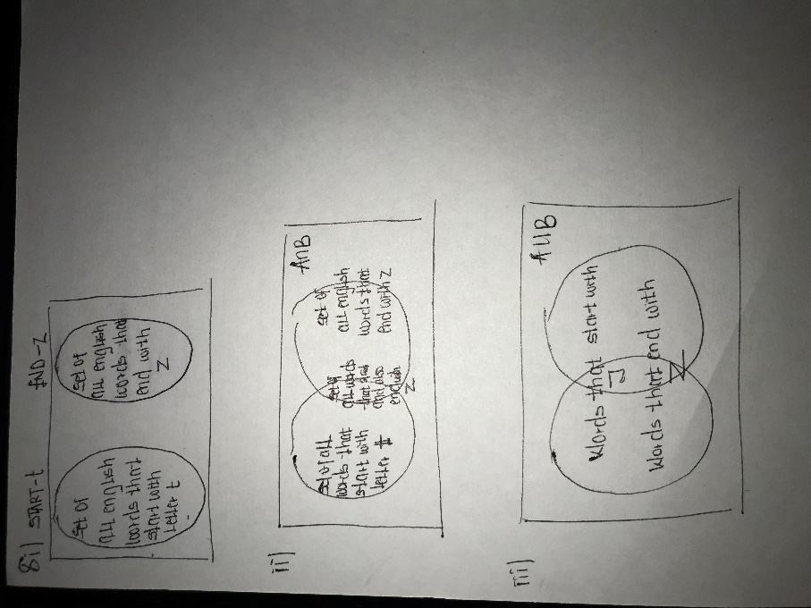
9)
i) {011, 11. 111, 0, 111, 1111,….}
ii) {01, 011, 001, 0101, 0011,……}
iii) {01, 10, 00, 11}
iv) {10, 0110, 0010, 010, 110,…..}
10)
i) {e, n, o, u, g, h}
ii) {b, e, a, r, 2, 0}
iii) {0, 1}
11)
i) {o, op, op²……}
ii) {o^{m}, p^{m} | m > 0}
iii) {o^{m}, p^{n} | m > 0, n > 0}
iv) {o^{m}, p^{n} | m = 4, n = 4}

12)
i) Consists of words starting with one or more B followed by one A
ii) Consists of words starting with zero or more A followed by A followed by one or more B
iii) Consists of words starting with zero or more B followed by zero or more B followed by
zero or more A
iv) {a^{m}, b^{n} | m > 0, n > 0} consists of words starting with one or more A followed by one or
more B
13)
i) {b^{m}, ab^{n} | m >= 0, n >=0}
ii) {b^{m}, a^{n} | m > 0, n >0}
iii) {b, bb, b²……………..}
iv) {a^{m}, b^{m} | m > 0}

14)
Union – L1 U L2 = {U ∈ ∑* | U ∈ L1 or U ∈ L2}
Intersection – L1 n L2 = {U ∈ ∑* | U ∈ L1 or U ∈ L2}
Difference – L1 – L2 = {U ∈ ∑* | U ∈ L1 or U ∉ L2}
Compliment – L’ = ∑*- L
Positive closure – L⁺ = _{i=0}∞ U L = L1 U L2 U….. UL^{i}, U…
Star operation – L* = _{i=0}∞ U L^{i} = L⁰UL¹UL²U……UL^{i}
Power – L⁰ = {∈}, L^{n} = L^{n-1}

