Name: Okunade Olateju Faith
Course code: PHS212
Matric number: 18/mhs02/139
Department: Nursing science
1. Discuss the diseases of the renal system.

The urinary system, also known as the renal system or urinary tract, consists of the kidneys, ureters, bladder, and the urethra. The purpose of the urinary system is to eliminate waste from the body, regulate blood volume and blood pressure, control levels of electrolytes and metabolites, and regulate blood pH.
Diseases is defined as:
A disease is a particular abnormal condition that negatively affects the structure or function of all or part of an organism, and that is not due to any immediate external injury. Diseases are often known to be medical conditions that are associated with specific symptoms and signs.
The urinary system, also known as the renal system or urinary tract, consists of the kidneys, ureters, bladder, and the urethra. The purpose of the urinary system is to eliminate waste from the body, regulate blood volume and blood pressure, control levels of electrolytes and metabolites, and regulate blood pH.

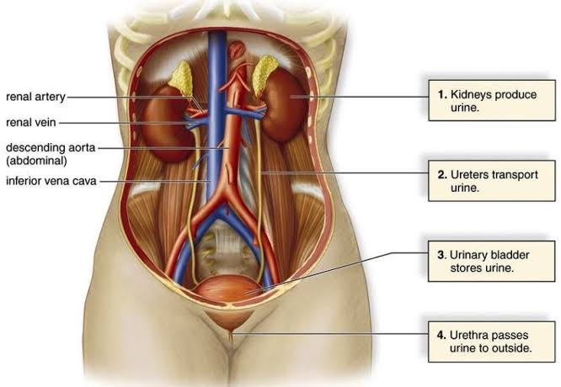
Kidney disease, or renal disease, also known as nephropathy, is damage to or disease of a kidney. Nephritis is an inflammatory kidney disease and has several types according to the location of the inflammation. Inflammation can be diagnosed by blood tests. Nephrosis is non-inflammatory kidney disease. Nephritis and nephrosis can give rise to nephritic syndromeand nephrotic syndrome respectively. Kidney disease usually causes a loss of kidney function to some degree and can result in kidney failure, the complete loss of kidney function. Kidney failure is known as the end-stage of kidney disease, where dialysis or a kidney transplant is the only treatment option.

What is kidney disease?
The kidneys are a pair of fist-sized organs located at the bottom of the rib cage. There is one kidney on each side of the spine.

Kidneys are essential to having a healthy body. They are mainly responsible for filtering waste products, excess water, and other impurities out of the blood. These toxins are stored in the bladder and then removed during urination. The kidneys also regulate pH, salt, and potassium levels in the body. They produce hormones that regulate blood pressure and control the production of red blood cells. The kidneys even activate a form of vitamin D that helps the body absorb calcium.

Damage may be caused by diabetes, high blood pressure, and various other chronic (long-term) conditions. Kidney disease can lead to other health problems, including weak bones, nerve damage, and malnutrition.

If the disease gets worse over time, your kidneys may stop working completely. This means that dialysis will be required to perform the function of the kidneys. Dialysis is a treatment that filters and purifies the blood using a machine. It can’t cure kidney disease, but it can prolong your life.

What are the symptoms of kidney disease?
Kidney disease is a condition that can easily go unnoticed until the symptoms become severe. The following symptoms are early warning signs that you might be developing kidney disease:

fatigue
difficulty concentrating
trouble sleeping
poor appetite
muscle cramping
swollen feet/ankles
puffiness around the eyes in the morning
dry, scaly skin
frequent urination, especially

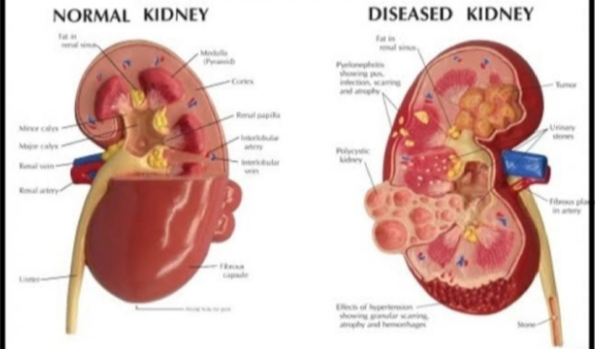

What are the types of kidney disease?
Chronic kidney disease
The most common form of kidney disease is chronic kidney disease. Chronic kidney disease is a long-term condition that doesn’t improve over time. It’s commonly caused by high blood pressure.

High blood pressure is dangerous for the kidneys because it can increase the pressure on the glomeruli. Glomeruli are the tiny blood vessels in the kidneys where blood is cleaned. Over time, the increased pressure damages these vessels and kidney function begins to decline.

Kidney function will eventually deteriorate to the point where the kidneys can no longer perform their job properly. In this case, a person would need to go on dialysis. Dialysis filters extra fluid and waste out of the blood. Dialysis can help treat kidney disease but it can’t cure it. A kidney transplant may be another treatment option depending on your circumstances.

Diabetes is also a major cause of chronic kidney disease. Diabetes is a group of diseases that causes high blood sugar. The increased level of sugar in the blood damages the blood vessels in the kidneys over time. This means the kidneys can’t clean the blood properly. Kidney failure can occur when your body becomes overloaded with toxins.

Kidney stones
Kidney stones are another common kidney problem. They occur when minerals and other substances in the blood crystallize in the kidneys, forming solid masses (stones). Kidney stones usually come out of the body during urination. Passing kidney stones can be extremely painful, but they rarely cause significant problems.

Glomerulonephritis
Glomerulonephritis is an inflammation of the glomeruli. Glomeruli are extremely small structures inside the kidneys that filter the blood. Glomerulonephritis can be caused by infections, drugs, or congenital abnormalities (disorders that occur during or shortly after birth). It often gets better on its own.
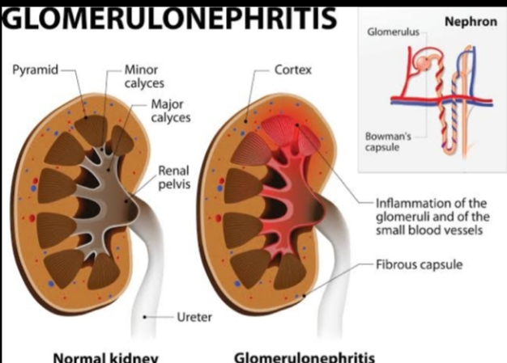

Kidney failure
Kidney failure is defined by functional impairment of the kidney, that is when the kidneys are functioning at 15% or less than normal capability. It is divided into acute kidney failure (cases that develop rapidly) and chronic kidney failure (those that are long term). Symptoms may include leg swelling, feeling tired, vomiting, loss of appetite, and confusion. Complications of acute disease may include uremia, high blood potassium, and volume overload. Complications of chronic disease may include heart disease, high blood pressure, and anemia.
Renal failure:
Kidneys are a pair of organs that are responsible for filtering out the waste products from the body. Not only that, but they also have a role in electrolyte balance maintenance, hormonal regulation, regulation of blood pressure and RBC synthesis. When any of these functions ceases to occur properly, it leads to renal failure. In most people, one kidney fails after the other. If detected in time, iit can be either removed or transplanted. In case of acute failure, the patient is required to survive on dialysis or kidney transplantation.
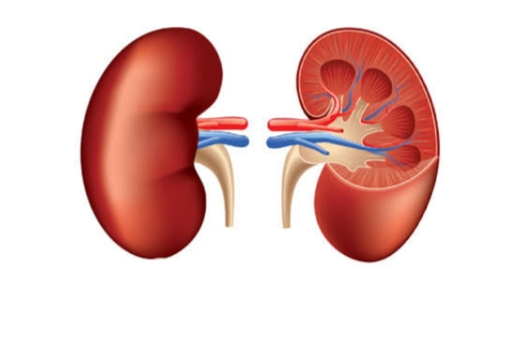
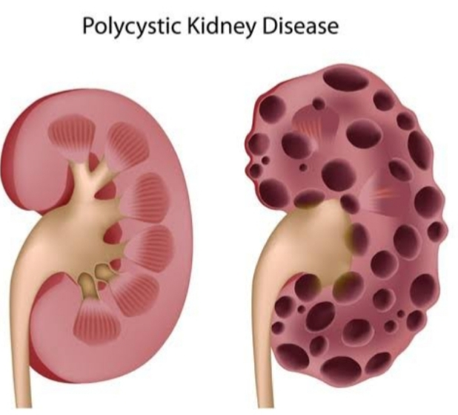

There are 2 types of renal failure:

Acute renal failure: This occurs suddenly. The patient experiences obvious discomfort and pain associated with it. This condition can be treated if diagnosed in time. Medications are usually enough to handle it. But if that fails, dialysis or transplantation also works well.

Chronic renal failure: This one is more dangerous. It takes approximately 3 months to develop and causes permanent damage to the kidneys.

How does renal failure occur?
Renal failure occurs in a number of steps. The glomerular filtration rate is the standard way of gauging the kidney functionality.

Stage 1 with normal or high GFR (GFR > 90 mL/min): The patients seldom realize that they are facing kidney issues. There are no telltale signs. Most get to know about it when they are diagnosed with diabetes or high BP>

Stage 2 Mild CKD (GFR = 60-89 mL/min): Blood may appear in the urine. But in most cases, the patient appears fit and fine.

Stage 3A Moderate CKD (GFR = 45-59 mL/min): Fatigue, fluid retention in the body, kidney pain, insomnia, and urine nature changes are seen in this stage.

Stage 3B Moderate CKD (GFR = 30-44 mL/min): GFR level is 30-44mL/min with blood in urine.

Stage 4 Severe CKD (GFR = 15-29 mL/min): The patient is at risk of developing complications at this stage. Most need to go through dialysis.

Stage 5 End Stage CKD (GFR <15 mL/min): This is the last stage. Apart from all the symptoms mentioned above, the patient‘s kidneys lose all their ability to work on their own. The patient may feel dizziness and hallucinate. Dialysis and kidney transplantation is extremely necessary to keep the patient alive.

- Urinary tract infections (UTIs) are infectionsthat affect part of the urinary tract. When it affects the lower urinary tract it is known as a bladder infection (cystitis) and when it affects the upper urinary tract it is known as a kidney infection (pyelonephritis). Symptoms from a lower urinary tract infection include pain with urination, frequent urination, and feeling the need to urinate despite having an empty bladder. Symptoms of a kidney infection include feverand flank pain usually in addition to the symptoms of a lower UTI. Rarely the urine may appear bloody. In the very old and the very young, symptoms may be vague or non-specific.
- Interstitial cystitis (IC), also known as bladder pain syndrome (BPS), is a type of chronic pain that affects the bladder. Symptoms include feeling the need to urinate right away, needing to urinate often, and pain with sex.
. IC/BPS is associated with depression and lower quality of life. Many of those affected also have irritable bowel syndrome and fibromyalgia.
- Incontinence (UI), also known as involuntary urination, is any uncontrolled leakage of urine. It is a common and distressing problem, which may have a large impact on quality of life. It has been identified as an important issue in geriatric health care. The term enuresis is often used to refer to urinary incontinence primarily in children, such as nocturnal enuresis (bed wetting).
- Benign prostatic hyperplasia (BPH), also called prostate enlargement, is a noncancerous increase in size of the prostate gland. Symptoms may include frequent urination, trouble starting to urinate, weak stream, inability to urinate, or loss of bladder control. Complications can include urinary tract infections, bladder stones, and chronic kidney problems.
- Prostatitis is inflammation of the prostategland. The affliction is classified into acute, chronic, asymptomatic inflammatory prostatitis, and chronic pelvic pain syndrome. It may occur as an appropriate physiological response to an infection, or it may occur in the absence of infection. In the United States, prostatitis is diagnosed in 8 percent of all urologist visits and 1 percent of all primary care physician visits.
- Urinary retention is an inability to completely empty the bladder. Onset can be sudden or gradual. When of sudden onset, symptoms include an inability to urinate and lower abdominal pain. When of gradual onset, symptoms may include loss of bladder control, mild lower abdominal pain, and a weak urine stream. Those with long term problems are at risk of urinary tract infections. Causes include blockage of the urethra, nerve problems, certain medications, and weak bladder muscles. Blockage can be caused by benign prostatic hyperplasia (BPH), urethral strictures, bladder stones, a cystocele, constipation, or tumors. Nerve problems can occur from diabetes, trauma, spinal cord problems, stroke, or heavy metal poisoning. Medications that can cause problems include anticholinergics, antihistamines, tricyclic antidepressants, decongestants, cyclobenzaprine, diazepam, NSAIDs, amphetamines, and opioids. Diagnosis is typically based on measuring the amount of urine in the bladder after urinating. Treatment is typically with a catheter either through the urethra or lower abdomen.
- Transitional cell carcinoma or bladder canceris any of several types of cancer arising from the tissues of the urinary bladder. It is a disease in which cells grow abnormally and have the potential to spread to other parts of the body. Symptoms include blood in the urine, pain with urination, and low back pain.
- Renal cell carcinoma (RCC) is a kidney cancer that originates in the lining of the proximal convoluted tubule, a part of the very small tubes in the kidney that transport primary urine. RCC is the most common type of kidney cancer in adults, responsible for approximately 90–95% of cases.
- Prostate cancer is the development of cancer in the prostate, a gland in the male reproductive system. Most prostate cancers are slow growing; however, some grow relatively quickly. The cancer cells may spread from the prostate to other areas of the body, particularly the bones and lymph nodes. It may initially cause no symptoms. In later stages, it can lead to difficulty urinating, blood in the urine or pain in the pelvis, back, or when urinating. A disease known as benign prostatic hyperplasia may produce similar symptoms. Other late symptoms may include feeling tired due to low levels of red blood cells.
- Urinary tract obstruction is a urologic disease consisting of a decrease in the free passage of urine through one or both uretersand/or the urethra. It is a cause of urinary retention. Complete obstruction of the urinary tract requires prompt treatment for renal preservation. Any sign of infection, such as fever and chills, in the context of obstruction to urine flow constitutes a urologic emergency.

Some diagram illustrating renal diseases

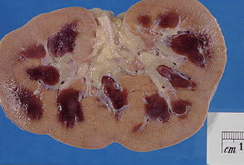

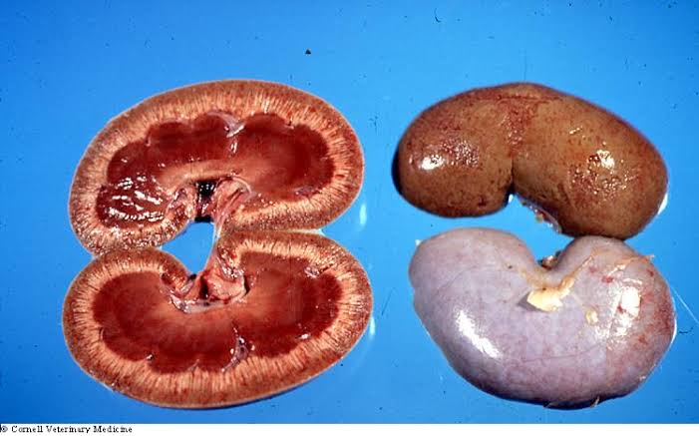

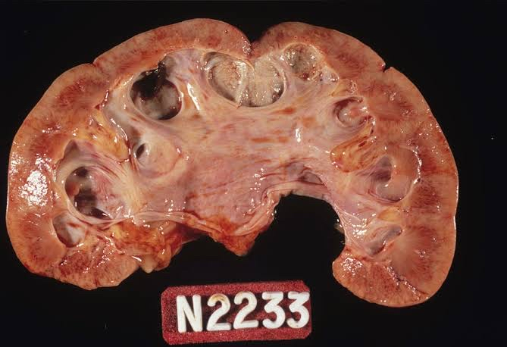

How to test for renal diseases
- Biochemical blood tests determine the amount of typical markers of renal function in the blood serum, for instance serum urea, serum uric acid, and serum creatinine. Biochemistry can also be used to determine serum electrolytes. Special biochemical tests (arterial blood gas) can determine the amount of dissolved gases in the blood, indicating if pH imbalances are acute or chronic.
- Urinalysis is a test that studies urine for abnormal substances such as protein or signs of infection. A Full Ward Test, also known as dipstick urinalysis, involves the dipping of a biochemically active test strip into the urine specimen to determine levels of tell-tale chemicals in the urine. Urinalysis may also involve MC&S microscopy, culture and sensitivity
- Urodynamic tests evaluate the storage of urine in the bladder and the flow of urine from the bladder through the urethra. It may be performed in cases of incontinence or neurological problems affecting the urinary tract. However the American Urogynecologic Society does not recommend that urodynamics are part of initial diagnosis for uncomplicated overactive bladder.
Ultrasound is routinely used in urology. In a pelvic sonogram, organs of the pelvic region are imaged. This includes the uterus and ovaries or urinary bladder. Males are sometimes given a pelvic sonogram to check on the health of their bladder, the prostate, or their testicles (for example to distinguish epididymitis from testicular torsion). In young males, it is used to distinguish more benign masses (varicocele or hydrocele) from testicular cancer, which is highly curable but which must be treated to preserve health and fertility. There are two methods of performing a pelvic sonography – externally or internally. The internal pelvic sonogram is performed either transvaginally(in a woman) or transrectally (in a man). Sonographic imaging of the pelvic floor can produce important diagnostic information regarding the precise relationship of abnormal structures with other pelvic organs and it represents a useful hint to treat patients with symptoms related to pelvic prolapse, double incontinence and obstructed defecation. It is used to diagnose and, at higher frequencies, to treat (break up) kidney stones or kidney crystals (nephrolithiasis).

Radiology based testing

- KUB stands for Kidneys, Ureters, and Bladder. The projection does not necessarily include the diaphragm. The projection includes the entire urinary system, from the pubic symphysis to the superior aspects of the kidneys. The anteroposterior (AP) abdomen projection, in contrast, includes both halves of the diaphragm. Despite its name, a KUB is not typically used to investigate pathology of the kidneys, ureters, or bladder, since these structures are difficult to assess (for example, the kidneys may not be visible due to overlying bowel gas.) In order to assess these structures radiographically, a technique called an intravenous pyelogram was historically utilized, and today at many institutions CT urography is the technique of choice.
- An intravenous pyelogram, also called an intravenous urogram (IVU), is a radiological procedure used to visualize abnormalities of the urinary system, including the kidneys, ureters, and bladder. Unlike a kidneys, ureters, and bladder x-ray (KUB), which is a plain (that is, non-contrast) radiograph, an IVP uses contrast to highlight the urinary tract.

There's no cure for chronic kidney disease (CKD), but treatment can help relieve the symptoms and stop it getting worse.

Your treatment will depend on the stage of your CKD.

The main treatments are:

lifestyle changes – to help you stay as healthy as possible
medicine – to control associated problems, such as high blood pressure and high cholesterol
dialysis – treatment to replicate some of the kidney's functions, which may be necessary in advanced (stage 5) CKD
kidney transplant – this may also be necessary in advanced (stage 5) CKD
Lifestyle changes
The following lifestyle measures are usually recommended for people with kidney disease:

stop smoking if you smoke
eat a healthy, balanced diet
restrict your salt intake to less than 6g a day – that's around 1 teaspoon
do regular exercise – aim to do at least 150 minutes a week
manage your alcohol intake so you drink no more than the recommended limit of 14 units of alcohol a week
lose weight if you're overweight or obese
avoid over-the-counter non-steroidal anti-inflammatory drugs (NSAIDs), such as ibuprofen, except when advised to by a medical professional – these medicines can harm your kidneys if you have kidney disease
Find out more about living with CKD and what you can do to stay healthy.

Medicine
There's no medicine specifically for CKD, but medicine can help control many of the problems that cause the condition and the complications that can happen as a result of it.

You may need to take medicine to treat or prevent the different problems caused by CKD.

High blood pressure
Good control of blood pressure is vital to protect the kidneys.

People with kidney disease should usually aim to get their blood pressure down to below 140/90mmHg, but you should aim to get it down to below 130/80mmHg if you also have diabetes.

There are many types of blood pressure medicines, but medicines called angiotensin converting enzyme (ACE) inhibitors are often used. Examples include ramipril, enalapril and lisinopril.

Side effects of ACE inhibitors can include:

a persistent dry cough
dizziness
tiredness or weakness
headaches
If the side effects of ACE inhibitors are particularly troublesome, you can be given a medicine called an angiotensin-II receptor blocker (ARB) instead.

Find out more about how high blood pressure is treated.

High cholesterol
People with CKD have a higher risk of cardiovascular disease, including heart attack and stroke.

This is because some of the causes of kidney disease are the same as those for cardiovascular disease, including high blood pressure and high cholesterol.

You may be prescribed medicines called statins to reduce your risk of developing cardiovascular disease. Examples include atorvastatin and simvastatin.

Side effects of statins can include:

headaches
feeling sick
constipation or diarrhoea
muscle and joint pain
Find out more about how high cholesterol is treated.

Water retention
You may get swelling in your ankles, feet and hands if you have kidney disease.

This is because your kidneys are not as effective at removing fluid from your blood, causing it to build up in body tissues (oedema).

You may be advised to reduce your daily salt and fluid intake, including fluids in food such as soups and yoghurts, to help reduce the swelling.

In some cases you may also be given diuretics (tablets to help you pee more), such as furosemide.

Side effects of diuretics can include dehydration and reduced levels of sodium and potassium in the blood.

Anaemia
Many people with advanced-stage CKD develop anaemia, which is a lack of red blood cells.

Symptoms of anaemia include:
tiredness
lack of energy
shortness of breath
a pounding, fluttering or irregular heartbeat (palpitations)
If you have anaemia, you may be given injections of a medicine called erythropoietin. This is a hormone that helps your body produce more red blood cells.

