Name: Okunade Olateju faith
Matric number: 18/mhs02/139
Department: Nursing science
Course title: PHS212
1. Write a short note on the characteristics and components of urine.
Urine is a liquid by-product of metabolism in humans and in many other animals. Urine flows from the kidneys through the ureters to the urinary bladder. Urination results in urine being excreted from the body through the urethra.
Cellular metabolism generates many by-products that are rich in nitrogen and must be cleared from the bloodstream, such as urea, uric acid, and creatinine. These by-products are expelled from the body during urination, which is the primary method for excreting water-soluble chemicals from the body. A urinalysis can detect nitrogenous wastes of the mammalian body.
Urine has a role in the earth's nitrogen cycle. In balanced ecosystems, urine fertilizes the soiland thus helps plants to grow. Therefore, urine can be used as a fertilizer. Some animals use it to mark their territories. Historically, aged or fermented urine (known as lant) was also used for gunpowder production, household cleaning, tanning of leather and dyeing of textiles.
"fish-like" odor because of contamination with bacteria that break down urea into ammonia. This odor is not present in fresh urine of healthy individuals; its presence may be a sign of an infection

Characteristics of urine includes;
^{1. Physical characteristics}
^{2. Chemical characteristics}
It can also be explained in the diagram below

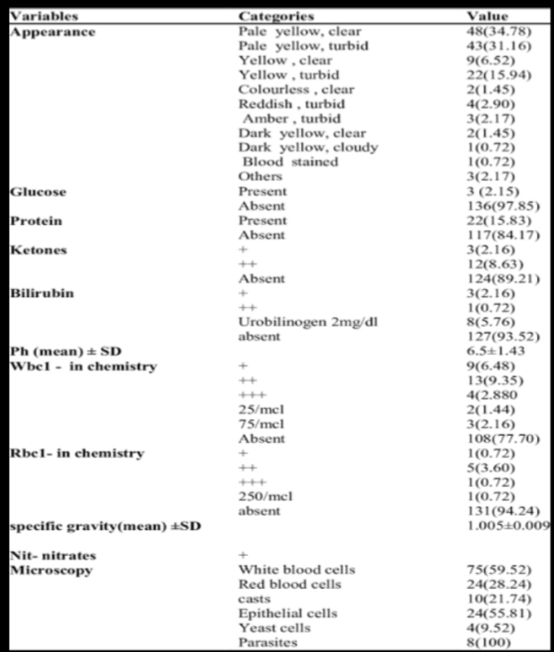

The Physical characteristics of urine includes:
Appearance. Urine is a transparent (clear) fluid. Color varies from pale yellow to dark amber, depending upon its concentration. (Concentration is the ratio of solutes to water.)

(1) Dilute urine may be pale, straw colored, or even appear colorless.

(2) Concentrated urine appears highly colored (for example, bright yellow or deep amber).

(3) Turbid (cloudy) urine is usually considered abnormal. It may be the result of blood, pus, sperm, or bacteria present in the urine.
Color: Typically yellow-amber, but varies according to recent diet and the concentration of the urine. Drinking more water generally tends to reduce the concentration of urine, and therefore causes it to have a lighter color. Dark urine may indicate dehydration. Red urine indicates red blood cells within the urine, a sign of kidney damage and disease.
Smell:

.The odor of normal human urine can reflect what has been consumed or specific diseases. For example, an individual with diabetes mellitus may present a sweetened urine odor. This can be due to kidney diseases as well, such as kidney stones.
Eating asparagus can cause a strong odor reminiscent of the vegetable caused by the body's breakdown of asparagusic acid. Likewise consumption of saffron, alcohol, coffee, tuna fish, and onion can result in telltale scents. Particularly spicy foods can have a similar effect, as their compounds pass through the kidneys without being fully broken down before exiting the body.

Turbidity
Turbid (cloudy) urine may be a symptom of a bacterial infection, but can also be caused by crystallization of salts such as calcium phosphate.
specific gravity. Remember that osmolarity is the number of osmoles or milliosmoles per liter of fluid (mOsmol/L). Urine osmolarity ranges from a low of 50–100 mOsmol/L to as high as 1200 mOsmol/L H2O.

Cells are not normally found in the urine. The presence of leukocytes may indicate a urinary tract infection. Leukocyte esterase is released by leukocytes; if detected in the urine, it can be taken as indirect evidence of a urinary tract infection (UTI).

Protein does not normally leave the glomerular capillaries, so only trace amounts of protein should be found in the urine, approximately 10 mg/100 mL in a random sample. If excessive protein is detected in the urine, it usually means that the glomerulus is damaged and is allowing protein to “leak” into the filtrate.

Ketones are byproducts of fat metabolism. Finding ketones in the urine suggests that the body is using fat as an energy source in preference to glucose. In diabetes mellitus when there is not enough insulin (type I diabetes mellitus) or because of insulin resistance (type II diabetes mellitus), there is plenty of glucose, but without the action of insulin, the cells cannot take it up, so it remains in the bloodstream. Instead, the cells are forced to use fat as their energy source, and fat consumed at such a level produces excessive ketones as byproducts. These excess ketones will appear in the urine. Ketones may also appear if there is a severe deficiency of proteins or carbohydrates in the diet.

Nitrates (NO3–) occur normally in the urine. Gram-negative bacteria metabolize nitrate into nitrite (NO2–), and its presence in the urine is indirect evidence of infection.

pH
The pH normally is within the range of 5.5 to 7 with an average of 6.2. In persons with hyperuricosuria, acidic urine can contribute to the formation of stones of uric acid in the kidneys, ureters, or bladder. Urine pH can be monitored by a physician or at home.
A diet which is high in protein from meat and dairy, as well as alcohol consumption can reduce urine pH, whilst potassium and organic acids, such as from diets high in fruit and vegetables, can increase the pH and make it more alkaline. Some drugs also can increase urine pH, including acetazolamide, potassium citrate, and sodium bicarbonate.
Cranberries, popularly thought to decrease the pH of urine, have actually been shown not to acidify urine. Drugs that can decrease urine pH include ammonium chloride, chlorothiazide diuretics, and methenamine mandelate.

Density
Human urine has a specific gravity of 1.003–1.035. Any deviations may be associated with urinary disorders.
Normal amount of urine per day:
The normal range for 24-hour urine volume is 800 to 2,000 milliliters per day (with a normal fluid intake of about 2 liters per day).
Amount. The average, normal adult will excrete approximately 1,500 to 2,000 ml of urine each day (every 24 hours). This will vary with fluid intake and fluid loss. Fluid losses other than urination include fluid lost through vomiting, diarrhea, and “insensible” losses. Insensible fluid loss is that which is not perceptible or appreciable. Such loss includes that fluid which is lost through respiration, evaporation from the skin, and fecal content.
Chemical characteristics:
On an elemental level, human urine contains 6.87 g/L carbon, 8.12 g/L nitrogen, 8.25 g/L oxygen, and 1.51 g/L hydrogen. The exact proportions vary with individuals and with factors such as diet and health.
Certain abnormalities in the urine composition occur in the following:
Hematuria- When blood is found in the urine, the condition is called as hematuria. This indicates some pathology either injury or infection-related.
Pyuria- This condition is characterized by the presence of pus cells in the urine. This indicates the presence of infection somewhere in the body.
Glycosuria- This is a condition characterized by the presence of glucose in the urine. This is indicative of diabetes that is most likely uncontrolled.
Proteinuria- This is a condition where protein molecules are found in the urine. This indicates some defect in the kidney’s filtration process.

Normal Urine Characteristics (Table 1)
Characteristic | Normal values
Color | Pale yellow to deep amber
Odor | Odorless
Volume | 750–2000 mL/24 hour
pH | 4.5–8.0
Specific gravity | 1.003–1.032
Osmolarity | 40–1350 mOsmol/kg
Urobilinogen | 0.2–1.0 mg/100 mL
White blood cells | 0–2 HPF (per high-power field of microscope)
Leukocyte esterase | None
Protein | None or trace
Bilirubin | <0.3 mg/100 mL
Ketones | None
Nitrites | None
Blood | None
Glucose | None

Urine Composition:
Over 99 percent of urinary solutes are composed of only 68 chemicals which have a concentration of 10 mg/L or more. 42 compounds are actually involved. They may be classified as follows:

Electrolytes such as sodium, potassium, calcium, magnesium and chloride
Nitrogenous chemicals such as urea and creatinine
Vitamins
Hormones
Organic acids such as uric acid
Other organic compounds
Total Dissolved Solids
Total dissolved solids in urine constitute between 24.8 to 37.1 g/kg. Urinary solids are primarily made up of organic matter, largely volatile solids. Urine has large amounts of nitrogen, phosphorus, and potassium. Nitrogen content in urine is high, mostly in urea, which makes up more than 50 percent of the total organic acids. This includes urea from protein metabolism, sodium and potassium both of which come from food. Dry solids thus comprise 14-18 percent nitrogen, 13 percent carbon, and 3.7 percent each of potassium and phosphorus. The largest excretion of these substances from the body is through urine
Nitrogen in urine is excreted mostly as urea, with about 11 g per day being the average excretion of nitrogen. It is most significantly affected by dietary protein intake, with a correlation of 0.91 existing between protein in diet and urinary nitrogenous components. About 80 percent of the dietary intake of nitrogen is balanced by the urinary excretion of nitrogenous compounds. Urinary urea concentration ranges from 9 to 23 g/L.
Creatinine is another important nitrogenous compound in urine, and its level depends on the body mass and muscle mass, as well as age. Gender differences may be correlated with these. On average, creatinine production in the body is about 1.6 g/day.
Nitrate is a third nitrogenous compound in urine, with increased concentrations if the person has a high protein diet.
In addition to causing alterations in urinary nitrogen concentrations, protein in diet also affects the levels of other minerals such as phosphorus and potassium. Additionally, an extremely low intake of protein may affect calcium levels.

Calcium in Urine
Calcium excretion is affected by protein intake, as above, and is heavily influenced by sodium excretion. A low sodium diet, therefore, will decrease calcium excretion and vice versa.
A normal urinary sample from an adult collected over 24 hours should receive a calcium level of 100 to 250 mg.

Other Ions
Other less common ionic groups in urine include ammonium, sulfates from amino acids, and phosphates depending on parathyroid hormone levels.

Overall Solute Concentrations
The concentration of the following constituents in urine may be regarded a s a careful approximation:

Urea: 9.3 g/dL
Creatinine: 0.670 g/ L
Sodium: 1.17 g/L
Potassium: 0.750 g/L
Chloride: 1.87 g/L

It can be explained in the table below:

