Name: Okunade olateju Faith
Matric number: 18/mhs02/139
Course code: PHS212
Department: Nursing science
1. Write a short note on urinalysis.
A urinalysis is a test of urine. A urinalysis is used to detect and manage a wide range of disorders, such as urinary tract infections, kidney disease and diabetes. A urinalysis involves checking the appearance, concentration and content of urine.

Urinalysis is a series of tests on urine. It is used to check for signs of common conditions or diseases. Other names for it are urine test, urine analysis, and UA.
A person may have a urinalysis as part of a routine check of the overall health, for instance as part of an annual physical. Urinalysis is one way to find certain illnesses in their earlier stages. They include:
- Kidney disease
- Liver disease
- Diabetes
A doctor may also want to test a person’s urine if the person is getting ready to have surgery or are about to be admitted to the hospital. Urinalysis can be part of a pregnancy checkup.
If a person has symptoms of a kidney or urinary tract problem, the person may have the tests to help find out what the problem is. Those symptoms include:
- Pain in your belly
- Pain in your back
- Pain when you pee or needing to go frequently
- Blood in your pee
There are three ways to analyze urine, and a test might use all of them.
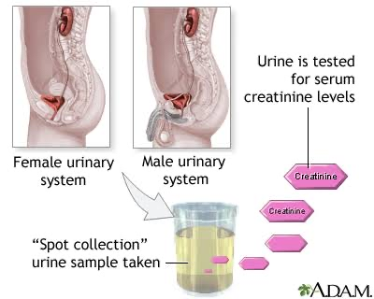
One is a visual exam, which checks the color and clarity. If a person’s urine has blood in it, it might be red or dark brown. Foam can be a sign of kidney disease, while cloudy urine may mean you have an infection.
A microscopic exam checks for things too small to be seen otherwise. Some of the things that shouldn't be in the urine that a microscope can find include:
- Red blood cells
- White blood cells
- Bacteria
- Crystals (clumps of minerals – a possible sign of kidney stones)
The third part of urinalysis is the dipstick test, which uses a thin plastic strip treated with chemicals. It’s dipped into your urine, and the chemicals on the stick react and change color if levels are above normal. Things the dipstick test can check for include:
- Acidity, or pH. If the acid is abnormal, you could have kidney stones, a urinary tract infection (UTI) or another condition.
- Protein. This can be a sign your kidneys are not working right. Kidneys filter waste products out of your blood.
- Glucose. A high sugar content is a marker for diabetes.
- White blood cells. These are a sign of infection or inflammation, either in the kidneys or anywhere else along urinary tract.
- Nitrites. This means that there is an infection with certain kinds of bacteria.
- Bilirubin. If this waste product, which is normally eliminated by your liver, shows up, it may mean your liver isn’t working properly.
- Blood in your urine. Sometimes this is a sign of infections or certain illnesses.
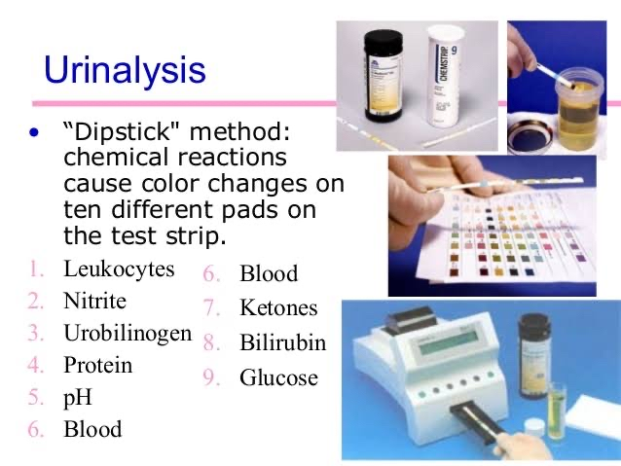
Urine test results should always be interpreted using the reference range provided by the laboratory that performed the test, or using information provided by the test strip/device manufacturer.

Color
The following are examples of some urine colors and their causes (not a complete listing).
- Nearly colorless: Excessive fluid intake for conditions; untreated diabetes mellitus, diabetes insipidus, and certain types of nephritis.
- Yellow: Distinctly yellow urine may indicate excessive riboflavin (vitamin B₂) intake.
- Yellow-amber: Normal.
- Yellow-cloudy: excessive crystals (crystalluria) and/or excessive pus (pyuria).
- Orange: Insufficient fluid intake for conditions; intake of orange substances; intake of phenazopyridine for urinary symptoms.
- Red: Leakage of red blood cells or of hemoglobin from such cells; hemolysis; intake of red substances.
- Dark:
  - Reddish-orange: Intake of certain medications or other substances.
  - Rusty-yellow to reddish-brown: Intake of certain medications or other substances.
  - Dark brown: Intake of certain medications or other substances; damaged muscle (myoglobinuria due to rhabdomyolysis) from extreme exercise or other widespread damage, possibly medication related; altered blood; bilirubinuria; intake of phenolic substances; inadequate porphyrin metabolism; melanin from melanocytic tumors; presence of an abnormal form of hemoglobin, methemoglobin.
  - Brownish-black to black: Intake of substances or medications; altered blood; a problem with homogentisic acid metabolism (alkaptonuria), which can also cause dark whites of the eyes and dark-colored internal organs and tissues (ochronosis); Lysol (a product that contains phenols) poisoning; melanin from melanocytic tumors). Paraphenylenediamine is a highly toxic ingredient of hair dye formulations that can cause acute kidney injury and result in black urine.
  - Purple due to Purple urine bag syndrome.[5]
- Magenta to purple-red: Presence of phenolphthalein, a stimulant laxativepreviously found in Ex-Lax.
- Green, or dark with a greenish hue: Jaundice(bilirubinuria); problem with bile metabolism. Recent surgery requiring high doses of propofol infusion. The use of a medication (Uribel) that is similar to phenazopyridine for the relief of urinary symptoms.
- Other colors: Various substances ingested in food or drink, particularly up to 48 hours prior to the presence of colored urine.

Smell
The odor (scent) of urine can normally vary from odorless (when very light colored and dilute) to a much stronger odor when the subject is dehydrated and the urine is concentrated. Brief changes in odor are usually merely interesting and not medically significant. (Example: the abnormal smell many people can detect after eating asparagus.) The urine of diabetics experiencing ketoacidosis(urine containing high levels of ketone bodies) may have a fruity or sweet smell.

Importance of urinalysis
Elimination of the worn-out products of tissue change and the unappropriated parts of the food takes place from the body in the expired air, skin, feces and urine. The oxidized carbon of the tissues by the lungs and cutaneous surface, the insoluble débris of the food excreted by the intestines, while the urine contains essentially the nitrogenous and other soluble products.
The urine containing the watery constituents of the blood, with some dissolved salts, is one of the most important excretions from the body, and with our present knowledge of urinalysis much can be learned by its examination. The changes which this secretion undergoes in health and disease have been studied since the earliest history of medicine. Hippocrates taught the effects of food and drink upon this excretion, its variation in color, odor and transparency, attributing their changes to disease of the urinary organs. Galen simply added to this knowledge

