NAME: EKO ELIZABETH ENE
MATRIC NUMBER: 18/MHS02/069
DEPARTMENT: NURSING SCIENCE
COURSE CODE: PHS 212
LEVEL: 200 LEVEL

Micturition
When 300 to 400ml of urine have accumulated in the bladder, afferent autonomic nerve fibres in the bladder wall sensitive to stretch are stimulated. In the infant this initiates a spinal reflex and micturition occurs. Urine passed in the response to parasympathetic stimulation of the bladder, causing contraction of the detrusor muscle and relaxation of the internal urethral sphincter. Urine is expelled from the bladder and passes through the urethra before leaving the body.
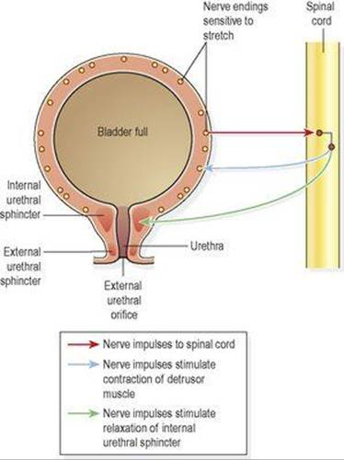

When the nervous system is fully developed, the micturition reflex is stimulated but sensory impulses also pass upwards to the brain and there is awareness of the need to pass urine. By learned and conscious effort, contraction of the external urethral sphincter and muscles of the pelvic floor can inhibit micturition until it is convenient to empty the bladder.
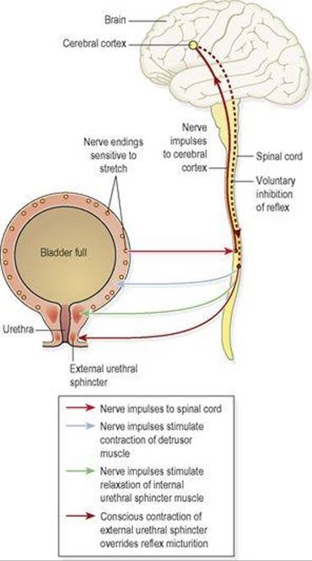
In adults, urine is passed when the detrusor muscle contracts, and there is reflex relaxation of the internal sphincter and voluntary relaxation of the external sphincter. It can be assisted by increasing the pressure within the pelvic cavity, achieved by lowering the diaphragm and contracting the abdominal muscles (Valsalva”s manoeure). Overdistension of the bladder is extremely painful, and when this stage is reached there is a tendency for involuntary relaxation of the external sphincter to occur alloeing a small amount of urine to escape, provided there is no mechanical obstruction. Involuntary loss of urine is known as incontinence.

