NAME: ABDULRAUF RABIAT
MATRIC NUMBER: 18/MHS02/002
DEPARTMENT: NURSING
COURSE: PHYSIOLOGY

DISCUSS THE DISEASES OF RENAL SYSTEM
Renal system disease, any of the diseases or disorders that affect the human urinary system. They include benign and malignant tumours, infections and inflammations, and obstruction by calculi. Diseases can have an impact on the elimination of wastes and on the conservation of an appropriate amount and quality of body fluid. Many of the manifestations of renal disease can be accounted for in terms of disturbance of these two functions, and the alleviation of symptoms in those renal diseases that cannot be cured depends on knowledge of how these two functions are affected. The eliminatory process does not, of course, end with the formation of urine; the urine has to pass down the ureters to the bladder, be stored there, and voided, usually under voluntary control. The whole mechanism can be deranged by structural changes in the lower urinary tract, by infection, or by neurological disorders that lead to abnormal emptying of the bladder. Disturbance of the lower urinary tract is an important cause of pain and distress, notably during pregnancy and in the elderly; and it can lead to serious and progressive damage to the kidneys, either by interfering with the drainage of urine or by allowing bacterial infection to have access to the kidney.
Renal system disease, any of the diseases or disorders that affect the human urinary system. They include belign and malignant tumours, infections and inflammations, and obstruction by calculi.
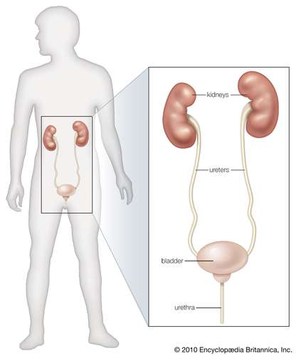
Diseases can have an impact on the elimination of wastes and on the conservation of an appropriate amount and quality of body fluid. Many of the manifestations of renal disease can be accounted for in terms of disturbance of these two functions, and the alleviation of symptoms in those renal diseases that cannot be cured depends on knowledge of how these two functions are affected.
The eliminatory process does not, of course, end with the formation of urine; the urine has to pass down the ureters to the bladder, be stored there, and voided, usually under voluntary control. The whole mechanism can be deranged by structural changes in the lower urinary tract, by infection, or by neurological disorders that lead to abnormal emptying of the bladder. Disturbance of the lower urinary tract is an important cause of pain and distress, notably during pregnancy and in the elderly; and it can lead to serious and progressive damage to the kidneys, either by interfering with the drainage of urine or by allowing bacterial infection to have access to the kidney.
Renal disease in its diverse forms can lead to bodily deficits or excesses of water, sodium, potassium, and magnesium, and also to protein deficits occasioned by great losses of protein in the urine. Inability of the kidney to function normally may lead to retention in the blood of the waste products of protein metabolism, such as urea and uric acid, and of other nitrogenous compounds such as creatinine. There may be abnormally high levels of phosphates in the blood, which in turn can lead (for reasons about which there is still some disagreement) to low blood levels of calcium. The calcium deficiency can cause tetany, a condition marked by muscular spasms and pain, and calcium may be lost from the bones in the process of restoring normal calcium levels in the blood and tissue fluid. For descriptive purposes, changes in volume, changes in composition, and protein depletion of renal origin will be discussed separately, but these disturbances can and often do coexist.
Though body fluid is most readily apparent in the bloodstream, it is present, and in larger amounts, in the tissues, both between the cells (interstitial fluid) and within them (intracellular fluid). Extracellular fluids, which include interstitial fluid and blood plasma, amount to 25 percent of body weight and contain sodium as their predominant cation (positive ion; metals and hydrogen in solution are cations). Intracellular fluids, amounting to 33 percent of body weight, have potassium as their predominant cation. These various “compartments” of body fluid are in osmotic equilibrium, so that if solute (e.g., sodium chloride) is added to the extracellular compartment so as to increase the concentration of the extracellular solution, water will join it to reduce the concentration, and that compartment will increase. An increase in extracellular fluid, if it is considerable, may be clinically apparent as edema, a swelling of the tissues by fluid, which can usually be displaced by firm pressure. Edema is present in acute inflammation of the kidney (nephritis), in protein deficiency of renal origin, and in chronic nephritis complicated by heart failure associated with abnormally high blood pressure; a factor common to all these states is failure of the kidneys to excrete sodium and water in adequate amounts.
The kidneys in such edematous states need not themselves be diseased; for example, normal kidneys, in a patient with heart failure, may retain sodium when handicapped in their function by poor circulation and by abnormal amounts of sodium-retaining hormones, such as aldosterone. Increase in extracellular fluids is the only volume change that is both common and easily discernible in renal disease, but the opposite condition, sodium depletion or clinical dehydration, is more commonly the result of vomiting and diarrhea when they are complications of terminal renal disease. Sodium and water depletion can be recognized by a lack of elasticity in the superficial tissues and by poor filling of the blood vessels, as well as by signs of impaired circulation, including a fall in blood pressure and an increase in pulse rate. Though changes in intracellular fluid volume occur in some diseases, especially when the potassium content of the body is affected, there is no easy way of detecting them.

