Question
NOTE: this is the last lap of the revised questions. Kindly use it to revise your note, since we all know that exam is the next thing after resumption. Do not limit yourself to what had been given you, extends your horizon for you to know more. I wish you all the best.
31. What is Automata theory? How can it be represented?
32. Construct a DFA that accepts set of all string over {a,b} such that:
i. Length of the string is 3
ii. That accepts substrings of three consecutive b’s
iii. That accepts strings beginning with aa. Draw the transition table for (ii).
33. Draw a transition table for the DFA that accepts any string over {a,b} that does not contain the string aab in it.
34. Construct the DFA that accepts a language over:
i. all strings {0,1} that ends with 101; and
ii. all strings {a,b} that contains the string {baba} in it
35. Construct the DFA accepting the Language of strings over {a,b} ending with bb.
36. Let L_1 be the set of all strings over {a, b} ending in ba. Create the DFA and find the transition table
37. Construct a DFA for all set of strings over {a,b} such that
i. The string containing only 2a’s.
iii. w∈{a,b}| |w|≅1 mod 3
ii. w∈{a,b}| |w|≅1 mod 2 iv. Length of string is at most 2
38. Construct a DFA that accepts a language over all string {0,1}
i. that begins with 111
ii. that ends with 100
iii. that contains 101

ANSWERS
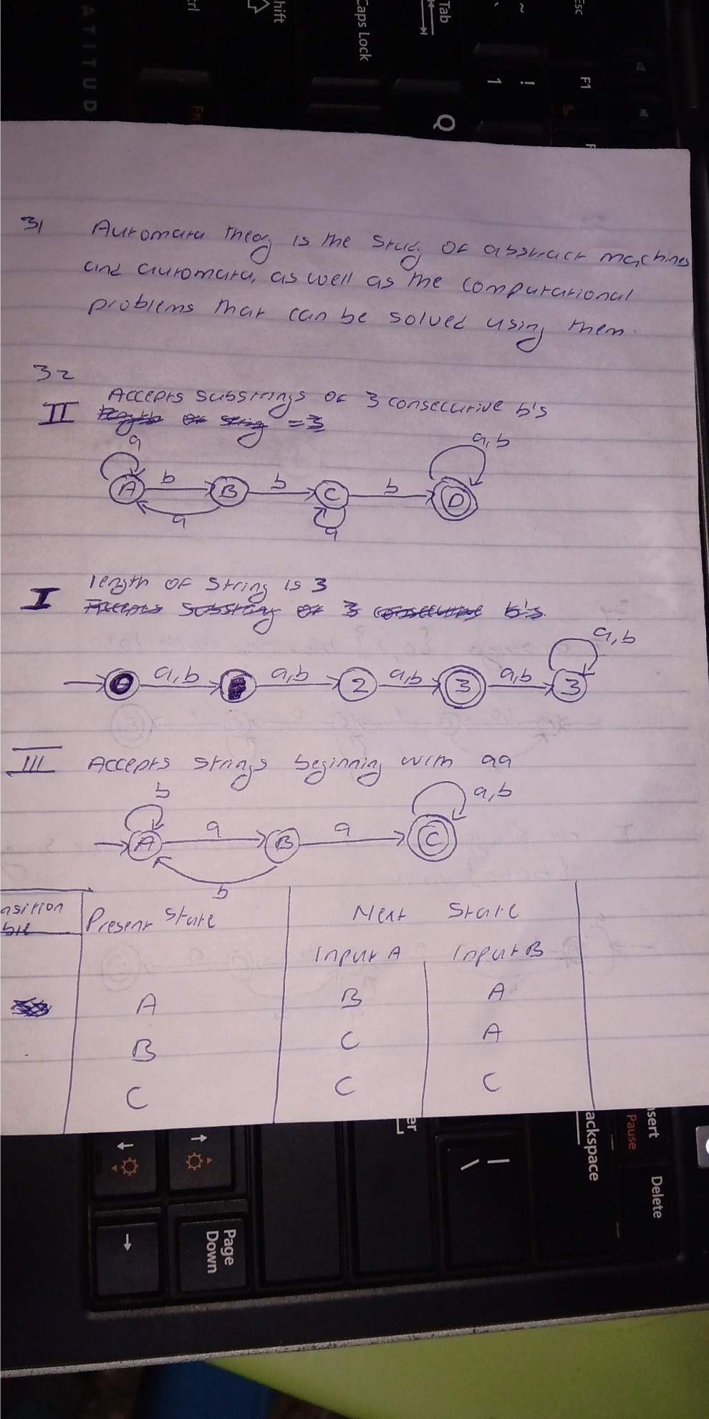
33) Mis

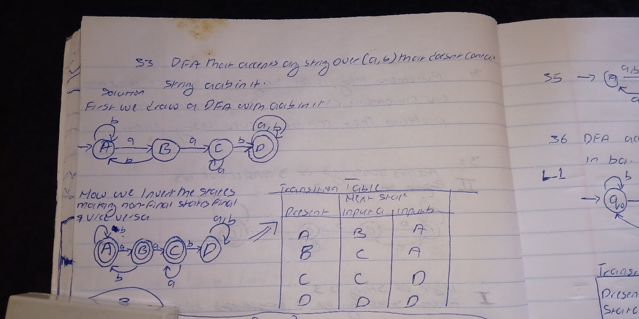

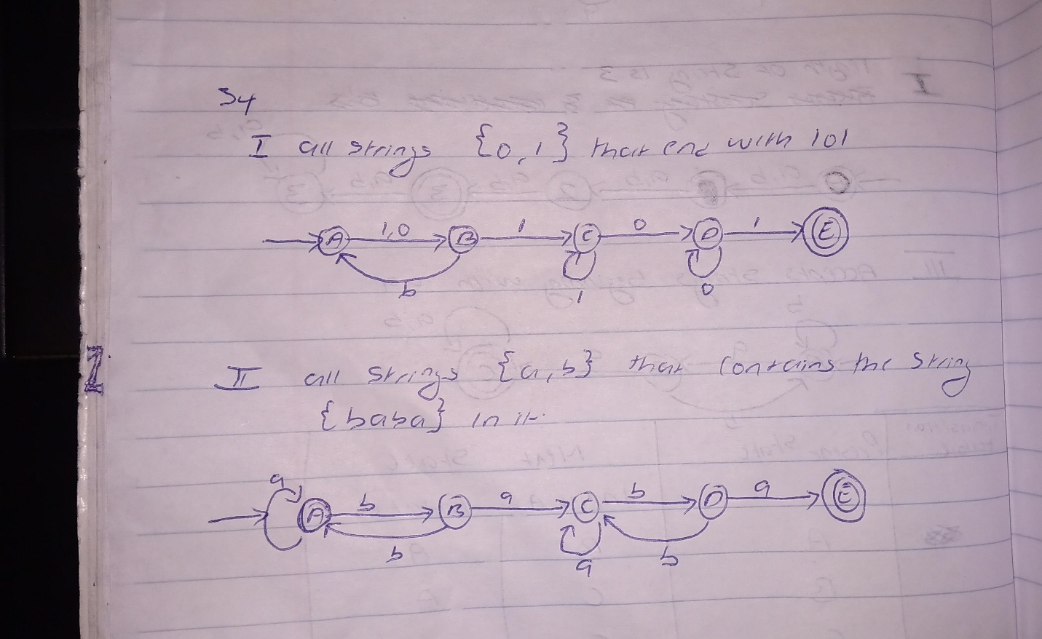

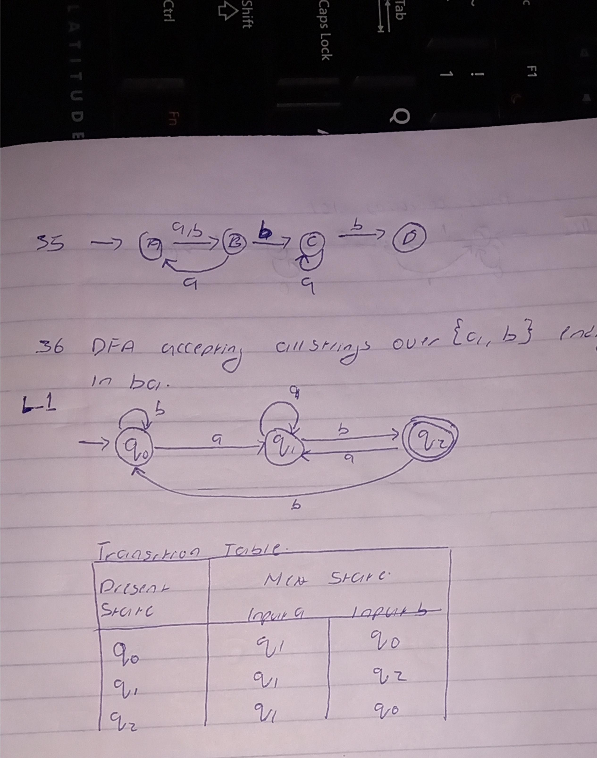

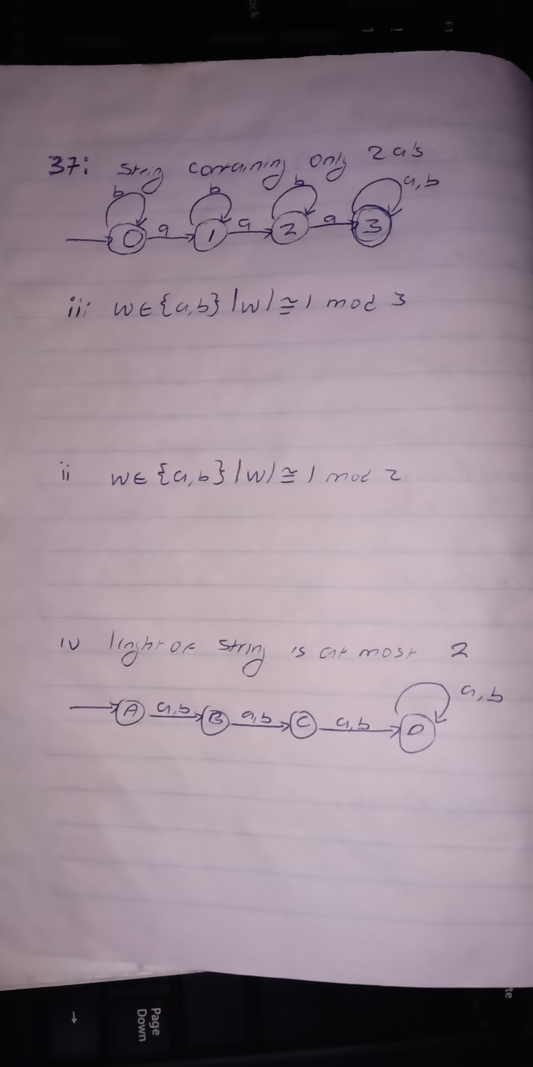
37)
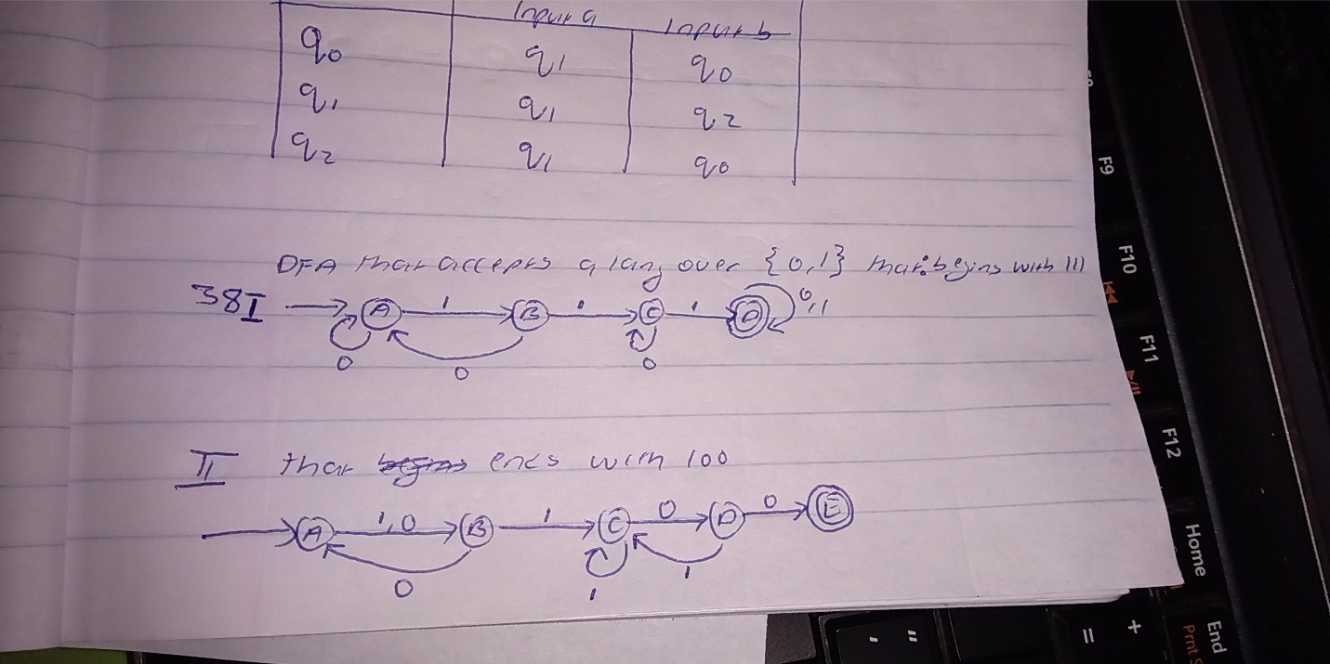

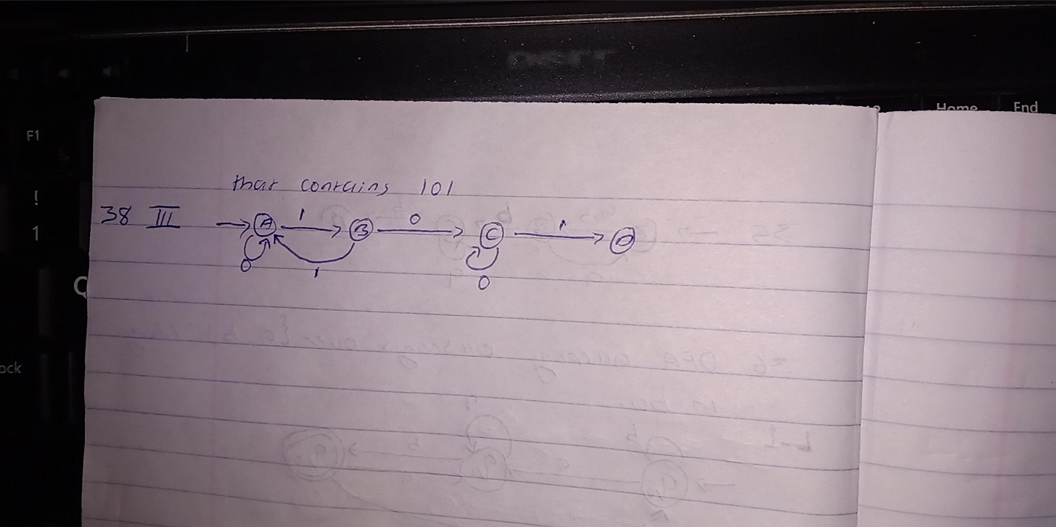
Caleb S

