EDIDIONG IME-ESSIEN
CSC 304
17/SCI01/041
PART 2

15. (i) length is at most 2: L ={∑, a, b, aa, ab, ba, bb}
∑+a+ b+ aa+ ab+ ba+ bb= (∑+a+b) (∑+a+b).
(ii) language of even length: ((a+b) (a+b))*
(iii) language starting and ending with the same letter: a(a+b)*a
(iv) language starting and ending with a different letter: a(a+b)*b+b(a+b)*a
16. Regular expression :these are used for representing certain sets of string in an algebraic fashion.
Identities in RE
L +M = M + L
2. (L +M) + N = L + (M + N)
3. (LM)N = L(MN)
4. L(M + N) = LM + LN
5. (M + N)L = ML + NL
6. L + L = L
7. (L*)* = L*
17. Each letter in A is a regular expression
If r is a RE then r* is a RE
If r1and r2 are RE then r1 Ur2 is a RE
If r1and r2 are RE then r1r2 is a RE.
5 symbols used RE : (),*,U,∑,λ.

18. r=b* i.e the language (r) consists of all powers of b including λ.
(ii) r=aa* i.e (r) consists of all positive powers of a excluding λ.
(iii) r={aUb} i.e L(aUb)= {a} u {b}. the language consists of all words over ∑.
iv. Let r=(a∪〖b)〗* : r consists of any word in a and b
v. Let r=aa(a∪〖b)〗*:
vi. Let r=(a〖∩b)〗* r consists of words either in a or b
19.

20. Regular set is any set that’s represented by a regular expression.
A string in L(r1+r2) is a string from R1 or a string r2
(ii) a string is L(r1r2) is a string from r1 followed by a string from r2
(iii) a string in L(r*) is a string obtained by concatenating n elements for some n>=0.
21. 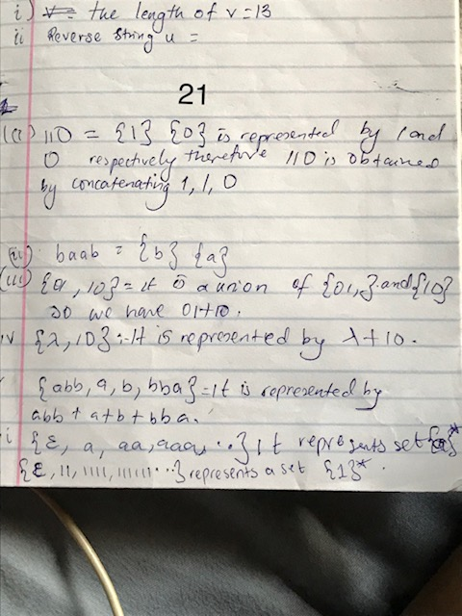
22. 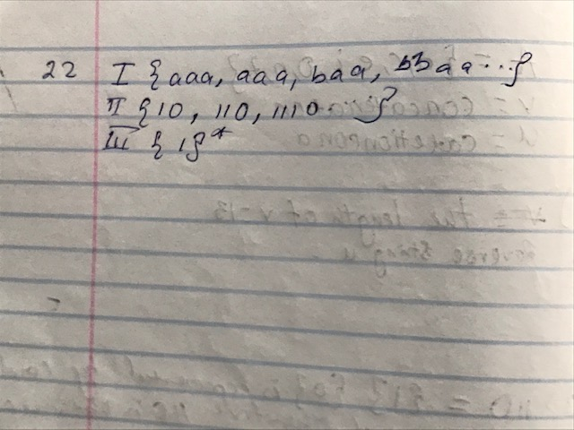
23. Grammars are finite set of rules used to describe languages, it is also a generator of language WHILE a language is a set of strings generated by a grammar.

