15.(i)length is at most 2:L={∑,a,b,aa,ab,ba,bb}
∑+a+b+aa+ab+ba+bb=(∑+a+b)(∑+a+b)
(ii)language of even length:((a+b)(a+b))*
L={∑,aa, ab,ba,bb,aaaa,...}
(iii)language starting and ending with the same letter:a(a+b)*+b(a+b)*bb
(iv)language starting and ending with a different letter:a(a+b)*b+b(a+b)*a

16. Regular expression: Regular expressions can be thought of as the algebraic description of a regular language. Regular expression can be defined by the following rules: Every letter of the alphabet ∑ is a regular expression. Null string є and empty set Φ are regular expressions.
Identies of regular expression
1. L + M = M + L
2. (L + M) + N = L + (M + N)
3. (LM)N = L(MN)
4. ∅ + L = L + ∅ = L
5. ¤L = L¤ = L
6. ∅L = L∅ = ∅
7. L(M + N) = LM + LN
8. (M + N)L = ML + NL
9. L + L = L
10. (L∗)∗ = L∗
11. ∅∗ =12. ¤∗ = ¤13. (xy)∗x = x(yx)∗14. The following are all equivalent:(a) (x + y)∗(b) (x∗ + y)∗(c) x∗(x + y)∗(d) (x + yx∗)∗(e) (x∗y∗)∗(f) x∗(yx∗)∗(g) (x∗y)∗x∗

17. Symbols used in regular expression
question mark (?),
backslash (\),
period (.),
caret (^),
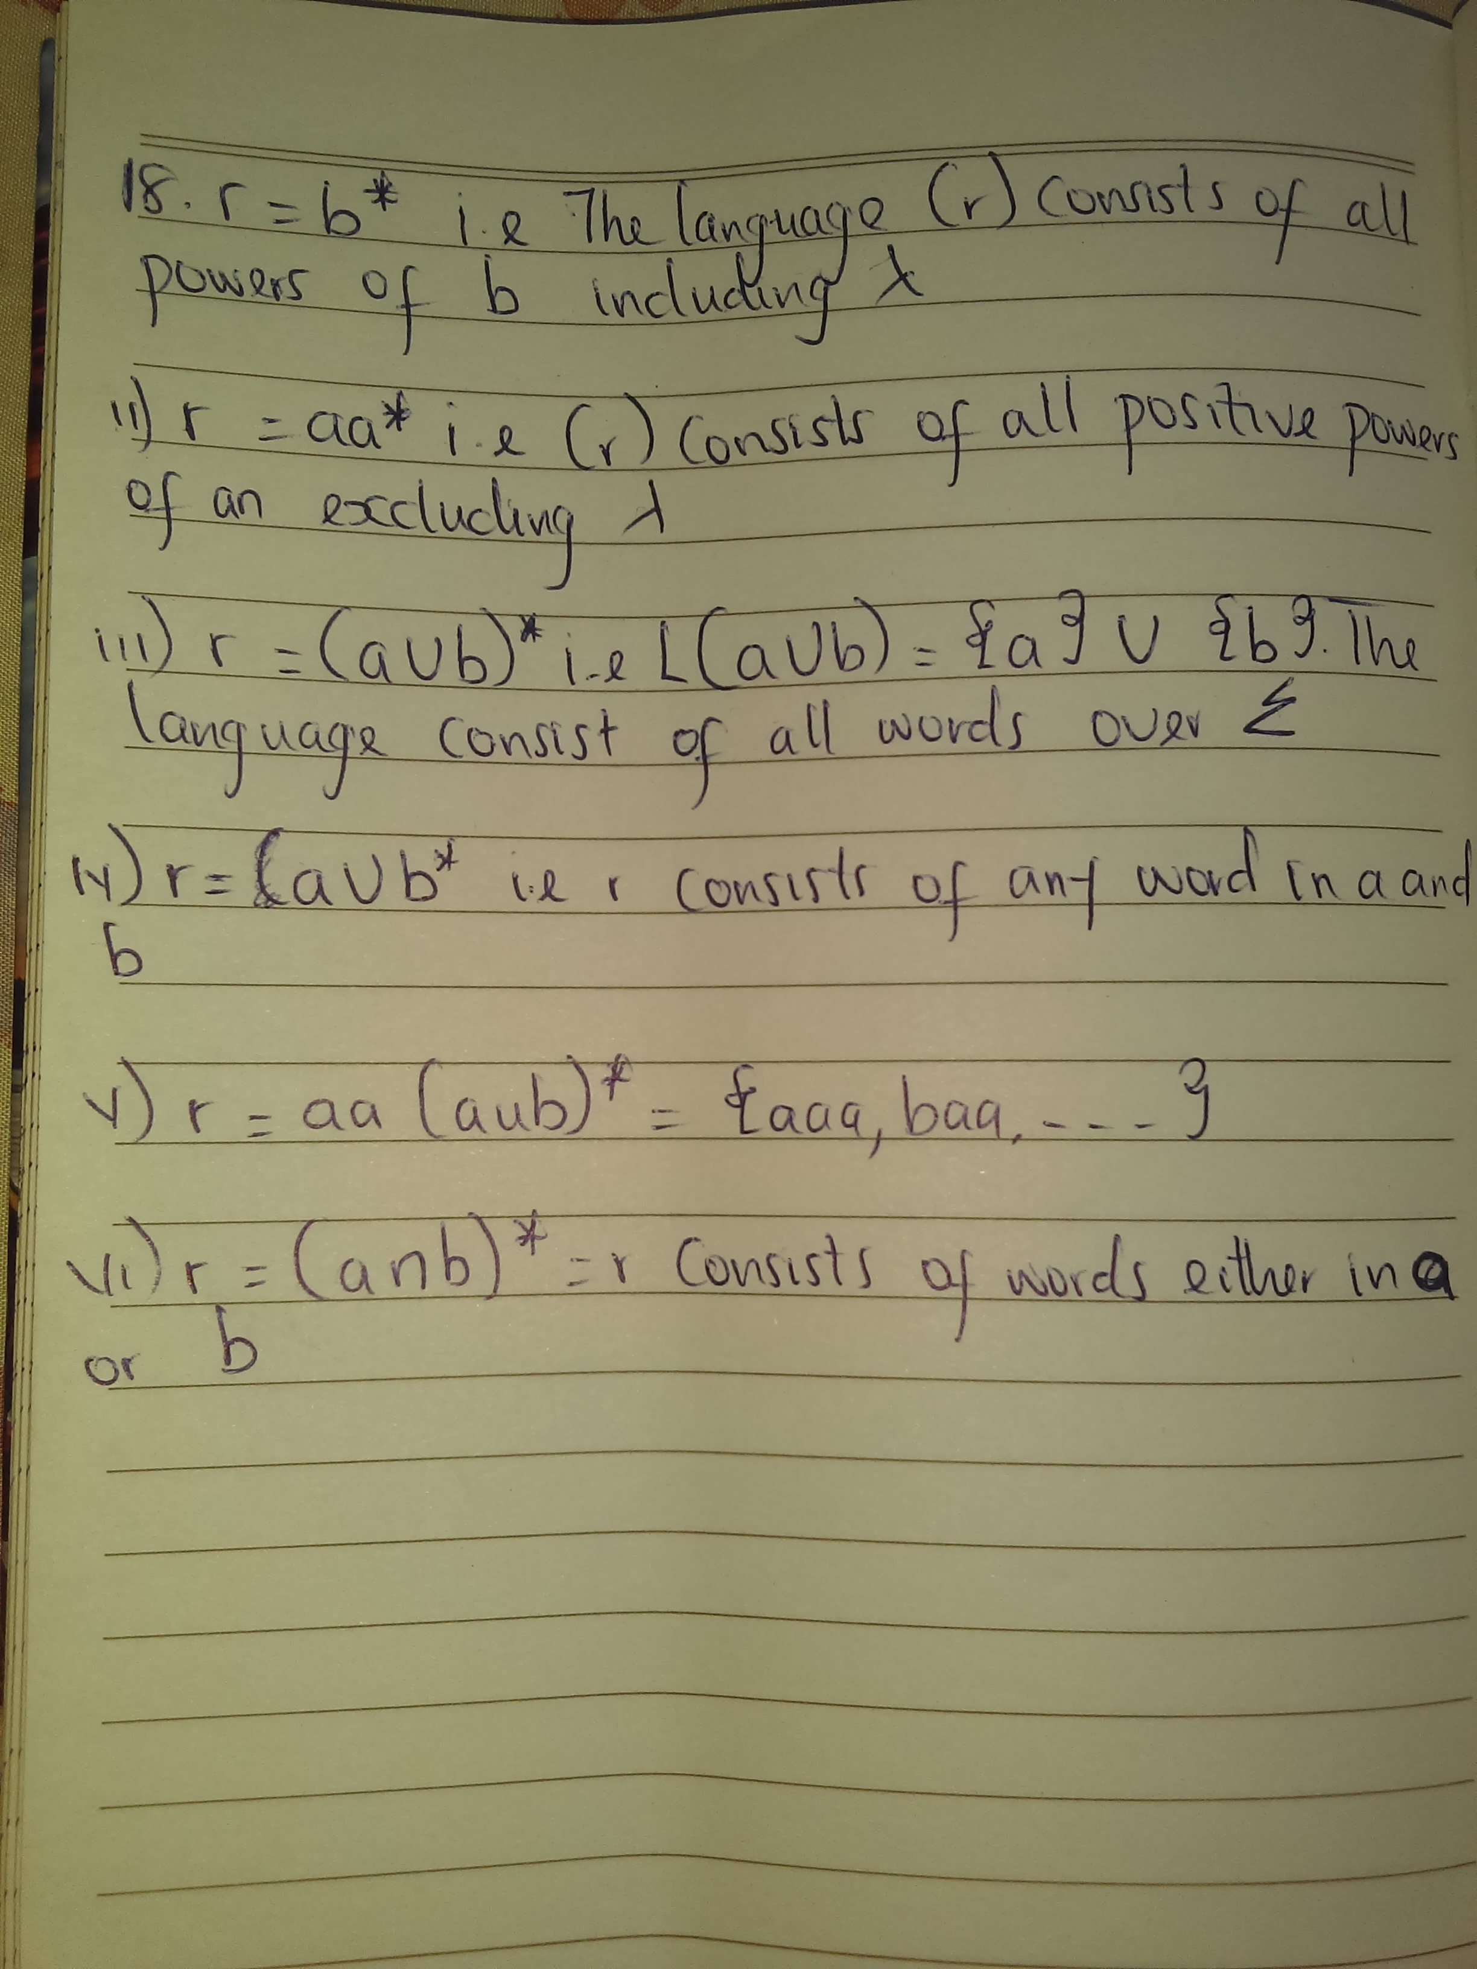
square brackets ([ and ])
18.

20. Any set that denotes the value of the Regular Expression is called a "Regular Set". Regular sets have various properties: Property 1).The union of two regular sets is also a regular set.
ii. A string in L(R1 + R2) is a string from R1 or a string from R2.
A string in L(R1R2) is a string from R1 followed by a string from R2.
A string in L(R*) is a string obtained by concatenating n elements for some n≥0
21i. 110= {1} {0} is represented by 1 and 0 respectively therefore 110 is obtained by concatenating 1,1,0
ii. baab ={b} {a}
iii. {01,10} = it is a union of {01} and {10} so we have 01+10
iv. {λ,10} it is represented λ+10
v. {abb,a,b,bba} it is represented by abb+a+b+bba
vi. {∑,a,aa,aaa,...} it represents sets {a}*
vii. {∑,II,III,IIII...} it represents sets {I}*

22i. {aaa, aaa, baa, bbaa,...}
ii. {10,110,1110}
iii. {1}*

23. Grammar:In formal language theory, a grammar (when the context is not given, often called a formal grammar for clarity) describes how to form strings from a language's alphabet that are valid according to the language's syntax.. A formal grammar is defined as a set of production rules for strings in a formal language.
Difference between language and grammar
Language in terms of the theory of computation can be referred to as the set of strings which is a subset of ∑*, which is the set of all possible combinations of the elements contained in the set of symbols ∑. Grammar can be treated as a language generator.

24. A sentential form is any string derivable from the start symbol. Thus, in the derivation of a + a * a , E + T * F and E + F * a and F + a * a are all sentential forms as are E and a + a * a themselves. A sentence is a sentential form consisting only of terminals such as a + a * a.

