NAME: SHOSAN HADIJAT ABIMBOLA
MATRIC NO:17/SCI01/076
1.

2. Computability theory deals primarily with the question of whether a problem is solvable at all on a computer.The statement that the halting problem cannot be solved by a Turing machine is one of the most important results in computability theory,as it is an example of a concrete problem that is both easy to formulate and impossible to solve using a Turing machine.Much of computability theory builds on the halting problem result.
Complexity Theory is part of the theory of computation dealing with the resources required during computation to solve a given problem.The most common resources are time(how many steps does it take to solve a problem)and space(how much memory does it take to solve a problem).Other resources can also be considered, such as how many parallel process or are needed to solve a problem in parallel. Complexity theory differs from computability theory which deals with whether a problem can be solved at all,regardless of the resources required.
3. A set: A set is a group or collection of objects or numbers, considered as an entity unto itself. Sets are usually symbolized by uppercase, italicized, boldface letters such as A, B, S, or Z. Each object or number in a set is called a member or element of the set.
Power set: The number of subsets with k elements in the power set of a set with n elements is given by the number of combinations, C(n, k), also called binomial coefficients. For example, the power set of a set with three elements, has: ... C(3, 3) = 1 subset with 3 elements (the original set itself).
Member of a set: Any element of a set is a member of that set. The symbol ∈ is used to denote the member of a set.Member of a set is always the subset of its parent set.
Subset: A set A is a subset of another set B if all elements of the set A are elements of the set B. In other words, the set A is contained inside the set B. The subset relationship is denoted as A⊂B. ... Since B contains elements not in A, we can say that A is a proper subset of B.
Proper set: Proper subset of a set A is a subset of A that is not equal to A. In other words, if B is a proper subset of A, then all elements of B are in A but A contains at least one element that is not in B. For example, if A={1,3,5} then B={1,5} is a proper subset of A.
Infinite set: An infinite set is a set whose elements can not be counted. An infinite set is one that has no last element. An infinite set is a set that can be placed into a one-to-one correspondence with a proper subset of itself.
Finite set: A finite set is a set that has a finite number of elements. Informally, a finite set is a set which one could in principle count and finish counting. For example, is a finite set with five elements. The number of elements of a finite set is a natural number and is called the cardinality of the set.
Unordered pair: An unordered pair or pair set is a set of the form {a, b}, i.e. a set having two elements a and b with no particular relation between them. In contrast, an ordered pair (a, b) has a as its first element and b as its second element.
Union of a set: The union of two sets A and B is the set of elements which are in A, in B, or in both A and B. In symbols, . For example, if A = {1, 3, 5, 7} and B = {1, 2, 4, 6, 7} then A ∪ B = {1, 2, 3, 4, 5, 6, 7}..
Intersection of a set: The set operation intersection takes only the elements that are in both sets. The intersection contains the elements that the two sets have in common. The intersection is where the two sets overlap. In set-builder notation, A ∩ B = {x ∈ U : x ∈ A and x ∈ B}.
Complement of a Set: The complement of a set, denoted A', is the set of all elements in the given universal set U that are not in A. ... Example: U' = ∅ The complement of the universe is the empty set. Example: ∅' = U The complement of an empty set is the universal set.
Difference of a set: The difference of two sets, written A - B is the set of all elements of A that are not elements of B. The difference operation, along with union and intersection, is an important and fundamental set theory operation.
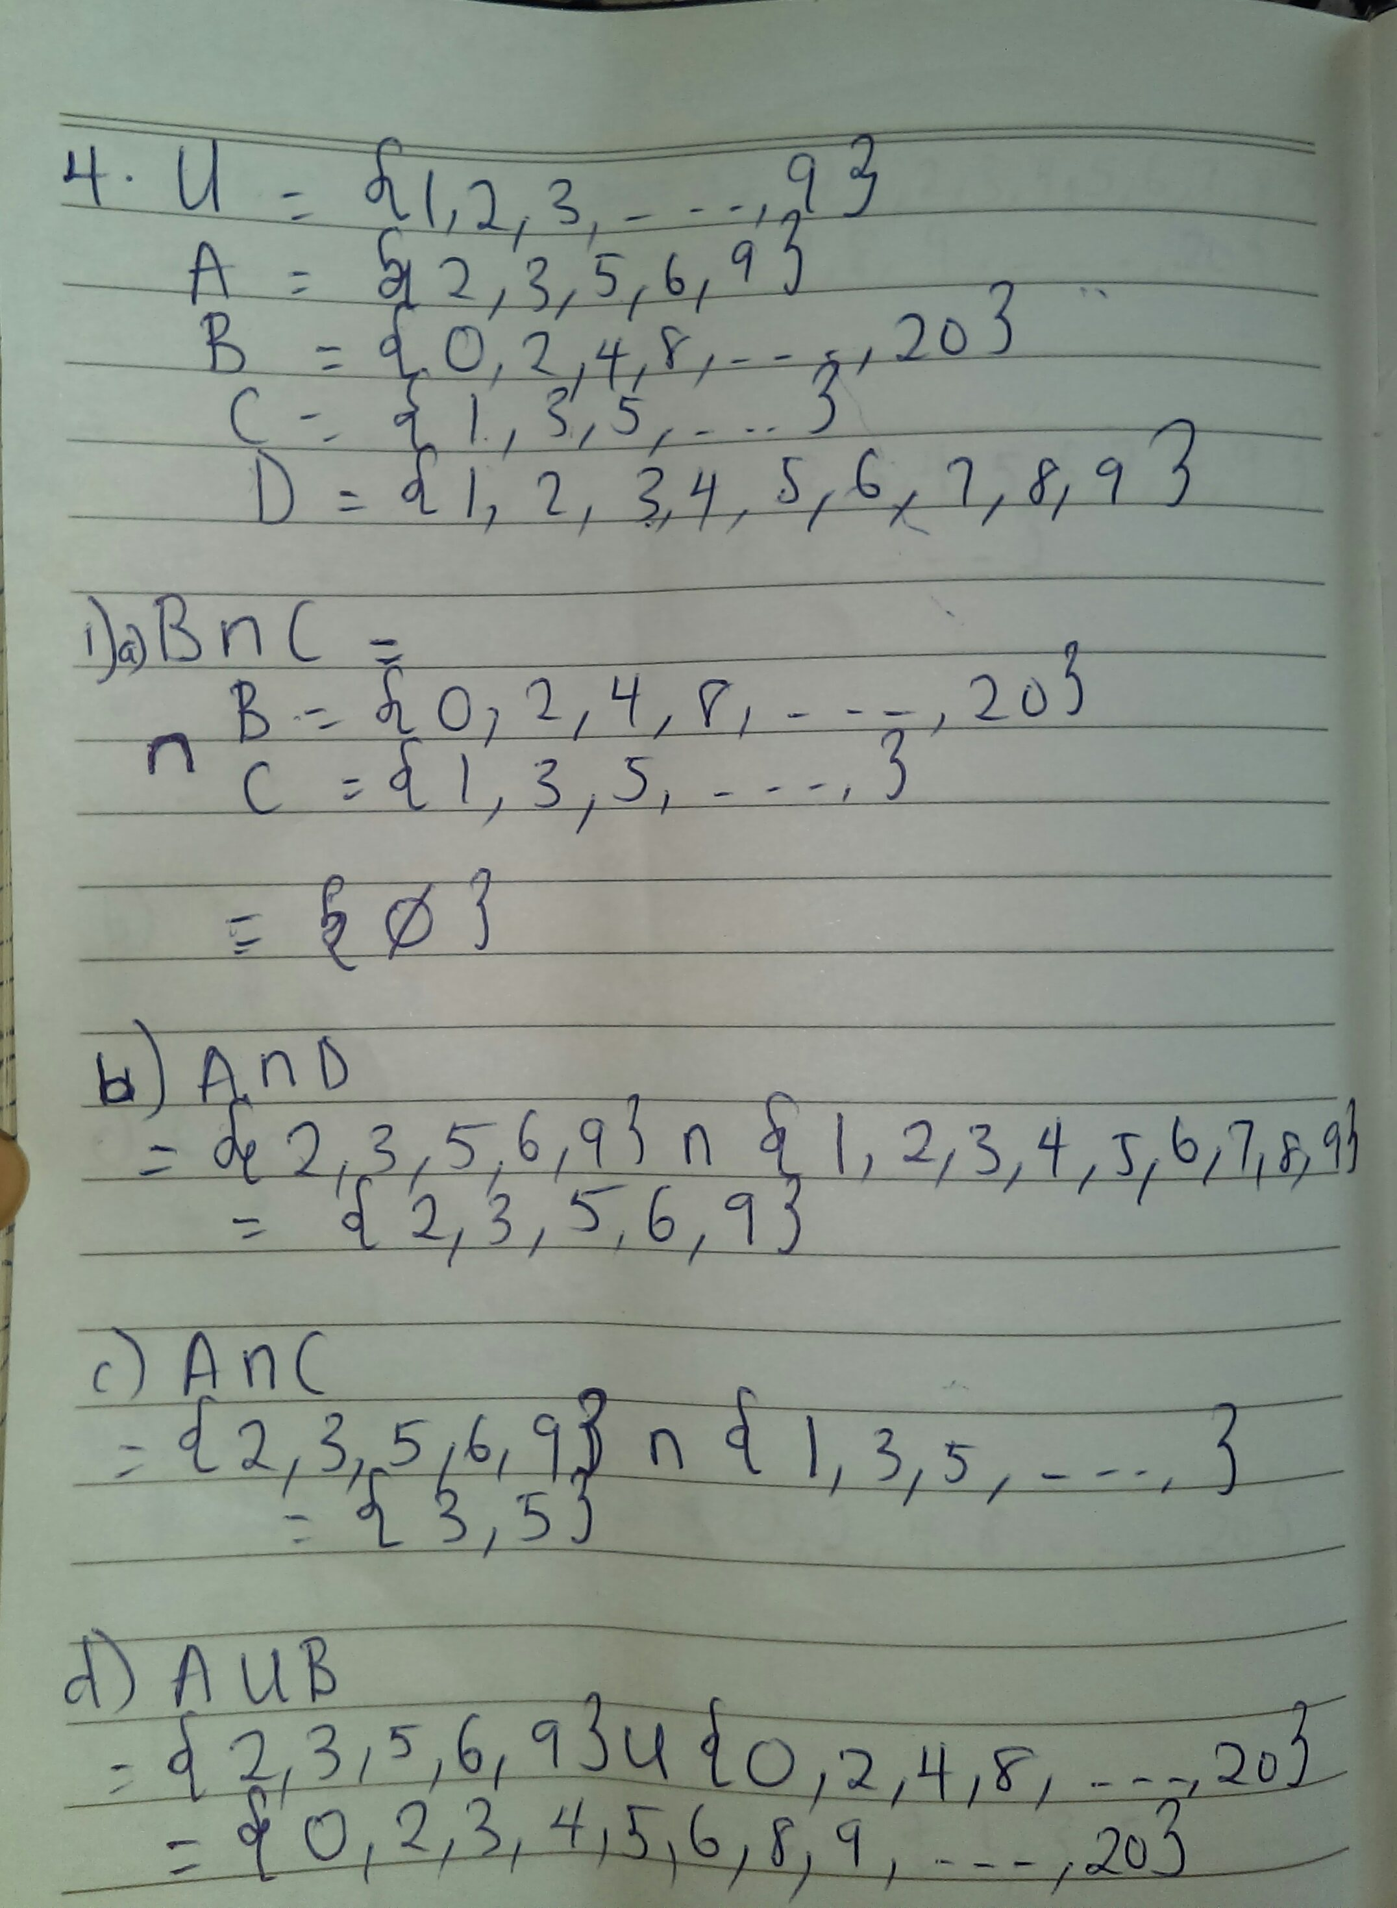
Symmetric difference of a set: The symmetric difference, also known as the disjunctive union, of two sets is the set of elements which are in either of the sets and not in their intersection. The symmetric difference of the sets A and B is commonly denoted by. or. or. For example, the symmetric difference of the sets and is .
4.

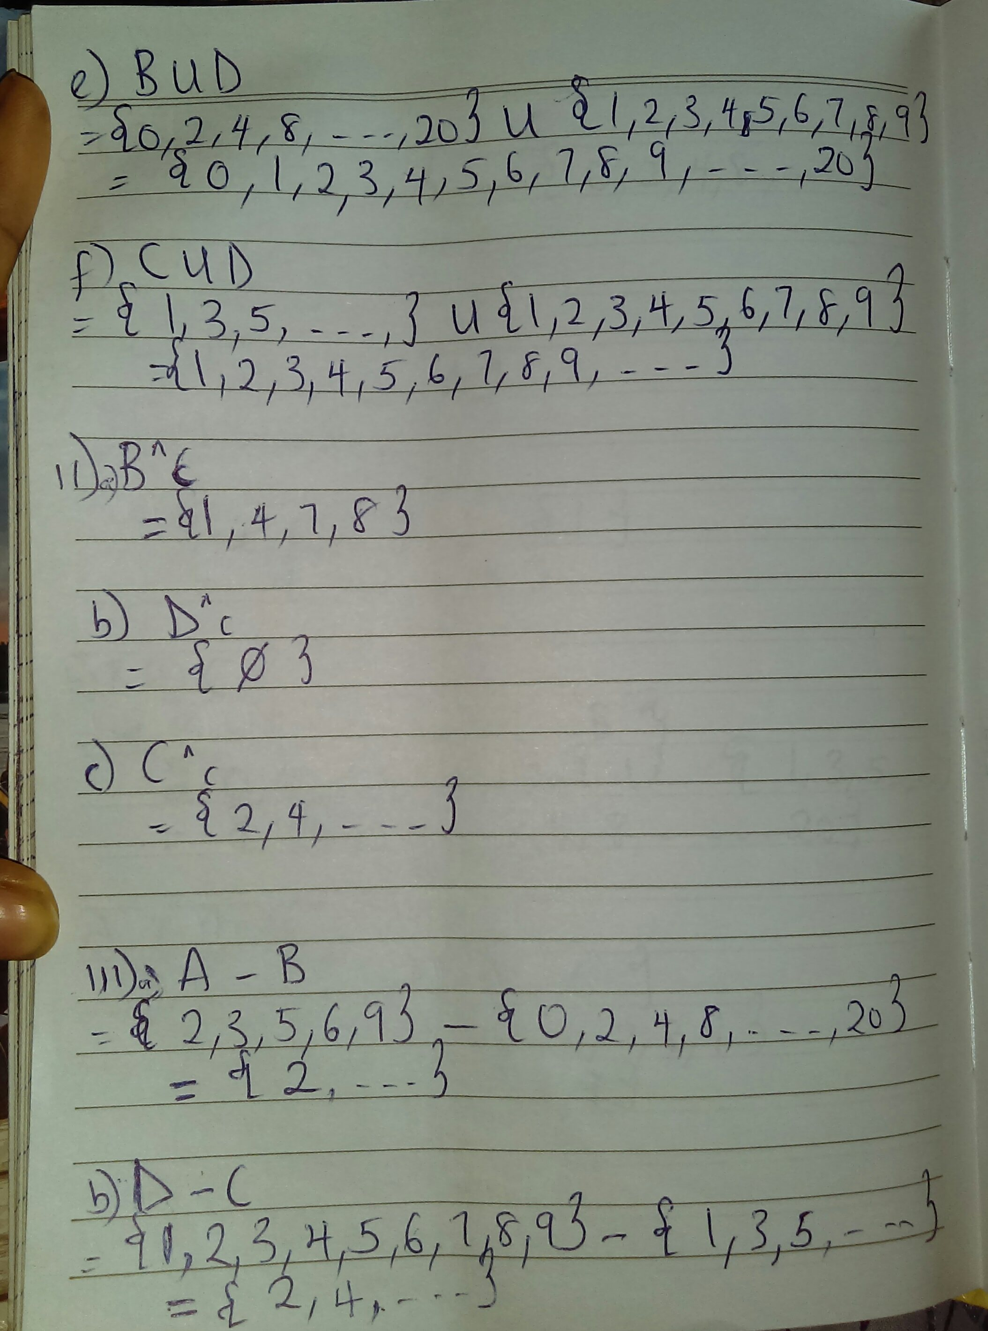

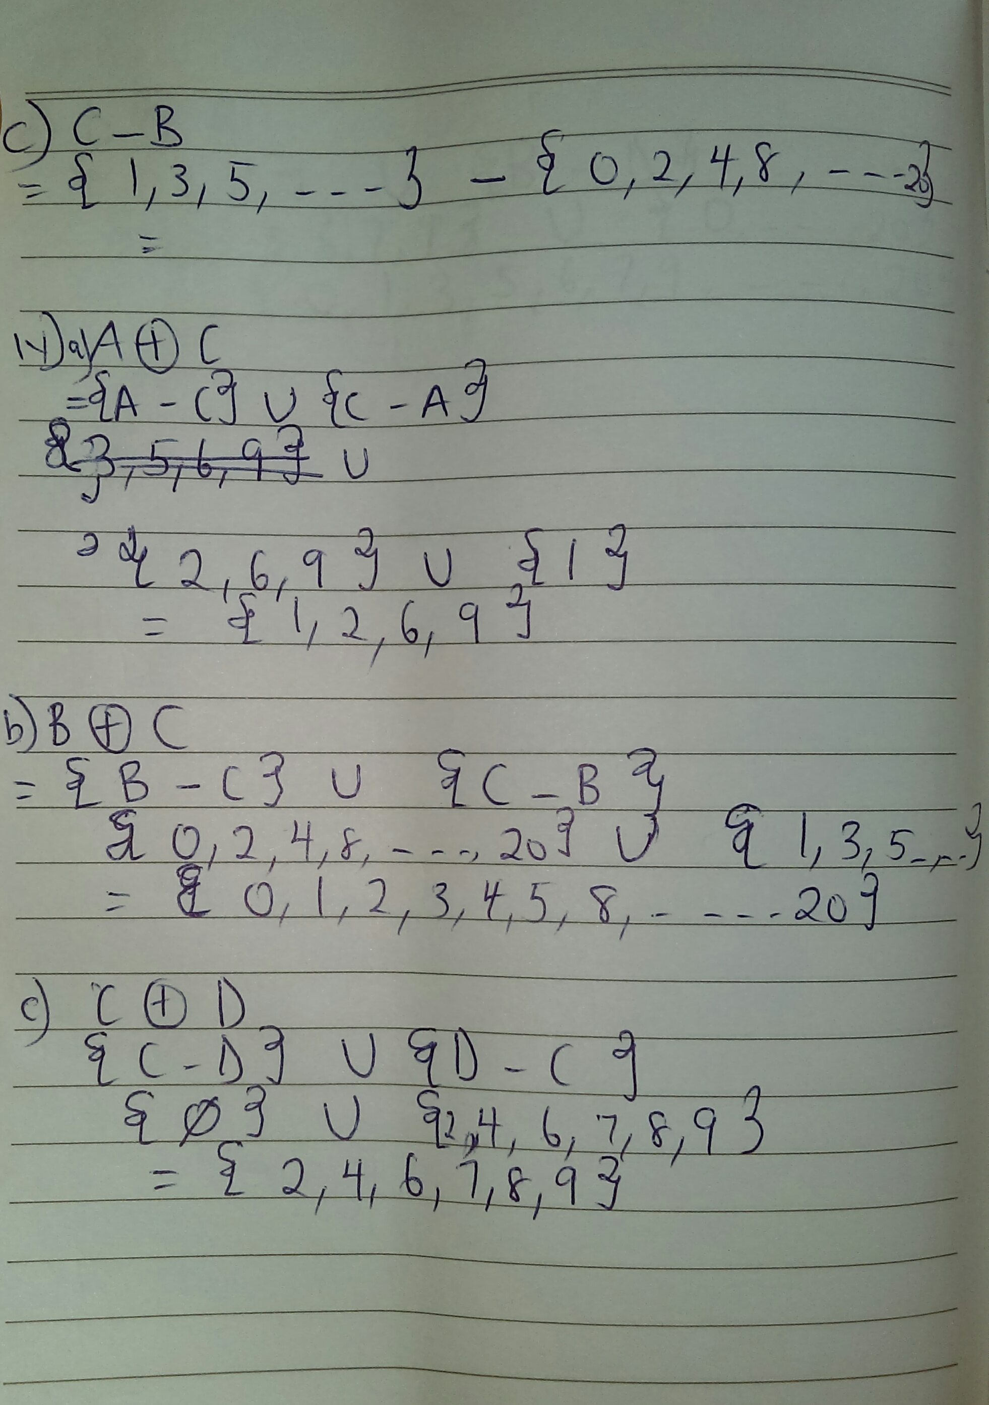

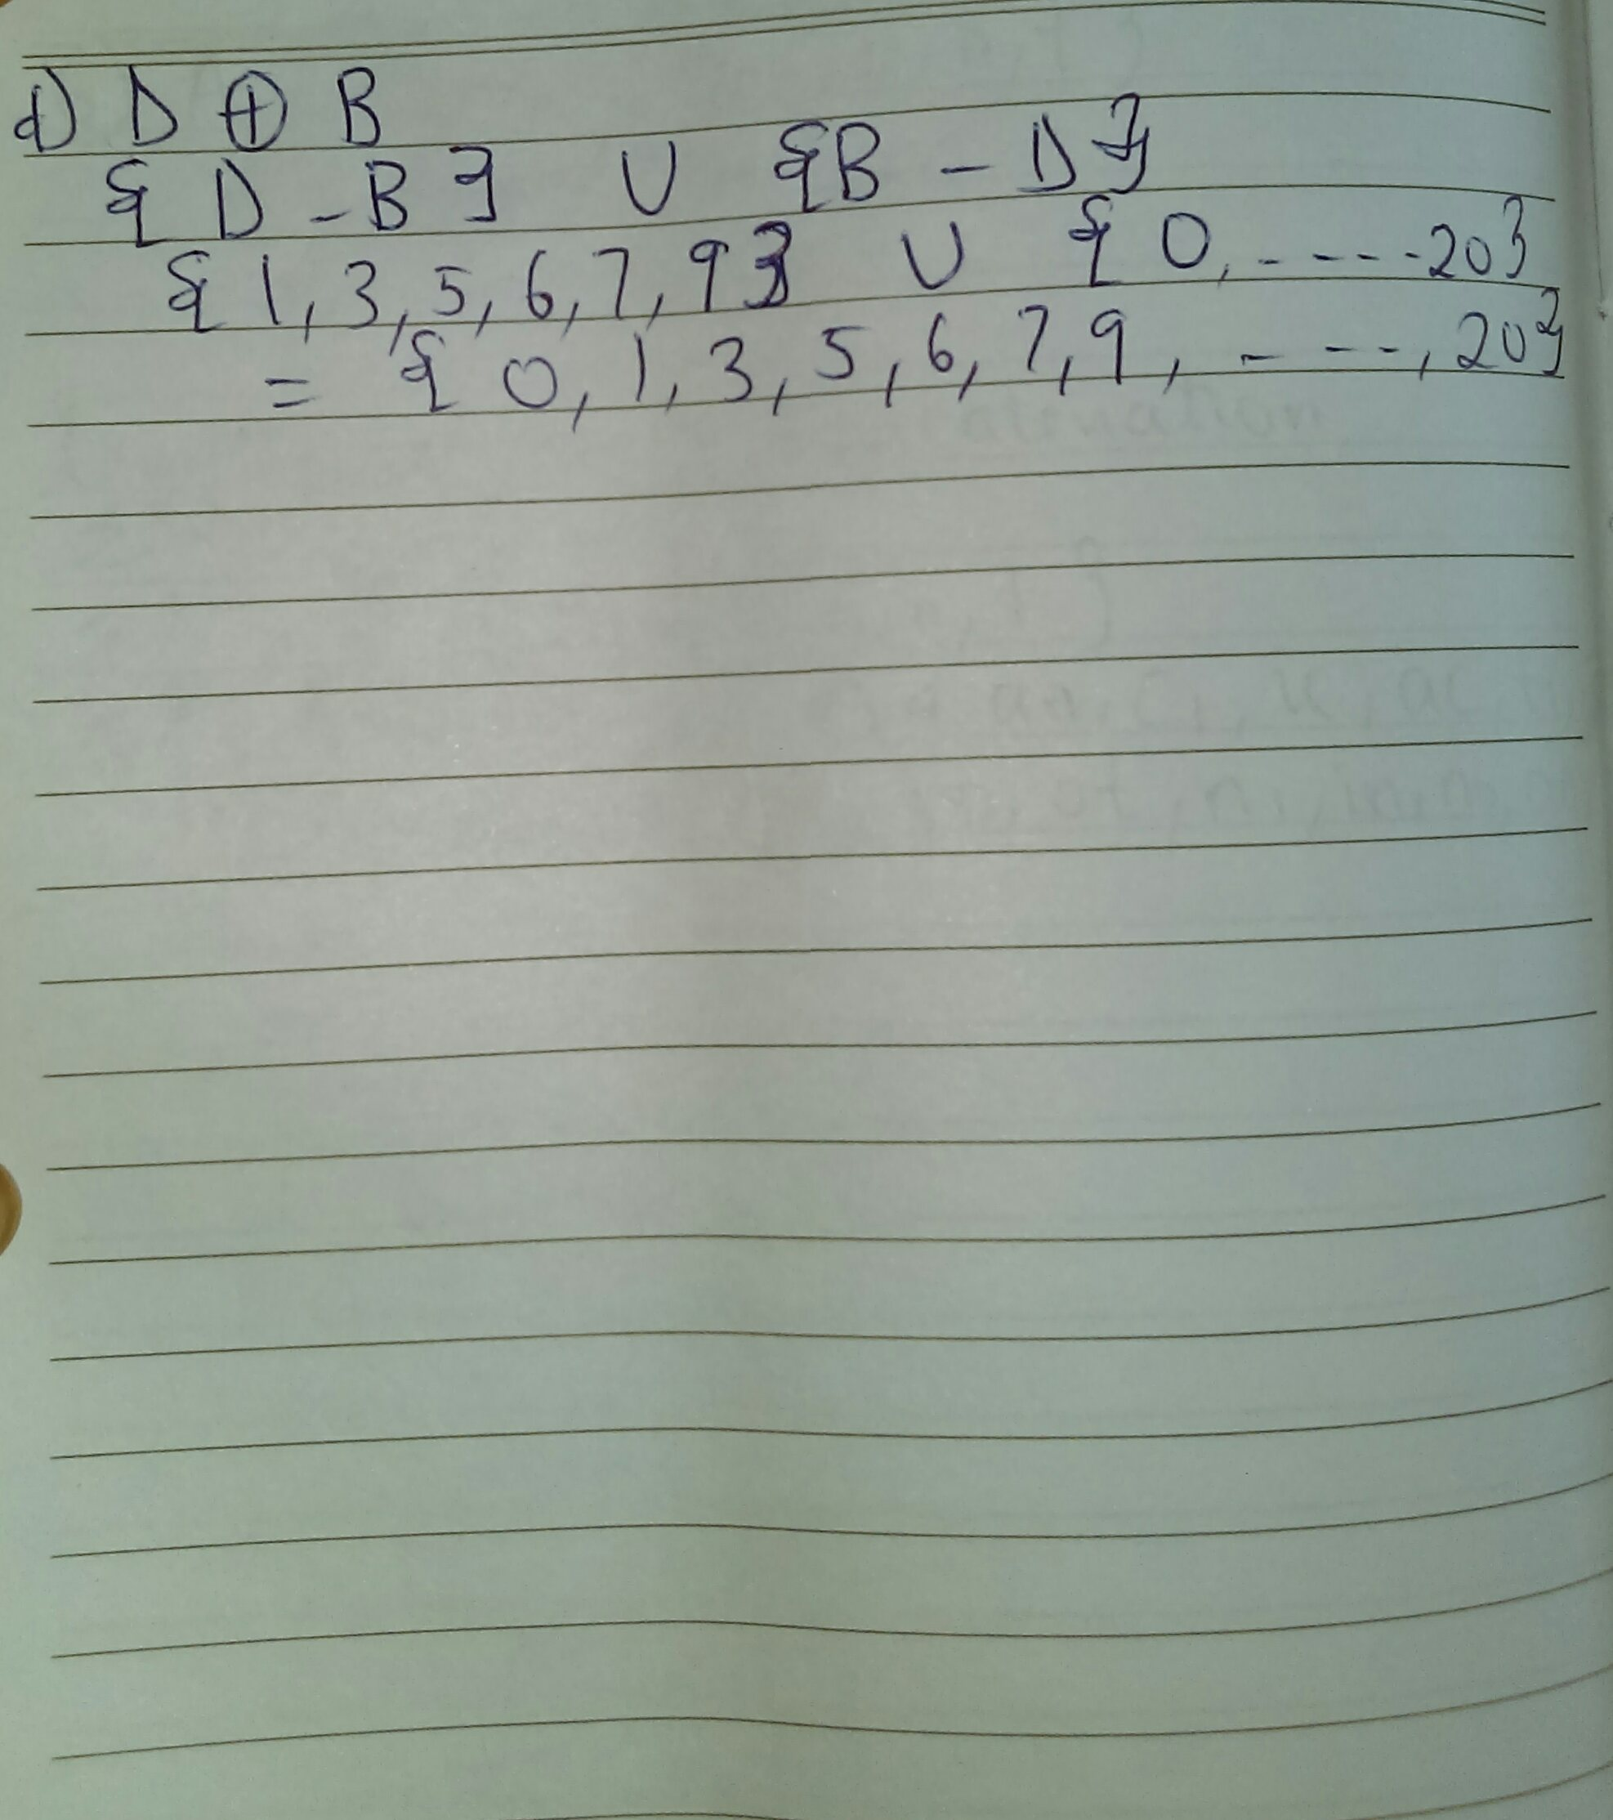

5. Alphabet: Alphabets are set of symbols, which are always finite. String: String is a finite sequence of symbols from some alphabet. String is generally denoted as w and length of a string is denoted as |w|.
Word: A word or string W on the set Σ is a finite sequence of its element.
Length of a word: The length of a word U written as |U| or (U) is the number of elements in its sequence of letter.
Substring: A substring is a contiguous sequence of characters within a string. For instance, "the best of" is a substring of "It was the best of times". This is not to be confused with subsequence, which is a generalization of substring.
Initial segment: It is anything that begins with first word of V.
Concatenation of string: Considering two words U and V on the alphabet Σ,the concatenation of V and U written as VU is the word obtained by writing down the letters of U followed by the of V.
Language: A language L over an alphabet Σ is a collection of strings/words on Σ

6. A={a,c,e,i,o,n,t}
v=concatenation
u=catetioncona
(i)the length of v=13
(ii)reverse string u=anocnoitetac
(iii)concatenate v and u=concatenationcatetioncona
(iv)substring of m if m=cacontatione
∑0={λ}
∑1={c,a,c,o,n,t,a,t,I,o,n,e}
∑2={ca,ac,co,on,nt,ta,at,ti,io,on,ne}
∑3={cac,aco,con,,ont,tat,tio,ion,one}
∑4={caco,acon,cont,onta,tati,atio,ione}
∑5={cacon,acont,conta,ontat,ntati,tatio,ation,tione}
∑6={cacont,aconta,contat,ontati,ntatio,tation,atione}
∑7={caconta,acontat,contati,ontatio,ntation,tatione}
∑8={cacontat,acontati,contatio,notation,ntatione}
∑9={cacontati,acontatio,contation,ontatione,}
∑10={cacontatio,acontation,contatione}
∑11={cacontation,acontatione}
∑12={cacomtatione}

7.substring of s={abracaba}
(i)∑0={λ}
∑1={a,b,r,a,c,a,b,a}
∑2={ab,br,ra,ca,ab,ba}
∑3={abr,bra,rac,aca,cab,aba}
∑4={abar,brac,raca,acab,caba}
∑5={abrac,braca,racab,acaba}
∑6={abraca,bracab,racaba}
∑7={abracab,bracaba}
∑8={abracaba}

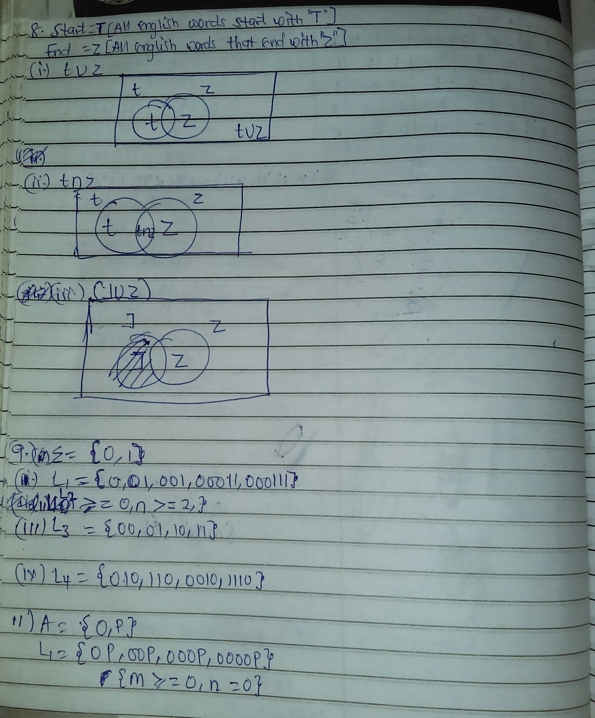
8.



