NAME: Ibegbu Ejiamike Albert
MATRIC NUMBER: 17/SCI01/036
COURSE CODE: CSC304
COURSE TITLE: Theory of Computing

- Differentiate between computability and complexity based on their objectives.

- With a given example describe complexity theory and computability theory

- Define the following with a given example
- A set
- Power set
- Members of a set
- Subset
- Proper subset
- Infinite set
- Finite set
- Unordered pair
- Union of a set
- Intersection of a set
xi. Complement of a set
xii. Difference of a set
xiii. Symmetric difference of a set

- Consider the universal set U. U = {1,2,3,.....,9} A = {2,3,5,6,9},
B = {0,2,4, 8,....,20}, C = {1,3,5,...} and D = {1,2,3,4,5,6,7,8,9}. Find
- B∩C, A∩D, A∩C
- B^c, D^c, C^c
- A⊕C, B⊕C, C⊕D, D⊕B
- A∪B, B∪D, C ∪D
v. A-B, D-C, C-B
- Define the following
- Alphabet
- Words
- Length of a word
- Substring
- Initial segment
- Concatenation of strings
- Language

- Suppose A = {a,c,e,i,o,n,t} with strings v = concatenation and u = catetioncona
- Find the length of word in v
- Reverse string u
- Concatenate v and u
- Find substring of string m, if m = cacontatione

- Consider the given word s = abracaba
- Find the substring of s
- find the initial segment of s

- Draw the Venn diagram to represent the following:
- Let the set START – t be the set of all English words that start with letter “t” and the set END – z of English words that ends with “Z”.
- The intersection between words that start with “t” and the ones the ends with “Z”. iii. The union of the words that start with “j” and ends with “Z”.

- Given the following set of strings chosen from ∑^*, L⊆∑^* and ∑ = {0,1}. Find the Language that generates
- Set of all strings containing 11 in it
- Set of all strings starting with 0 and ending with 1
iii. Set of all strings with length 2
iv. Set of all strings ending with 10; and

- If A denotes an alphabet, A^* is a set of strings over A. Find the possible alphabet for the following languages:
- L={en, nouh, ugh}
- L={bear,rear,2200}
- The language of all binary strings.

- Given the following set of strings chosen from A^*, L⊆A^* and A = {o, p}. Find the Language that generates
- Set of all strings ending with p
- Set of all strings with equal no of o’s and p’s;
- Set of all strings starting with p and ending with o
- Set of all strings with length 4

- Let ∑ = {a, b}, describe the Languages that produce the following set of strings.
- {b^n a| n>0}
- { a^n ab^m | n≥0,m>0}
- { b^n b^m a^m | n≥0,m≥0}
- {ab, abb, aab, aaa, abbb,.....}

- Let A = {a, b}, describe the Languages that produce the following set of strings.
- {b, ba, bab, baa, bbb,.....}
- {bab, babb, bbab, bbabb, babbb, bbbab...}
- {b, bb, bbb, bbbb, ....}
- {ab, aabb, aaabbb,.....}
- If L,L1, L2 are languages over ∑ , then define the following operations: . Union . intersection . Difference . complement . Positive closure . star operation . Multiplication . power

Answer
1.The goal or objective of computability theory is to determine which problems, or classes of problems, can be solved in each model of computation. It is also concerned with the classification of problems by difficulty

WHILE

The complexity of a problem or the objective of complexity theory is to describe whether a problem can be solved using algorithms, and how much resources (in form of time and space) it will take to solve a problem algorithmically

2.Computability theory deals primarily with the question of whether a problem is
solvable at all on a computer. The statement that the halting problem cannot be
solved by a Turing machine is one of the most important results in computability
theory, as it is an example of a concrete problem that is both easy to formulate and
impossible to solve using a Turing machine. Much of computability theory builds on
the halting problem result.
Complexity Theory is part of the theory of computation dealing with the resources
required during computation to solve a given problem. The most common resources
are time (how many steps does it take to solve a problem) and space (how much
memory does it take to solve a problem). Other resources can also be considered,
such as how many parallel processors are needed to solve a problem in parallel.
Complexity theory differs from computability theory, which deals with whether a
problem can be solved at all, regardless of the resources required.

3.
- Set: A set is a well-defined collection of distinct objects, considered as an object in its own right and is always denoted by a capital letter. Eg: A={0,1,2,3,…}, A is a set of numbers starting from ‘0’.
- Power Set: A power set of any set A is the set of all subsets of A, including the empty set and A itself. It is denoted by P(A).Eg: A={0,1}, P(A) ={Ø,{0},{1},{0,1}}.
- Members of a Set: Any element of a set is a member of that set.The symbol ϵ is used to denote the member of the set, and any member of a set is always a subset of its parent set. Set A={1, 3, 5, 7} implies that 1, 3, 5, 7 are members or elements of A.
- SubSet: A set for which all elements of that set are contained in another set. Eg: if set A={1, 2, 3} and B={1, 2, 3}, it means A is a subset of B.
- Proper Sub-Set: A proper subset of a set A is a subset of A that is not equal to A.In other words, if B is a proper set of A, then all elements of B are in A but A contains at least one element that is not in B. Eg: if A={1, 3. 5} and B={1, 5} then B is a proper sub-set of A.
- Infinite Set: An infinite set is a set containing unlimited or uncountable elements.For example set of all positive integers that are multiples of 3.
- Finite Set: A finite set is a set that has a finite number of elements.For example, {2,4,6,8,10}
- Unordered pair: An unordered pair or pair set is a set of the form {a, b}, i.e. a set having two elements a and b with no particular relation between them.
- Union of a set: The union of a collection of sets is the set of all elements in the collection.Eg: A={1,2} , B={3,4} therefore, A∪B={1,2,3,4}
- Intersection of a set: The intersection of two sets is the set of all elements that are present in both sets. Eg: A={1,2,3} , B={3,4,5} therefore, A∩B={3}
- Complement of a set: the complement of a set A refers to elements not in A. When all sets under consideration are considered to be subsets of a given set U, the absolute complement of A is the set of elements in U but not in A. Eg: the universal set U={1,2,3,4,5} and A={3}, then a compliment of A is given as A’={1,2,4,5}.
- Difference of two sets: The difference of two sets, written A - B is the set of all elements of A that are not elements of B. Eg: A={1,2,3} , B={3,4,5} therefore, A-B={1,2}.
- Symmetric difference of a set:the symmetric difference, also known as the disjunctive union, of two sets is the set of elements which are in either of the sets and not in their intersection, denoted by ⊕ .For example, the symmetric difference of the sets {1,2,3}and {3,4} is {1,2,4}.

4i. B∩C={Ø}
A∩D={2,3,5,6,9}
A∩C={3,5}
4ii. B^{c} ={1,3,5,6,7,9}
D^{c} ={Ø}
C^{c} ={2,4,6,8}
4iii.A⊕C = A-C ∪ C-A
A-C ={2,6,9}
C-A ={1,7,11,…}
A-C ∪ C-A = {1,2,6,7,9,11,…}

B⊕C= B-C ∪ C-B
B-C ={0,2,4,8,…,20}
C-B ={1,3,5,…}
B-C ∪ C-B = {0,1,2,3,4,5,7,8,…,20}

C⊕D = C-D ∪ D-C
C-D ={11,13,17}
D-C ={1,7,11,…}
C-D ∪ D-C = {1,2,6,7,9,11,…}

D⊕B = D-B ∪ B-D
D-B ={1,3,5,6,7,9}
B-D ={0,…,20}
D-B ∪ B-D = {1,2,6,7,9,11,…}
iv. A∪B={0,2,3,4,5,6,8,8,…,20}
B∪D={0,1,2,3,4,5,6,7,8,9,…,20}
C∪D={1,2,3,4,5,6,7,8,9,…}
- A-B={3,5,6,9}
D-C={2,4,6,9}
C-B={1,3,5,…}

- Alphabets:An alphabet is a finite non-empty set. The elements of an alphabet are called the letters or symbols of the alphabet.

Words: A word or string w on the set Ʃ(known as the alphabet) is a finite sequence of the elements in the set Ʃ.

Length of a Words: The length of a word U written as |U| or l(U) is the number of elements in it sequence of letters.

Substring: Consider any word u=a₁,a₂,a₃,…,a_{n} on an alphabet Ʃ, any sequence w=a_{j},a_{j+1},…,a_{k} is called a substring of u.

Initial Segment: Consider any word u=a₁,a₂,a₃,…,a_{n} on an alphabet Ʃ, any sequence w=a_{j},a_{j+1},…,a_{k} is called a substring of u. The substring w =a_{j},a_{j+1},…,a_{k} beginning with the first letter of u is called an initial segment of u.

Concatenation of Strings: Consider two words u and v on the alphabet Ʃ. The concatenation of u and v written as vu is the word obtained by writing down the letters of v followed by the letters of u.

Language: A language l, over Ʃ is a collection of strings/words on Ʃ.

- A = {a,c,e,i,o,n,t}
v = concatenation
u = catetioncona
(i) the length of v= 13
(ii) reverse string u= anocnoitetac
(iii) concatenate v and u= concatenationcatetioncona
(iv) substring of m if m=cacontatione
∑0={λ}
∑1= { c,a,c,o,n,t,a,t,I,o,n,e}
∑2= {ca,ac,co,on,nt,ta,at,ti,io,on,ne}
∑3= {cac,aco,con,,ont,tat,tio,ion,one}
∑4={caco,acon,cont,onta,tati,atio,ione}
∑5={cacon,acont,conta,ontat,ntati,tatio,ation,tione}
∑6={cacont,aconta,contat,ontati,ntatio,tation,atione}
∑7={caconta,acontat,contati,ontatio,ntation,tatione}
∑8={cacontat,acontati,contatio,notation,ntatione}
∑9={cacontati,acontatio,contation,ontatione,}
∑10={cacontatio,acontation,contatione}
∑11={cacontation,acontatione}
∑12={cacomtatione}
∑= { λ,c,a,c,o,n,t,a,t,I,o,n,e, ca,ac,co,on,nt,ta,at,ti,io,on,ne, cac,aco,con,,ont,tat,tio,ion,one, caco,acon,cont,onta,tati,atio,ione, cacon,acont,conta,ontat,ntati,tatio,ation,tione,cacont,aconta,contat,ontati,ntatio,tation,atione,caconta,acontat,contati,ontatio,ntation,tatione, cacontat,acontati,contatio,notation,ntatione, cacontati,acontatio,contation,ontatione, cacontatio,acontation,contatione, cacontation,acontatione, cacomtatione}

7. substring of s={abracaba}
(i) ∑0={λ}
∑1={a,b,r,a,c,a,b,a}
∑2={ab,br,ra,ca,ab,ba}
∑3={abr,bra,rac,aca,cab,aba}
∑4={abar,brac,raca,acab,caba}
∑5={abrac,braca,racab,acaba}
∑6={abraca,bracab,racaba}
∑7= {abracab,bracaba}
∑8={abracaba}
∑= { λ, a,b,r,a,c,a,b,a, ab,br,ra,ca,ab,ba, abr,bra,rac,aca,cab,aba, abar,brac,raca,acab,caba, abrac,braca,racab,acaba, abraca,bracab,racaba, abracab,bracaba, abracaba}

(ii) initial segment of S={a,ab,ac,abr,aca,aba,abra,acab,abrac,acaba,abracab,abracaba}

8.
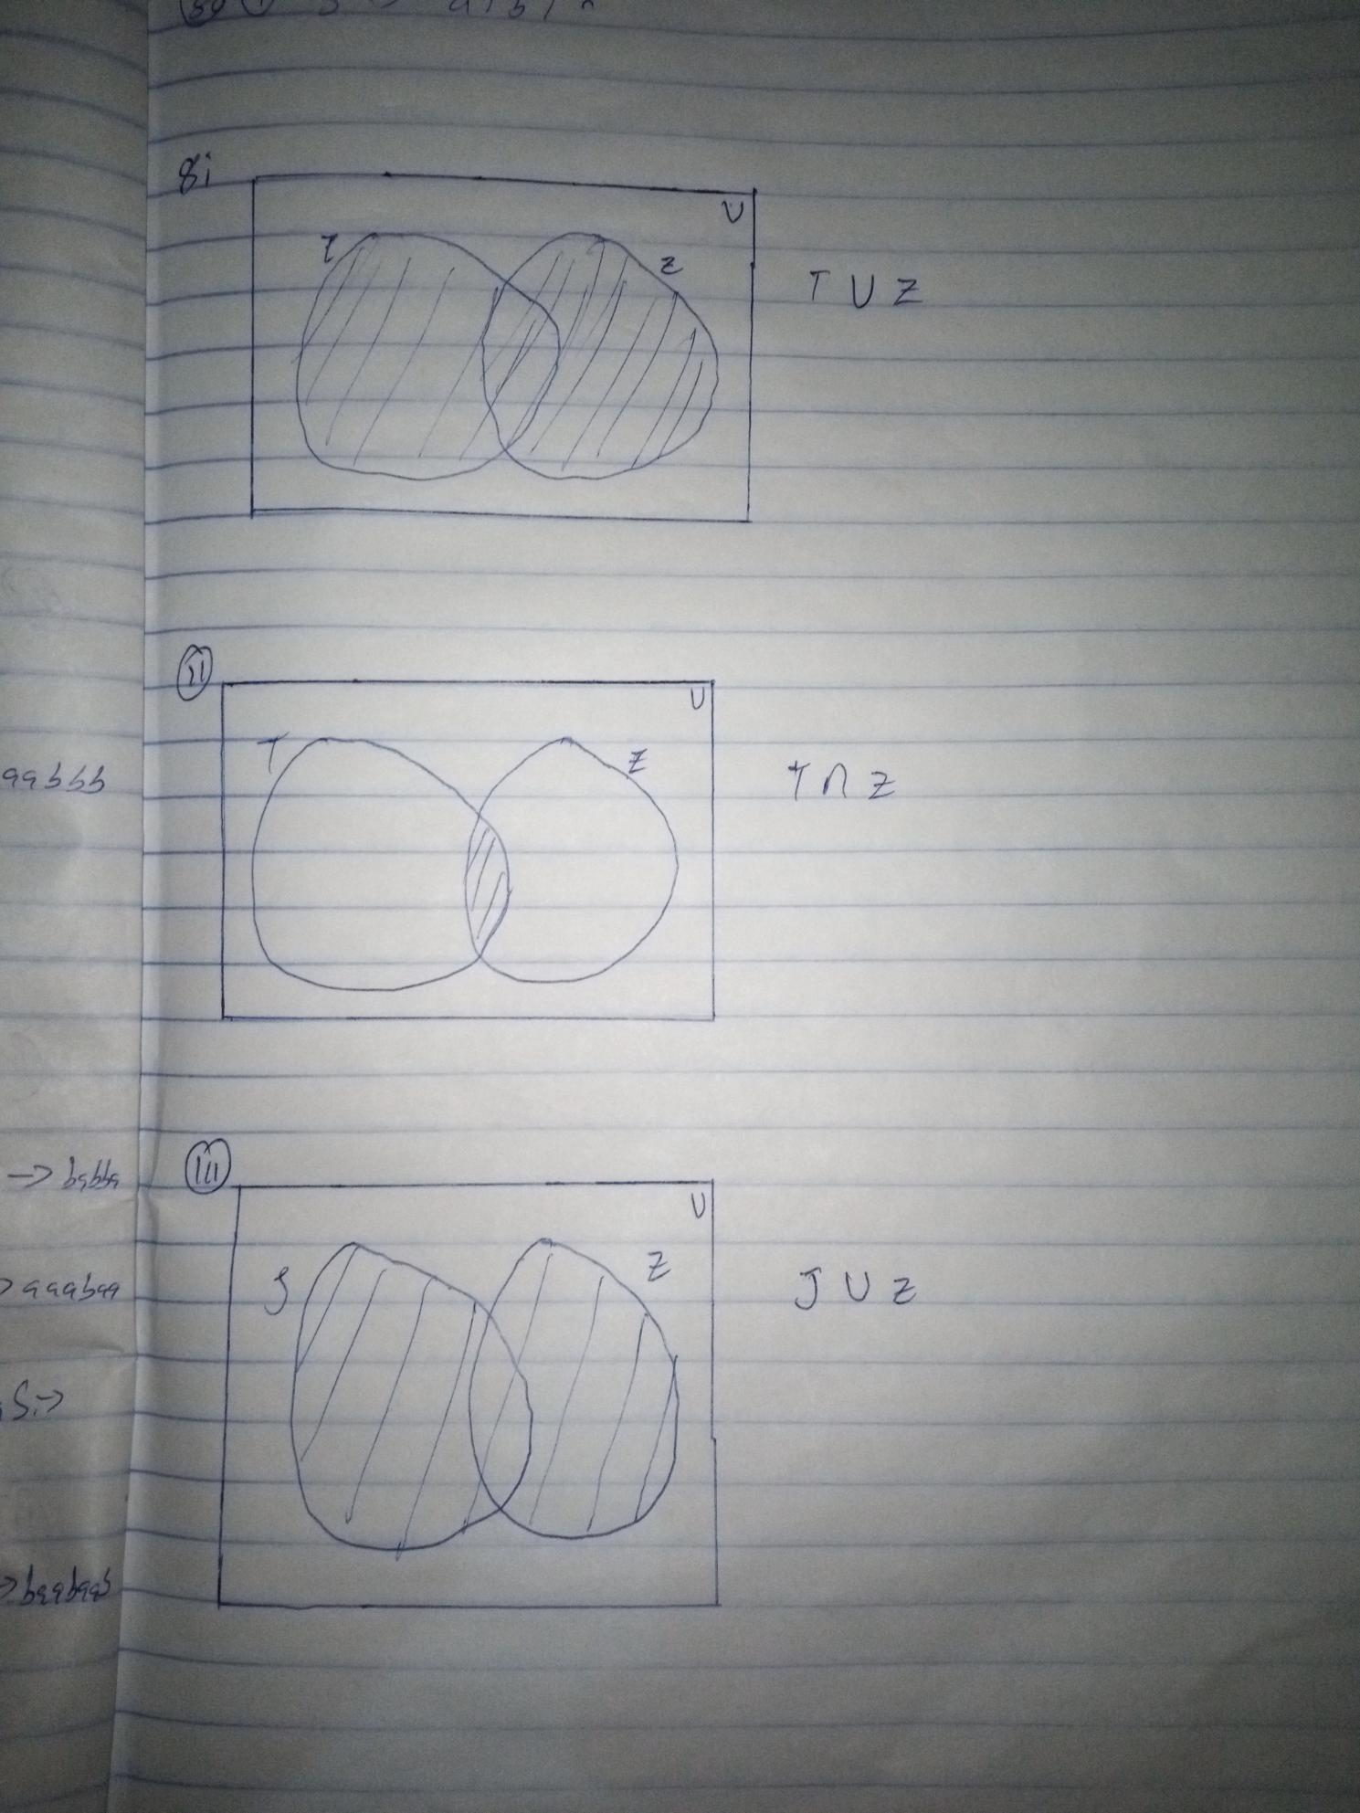
9.
- (0∪1)^{m}11(0∪1)^{n}11^{q}|m,n,q>=0
L={11,011,110,111,…}
- 0(0∪1)^{m}1|m>=0
L={01,001,011,0001,…}
- (0∪1)^{m}|m=2
L={00,01,10,11}
- (0∪1)^{m}10|m>=0

10.
- A={λ,e,g,h,n,o,u}
- A={0,2,a,b,e,r}
- A={0,1}

11.
- (o∪p)^{m}p|m>=0
L={p,op,pp,oop,opp,pop,ppp,…}
- p^{n}o^{m}p^{m}o^{n}|m,n>=0
L={λ,op,po,oopp,ppoo,popo,…}
- p(o∪p)^{m}o|m>=0
L={po,poo,ppo,…}
- (o∪p)^{m}|m=4
L={oooo,ooop,oopp,oppp,pooo,…}

- {b^n a| n>0} L={a, ba, bba, bbba,…}
This language consists of words with one or more b’s ending with one a
- { a^n ab^m | n≥0,m>0} L={ab,aab,aabab,…}
This language consists of words beginning with one a followed by zero or more a’s and or b’s in between and ending with b.
- { b^n b^m a^m | n≥0,m≥0} L={λ,ba,bba,bbaa,bbbaa,…}
This consists of words starting with zero or more b’s followed by equal number of b’s and a’s
- {ab, abb, aab, aaa, abbb,.....}, a^{n}b^{m}|n,m>0
This language consists of zero or more a’s followed by zero or more b’s

- {b, ba, bab, baa, bbb,.....}

- {bab, babb, bbab, bbabb, babbb, bbbab...}

- {b, bb, bbb, bbbb, ....}

- {ab, aabb, aaabbb,.....}

14.

- The Union of L1 and L2 denoted by L1,L2, as set of all words in L1 or in L2
L={u ϵ∑*| uϵL1 or uϵL2}
- Intersection-L1∩L2:{u ϵ∑*| uϵL1 and uϵL2}
- Difference-L1-L2:{u ϵ∑*| uϵL1 and u does not belong toL2}
- Compliment-L’: the difference between ∑* and L; denoted by ∑*-L
- The multiplication of L1 and L2, denoted by L1L2, as the set of all words given by the concatenation of any word in L1 with any word in L2.
L={x|x=uv and u belongs to L1 and v belongs to L2}
- Power-Lº:{λ}or{ε}, L^{n}=L^{n-1} L if n>=1
- The Kleene closure/star operation of L, denoted by L*, as the language:
L*=L0 U L1 U L2 U ...
where L0 is the empty string and Ln=Ln-1L is the language consisting of the words of length n for n>0.
- Positive closure denoted by L⁺, as the language:
L⁺=L1 U L2 U ...
L-Ln is the language consisting of the words of length n for n>0.

