Name: Etuk Esther Emmanuel
Matric. No.: 17/mhs01/124
Department: Medicine and Surgery
Level: 300 lvl
Assignment Title: Renal Physiology for MBBS student
Course Title: Renal Physiology Body Fluid and Temperature Regulation
Course Code: PHS 303
Question
Second assignment
1. Discuss the pathophysiological process involves in renal failure?
Answer
Renal failure, also known as end-stage renal disease, is a medical condition in which the kidneys are functioning at less than 15% of normal. Kidney failure is classified as either acute renal failure, which develops rapidly and may resolve; and chronic renal failure, which develops slowly.
Acute Renal Failure
acute renal failure (ARF) is a rapidly progressive loss of renal function, generally characterized by oliguria (decreased urine production, quantified as less than 400 mL, per day in adults, less than 0.5 mL/kg/h in children or less than 1 mL/kg/h in infants); and fluid and electrolyte imbalance. AKI can result from a variety of causes, generally classified as prerenal, intrinsic, and postrenal. Many people diagnosed with paraquat intoxication experience AKI, sometimes requiring hemodialysis. The underlying cause must be identified and treated to arrest the progress, and dialysis may be necessary to bridge the time gap required for treating these fundamental causes.

Types of acute renal failure

Acute prerenal kidney failure
Insufficient blood flow to the kidneys can cause acute prerenal kidney failure. The kidneys can’t filter toxins from the blood without enough blood flow. This type of kidney failure can usually be cured once your doctor determines the cause of the decreased blood flow.

Acute intrinsic kidney failure
Acute intrinsic kidney failure can result from direct trauma to the kidneys, such as physical impact or an accident. Causes also include toxin overload and ischemia, which is a lack of oxygen to the kidneys.
The following may cause ischemia:
- severe bleeding
- shock
- renal blood vessel obstruction
- glomerulonephritis

Signs and Symptoms of Acute Kidney Failure
Signs and symptoms of acute kidney failure may include:
- Decreased urine output, although occasionally urine output remains normal
- Fluid retention, causing swelling in your legs, ankles or feet
- Shortness of breath
- Fatigue
- Confusion
- Nausea
- Weakness
- Irregular heartbeat
- Chest pain or pressure
- Seizures or coma in severe cases
Chronic Renal Failure
Chronic renal failure can also develop slowly and, initially, show few symptoms. Chronic Renal Failure can be the long term consequence of irreversible acute disease or part of a disease progression. The most common causes of chronic failure are diabetes mellitus and long-term, uncontrolled hypertension. Polycystic kidney disease is another well-known cause of chronic failure. The majority of people afflicted with polycystic kidney disease have a family history of the disease. Other genetic illnesses cause kidney failure, as well.
Overuse of common drugs such as ibuprofen, and acetaminophen (paracetamol) can also cause chronic kidney failure. Some infectious disease agents, such as hantavirus\, can attack the kidneys, causing kidney failure.

Types of chronic renal failure

Chronic prerenal kidney failure
When there isn’t enough blood flowing to the kidneys for an extended period of time, the kidneys begin to shrink and lose the ability to function.

Chronic intrinsic kidney failure
This happens when there’s long-term damage to the kidneys due to intrinsic kidney disease. Intrinsic kidney disease develops from a direct trauma to the kidneys, such as severe bleeding or a lack of oxygen.

Chronic post-renal kidney failure
A long-term blockage of the urinary tract prevents urination. This causes pressure and eventual kidney damage.

2. With the aid of suitable diagrams discuss the types of dialysis you know?
Answer
There are three different types of dialysis.

a). Hemodialysis
Hemodialysis is the most common type of dialysis. This process uses an artificial kidney (hemodialyzer) to remove waste and extra fluid from the blood. The blood is removed from the body and filtered through the artificial kidney. The filtered blood is then returned to the body with the help of a dialysis machine. To get the blood to flow to the artificial kidney, your doctor will perform surgery to create an entrance point (vascular access) into your blood vessels. The three types of entrance points are:
- Arteriovenous (AV) fistula. This type connects an artery and a vein. It’s the preferred option.
- AV graft. This type is a looped tube.
- Vascular access catheter. This may be inserted into the large vein in your neck.
Both the AV fistula and AV graft are designed for long-term dialysis treatments. People who receive AV fistulas are healed and ready to begin hemodialysis two to three months after their surgery. People who receive AV grafts are ready in two to three weeks. Catheters are designed for short-term or temporary use. Hemodialysis treatments usually last three to five hours and are performed three times per week. However, hemodialysis treatment can also be completed in shorter, more frequent sessions. Most hemodialysis treatments are performed at a hospital, doctor’s office, or dialysis center. The length of treatment depends on your body size, the amount of waste in your body, and the current state of your health. After you’ve been on hemodialysis for an extended period of time, your doctor may feel that you’re ready to give yourself dialysis treatments at home. This option is more common for people who need long-term treatment.
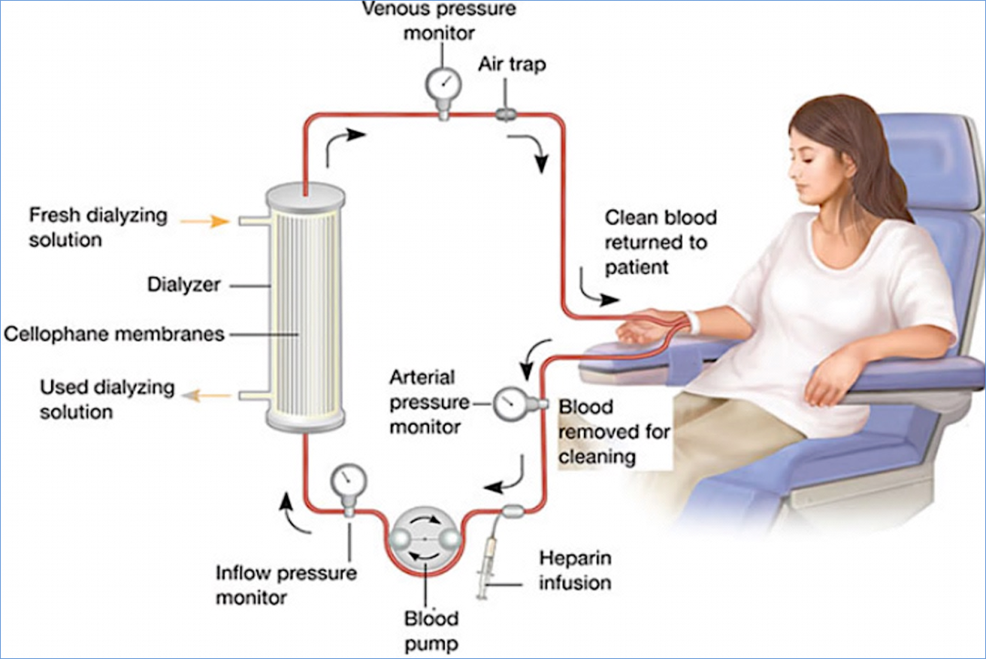
Hemodialysis

Risks associated with hemodialysis
Hemodialysis risks include:
- low blood pressure
- anemia, or not having enough red blood cells
- muscle cramping
- difficulty sleeping
- itching
- high blood potassium levels
- pericarditis, an inflammation of the membrane around the heart
- sepsis
- bacteremia, or a bloodstream infection
- irregular heartbeat
- sudden cardiac death, the leading cause of death in people undergoing dialysis

b). Peritoneal dialysis
Peritoneal dialysis involves surgery to implant a peritoneal dialysis (PD) catheter into your abdomen. The catheter helps filter your blood through the peritoneum, a membrane in your abdomen. During treatment, a special fluid called dialysate flows into the peritoneum. The dialysate absorbs waste. Once the dialysate draws waste out of the bloodstream, it’s drained from your abdomen.
This process takes a few hours and needs to be repeated four to six times per day. However, the exchange of fluids can be performed while you’re sleeping or awake.
There are numerous different types of peritoneal dialysis. The main ones are:
- Continuous ambulatory peritoneal dialysis (CAPD). In CAPD, your abdomen is filled and drained multiple times each day. This method doesn’t require a machine and must be performed while awake.
- Continuous cycling peritoneal dialysis (CCPD). CCPD uses a machine to cycle the fluid in and out of your abdomen. It’s usually done at night while you sleep.
- Intermittent peritoneal dialysis (IPD). This treatment is usually performed in the hospital, though it may be performed at home. It uses the same machine as CCPD, but the process takes longer.

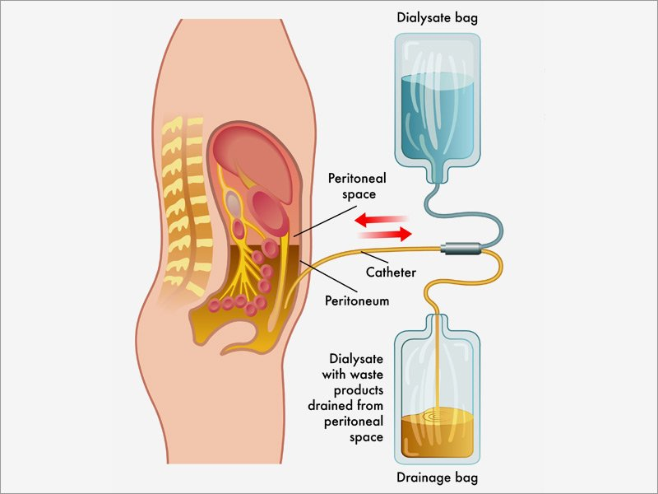

Peritoneal Dialysis

Risks associated with peritoneal dialysis
Peritoneal dialysis is associated with an increased risk for infections in or around the catheter site in the abdominal cavity. For example, after catheter implantation, a person can experience peritonitis. Peritonitis is an infection of the membrane lining the abdominal wall.
Other risks include:
- abdominal muscle weakening
- high blood sugar due to the dextrose in the dialysate
- weight gain
- hernia
- fever
- stomach pain

c). Continuous renal replacement therapy (CRRT)
This therapy is used primarily in the intensive care unit for people with acute kidney failure. It’s also known as hemofiltration. A machine passes the blood through tubing. A filter then removes waste products and water. The blood is returned to the body, along with replacement fluid. This procedure is performed 12 to 24 hours a day, generally every day.
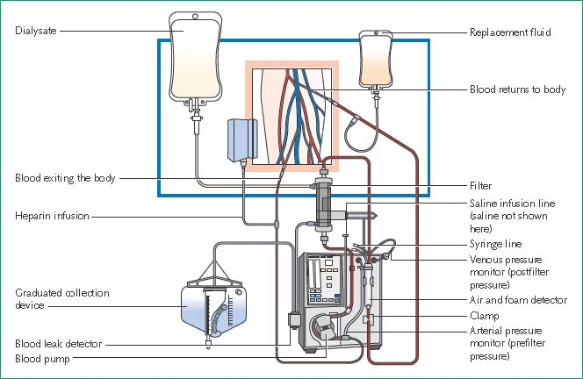
Continuous renal replacement therapy

Risks associated with CRRT
The risks associated with CRRT include:
- infection
- hypothermia
- low blood pressure
- electrolyte disturbances
- bleeding
- delayed renal recovery
- weakening of bones
- anaphylaxis

