EMMANUEL-ANTHONY HANNAH
17/MHS01/114
NEUROHISTOLOGY ASSIGNMENT
ORGAN OF CORTI.
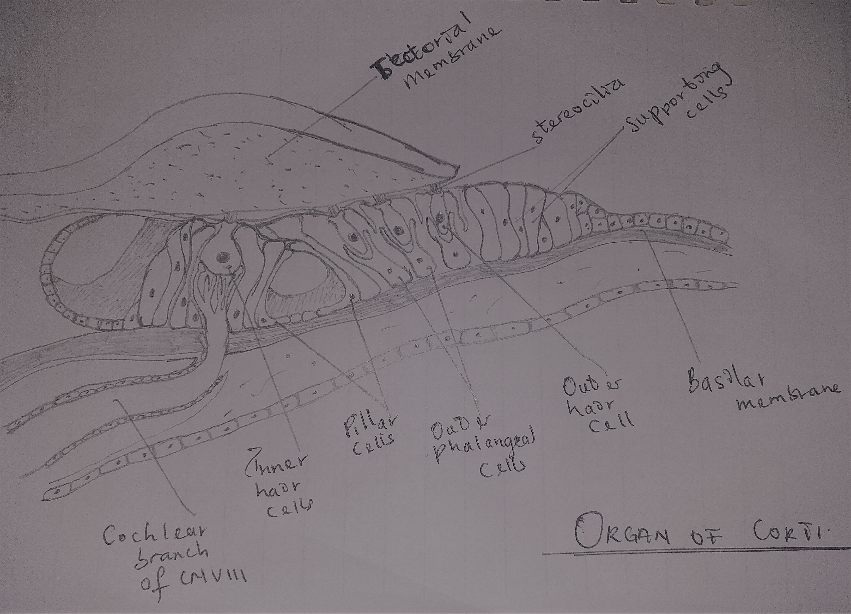
DIAGRAM OF THE ORGAN OF CORTI

The Organ of Corti (a.k.a spiral organ) is an organ in the middle ear located within the cochlea (housed inside the Scala media) which contributes to audition and can be called the body's microphone. It rests on the surface of the basilar membrane in the cochlea and contains hair cells with other epithelial structures. The organ of corti includes three rows of outer hair cells and one row of inner hair cells, theses hair cells transduce mechanical sound vibrations into nerve or electrical impulses that can be interpreted by the brain. The sound vibrations which arises from the basilar membrane, bend the stereocilia on these hair cells through an electromechanical force.
CELLS OF THE ORGAN OF CORTI
1. Hair cells: there are two types of hair cells, inner and outer hair cells. They are receptive cells found in the inner ear. They are organized in two rows along the cochlear duct. The hairs of these cells project towards the inside of the cochlear duct. Hair cells on the inner side of the organ of Corti are known as inner hair cells, while hair cells nearer the opposite side of the organ of Corti are known as outer hair cells. Generally, outer hair cells are more numerous than inner hair cells in humans. Inner hair cells are innervated by more afferent nerves than efferent nerves while outer hair cells are innervated by more efferent nerves than afferent nerves.
a. Inner hair cells: Inner hair cells are the main type of receptive cells found in the cochlea and they are responsible for converting sound waves into nerve impulses. They are shorter than the outer hair cells and from a single row of about 3,500 cells, each with a single row of shorter stereocilia.
b. Outer hair cells: they approximately 12,000 in total occurring in three rows near the saccule and increasing to five rows near the apex of the cochlea. Each columnar outer hair cell bears a V-shaped bundle of stereocilia. The main function of the outer hair cells is to pre-amplify the sound waves with a low amplitude.
2. Supporting cells:
a. Hensen’s cells: are a layer of tall cells arranged in the organ of Corti in the cochlea, which are part of the supporting cells lie on the outer hair cells. Their appearance is upper part wide with lower part narrow, column like cells.
b. Claudius cells: they are considered as supporting cells within the organ of Corti in the cochlea. These cells extend from Hensen's cells to the spiral prominence epithelium, forming the outer sulcus. They are in direct contact with the endolymph of the cochlear duct. These cells are sealed via tight junctions that prevent flow of endolymph between them.
c. Boettcher cells: are polyhedral cells on the basilar membrane of the cochlea, and are located beneath Claudius cells. They are present only in the lower turn of the cochlea. These cells interweave with each other, and project microvilli into the intercellular space.
d. Deiters' cells: also known as phalangeal cells or cells of Deiters, are a cell type found within the inner ear. They contain both micro-filaments and micro-tubules which run from the basilar membrane to the reticular membrane of the inner ear. These cochlear supporting cells include a somatic part (with its cupula) which is known as the part where the hair cells sit on and a phalangeal process, which links the Deiters soma to the reticular lamina. The part of the phalanx which is included in the reticular lamina is the apex of the phalanx. the apical ends of the phalangeal cells are joined to those of the hair cells by tight zonulae occludens, forming an apical plate across the spiral organ through which the stereocilia bundles project into endolymph.
Other structures
a. Tunnel of corti; the spiral canal in the organ of Corti is triangular in shape and is formed by the outer and inner pillar cells or rods of Corti. Pillar cells is a supporting cell also which are stiffened by heavy bundles of keratin and outline the inner tunnel between the outer and inner complexes of the hair cells and phalangeal cells. the stiff inner tunnel also plays a role in sound transmission.
b. Basilar membrane: The basilar membrane is a stiff structural element within the cochlea of the inner ear which separates two liquid-filled tubes that run along the coil of the cochlea, the Scala media and the Scala tympani. The basilar membrane moves up and down in response to incoming sound waves, which are converted to traveling waves on the basilar membrane. It is an acellular membrane.
c. Tectorial membrane: it is an acellular gel like structure that extends over the organ of corti. "Tectorial" in anatomy means forming a cover. The tectorial membrane is located above the spiral limbus and the spiral organ of Corti and extends along the longitudinal length of the cochlea parallel to the basilar membrane.

