Name: Salawu Azeezat ojuolape
Matric number: 17/ mhs01/292
Ana 303 assignment
The cerebellum represents 10% of the brain's total volume, but contains more than half of our neurons. It acts as a coordination centre, using sensory inputs from the periphery to fine-tune our movement and balance. It is one of the first structures in the brain to begin to differentiate, but one of the last to mature, and its cellular organization continues to change for many months after birth. The mesencephalon and metencephalon both contribute to the developing mouse cerebellum. The patterning of these two regions depends on signals from the isthmus organizer (IO), located just caudal to their junction. Purkinje cells (PCs), Golgi neurons, stellate and basket cells all arise from the ventricular neuroepithelium. PCs are born around embryonic day 13, and they migrate along radial glial fibres into the cerebellar anlage. During their final maturation phase, PCs develop extensive dendritic arbors and synapse onto granule neurons. This depends on granule neuron signals.

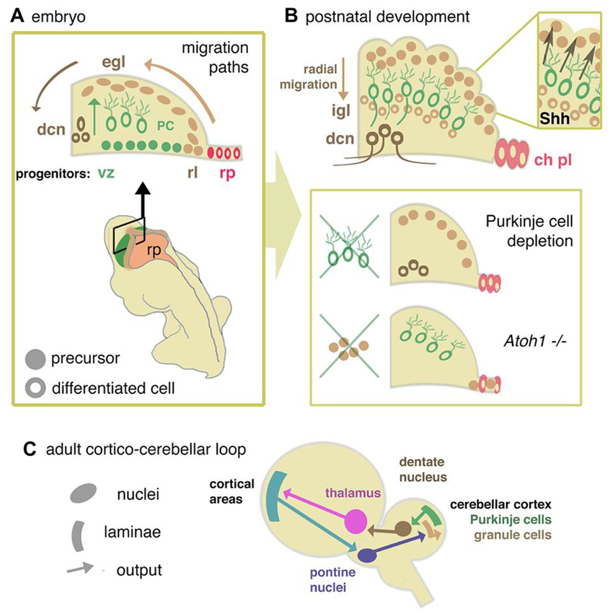

The cerebellum is a pivotal centre for the integration and processing of motor and sensory information. Its extended development into the postnatal period makes this structure vulnerable to a variety of pathologies, including neoplasia. These properties have prompted intensive investigations that reveal not only developmental mechanisms in common with other regions of the neuraxis but also unique strategies to generate neuronal diversity. How the phenotypically distinct cell types of the cerebellum emerge rests on understanding how gene expression differences arise in a spatially and temporally coordinated manner from initially homogeneous cell populations. Increasingly sophisticated fate mapping approaches, culminating in genetic-induced fate mapping, have furthered the understanding of lineage relationships between early- versus later-born cells. Tracing the developmental histories of cells in this way coupled with analysis of gene expression patterns has provided insight into the developmental genetic programmes that instruct cellular heterogeneity. A limitation to date has been the bulk analysis of cells, which blurs lineage relationships and obscures gene expression differences between cells that underpin the cellular taxonomy of the cerebellum. This review emphasises recent discoveries, focusing mainly on single-cell sequencing in mouse and parallel human studies that elucidate neural progenitor developmental trajectories with unprecedented resolution. Complementary functional studies of neural repair after cerebellar injury are challenging assumptions about the stability of postnatal cellular identities. The result is a wealth of new information about the developmental mechanisms that generate cerebellar neural diversity, with implications for human evolution.
The internal structure of the cerebellum reflects an intriguing paradox; its cytoarchitecture is relatively simple and repeated throughout, yet the connections between its neurons are wired into a complex array of gene expression domains and functional circuits. The developmental mechanisms that coordinate the establishment of cerebellar structure and circuitry provide a powerful model for understanding how functional brain networks are formed. Two primary germinal zones generate the cells that make up the cerebellum. Each zone expresses a specific set of genes that establish the cell lineages within the cerebellar anlage. Then, cohorts of differentiated projection neurons and interneuron progenitors migrate into the developing cerebellum. Thereafter, a number of remarkable patterning events occur including transformation of the smooth cerebellar surface into an intricately patterned series of folds, formation of three distinct cellular layers, and the demarcation of parasagittal gene expression domains. Together, these structural and molecular organizations are thought to support the proper connectivity between incoming afferent projections and their target cells. After birth, genetic programs and neural activity repattern synaptic connections into topographic neural networks called modules, which are organized around a longitudinal zone plan and are defined by their molecular, anatomic, and functional properties.
The major features of cerebellar development can be briefly summarized as follows. Neuronal populations are generated in a sequential manner. The inhibitory interneurons emerge from the ventricular zone and the glutamatergic neurons are generated by the rhombic lip. In mouse, the glutamatergic and gabaergic neurons in nuclei are produced first, followed by Purkinje neurons. It is established that gabaergic interneurons of the cerebellar cortex originate from a ventricular zone progenitor. After generation of cerebellar nuclei, the external granular layer is formed from precursors of granule cells originating from the rhombic lip. Granule cells will migrate to form the internal granular layer. It is interesting to note that these events occur at the third trimester of development in human (see also below the impact of very premature birth upon cerebellar development). Survival and maintenance of Purkine neurons and granule cells is dependent on the antiapoptotic protein Lifeguard, which is highly expressed in the cerebellum and is strongly upregulated during postnatal brain development.
The cerebellum has long been recognized for its role in motor co-ordination, but it is also increasingly appreciated for its role in complex cognitive behavior.
Genetic bases of known cerebellar disorders.
Cerebellar disorders have numerous causes, including congenital malformations, hereditary ataxias, and acquired conditions. Symptoms vary with the cause but typically include ataxia (impaired muscle coordination). Diagnosis is clinical and often by imaging and sometimes genetic testing. Treatment is usually supportive unless the cause is acquired and reversible.
1. Acute Cerebellar Ataxia (ACA) is a disorder that occurs when the cerebellum becomes inflamed or damaged. The cerebellum is the area of the brain responsible for controlling gait and muscle coordination.The term ataxia refers to a lack of fine control of voluntary movements. Acute means the ataxia comes on quickly, on the order of minutes to a day or two. ACA is also known as cerebellitis. People with ACA often have a loss of coordination and may have difficulty performing daily tasks. The condition most commonly affects children, particularly those between ages 2 and 7. However, it occasionally affects adults as well.
Causes of ACA- chicken pox, measles, mumps, hepatitis A, bleeding in the cerebellum etc

