NAME : IHENSEKHIEN EBUNOLUWA PEARL
MATRIC: 17/MHS01/151
DEPT: MEDICINE AND SURGERY (300L)
COURSE: NEUROANATOMY
QUESTION; WRITE A CONCISE REVIEW ON THE DEVELOPMENTAL GENETICS OF THE CEREBELLUM AND HIGHLIGHT THE GENETIC BASES OF KNOWN CEREBELLAR DISORDERS
ABSTRACT
the list of genes that when mutated cause disruptions in cerebellar development is rapidly increasing. The study of both spontaneous and engineered mouse mutants has been essential to this progress, as it has revealed much of our current understanding of the developmental processes required to construct the mature cerebellum. Improvements in brain imaging, such as magnetic resonance imaging (MRI) and the emergence of better classification schemes for human cerebellar malformations, have recently led to the identification of a number of genes which cause human cerebellar disorders. In this review we argue that synergistic approaches combining classical molecular techniques, genomics, and mouse models of human malformations will be essential to fuel additional discoveries of cerebellar developmental genes and mechanisms.
INTRODUCTION
In the last several decades, various approaches have contributed to our understanding of the molecular basis of cerebellar development. The study of spontaneous neurological mouse mutants aided many initial discoveries that are further reviewed below. Significant advances in mouse genetics have allowed for more targeted studies using engineered gene knockouts and transgenic mice. These mice have facilitated the examination of more subtle phenotypes such as mild behavioral abnormalities and small disruptions in cerebellar circuitry. Advances in brain imaging techniques and improvements in the classification of human cerebellar malformations have further aided the discovery of genes regulating cerebellar development. Genetics has recently enabled the identification of genes causing human pontocerebellar hypoplasia, Joubert syndrome, and Dandy–Walker malformation (DWM). When combined with studies in mouse, a variety of molecular mechanisms, including transcriptional regulation, mitochondrial function, and ciliary signaling have been implicated in homeostasis, patterning, and cell proliferation during cerebellar development. Concurrently, the application of new genomic techniques, which amass vast amounts of biological information, is just beginning to unravel the systems biology of the developing cerebellum. Here we discuss these issues and advocate the integrated use of human and mouse systems to further advance our knowledge of the molecular and developmental processes that form the cerebellum.
DISCUSSION
The cerebellum as a genetic system
Basis of cerebellar development. The study of spontaneous neurological mouse mutants aided many initial discoveries that are further reviewed below. Significant advances in mouse genetics have allowed for more targeted studies using engineered gene knockouts and transgenic mice. These mice have facilitated the examination of more subtle phenotypes such as mild behavioral abnormalities and small disruptions in cerebellar circuitry. Advances in brain imaging techniques and improvements in the classification of human cerebellar malformations have further aided the discovery of genes regulating cerebellar development. Genetics has recently enabled the identification of genes causing human pontocerebellar hypoplasia, Joubert syndrome, and Dandy–Walker malformation (DWM). When combined with studies in mouse, a variety of molecular mechanisms, including transcriptional regulation, mitochondrial function, and ciliary signaling have been implicated in homeostasis, patterning, and cell proliferation during cerebellar development. Concurrently, the application of new genomic techniques, which amass vast amounts of biological information, is just beginning to unravel the systems biology of the developing cerebellum. Here we discuss these issues and advocate the integrated use of human and mouse systems to further advance our knowledge of the molecular and developmental processes that form the cerebellum.
TYPES OF HUMAN CEREBELLAR MALFORMATIONS
Advances in imaging, genetics, and classification are enabling previously consolidated malformations to be delineated into distinct categories. Here we will discuss cerebellar vermis hypoplasia (CVH), DWM, Joubert syndrome and related disorders (JSRD), and pontocerebellar hypoplasia (PCH) The defining features of these diagnoses are based on imaging criteria rather than clinical outcome, with most of these diagnoses associated with intellectual and motor disabilities. CVH is characterized by a small hypoplastic cerebellum with the vermis more affected than the hemispheres. DWM includes CVH; however, there is also an upward rotation of the cerebellar vermis that results in an enlarged fourth ventricle, and an increased size of the posterior fossa. DWM is the most common cerebellar malformation, with an estimated incidence of approximately 1 in 5,000. CVH is also relatively common and often confused with DWM, making estimations of incidence problematic. CVH and DWM often present as sporadic cases, although there are several CVH loci with known recessive or X-linked inheritance. Mendelian inheritance for DWM is rare, and the genetics are likely oligogenic. In contrast, JSRD are most often autosomal recessive disorders and are rare, with a population incidence estimated to be 1/100,000. As a group, JSRD are characterized by cerebellar vermis hypoplasia plus the presence of elongated cerebellar peduncles and a deepened interpeduncular fissure that appear as a “molar tooth” on axial brain scans. In addition, these patients exhibit axon guidance defects that include a decussation failure of the pyramidal tract and superior cerebellar peduncles. Patients with PCH exhibit a heterogeneous set of malformations characterized by hypoplasia and atrophy of the cerebellum, inferior olive, and ventral pons. This degenerative disorder often begins with embryonic atrophy of these regions.

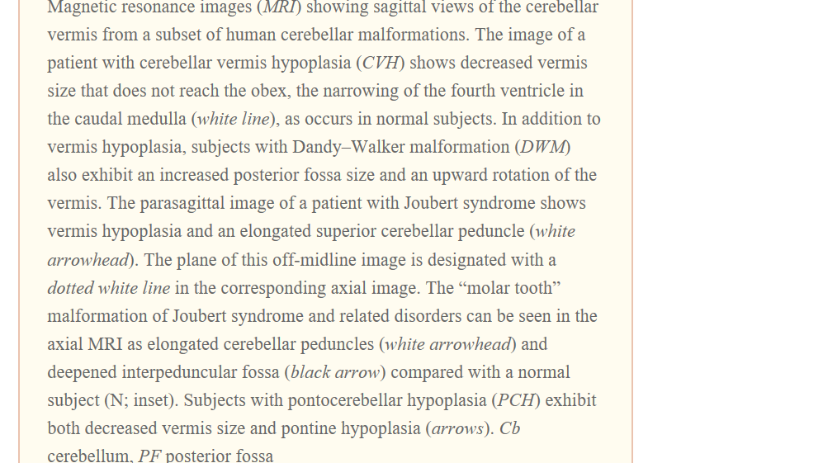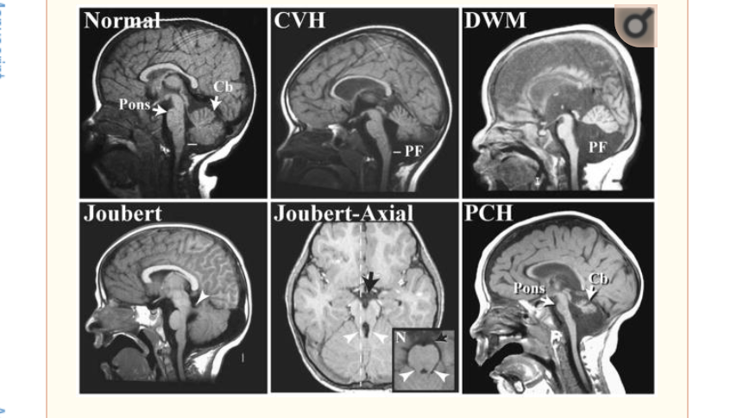
Causative Genes in Human Cerebellar Malformations
In the last decade, there has been considerable effort in defining the genetic basis of human cerebellar malformations. Causative genes include those involved in cerebellar patterning, cell fate specification, and other developmental processes

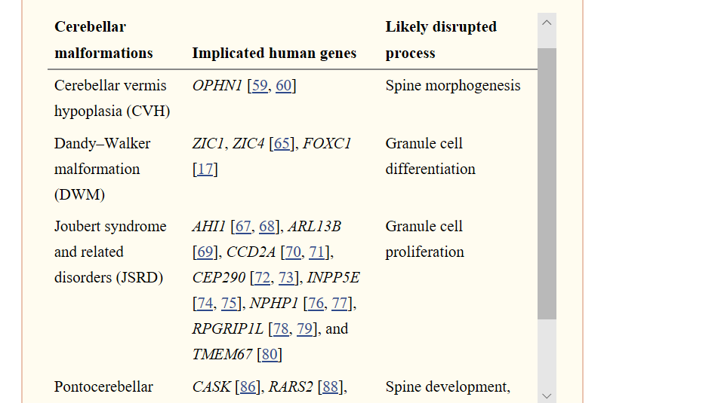
Pancreas specific transcription factor 1a (Ptf1a) was initially implicated as a basic helix–loop–helix transcription factor in pancreatic development since mice with a targeted deletion lacked pancreatic tissue. However, its role in brain development was not investigated until truncations of this gene were found to result in cerebellar agenesis in multiple families. Further investigations determined that loss of Ptf1a causes a failure to generate GABAergic cerebellar neurons in the embryonic cerebellar anlage in both human and mouse. Since Purkinje cells, which are GABAergic, are also required for the proliferation of cerebellar granule neurons, humans and mice lacking Ptf1a exhibit profound cerebellar agenesis. Transcription factors have also been implicated in other types of cerebellar malformations. Heterozygous loss of the ZIC1 and ZIC4 genes encoding zinc finger transcription factors can cause DWM, a phenotype which is mimicked in Zic1 and Zic4 double heterozygous mutant mice. Mutations in FOXC1, a transcription factor gene located in the 6p25.3 locus, have recently been shown to contribute to human DWM. Mouse models have demonstrated that Foxc1 is developmentally expressed in the mesenchyme adjacent to the cerebellum, where it is critical for normal posterior fossa development. In addition to regulating skull development, Foxc1 controls mesenchymally expressed signaling molecules including Bmp2 and Bmp4. Loss of these signaling molecules causes the adjacent cerebellar rhombic lip to lose Atoh1 (Math1) expression, a gene critical for normal granule cell differentiation. These findings, based on studies in both human and mice, have surprisingly implicated mesenchymal signaling as a critical regulator of early cerebellar anlage development.
Studies of JSRD patients have also provided surprising insights into new developmental mechanisms. Of the nine loci linked to JSRD, eight have been cloned and the following causative genes identified: AHI1, ARL13B, CC2D2A, CEP290, INPP5E, NPHP1, RPGRIP1L and TMEM67. Many of these genes are implicated in normal ciliary function and their protein products localize to the cilia or basal bodies. One such cilia-related protein is Nephrocystin, the product of NPHP1, which interacts with beta-tubulin and localizes to primary cilia. In cell culture, CEP290, centrosomal protein 290, is involved in ciliogenesis, localizes to centrioles in a microtubule-dependent manner, and regulates the microtubule network, as shown through RNAi. Furthermore, CEP290 interacts with the protein product of CCD2A both genetically and physically. Most recently, mutations in the INPP5E gene, which codes for inositol polyphosphate-5-phosphatase E, were found in patients with Joubert syndrome. While it was known that this enzyme hydrolyzes phosphatidylinositols, INPP5E was found to be localized to cilia and mutations resulted in premature destabilization of cilia after stimulation. Thus, examination of human patients led to a novel role for INPP5E in both cilia signaling and Joubert syndrome. Mutations in many components of this single biological pathway result in similar cerebellar defects. The actual purpose of cilia in the cerebellum is likely to be linked to SHH signaling. Significantly, loss-of-function mutations in murine Kif3a and Ift88—genes encoding
ntraflagellar transport proteins for the formation and maintenance of cilia—cause SHH-dependent proliferation defects of granule cell progenitors. This loss of SHH signaling results in cerebellar phenotypes resembling those seen in JSRD. JSRD now provide a model for how studies of human cerebellar malformations can lead to the discovery of causative genes and expand our knowledge of the pathways involved in cerebellar development.
Additional molecules have been implicated in human cerebellar malformations, which are certain to illuminate new cerebellar developmental mechanisms. Deletions of the Rho-GAP protein encoding gene Oliogphrenin-1 (OPHN1) have been found in multiple families with X-linked CVH. While Ophn1 is required for the stabilization of glutamatergic spines, it has not been implicated in regulating earlier developmental events such as cell division. Interestingly, mice with a targeted deletion of Ophn1 exhibit learning deficits and have dilated lateral and third ventricles, but their cerebellar size and morphology are normal. This suggests that the mental retardation (MR) seen in human patients may not be due to cerebellar defects. However, until the connectivity and plasticity of the mutant mouse cerebellum are examined in detail this only remains a speculation. Recently Ophn1 has been shown to facilitate clathrin-mediated endocytosis of post-synaptic vesicles, including the AMPA receptor, by repressing the RhoA/ROCK pathway. Because of this, mutant mice lack LTD in the hippocampus. Cerebellar LTD still remains to be examined.
Mutations of another molecule with a known role in synapse development have also been seen in PCH. CASK is a calcium/calmodulin-dependant serine/threonine kinase localized to synapses via membrane-associated molecules, including Neurexin. CASK also regulates gene transcription during cell proliferation. Although mouse Cask mutants have cerebellar hypoplasia, the developmental basis for this pathology has not yet been studied. Genes from the tRNA splicing pathway have also been observed to cause PCH when mutated in humans. One family has been found with three members containing mutations in the RARS2 gene, which encodes mitochondrial arginine-transfer RNA synthase. Individuals with PCH have also been found to have mutations in TSEN54, TSEN34, and TSEN2, which all encode tRNA splicing proteins. The study of mouse models will be essential to determine why developing cerebellar and pontine cells are particularly sensitive to the loss of these genes even though they are ubiquitously expressed.
Human studies have demonstrated that patient clinical phenotypes associated with severe congenital cerebellar malformations described here can be highly variable. Less severe cerebellar malformations have been reported in patients with non-syndromic MR, Autism Spectrum Disorders, and schizophrenia. Evidence of Purkinje cell dysfunction in cerebella from autistic patients has been demonstrated by reduced levels of glutamate decarboxylase (GAD67), which codes for a GABA-synthesizing enzyme. In addition, levels of various gene transcripts involved in GABAergic transmission are altered in lateral cerebellar hemispheres of schizophrenic patients. Specifically, GAD67, GAD65, GAT-1, MGLUR2, and NOS1 were downregulated whereas GABA_{A}-alpha6, GABA_{A}-delta, GLUR6, and GRIK5 were upregulated. Thus, it is likely that the genes underlying these more common and genetically complex neurodevelopmental disorders also influence cerebellar development. Notably, most patients with MR, autism, and other neurodevelopmental disorders rarely undergo brain imaging. Therefore, the coincidence of these disorders with cerebellar malformation is often missed. In order to fully and accurately delineate clinical phenotypes, we strongly advocate routine brain imaging of all human neurodevelopmental disorders. Further, given the extremely fine resolution with which cerebellar phenotypes can now be characterized in mice at the molecular, cellular, and systems level, mouse models for these common neurodevelopmental disorders are certain to be highly informative regarding their underlying pathology.

CONCLUSION
Our current understanding of the molecular and genetic basis of cerebellar development is derived primarily from the study of spontaneous and targeted mouse mutants. Only recently have human patients with cerebellar malformations begun to contribute to the discovery of genes that regulate the development of the cerebellum. Continued advances in the genomic technologies described here will facilitate the identification of other causative genes in human cerebellar malformations. In conjunction with continued use of model vertebrates, these novel approaches will yield additional genes—and hence networks—required in normal cerebellar development.
REFERENCES
MAIN SOURCE : https://www.ncbi.nlm.nih.gov/pmc/articles/PMC2921561/
1. Crepel F, Delhaye-Bouchaud N, Guastavino JM, Sampaio I. Multiple innervation of cerebellar Purkinje cells by climbing fibres in staggerer mutant mouse. Nature. 1980;283 (5746):483–4. [PubMed] [Google Scholar]
2. Herrup K, Mullen RJ. Staggerer chimeras: intrinsic nature of Purkinje cell defects and implications for normal cerebellar development. Brain Res. 1979;178(2–3):443–57. [PubMed] [Google Scholar]
3. Takayama C, Nakagawa S, Watanabe M, Mishina M, Inoue Y. Developmental changes in expression and distribution of the glutamate receptor channel delta 2 subunit according to the Purkinje cell maturation. Brain Res Dev Brain Res. 1996;92(2):147–55. [PubMed] [Google Scholar]
4. Lorenzon NM, Lutz CM, Frankel WN, Beam KG. Altered calcium channel currents in Purkinje cells of the neurological mutant mouse leaner. J Neurosci. 1998;18(12):4482–9. [PMC free article] [PubMed] [Google Scholar]
5. Patil N, Cox DR, Bhat D, Faham M, Myers RM, Peterson AS. A potassium channel mutation in weaver mice implicates membrane excitability in granule cell differentiation. Nat Genet. 1995;11(2):126–9. [PubMed] [Google Scholar]
6. Kashiwabuchi N, Ikeda K, Araki K, Hirano T, Shibuki K, Takayama C, et al. Impairment of motor coordination, Purkinje cell synapse formation, and cerebellar long-term depression in GluR delta 2 mutant mice. Cell. 1995;81(2):245–52. [PubMed] [Google Scholar]
7. Conquet F, Bashir ZI, Davies CH, Daniel H, Ferraguti F, Bordi F, et al. Motor deficit and impairment of synaptic plasticity in mice lacking mGluR1. Nature. 1994;372(6503):237–43. [PubMed] [Google Scholar]

